Label Brief: Cosmic Gummies

Brand Name:
Cosmic Gummies

Project Overview:
Cosmic Gummies is made out of the psychedelic Amanita mushroom that enhances one's reality and sends you on a trip. This is the most universally identifiable mushroom (red with white dots). This brand’s identity is trippy, psychedelic, fun and escapism. The Cosmic Gummies label will be placed on gummy bottles and gummy bags that will be sold online through an ecommerce webpage, social media campaigns and on shelves in retail stores. This is a fun label, have a blast with this.

Label Request:
Below is an example template of the label real estate available and the necessary label components:

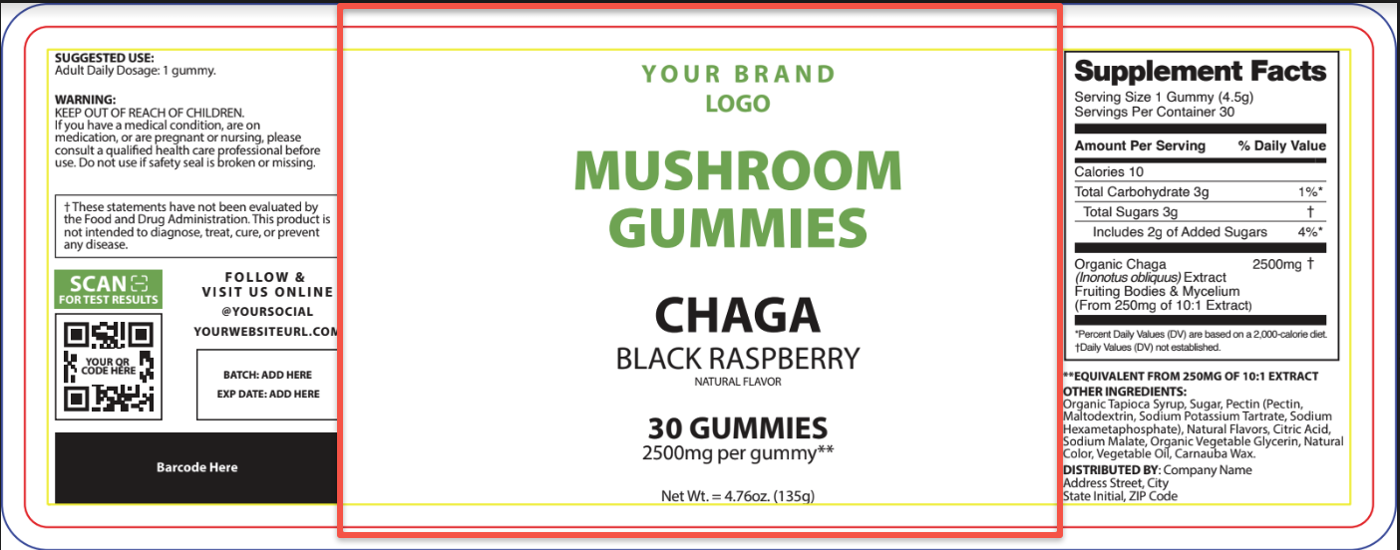

Label must include:
- Logo: TBD
- Product name: Cosmic Gummies
- Flavor: TBD
- Front Label Ingredients: TBD (2 total up total - about 24 characters at most)
- Back Label Ingredients:
- Gummy count
  - Dosage per gummy
- Net weight

Label elements we like:
- Label should incorporate the Amanita mushroom either literally or in some trippy/psychedelic representation.
- Label should be fun to look at sober, and trippy (a blast) to look at after you've taken the product
- Label should invoke a mushroom effect. Examples of “the mushroom effect” below:
  - Mostly it’s just glowing colors, distortions, details popping out…good vibes
  - an explosion of stimuli, my mind zipped through so many connections
  - Your sense of time and space perception will be warped
  - colors appear to glow
  - You’ll notice surfaces glittering and an increased richness in texture of (all) things.
  - You may find yourself smiling uncontrollably, or feeling especially giggly.
  - First feelings are usually those of euphoria and an "opening up" of the world where colors become more vivid and solid objects appear to "breathe."

Label Examples we like:
- Dozo
  - 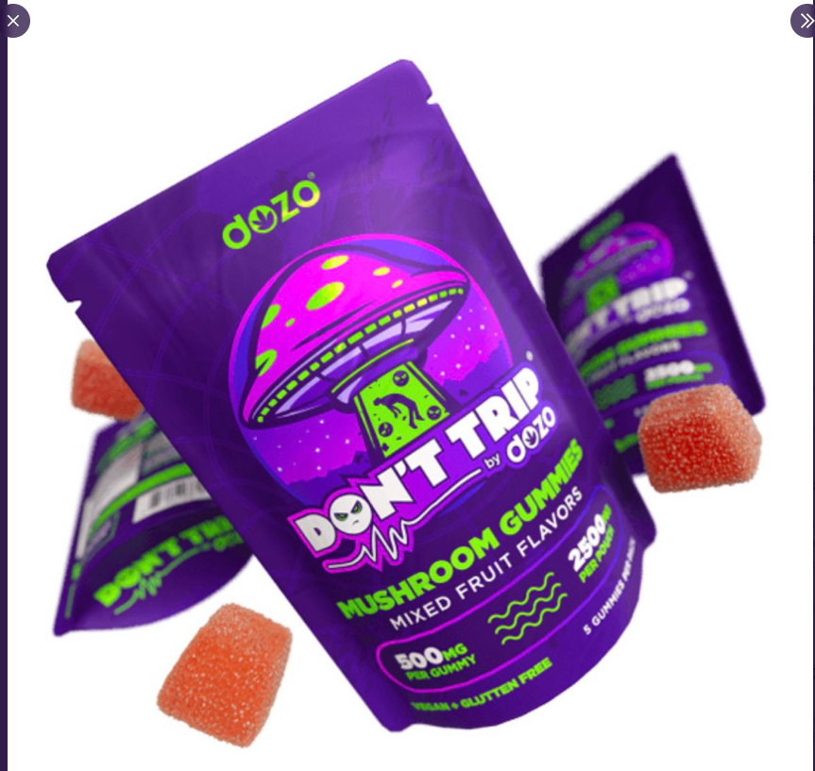
- https://thehelpingfriendlysalve.com/moon-shrooms-gummies-mango/
  - 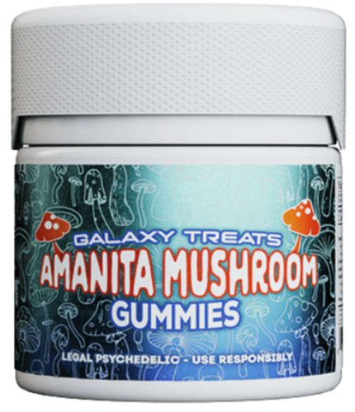
- https://eightysixbrand.com/products/funguy-bluerazz-amanita-gummies/
  - 