Personal Data

Short Profile

- I am a results-oriented, sagacious and responsible business administrator with a special affinity for marketing
- This includes 20 years of leadership experience for large corporations and SMEs in the sports, trade, media and financial industry. Thereof 8 years at management level.
- Executive MBA / Economics and Business Administration / Dipl. Communications Director
- Several years of experience abroad (USA, France, Brazil)
- I characterize myself as persistent, fast, analytical, responsible, composed, committed, capable of building bridges to unite or reconcile, prioritize intelligently, athletic, loyal, positive and successful

Work Experience
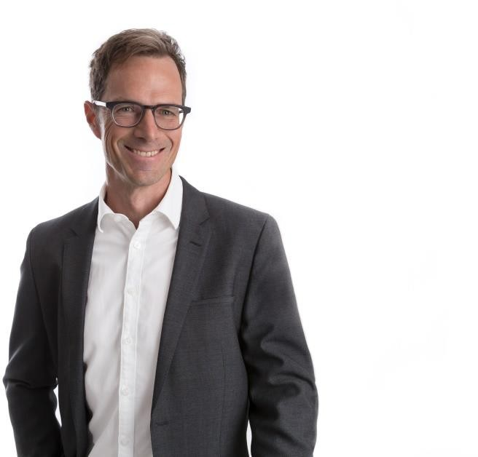
Given name
Albrecht
Surname
Adrian
Address
Amstutzstrasse 7 CH-6010 Kriens
Telephone
+41 79 706 73 38
E-mail
albrecht_adrian@yahoo.com
Date of birth
August 1, 1969
Nationality
Swiss
Marital status
married, two children (14 and 17 years old)

10.22 – 03.23 Interims Management:
Head of Marketing & Category Management Webstar AG, Dielsdorf
Areas of responsibility:
- Head of Marketing & Communication
- Branding / CICD
- Management Marketing team
- Management CSR team

Key activities:
- Temporary bridging of the vacancy "Head of Marketing”
- Finalization of complete re-branding and CICD project
- Head of CSR expert group incl. Ecovadis project
- Support / coaching of Marketing Team

02.17 – 09.22 Head of Marketing Transgourmet Switzerland AG (largest international subsidiary of Coop Group), Moosseedorf
Areas of responsibility:
  - Business development Marketing
  - All communication channels in the marketing mix
  - Digital transformation
Key activities:
  - Management and development marketing team of close to 40 people
  - Development and implementation of marketing strategy
  - Implementation Marketing Automation (BSI)
  - Digitalisation initiatives
  - Data-driven, analytical (direct) marketing
  - International projects Transgourmet International

Main achievements:
  - Development from "marketing services" to "marketing"
  - Build-up and transformation of digital marketing (Marketing Automation, Digital Marketing Hub)
  - Effectiveness and efficiency significantly improved / large cost saving programs
  - Restructuring / teambuilding

09.08 – 07.16 Chief Marketing Officer & Member of Management
Stöckli Swiss Sports AG, Wolhusen
Areas of responsibility:
- Brand building
- Business development marketing
- All communication channels in the marketing mix
- Further development of the company as a member of management
Key activities:
- Developing and implementing marketing strategy for three business sectors, specifically skis, bikes and retail (international, national, regional)
- Further development and anchoring of brand identity
- Transformation, digitization of communication channels
- Working out customer insights and consumer benefits
- Creating customer journeys
- Marketing automation / evaluation and implementation of CRM
- Input on product development for the ski & bike area, pricing, distribution and sales (retail, Swiss specialized stores, export)
- Responsible for budget and return on marketing investment
- Various tasks and projects as a member of management
- Management of a 10-person marketing team

Main achievements:
- Massive expansion of brand awareness, brand image and trust in the Stöckli brand
- Successful launch of customer loyalty program, important communities, and marketing automation
- Despite routinely low budgets, effectiveness was measurably increased
- Optimized consistency, motivation, and output marketing team
- Important sparring partner for all business areas

09.04 – 09.08 Head of Marketing Neue Luzerner Zeitung, Lucerne
Areas of responsibility:
- All areas of marketing communications
- Sales
Key activities:
- Development and implementation of a marketing strategy and concepts
- Customer loyalty and customer acquisition concepts via direct marketing and outbound activities
- The most important projects were establishment of youth marketing, CRM evaluation, and launch of “Central Switzerland on Sunday”
- Management of a 20-person marketing team (4 directly reporting to me, plus 16 other employees)
Main achievements:
- Securing the future with comprehensive, successful launch of youth marketing strategy
- Greatly improved renewal rates and revenue thanks to implementation of customer dialogue initiatives
- Together with the CEO, development of business plan introduction “Central Switzerland on Sunday”

  - – 06.04 Goldbach Media Group
(different functions as a result of internal restructuring):

  - to 06.04: Head of Product Marketing
IP Multimedia (Switzerland) AG, Küsnacht
    - Conception and planning of all product marketing actions
    - Maintaining contacts with foreign partners (TV and radio stations)
    - Pricing
    - Managing 4 product managers
  - – 06.03: Head of Communication
Goldbach Media Management AG, Küsnacht
    - Conception, planning, implementation of all communication actions
    - Annual planning and budget responsibility
    - Managed 1 employee

  - – 07.01: Director Marketing & Services
Banner.ch AG, Küsnacht
    - Establishment and management of “Marketing & Services” department of the start-up Banner.ch
    - Development and maintenance of the marketing portfolio
    - Managing of 5 employees
Main achievements:
    - Initiation and successful launch of category marketing platform “Mediarena” on the topic of “cross-media.”
    - Brought annual report to a new level
    - In the start-up “Banner.ch” established extremely fast functioning structures and processes

02.99 – 12.00 Marketing Specialist / member of the “Corporate Clients Marketing” team UBS AG, Zurich
- Marketing & Communications project management especially in the area of institutional investment advisory and private equity
03.96 – 01.99 Underwriter Swiss Re, Zurich
- Training program “Intro” for university graduates
- Swiss Re Brazil, Sao Paulo (6 months)
- Property Underwriting
07.95 – 02.96 Marketing Internship Geberit Sàrl, Antony (France)

Sideline activities

02.07 – 09.11 Mentor at the University of Lucerne (Institute of Communication & Marketing)

04.02 – 04.09 Expert for “advertising and promotion / integrated communication”
at Swiss federal examinations for marketing planners

09.02 – 06.07 Lecturer on “Communication Planning” for communication planner course and with federal degree at the Institute of Continuing Education (IWB) of the Business Training Centre Lucerne

Education

03.08 – 03.10 Executive MBA at the Lucerne School of Business, Lucerne

01.00 – 09.01 Swiss Graduate (Dipl.) Communications Director at SAWI (Swiss Training Centre for Marketing, Advertising and Communications)

IAA Diploma in Marketing Communications

09.91 – 07.94 Bachelor of Business Administration, Zurich

08.89 – 07.90 Student Exchange at Northwestern Michigan College (USA)

Languages

German native language

Romansh native language

English fluent (spoken and written)

French good to very good knowledge (spoken and written) Spanish residual knowledge from long language trips and stays

Availability

within 1 – 2 months

