Need packaging concept and mock-up for new product line of handmade bar soaps for men.

Our company, Man In His Prime™, specializes in high-end self-care products for men. We focus on the needs of high-performing men in their mid-30’s to 50’s who have worked hard to achieve their goals. We encourage a strong, positive view of masculinity where traits such as courage, bravery, competition, stoicism, toughness, and independence are celebrated.

Our body and skincare products use natural and organic ingredients that are designed to inspire confidence in everything men do, with a distinct focus on anti-aging benefits and enhancement to overall male virility and health. We avoid estrogenics and other ingredients that have been shown to have adverse effects on men’s health, most notably the production of testosterone.

Elements™ is our initial product line consisting of all-natural handmade soaps that make up a basic daily skin care routine for men in our target niche. This product line is inspired by the Greek philosopher, Aristotle, who was the first to theorize about the four (4) natural elements: Fire, Water, Air and Earth. There are four (4) individual soap variations, each one associated with one of these elements. The alignment of the Elements™ collection to Ancient Greece perfectly embodies the idea of manhood we promote at Man In His Prime™, with this classical conception of masculinity defining manhood in the West up until the middle of the 20th century.

In addition to Elements™ there will be additional collections released in the future, each one with it’s own concept, theme and design considerations.

Package design considerations for Elements™ are as follows:

- Approximate soap product dimensions will be 3” length x 3” width x 1” depth.
- Package should include the Man In His Prime™ corporate logo (different variations provided to be used at designer’s discretion).
- All soap bars incorporate a top-bottom 2-layer color scheme (Example shown in Figure 1). The front portion of the package should include a cutout window that clearly displays this 2-layer color scheme of the soap (Examples shown in Figure 2 and Figure 3). The designer has the flexibility to change the location of the cutout based on the overall design concept.

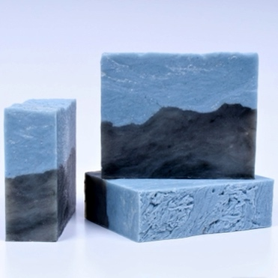  Figure 1 | 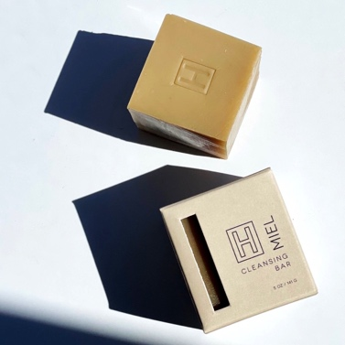  Figure 2 | 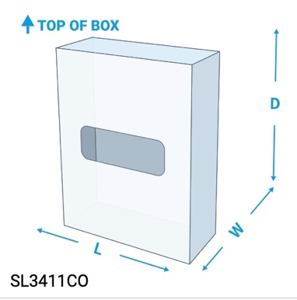  Figure 3
- Corporate brand color scheme is provided below for reference (Figure 4), but it is desired to create a specific product-specific color scheme as deemed fit by designer to incorporate the suggested color scheme based on individual products:
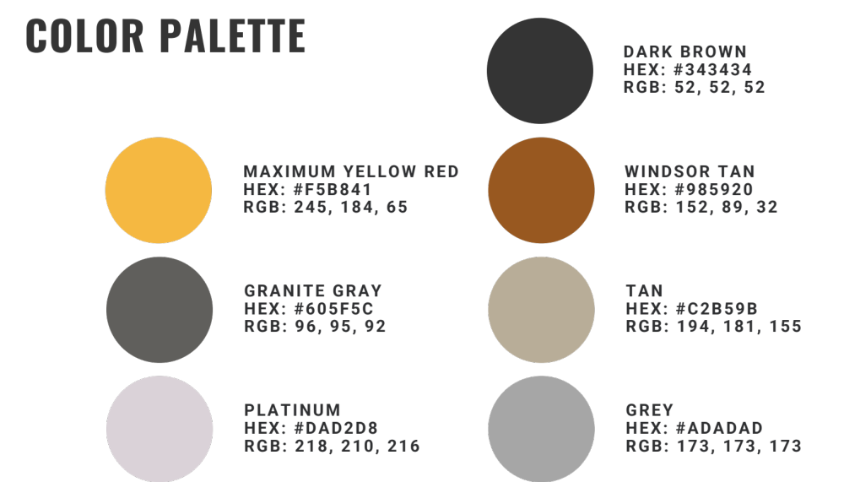
Figure 4

- Branding should reflect the product’s connection to Ancient Greece.
- Product should clearly identify that these are natural and organic handmade soaps for men.
- Each product should feature the name of the product line, Elements™, and the element symbol. Reference to the qualities, scent and colors of each should be considered in the design.

Element | Symbol | Qualities | Scent (*Subject To Change) | Colors
Fire | 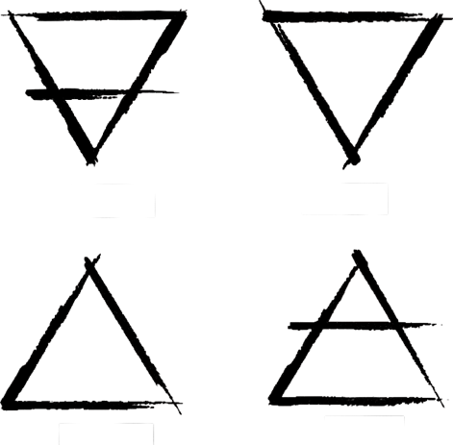 | - Courageous  - Strong  - Powerful  - Passionate | Cinnamon, clove, orange and cade, make for a spicy mysterious blend with a touch of smoke. | - Red-orange  - Yellow
Water | 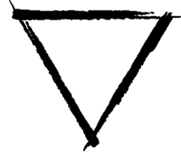 | - Healing  - Rebirth  - Peaceful  - Trusting | Aqua scent with peppermint and menthol along with musky notes of a warm amber and bourbon. Sea Salt and pumice for exfoliation. | - Dark Blue  - Grey
Air | 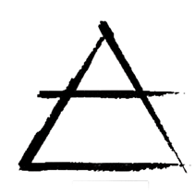 | - Knowledge  - Perceptive  - Creative  - Strategic | Intricate blend of fresh sea and sharp mountain air, sweet melons. | - Blue  - White
Earth | 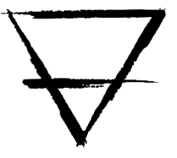 | - Stability  - Security  - Fertility  - Grounded  - Hard-working | Earthy patchouli, amber musk, with a touch of sweet spice, tobacco and vanilla. | - Green  - Brown

- Package should contain the product ingredients. Sample as follows:

Saponified Oils (Olive Oil, Organic Palm Oil**, Organic Coconut Oil*, Organic Shea Butter*, Avocado Oi), Pumice, Fragrance, Peppermint Essential Oil, Bentonite Clay, Salt, Menthol, Ultramarines, Iron Oxide. **Fair Trade, Sustainable-Palm Done Right, *Fair Trade

- Trust icons should be leveraged (i.e. All-Natural, Organic, Fair Trade, etc.).
- Space should be allotted for SKU and Barcode.

Examples of previous concepts that didn’t quite make final selction:

