Care Gap Management
Manage patient care gaps, your patient roster, and view incentive progress all in one user-friendly web platform.
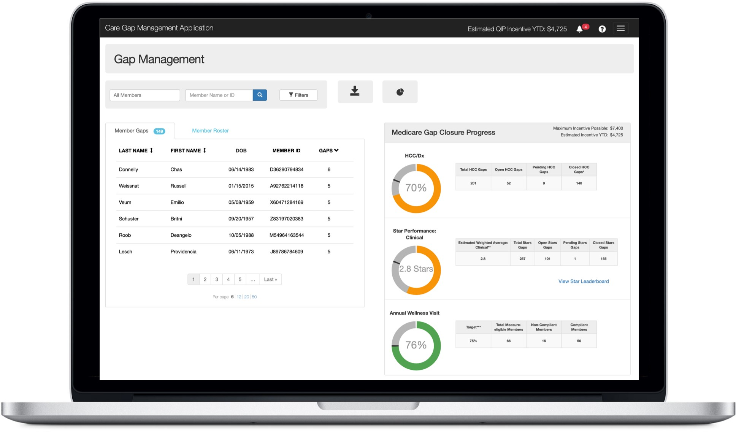

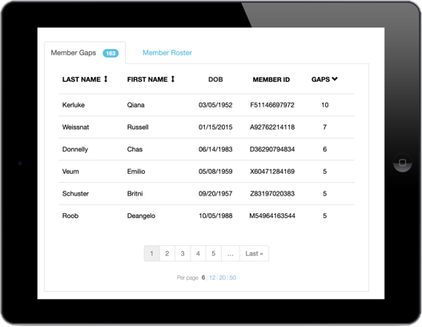
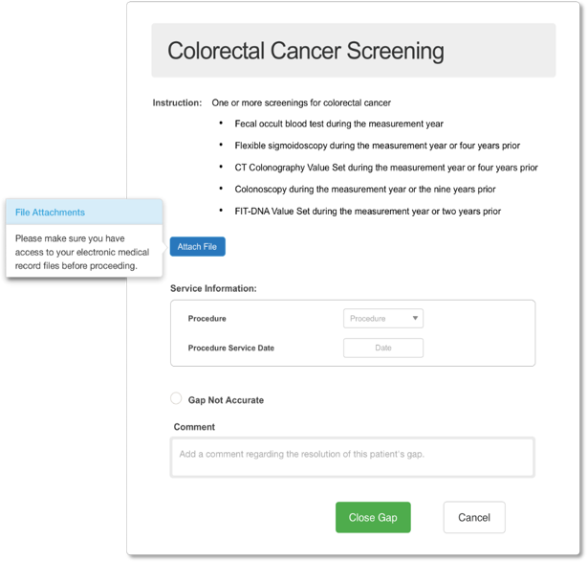

Close care gaps.

View care gaps.
Care coordinators, medical assistants, and practice managers can view a regularly refreshed listing of patient care gaps, increasing preparedness for patient encounters and improving the patient experience.
Easily submit evidence to close patient care gaps. Streamlined web forms let you quickly upload charts and submit evidence needed to satisfy both Star measure gaps and risk adjustable gaps.

Is a gap not applicable or accurate for the member? Then select Gap Not Accurate - unique to the Novillus platform - to let us know why, saving you time and effort for the gap exclusion/invalidation process that otherwise is very cumbersome.



Powered by:

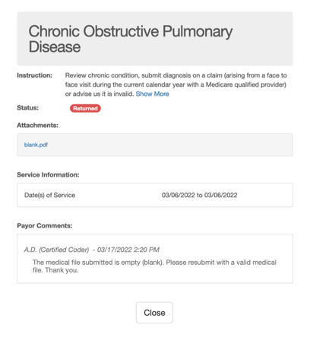
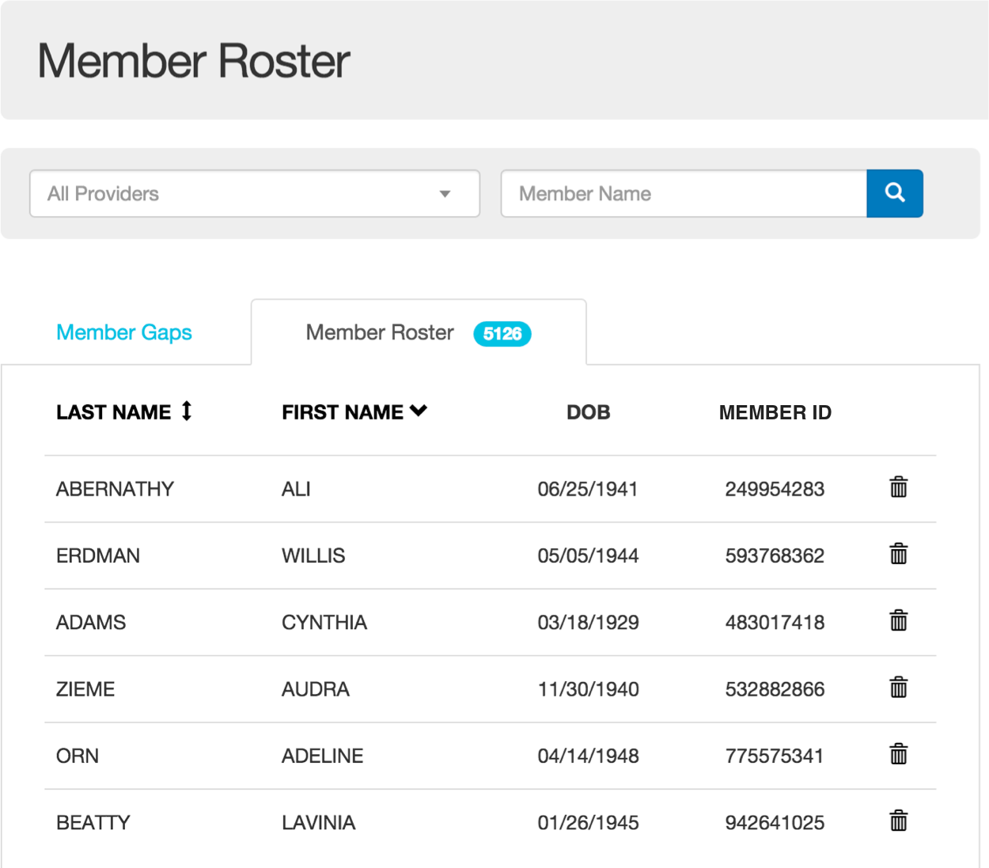
Manage your patient roster.
Real-time workflows.
Secure workflows route your gap closure submissions to health plan gap validators for review and approval.

If there is an issue with your submission, you'll be notified with an email and a notification in the tool with instructions for resubmitting. This will save you time, effort, and frustration by avoiding phone-tag or email correspondence.
View a continually refreshed listing of patients attributed to your provider group.

Should the patient be removed from your roster?
The application makes it quick and easy to request
the patient be removed from your roster, and the reason why with a click of a button - another time-saving benefit to your practice. We will reattribute after confirming
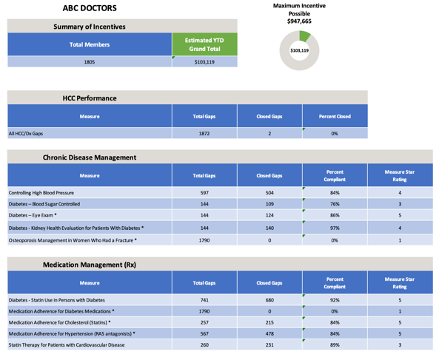
with the patient.

View incentive program progress.
View incentive program year-to-date earnings results for your practice, right alongside patient gaps, gap closure performance and your refreshed patient roster - all in one place - creating new efficiencies for you and your practice.

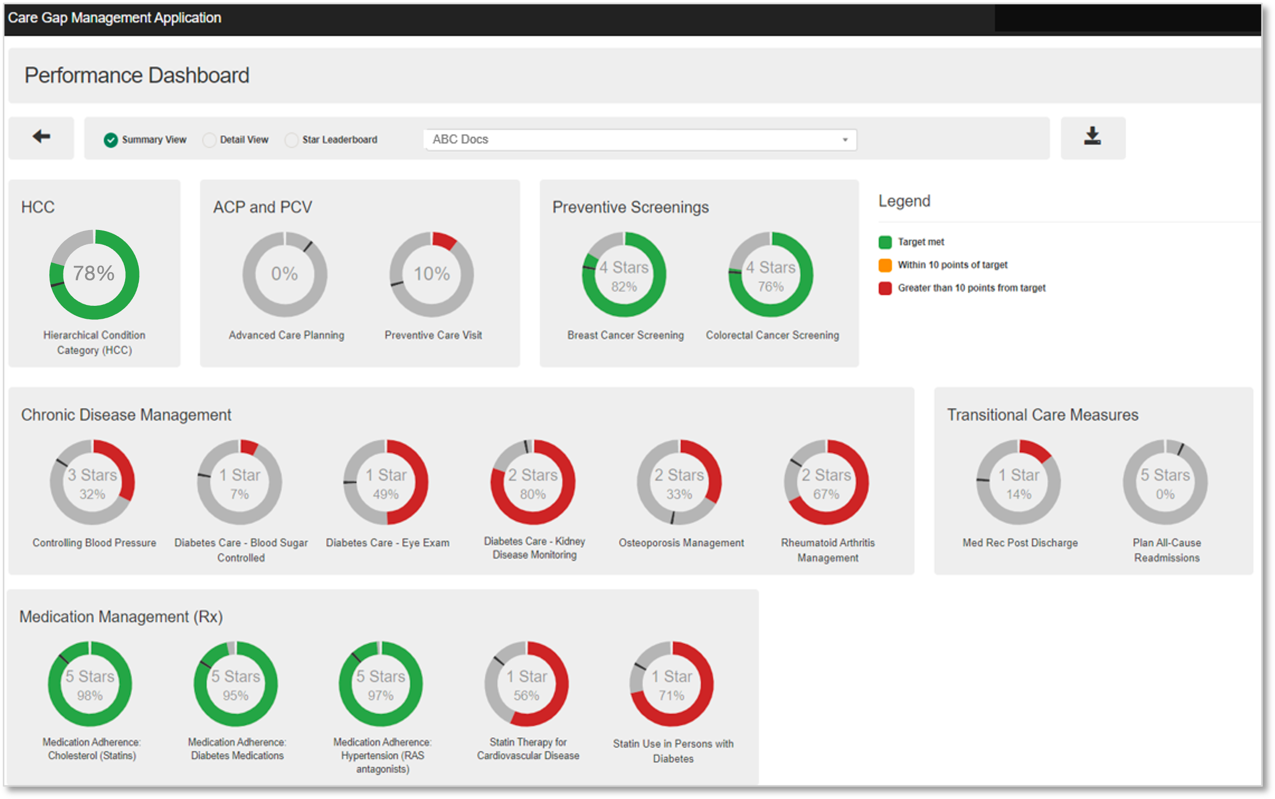
Actionable insights.
View your gap closure performance at a glance with color-coded "donuts" on the Performance Dashboard that shows gap closure progress against target goals for each measure and the current rating for Star measures.

Taking action from the Performance Dashboard is easy; with one click you can see a list of patients

with open gaps for any measure, saving time when planning patient outreach for encounters.



Powered by:

