Page 1 (Chambroad Sinopoly)
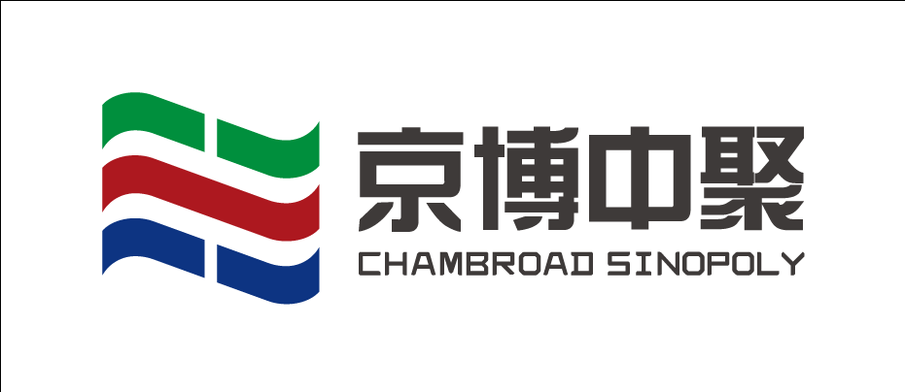

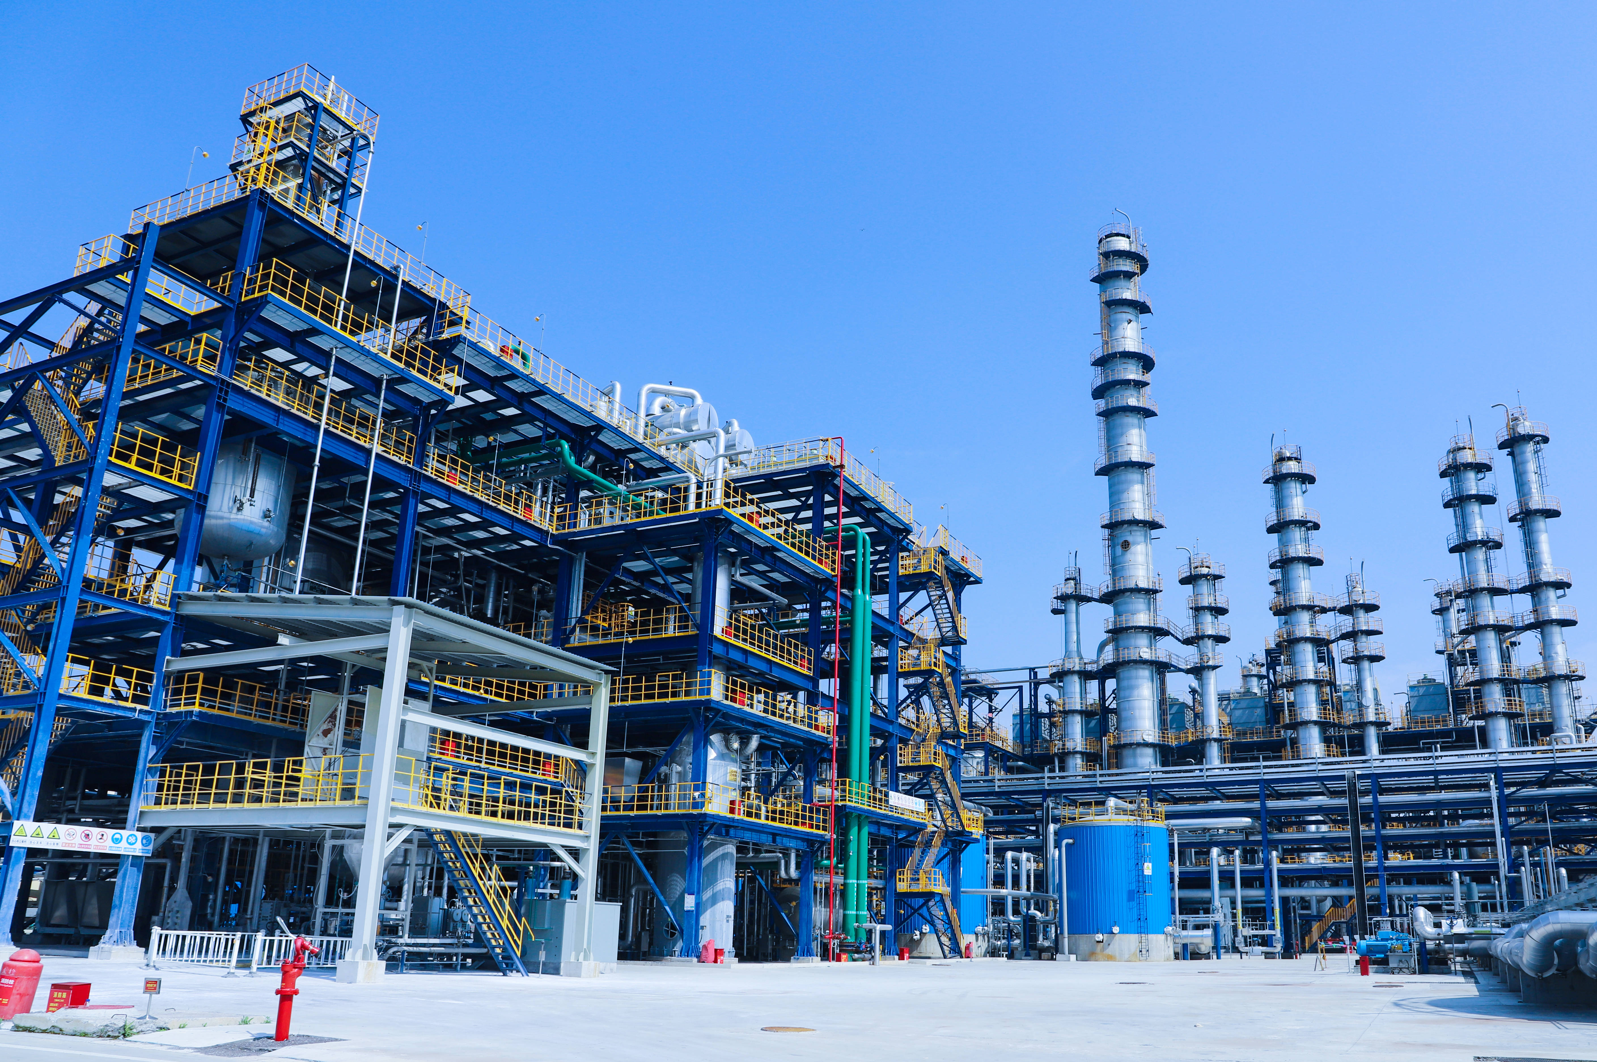
Shandong Chambroad Sinopoly New Materials Co., Ltd. is a high-tech enterprise focusing on the R&D, production, sales and service of special synthetic rubber.
Main products
Regular Butyl Rubber Bromobutyl Rubber Chlorobutyl Rubber

Styrene Butadiene Latex Bio-IBR

Page 2 (Chambroad Sinopoly)
Advantage：
1、 Stable Quality
Realize uniform and stable product quality in the process.
Feed self-sufficiency+long reaction cycle.
- Wide Molecular Weight Distribution
Improve processing performance.
- More Pure
Reduce the process of polymerization flocculation and alkali addition, and reduce the residual salt content.
The new process uses a new bromination process, reducing the amount of bromine by nearly 20%,The residue of sodium bromide in rubber is reduced.

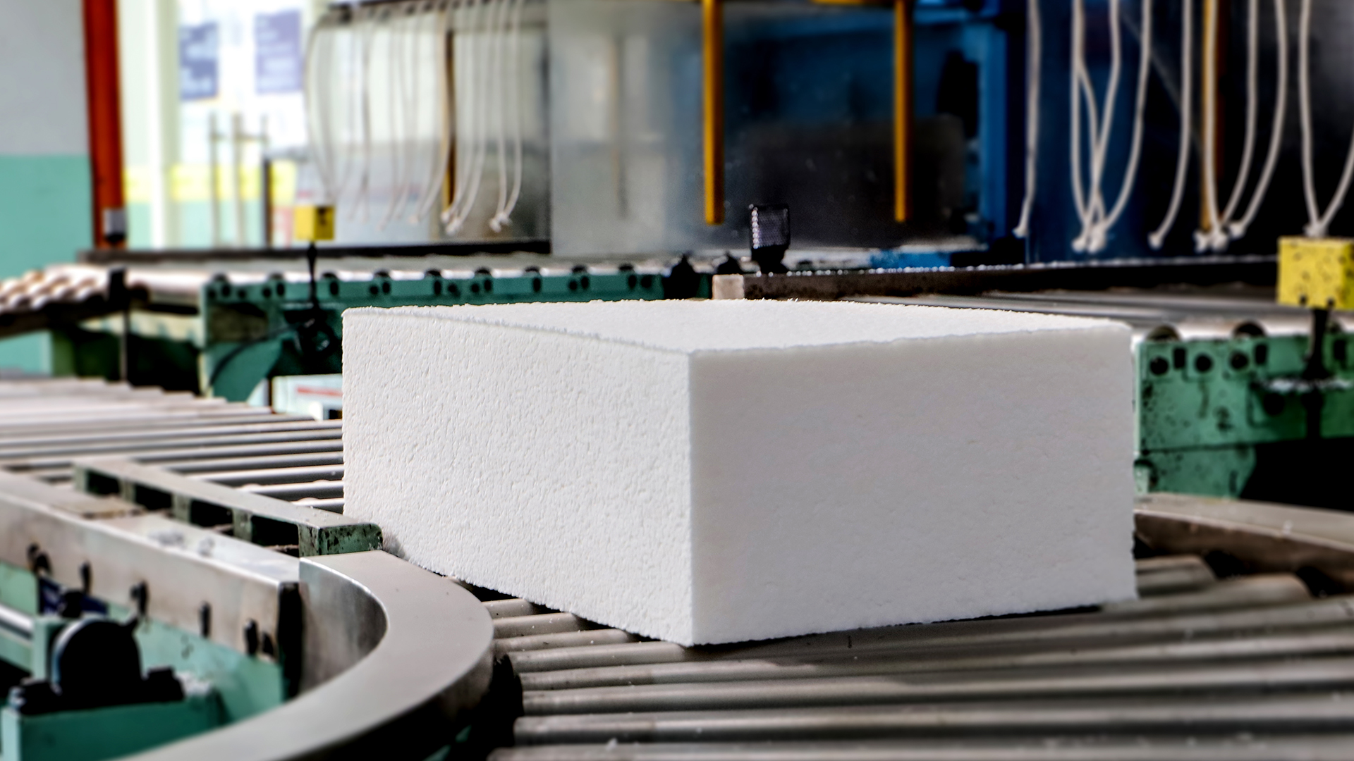

Page 3 (Chambroad Sinopoly)

Advantage：

- Green and environmental protection
A more efficient brominated brine recovery unit was added to reduce the generation of waste gas, waste water and solid waste, and the waste water was reduced by 30%.
- Full range of product supply
- Efficient and convenient service

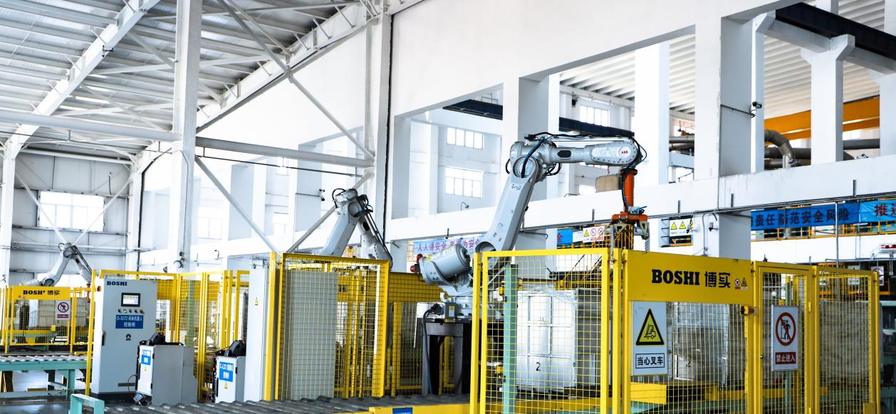

Page 4 (Chambroad Sinopoly)

Butyl rubber is the main product of Chambroad Sinopoly at present
Butyl rubber production capacity and process
120000 t/a (Halogenated) Butyl Rubber
50000 t/a (Halogenated) Butyl Rubber 70000T/a Brominated Butyl Rubber
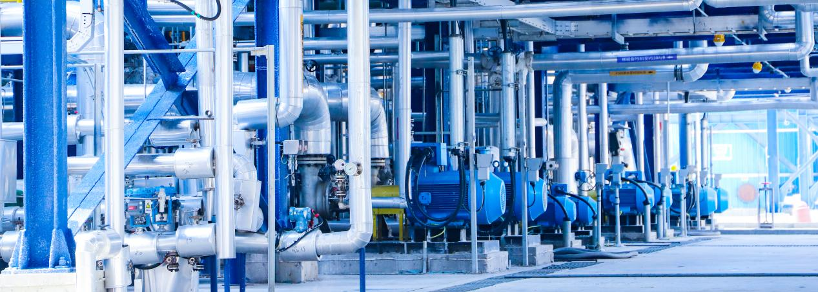

Page 5 (Chambroad Sinopoly)
Our Honor
Passed ISO9001, ISO45001, ISO14001,IOS50001, IATF16949 Management System Certification.
It has been awarded the titles of national "Small Giant", "high-tech enterprise", “Green Factory”, etc.
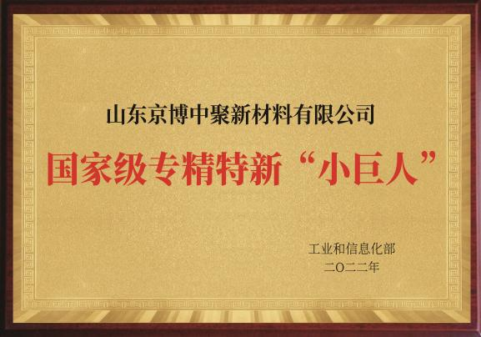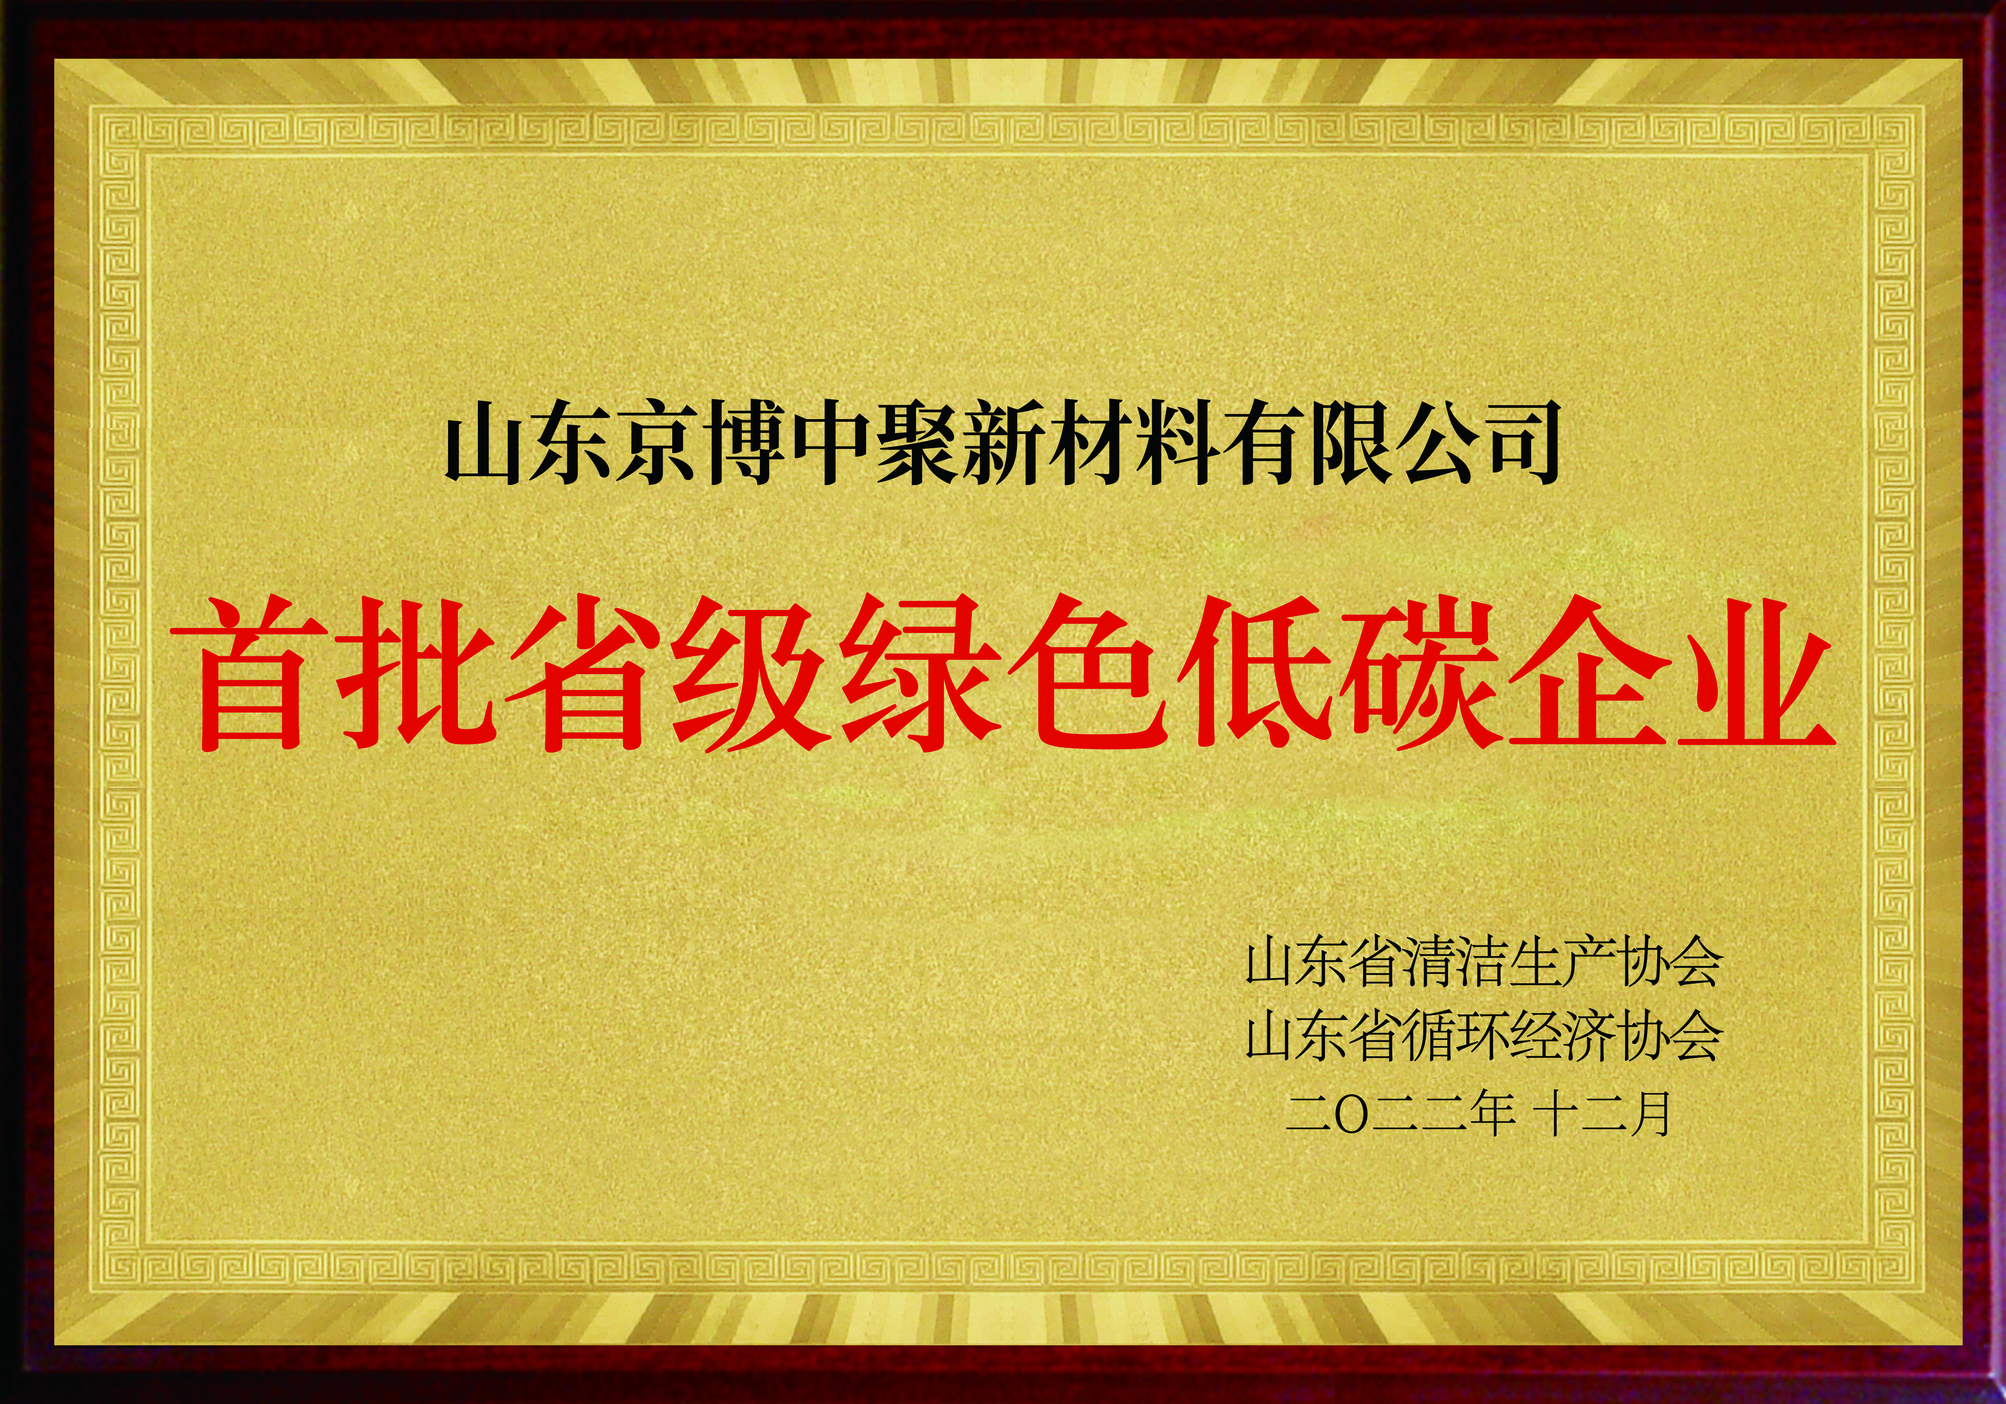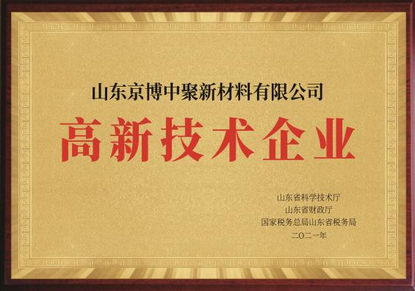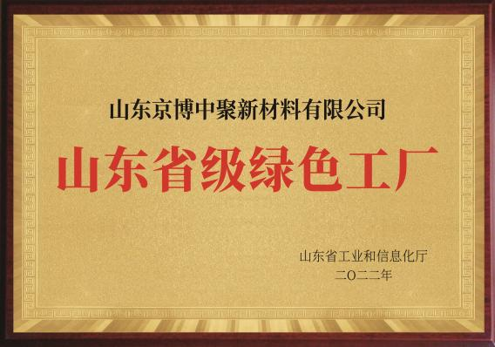

Page 6 (Target Maxx)

About us
Established since 2004, Target Maxx is a specialties chemicals and polymer distribution company serving to various industries.


Diversified Focused Industries
- Coating
- Agricultural
- Automotive
- Electrical & Electronic
- Construction
- Consumer Industrial Goods
- Food & Feeds
- Health Care
- Lubricants
- Medical
- Packaging
- Textile
- Tire and Rubber
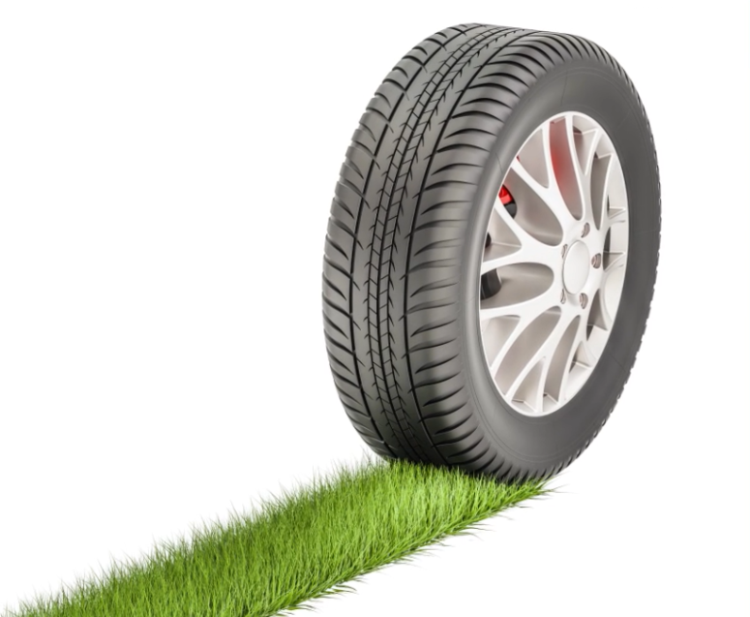
Page 7 (Target Maxx)

Synthetic Rubber
- SBR, SSBR, BR
- IIR, BIIR, CIIR
- NBR, NBR/PVC, HNBR
- FKM Compound
- NB Latex
Filler
- Silica - Micro Pearl / Powder / Granule
- Silane Coupling Agent (Si69, Si75)
- China Clay, Kaolin Clay
- Barium Sulfate
- Talc
- Wollastonite
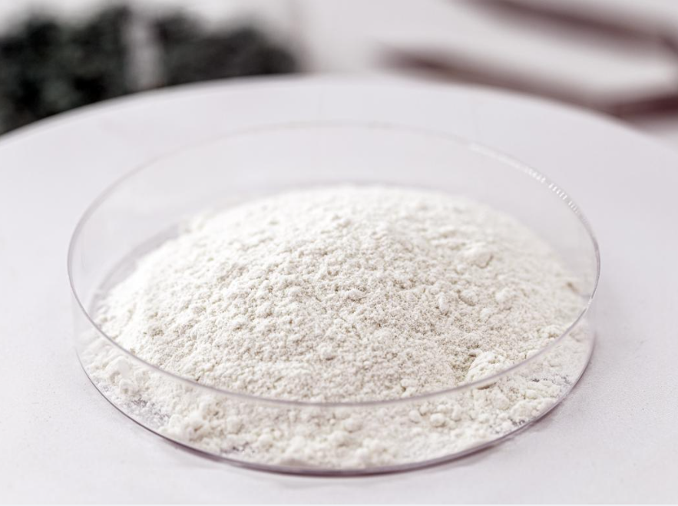

Page 8 (Target Maxx)
Wax
- PE Wax
- Oxidized Wax
- FT Wax
- Micro Crystalline Wax
- Anti Ozonant Wax
Process Oil and Plasticizer
- Paraffinic Oil
- Naphthenic Oil
- Mineral White Oil
- Bio Based Oil
- Non Phthalate Plasticizer (DOA, DOS, DOTP)
- Bio Based Plasticizer

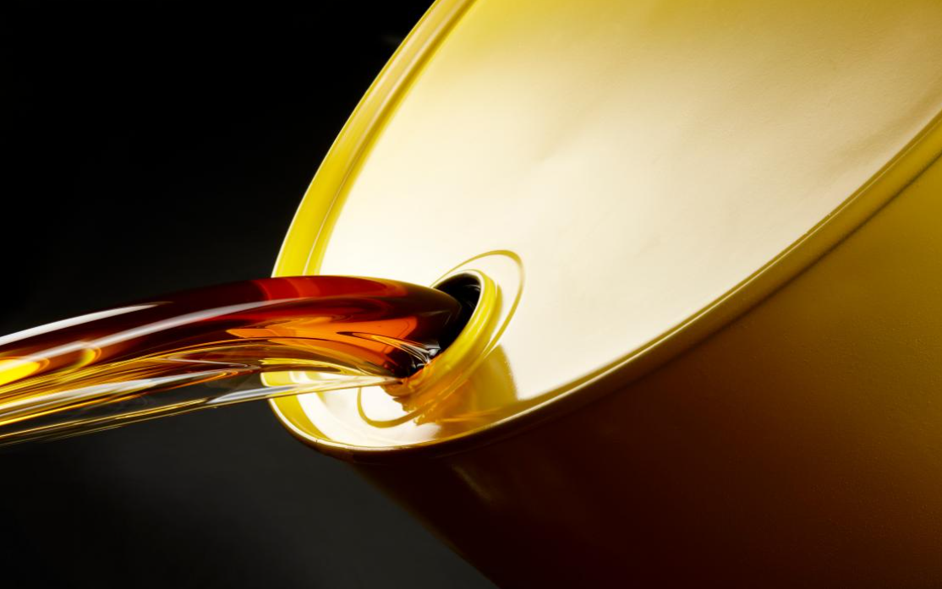

Page 9 (Target Maxx)

Thermoplastics Elastomer
- SBS
- SEBS
- TPE
- TPV
- TPU
- TPEE
- POE
Polyurethanes
- Polyester Polyol
- Polyether Polyol
- PU System
Industrial Yarn
- PA Industrial Filament
