We are looking for three splash images to promote our services and technology in the accommodation, hospital and aged care facilities. The look and feel would be preferred to look like the image below but with the mentioned screen and products for each.
The images I have provided are the only ones we have and, therefore, cannot be supplied in higher res. Note – this is only for webpages n, not print.

Sample style
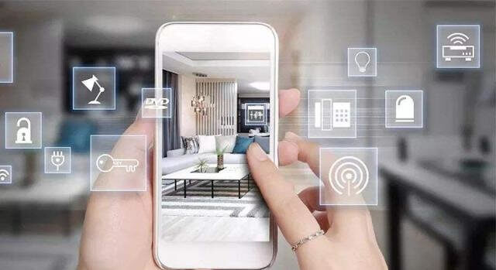

Market 1 - Accommodation
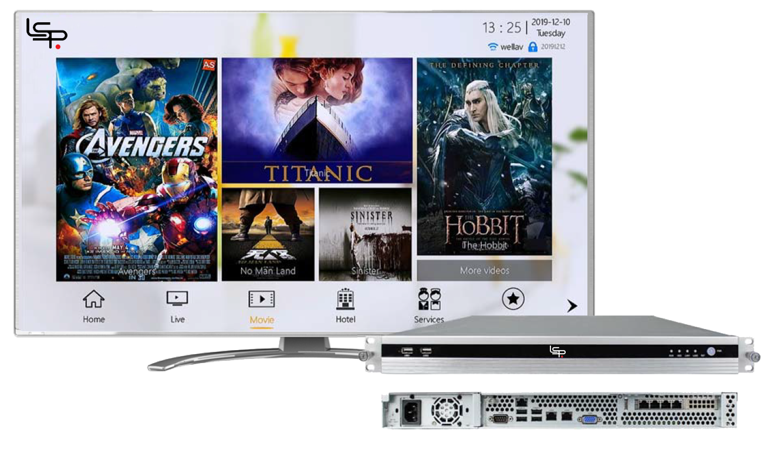

RTLS
Guest Wi-Fi
Tablets
BYOD
Digital Signage
Information Kiosks
Food Ordering
Onscreen Check Out
Reporting
EoC
Sonos
IoT

Market 2 – Hospital
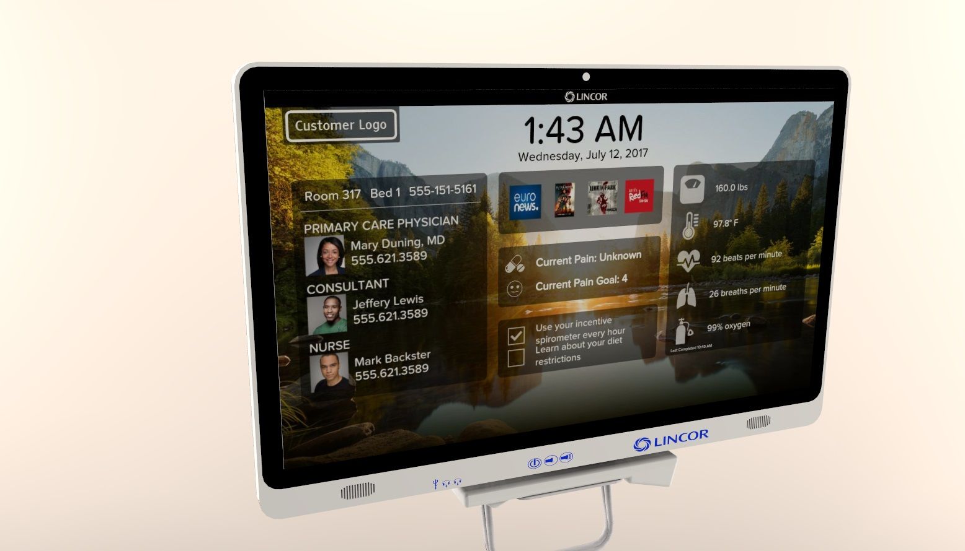

RTLS
Patient Wi-Fi
Tablets
BYOD
Digital Signage
Information Kiosks
Food Ordering
MyCareBoard
eConcierge
Multilingual
Surveys
Reporting
Telephony
IoT

Market 3 – Aged Care
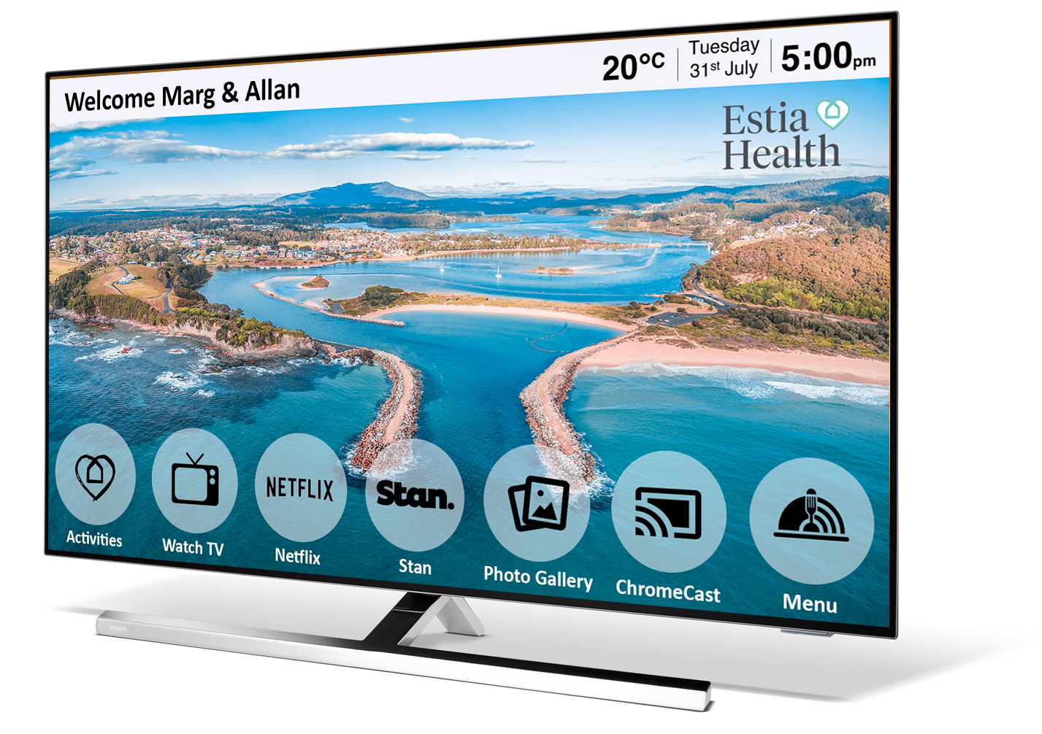
Streaming
RTLS
Guest Wi-Fi
Digital Signage
Information Kiosks
Food Ordering
Multilingual
Reporting

