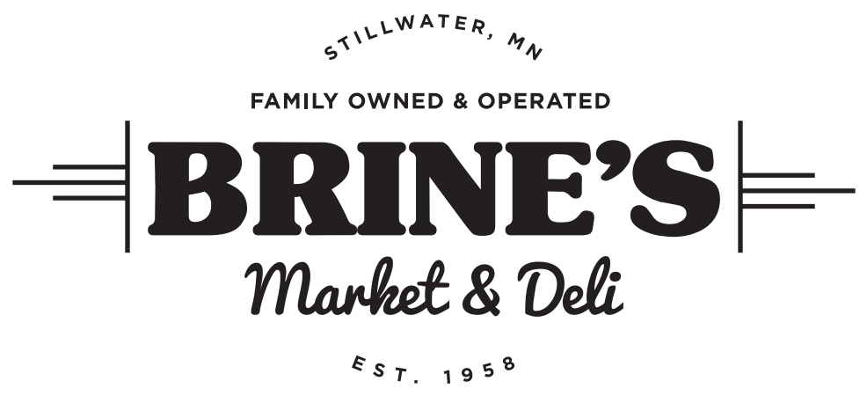

Re-Branding Labels Scope of Work Document

Purpose: The purpose of this document is to clearly outline the work that is needed for Brine’s Market and Deli regarding rebranding private labels, which includes sauces, jams, dressings, species, whole meat, and jerky as well as storytelling to support the Brine’s Market and Deli brand.
Brand: Brine’s Market and Deli is a full-service Deli and Butcher shop that serves our guest quality food made from scratch by our dedicated team members. We invite you to come and experience the quality food products found only at Brine’s along with the friendly service at our Meat Market & Deli.
Brine’s Signature Items: Brine’s offers numerous signature items that consist of family recipes that are still made in our kitchen and smokehouse today. Brine’s signature items can be found all over the store
Brines Market and Deli’s
- Consistent branded label
- Jams (size)
- Dressing (size)
- BBQ Sauce ( 2 sizes)
- Spices (size)
- Box stickers for Gift Boxes
- Sicker for wholesale meat products
- Label for jerky
- Bags
Brines Market and Deli’s Immediate Needs (with timelines):
- )

Communication Process:

A couple of notes:

- We should never market raw products, all pictures should be of prepared food
- Price does not always matter for our store. Quality, signature, service, and telling our story is half the battle
- I prefer darker colors, with impulsive pictures on product ads (See Local example)
Below are some past examples of how we were pushing the brand:

Signature Butcher in color
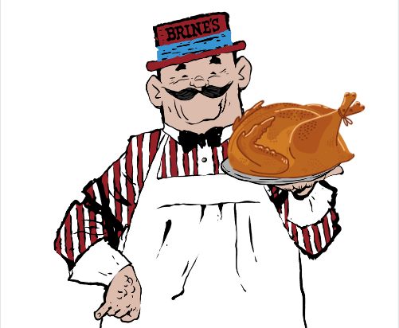

Staff Spotlight Example
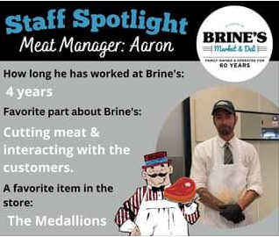

Seasonal Monthly Meal Calendar Example:
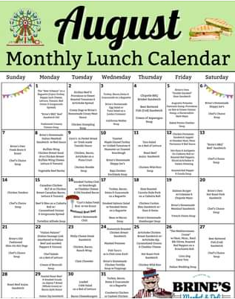
Signature Item Ad Example (Price is not necessary)
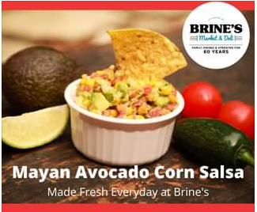
Example of Local promotion and Color Scheme
