my old logo

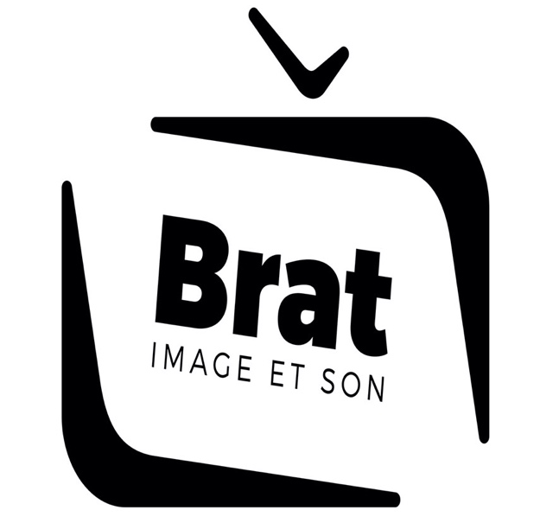

would like to keep the same writing put 4 logo voted from the mount
(CCTV logo speaker logo tv and wifi screen logo

I put logo example


