DIRECTIONS
- Upgrade old product brochure ( https://www.dropbox.com/s/olm1n6mvu0jzr3o/EVI%20open%20layout%20brochure_rev1.pdf?dl=0 ) for a fresh new look.
- These directions follow the order of the old open layout product brochure but the new layout doesn’t necessarily have to go in that order.
- Company colors: titanium silver, teal/turquoise, and white
- Communicate these tones: serious, professional, precision (natural for a medical device company)
- 6-8 internal pages.
- Descriptions to include are in “quotes”. All other words are guidance.
- Write this fine print on every internal page “Investigational device. Limited by federal (or United States) law to investigational use.”
-----------------------------------------------------------------------------------------------------EVI Houston logo https://www.dropbox.com/s/ow6nhtt12xf3b9m/Evaheart_trans.png?dl=0
https://www.dropbox.com/s/pg86ggzjea0p4yx/EVAHEART01%20-%20simple%20Logo.ai?dl=0

“Evaheart, Inc.
4900 Fournace Place, Suite 222
Bellaire, TX 77401, USA
+1-713-520-7979
htpp://www.evaheart-usa.com”

“Evaheart, GmbH
Rotkehlchenweg 14
32547 Bad Oeynhausen
Germany”

EVI Japan logo https://www.dropbox.com/s/c1q9tpfcmz04bj9/EVIjapan_logo.ai?dl=0

“86-7 Emadaira, Watari
Fukushima-city, Fukushima
960-8141, Japan
+81-24-526-0707”

“EVAHEART® 2
Left Ventricular Assist Device System
Product Brochure”

Professional EVA2 photo: https://www.dropbox.com/s/95a3oug0vzxx8vd/_MG_0489_retouch.JPG?dl=0

“Rotary Pump yet Pulsatile”
“The EVAHEART® 2 LVAS (EVA2) was developed to support end-stage heart failure patients for bridge-to-transplant (BTT) or destination therapy (DT). The EVA2 features a unique centrifugal blood pump mechanism with a hydrodynamic levitated impeller using sterile water to lubricate the mechanical seal interface. The open vane impeller design with large flow gaps allows for excellent blood washout and operates at lower speeds to reduce shear stress. The EVAHEART hydrodynamic impeller suspension demonstrated durability – lasting over 10 years in both bench tests and clinical use. The EVAHEART is designed as a full cardiac support LVAD providing over 10 L/min blood flow without attenuating native arterial pulsatility. To reduce the risk of thrombosis, all blood-contacting surfaces are coated with an anti-thrombogenic polymer coating. As a result of Evaheart’s continuous research and development efforts, the proprietary double cuff tip-less (DCT) inflow cannula was developed with the intention to minimize cannula malposition and eventually reduce the risk of post-LVAD stroke. The EVAHEART pump has been optimized in size without sacrificing performance. This new LVAS, “EVAHEART® 2”, is undergoing US clinical trials and will soon be available in Japan and the EU market.”

“Preserved pulsatility
- High peak flow
- Less attenuation of aortic pulsatility
- Auto-regulated flow (flow responsive)
CFD-based open vane design
- Excellent blood wash out and anti-thrombogenic
- Reduces shear stress (low hemolysis & vWF degradation)
Long-term durability
- Durable (no failure on bench test >8 years)
- Reliable (no pump mechanical failure in clinical use >10 years)
Cool-Seal Unit (CSU) System
Controller contains the Cool-Seal Unit (CSU), which circulates sterile water to lubricate/suspend the impeller, filters debris and bacteria, and cools down the motor. The CSU is replaced every 2-6 months.”

Label this image with same descriptions that are on the product brochure:
https://www.dropbox.com/s/eljr3tu758fcshi/p.03%E3%82%A4%E3%83%A9%E3%82%B9%E3%83%88.eps?dl=0

“Hydrodynamic impeller suspension”
“The EVAHEART® 2 LVAS applies a unique impeller suspension mechanism, the “cool-seal” hydrodynamic system, to suspend the rotating impeller with continuously circulating sterile water through the driveline.”
“Blood Inlet
- Connected to inflow cannula to draw blood from the left ventricle.
Blood outlet
- Connected to 14mm ID outflow graft
CSU outlet
- Returns water to external controller
CSU inlet
- Delivers water to motor and hydrodynamic impeller levitation system
Motor Coil
- Driven by the external controller with 2 modern lithium-ion batteries, this power efficient motor impeller mechanism allows over 8 hours of continuous operation”
Impeller
- CFD aided open vane design minimizes wall shear stress.
- Wider secondary flow gaps retain high peak flow and aortic pulsatility.”
Hydrodynamic suspension system: Cushion ring. Seal ring. Seat ring.”

Blood pump cross section: https://www.dropbox.com/s/6se69srqwubdrfb/EVA2.eps?dl=0

“Flat HQ curve and high peak flow”
“The EVAHEART HQ curve is head-pressure sensitive (flat HQ curve) demonstrating high systolic peak flow, which contributes to aortic pulsatility (minimal pulsatility attenuation).”
https://www.dropbox.com/s/tav9yl7eqv58loh/Peak%20flow%20graph.ai?dl=0

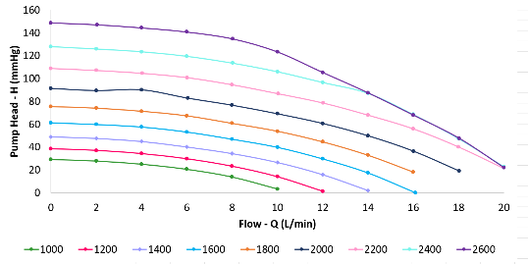

“Superior hemocompatibility”
“A mock loop experiment involving the EVAHEART® 2 LVAS demonstrated finer preservation of Von Willebrand Factor (vWF), the degradation of which is implicated in nonsurgical bleeding.
Bartoli, Carlo R. et al. The Annals of Thoracic Surgery, Volume 103, Issue 4, 1239-1244
vWF large multimer degradation”
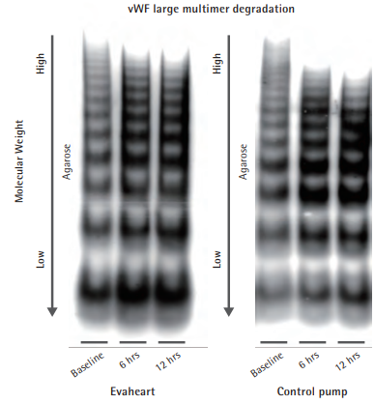
“Open vane design minimizes shear stress”
“The open vane design creates wider secondary flow gaps and reduces shear stress in the pump, which results in better hemocompatibility.”

Shear stress CFD: Naomi is finding
Blood pump impeller: https://www.dropbox.com/s/f1jvk7xdfg3bldy/Pomp_impeller.jpg?dl=0

“Manufacturing and distribution”
“The EVAHEART® 2 LVAS is manufactured by Sun Medical Research Technology Corp. (SMT) in Suwa, Nagano, Japan. As a pioneer in precision machining such as is required in watchmaking, SMT and their team of highly skilled engineers (TAKUMI) have applied this same expertise into the manufacturing of medical devices. Their exacting standards are best demonstrated by excellent results in bench testing of the EVAHEART blood pump for over 8 years with no mechanical failures in clinical use to date. In the US, distribution is maintained by Evaheart, Inc. (EVI) based in Texas.”

https://www.dropbox.com/s/bqm7z8tfx6odv0w/Sun%20Medical%20Technologies%2C%20Corp.jpg?dl=0
“Sun Medical Technologies, Corp Manufacturing facility (Suwa, Japan)”

https://www.dropbox.com/s/owvcyq6tubmsvwn/%E5%BB%BA%E7%89%A9%E3%83%91%E3%83%8D%E3%83%AB%E6%A1%88.jpg?dl=0
“EVI Japan (Fukushima, Japan), EVAHEART’s secondary assembly facility”

https://www.dropbox.com/s/j490cqwcfl2zbjw/Fournace%20Building%201.jpg?dl=0

From this pdf (https://www.dropbox.com/s/ipwjq0l3oi9ebqb/Photos%204800%20Fournace%20PDF%20%281%29.pdf?dl=0) use this photo:
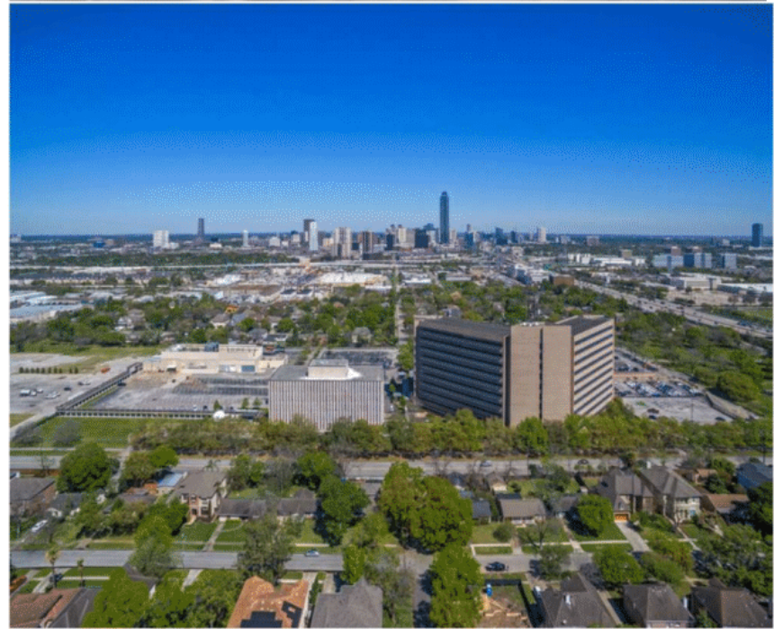
“Evaheart (EVI) headquarters located in the greater Houston, Texas area.”

“Improved anatomical fitting with the Double Cuff Tipless (DCT) inflow cannula”
“The GU100 Double Cuff Tipless (DCT) inflow cannula improves anatomical fitting. The dilated cardiomyopathy model (computer-simulated) is shown with the DCT cannula. The rightmost image shows the flush inflow ostium in the left ventricle, low profile inflow design, rotational apex suture cuff, and miniaturized pump head which all enhance the cannula fitting thereby allowing pump implantation in patients with a smaller body frame. This could minimize the risk of inflow cannula malposition and wedge thrombus.”
- “Double Cuff Tipless Inflow Cannula (GU100)” https://www.dropbox.com/s/fny3owpr8k064x2/DCT%20Inflow%20Cannula%20%28GU100%29%20professional%20photo.jpg?dl=0
- “Inflow cannula anatomical fit (computer simulation)” https://www.dropbox.com/s/9ljg4djff5i9wmc/GU100.png?dl=0
- https://www.dropbox.com/s/lg0tz7ljzzpe6ie/DCT%20bovine%20picture%20POD%2064.png?dl=0
“Inflow cuff and ostium (POD 64 GLP animal study)
  - No wedge thrombus
  - No pannus formation
  - No evidence of suction
  - Good cuff tissue integrity"

“Surgical procedure of DCT inflow cannula”
https://www.dropbox.com/s/i118rfmbrvl7trs/Inflow%20implant1.eps?dl=0
https://www.dropbox.com/s/sfjxur24wqciohu/Inflow%20implant2.eps?dl=0
https://www.dropbox.com/s/ydmkfu5jdw8ynn0/Inflow%20implant4.eps?dl=0
https://www.dropbox.com/s/rzt1gnmai6s5xru/Inflow%20implant5.eps?dl=0
https://www.dropbox.com/s/qafmz645xm9hga2/Inflow%20implant6.eps?dl=0
https://www.dropbox.com/s/9u7176a4f3tkwo1/Inflow%20implant7.eps?dl=0
https://www.dropbox.com/s/gsfpioprxkg7dun/Inflow%20implant8.eps?dl=0
https://www.dropbox.com/s/bgotlb2m5l26zs7/Inflow%20implant11.eps?dl=0

“EVAHEART 2 LVAS System”
Please label this image: https://www.dropbox.com/s/rnlydl88xegqfpu/system.eps?dl=0
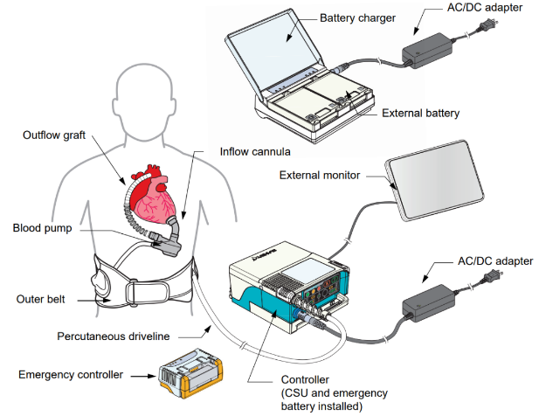
With these labels:

“EVAHEART® 2 System Components”
“System and Accessories”

“Blood pump: Centrifugal pump which pumps blood from the left ventricle into the outflow graft.
Main Specifications
Blood Pump Unit
- OD 51mm x Height 67.5mm
- Weight 262g
- Anti-thrombogenic coating (on blood-contacting surfaces)
Pump Cable: contains 2 CS water lines and blood pump power cord.
- Length 3m x OD 10mm
https://www.dropbox.com/s/36grrujwg0501hl/Blood%20pump.eps?dl=0

Inflow cannula (Double Cuff Tipless): Connects the blood pump to the left ventricular apex.
Main Specifications
- ID 16mm
- Titanium bend conduit
- Proximal and distal suture cuff
- Anti-thrombogenic coating inside the titanium conduit
https://www.dropbox.com/s/bm3ioqrux9gtni8/Inflow%20cannula.eps?dl=0

Outflow graft: Connects the blood pump to the ascending aorta.
Main Specifications
- ID 14mm
- PE polyester graft
- Anti-thrombogenic coating inside
https://www.dropbox.com/s/rdn1uqqjp8pv2v2/GU200%20Outflow%20graft.eps?dl=0

CSU: The main component for the CS system that levitates the blood pump impeller.
Main Specifications
- Dimensions 170mm x 50mm x 73mm
- Weight 345g
https://www.dropbox.com/s/7p8ho6c30d1w3ot/CSU.eps?dl=0)

Controller: Controls the blood pump, CSU, and power system.
Main Specifications
- Dimensions 150mm x 168mm x 80mm
- Weight 850g
https://www.dropbox.com/s/43nh90d04o5ziuc/Controller.eps?dl=0)

External Battery: Main power source for the controller (provides at least 4-6 hours of operation per battery).
Main Specifications
- Dimensions 70mm x 92mm 23mm
- Weight 240g
- Lithium-ion cells
https://www.dropbox.com/s/dnu59j1md2jqd9n/External%20battery.eps?dl=0

Emergency battery: Backup power source for emergency use for at least 15 minutes.
Main Specifications
- Dimensions 26mm x 78mm x 21mm
- Weight 65g
- Lithium-ion cell
https://www.dropbox.com/s/5lv2txcejbdpf7z/Emergency%20battery.eps?dl=0

Emergency controller: Backup controller for use during a controller failure.
- Dimensions 97mm x 64mm x 41 mm
- Weight 165g
https://www.dropbox.com/s/3i9da2xr55jn0iv/Emergency%20controller.eps?dl=0

AC/DC adapter: Provides power to the controller and charger from an AC power source.
Main Specifications
- Dimensions 129mm x 31mm 51mm (excluding cable)
- Weight 410g
https://www.dropbox.com/s/2mh5uo6ylb0fjjs/ACDC%20adapter.eps?dl=0

Battery charger: Fully charges 2 external batteries.
Main Specifications
- Dimensions 150mm x 139mm x 43mm
- Weight 375g
https://www.dropbox.com/s/a676pjnw6vske6n/Charger.eps?dl=0

Controller connection kit: Connects the CS lines to the controller. https://www.dropbox.com/s/9ian9hjkoyqnxzh/Controller%20connection%20kit.eps?dl=0 “

External Monitor: Monitors and sets the EVAHEART system parameters.
- Dimensions 312mm x 200mm x 37mm
- Weight
https://www.dropbox.com/s/hbtk1xxob2nebz8/EM310%20Monitor.eps?dl=0

External monitor connection cable: Connects the controller to the external monitor.
https://www.dropbox.com/s/cede775syhgcbdj/External%20monitor%20cable.eps?dl=0

Tunneler: Guides the percutaneous driveline through the patient’s abdomen.
Main Specifications
- Length 325mm
- Weight 214g
https://www.dropbox.com/s/lu7tde1ek9ceh2n/SS100%20Tunneler.eps?dl=0

Long wrench: For tightening connector nuts.
Main Specifications
- Length 162.3mm
- Weight 92g
https://www.dropbox.com/s/ab6ol3703x6gcfq/Long%20wrench.eps?dl=0

Long inflow wrench: To assemble the inflow cannula in conjunction with the long wrench. (https://www.dropbox.com/s/17uj4c3ddzrd7lz/Long%20inflow%20wrench.eps?dl=0

Short wrench: For tightening connector nuts.
Main Specifications
- Length 113.2mm
- Weight 65g
https://www.dropbox.com/s/juq6x089qs8mlh6/SS31%20Wrench.eps?dl=0

Coring Knife: Cores a hole in the left ventricular apex to sew into the inflow cannula.
Main Specifications
- Length 69.8mm
- Weight 213g
https://www.dropbox.com/s/61eer9iesvclksi/SS170%20Coring%20knife.eps?dl=0

Explant Dissector: Removes body tissues adhered to the driveline.
Main Specifications
- Length 310mm
- Weight 170g
https://www.dropbox.com/s/00wmvxr8vukm4u0/SS41%20Dissector.eps?dl=0

Pump Sizer: Determines position of the pump and size of the pump pocket.
Main Specifications
- 257g
https://www.dropbox.com/s/kb43dcv12za0j2x/SS150%20Pump%20Sizer%5BEVA2%5D%20assy.eps?dl=0

Carrying Bag: Holds the controller while using the system at home or on the move.
https://www.dropbox.com/s/tfu0lw72zz81g4q/Carrying%20bag.eps?dl=0

Driveline cover: Protects the driveline from UV light, tears, and dust and debris. https://www.dropbox.com/s/a8uxh5def9zqci8/PumpCableCaver.eps?dl=0

Outer belt: Secures the percutaneous driveline around the patient’s waist to reduce stress on the exit site. Comes in sizes: S, M, L, XL, XXL. https://www.dropbox.com/s/4kixuu9l6856w1n/PS31%20Outer%20belt.eps?dl=0

