LOGO DESIGN BRIEF
Mirare is a Holding Company, acting as an investment company that invest in other several companies in Brazil and abroad with capital and knowledge, focused in Technology, Internet , Security and Fiber Optics.
All these companies invested by Mirare are working on the “edge” or the future, next generation technology.

INDUSTRIES / MARKET

We work as a holding investment company with strategy and capital in technology market.

Product Description
Mirare has no specific product or solution, is a holding company.

Name source

Mirare comes from the latin word that means “VISION”. So, we are a visionary company that can see beyond reach, we have a very strategic vision for the future in our endeavours.

Logo Objective
Logo must be modern, professional, masculine, not too colorful and serious.

LOGO TEXT
MIRARE
On capital letters

LOGO REFERENCES

I am attaching below, some references. Not necessarily a pictorial logo, is optional.
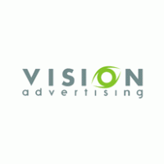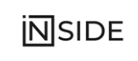
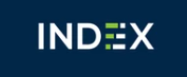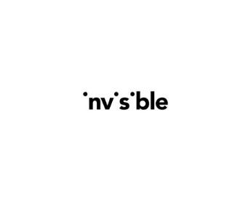

COLORS
Any color that the designer may chose that is related to our objective like blue navy, gray, black, etc.

LOOK AND FEEL
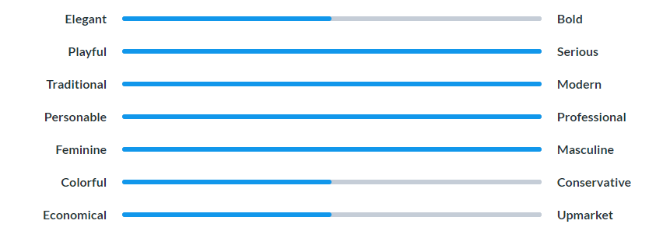

Requirements
MUST HAVE
- Our logo must have a symbol related to future / vision / strategy. Please follow your creativity, but just for reference, can be either an eye, a seed, a telescope, binoculars, searchlight, a etc. Even a chess board symbol. Please find a very strong, powerful and easily usable symbol and in an abstract form.

  - the symbol must be very soft and delicate in terms of appearance, i.e., better if the logo is the symbol is not fully complete, so we can “fill the blank” with our mind.

- It should be simple and intuitive, serious and modern. Corporate-driven.
- It should also have a very modern and unique and strong font type

- we would like to see minimalist, high impact and objective logos that can represent the concept of the company

