Teeth Whitening Poster
Logo

Want Whiter, Brighter Teeth?

Teeth Whitening under Professional Supervision is the most effective method to improve a smile.
Safe and Effective

Show a photo of before and afters etc

Infographic (3000 + Whitening Cases Completed, Over 100 Years Combined Experience), 100% Satisfaction Rate)

Designed Similar to below but with above content
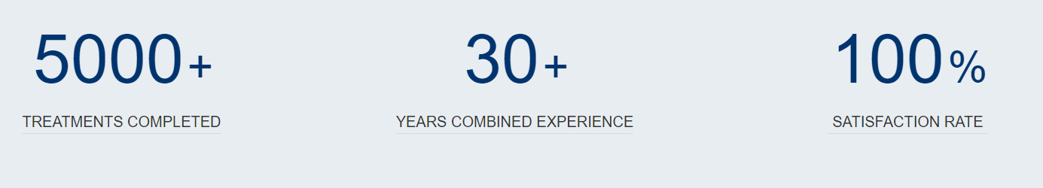

How to Book?
No Referral Needed

No Referral Needed, You can book at reception or Online 24/7 at

www.dentalcarecentreuk.co.uk/book-online-now

(Select Teeth Whitening Consultation from Drop Down Menu ‘Reason’)

Or Scan to Book

