

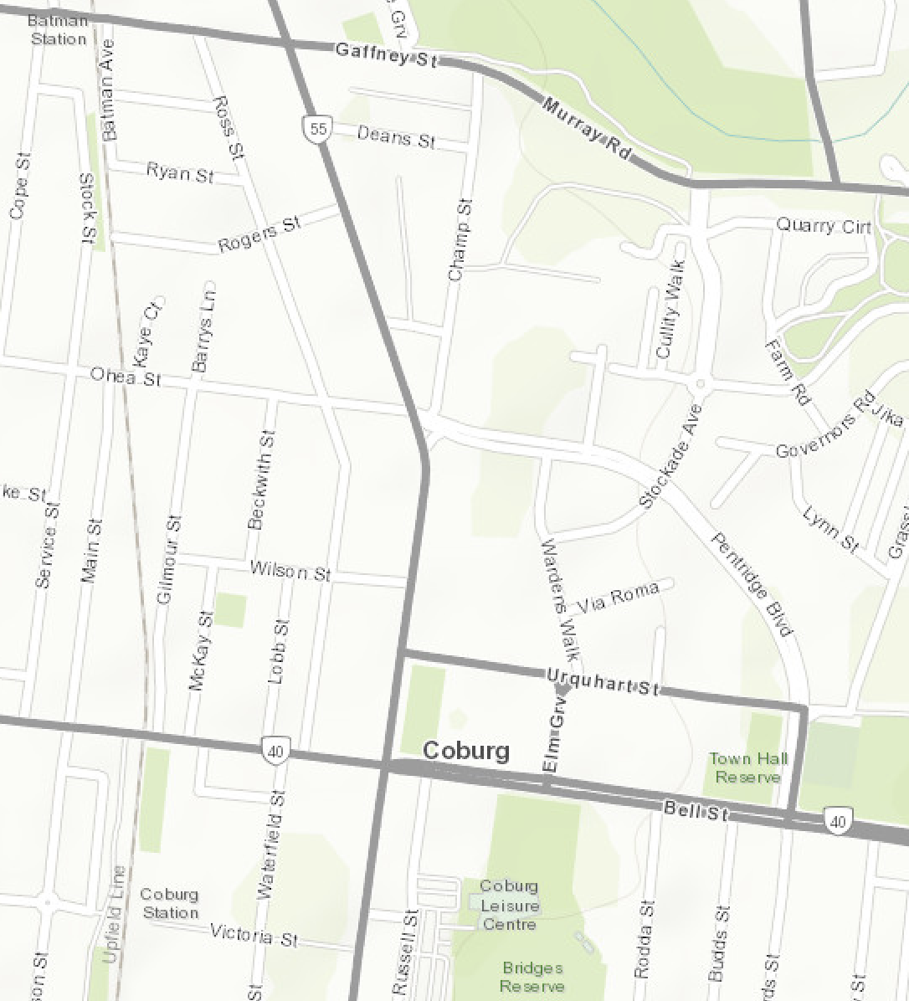
2 Hour parking on Pentridge Bvd
Coburg Train Station
8 min walk
Bell St/Sydney Rd Tram Stop
St Paul’s
Catholic Church/
Sydney Rd
Tram Stop
Champ St/ Sydney Rd
Bus Stop 530 534
Urquhart St/
Sydney Rd
Bus Stop 526 530
Shopping centre car park accessed via Whatmore Drive – first 3 hours free

All day car parking
Guidestar
Shopping centre car park accessed via Whatmore Drive – first 3 hours free

