Hi – Thank you for making the initial edits, we are very impressed! Now that we have the basic design and selected to move forward with you, we’d like to edit the content and make some revisions to the Design. Please see all our comments below and feel free to ask any questions if you need them. You may reference our website – www.socialdatabase.com for inspiration as well.
Main Title: “The Power of Superaudiences” (please change the background image to a more generic image that has to do with Advertising or Twitter or Digitial media as this is no longer a crypto specific PDF but a more general advertising PDF). Remove all other text.
Subtitle 1: About Socialdatabase
Body 1: SuperAudiences bring audience targeting on Twitter to an entirely new level! As the #1 Twitter Audience partner, we build highly relevant, scalable audiences that increase audience reach and improve overall media effectiveness.
SuperAudiences allow for more precise targeting and audience segmentation than what was previously possible. Job titles, combined interests, competitor audiences and exclusion audiences are all possibilities. Socialdatabases technology is unique in that it does not use of any 3rd party data, use cookies or PII to build its audiences.
*you may either place subtitle 1 and body 1 in the same section as the Title (to replace existing text) or put it it in the blue section – we leave this up to you.
Subtitle 1: (Make more prominent/highlight better/): Tailor-made audiences to match your campaign goals.

- Remove laptop images as they are no longer applicable
Subtitle 2: Just a few examples of our Superaudiences (Example profiles included below if you want to use them)
Body 2: Change examples to IT Decision Makers, SMB Owners, VPs in Finance, Oncologists, Affluent Households. Make these examples a bit more prominent as they are important for clients to see as examples.

Subtitle 3: What Superaudiences can do for you:

Body 3: Reach your relevant audience, Deliver higher VCR & CTR rates, Improved time on site, Increased lead quality (this can be arrange in any way but are really the unique selling points of Socialdatabase)
Subtitle 4. The Audience Building process

Body 4: Make this less prominent, either smaller or less grey or make the body text smaller. The titles such as “Analyze Sample, The Perfect Sample” are good that they are bigger, but the details are not as important. Please change the logos to be more representive of what the process is (sample/analysis/scale) The last one is good though.

Audience Examples Profiles

- SMB Owners

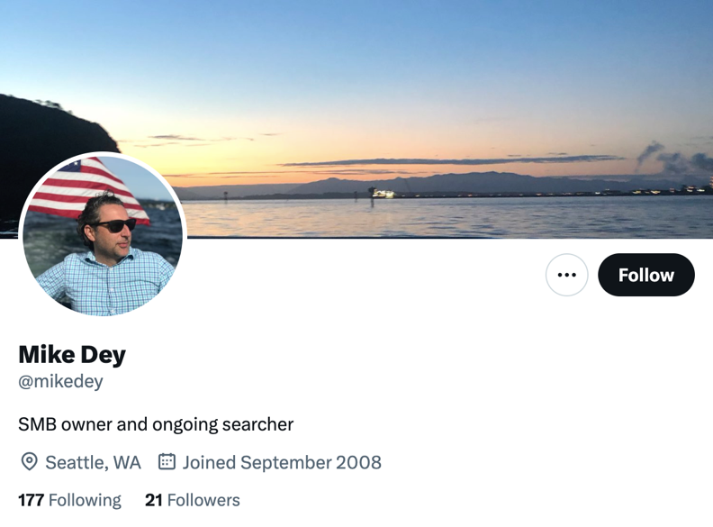

- IT Decision Makers
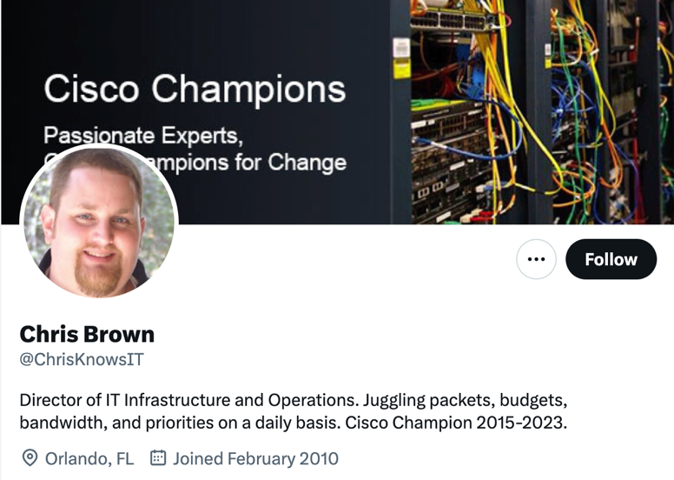

- Oncologists
