I hope this is not to confusing but trying to include as much info as possible. This layout is copying www.midwestpest.com and www.naturalstatepestcontrol.com. I’m including my own info to somewhat swap out for what they have. Hopefully this is a good start.

(Buttons/Navigation)
Services>Drop Down  Commercial Pest Control  Residential Pest Control  Termite Control  Mosquito Control  Rodent Control | Service Area | About Us | Special Offers | Contact Us> Drop Down  Get A Quote  Refer A Friend  Customer Login

Service Area Page
Areas We Service For Pest Control In Missouri
If you're looking for professional pest control services in Missouri, trust Orange Mango Pest Control for effective treatments, quality customer service, and lasting results. We are small family owned and operated business and we service areas in and around the state of Missouri. Check out our entire list of pest control services to see if we can help!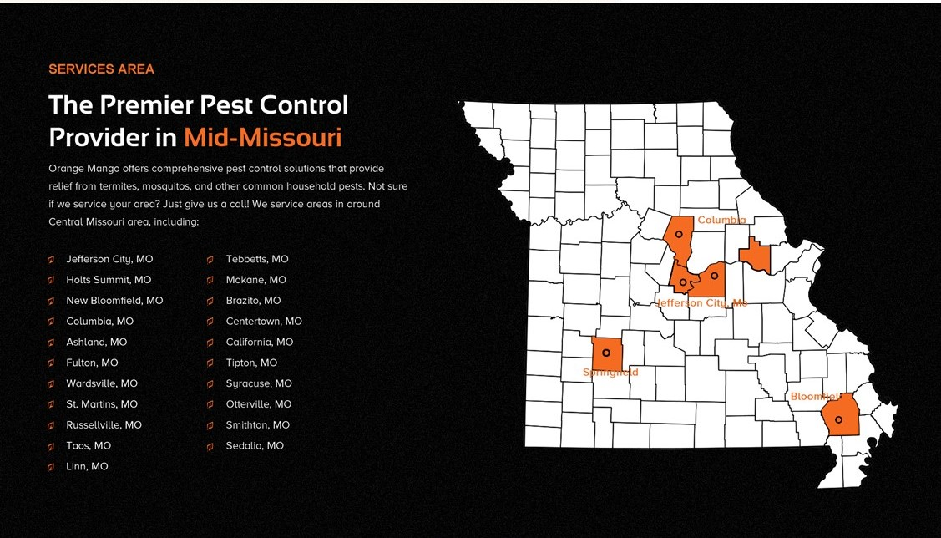

100% Satisfaction Guaranteed
Nothing pleases us more than knowing we have met or exceeded your expectations. Your satisfaction is so important to us that we guarantee it! We want you to trust in our team and feel we have served you and your business well. If you are unsatisfied with our service, contact us right away and we’ll send an exterminator for free retreatment.

