I hope this is not to confusing but trying to include as much info as possible. This layout is copying www.midwestpest.com and www.naturalstatepestcontrol.com. I’m including my own info to somewhat swap out for what they have. Hopefully this is a good start.

(Buttons/Navigation)
Services>Drop Down  Commercial Pest Control  Residential Pest Control  Termite Control  Mosquito Control  Rodent Control | Service Area>Drop Down  Pest Control Service Area | About Us | Special Offers | Contact Us> Drop Down  Get A Quote  Refer A Friend  Customer Login

Residential Pest Control Page
THE BEST PEST CONTROL IN MISSOURI STARTING AT $45 A MONTH! 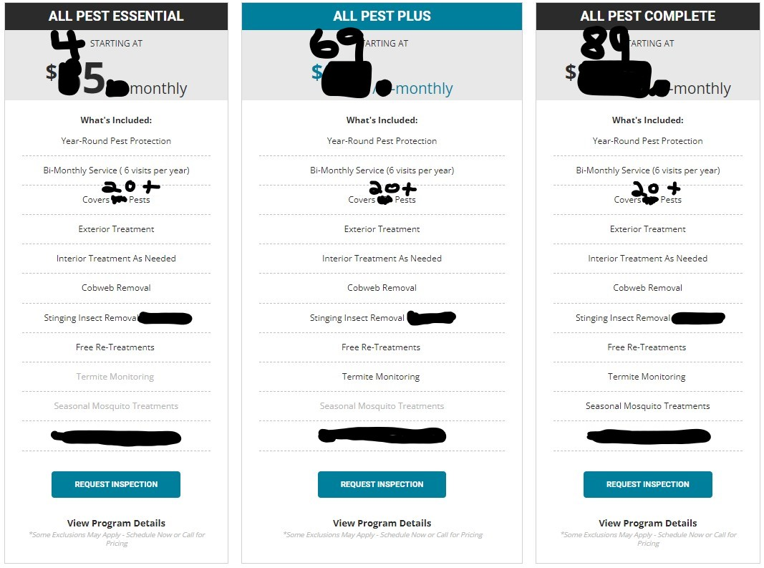
Rodent Control
Rodent Control
Rodent Control
Pest Protection for Your Home
Pests are constantly trying to enter your home, which can easily cause frustration and damage to your home and belongings. That's why we at Orange Mango Pest Control provide seasonally designed, proactive home pest control plans to protect your family and your home.
Our home pest control plans offer effective and affordable solutions to all your pest issues in and around your home. If you have pest problems, schedule your free inspection today!
Home Defense Bronze  Starting At  $45 Monthly  These titles instead on the one above | Most Popular Package Banner  Home Defense Silver  Starting At  $69 Monthly  These titles instead on the one above | Home Defense Gold  Starting At  $89 Monthly  These titles instead on the one above
Pest Control in Missouri
If you live in the Midwest, you know that bugs are a common occurrence. Its hard to know where to start and it can be overwhelming, but don’t let bugs get you down. We are highly trained and have years of experience managing customer’s issues so you can focus on what's important to you.
Reliable Results from Trained Exterminators – Guaranteed
Not just anyone can provide effective and efficient pest control, which is why we are specially trained in handling all your pest control troubles. Armed with the latest technology and the most up-to-date information, our exterminators can handle any pest control issue that your home throws at them. With our experts on the case, you will enjoy fast, reliable results that last!
Advanced Treatments Provide Long-Term Protection
We don’t call it quits after we eliminate your home’s pest problem. Instead, we are determined to prevent future infestations and keep pests out for the long haul. After all, what good is pest control if the bugs just keep coming back? Our advanced treatments provide you with pest protection that lasts, so you can enjoy a bug-free home for years to come. We even offer a satisfaction guarantee! If you find pests in your home between services, we will gladly return to retreat your home, absolutely free!
We Make Pest Control Affordable - Starting at Only $45/Month
At Orange Mango, we believe everyone deserves a pest-free home, which is why we strive to offer effective, affordable pest control. Check out our special offers and packages to learn how you can keep your home protected year-around with one of our Home Defense Program. So, what are you waiting for? Let us help make the pest control treatments you need within reach.
