I hope this is not to confusing but trying to include as much info as possible. This layout is copying www.midwestpest.com and www.naturalstatepestcontrol.com. I’m including my own info to somewhat swap out for what they have. Hopefully this is a good start.

(Buttons/Navigation)
Services>Drop Down  Commercial Pest Control  Residential Pest Control  Termite Control  Mosquito Control  Rodent Control | Service Area>Drop Down  Pest Control Service Area | About Us | Special Offers | Contact Us> Drop Down  Get A Quote  Refer A Friend  Customer Login

Commercial Pest Control Page
Protect Your Business From Pests
When it comes to businesses, pest sightings are unacceptable. Whether it’s a single sighting of a rodent or a full-blown roach infestation, pest problems can scare away customers, shut down your business temporarily or long-term, and destroy your company’s hard-earned reputation.
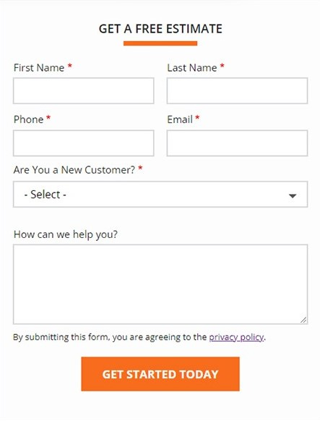
- Mosquitoes
- Rodents
- Flies
- Wasps
- Cockroaches
- And more!

- Spiders
- Ants
- Bees
- Earwigs
- Centipedes

Our state-certified exterminators protect your business from:

Top Rated Exterminators at Your Service
At Orange Mango Pest Control, we want to make sure we serve you to the best of our ability. Our pest control experts undergo extensive ongoing training, which ensures we all stay informed on the best pest control practices and the latest, safest products. Our pest control company in Missouri is dedicated to providing quality service every time, so we do our part in staying educated and implementing changes in our service that best accommodate our ever-changing world.

100% Satisfaction Guaranteed
Nothing pleases us more than knowing we have met or exceeded your expectations. Your satisfaction is so important to us that we guarantee it! We want you to trust in our team and feel we have served you and your business well. If you are unsatisfied with our service, contact us right away and we’ll send an exterminator for free retreatment.

