Wally, thank you for your design. (I had to remove your design which was positioned above this since I do not believe others are to see the designs of other folks).
It is terrible of me to ask for changes that I do not know if they will even work, however, if you do not mind, I will ask you to consider:
- No matter who submits a design, it seems the most difficult image to portray is Jesus. Which is why I wanted to begin with a golden face (Oscar statue) and then have it fade so His face is difficult to see but not enough to realize who it is – and this is why I also mentioned to bring in some golden swirls or lights that might allow for more of his golden features / face to show (less fade or transparency) but behind the golden lights (hope that makes some sense),

- As a direct result of the problem with the image of Jesus, I have been attempting to rethink this cover page –
Possible Option #1 – continue attempting to find an image / face of Jesus and alter the parts of His face that can be seen. In the image directly below, if it is possible to convert or change His features to a golden face? Or somehow fade His features with light?
If something like this is possible and “works” then it would be seen as
though Jesus was looking over to the image of the book of Daniel and
commenting, “Can you see me now….”

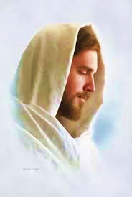
If step 1 is doable, then the image of the book of Daniel must be found
Him to look upon. Here are some images of the book of Daniel and I
do not know if they “work,”


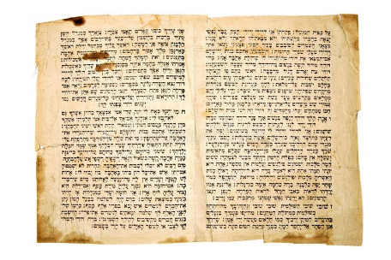
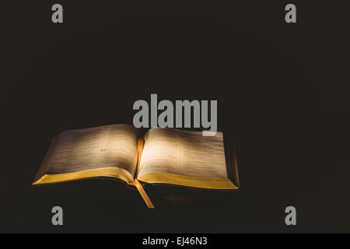

In this option, I would suspect there is a need to “connect” the two images with lights / bright swirls, whatever that show how His face is now bringing light (understanding) to the verses within the book of Daniel.

Possible Option #2 – If finding or working with two separate images – face of Jesus and a separated book of Daniel just can not be done in the way we all might want to see it, then a second option may be needed. Directly below is an image of Jesus (no head shot so we do not have to concern ourselves with trying to hide His face or make it golden and also transparent at the same time). Perhaps this image might work and send the desired message of “Can you see me now…”




Adobe stock


Using this image it might be necessary to not only find a way to connect this image to the “sub-title” but also there might be a need to add further lights / swirls, golden lights, whatever, to enhance the total cover. I have gone through so many images on the net and there is no shortage of beautiful images … to bring in and compliment / enhance the overall cover.

Now, for the “connection” of the above image to the sub-title….
I do not know how or if this can be done, or, you might have your own creative ways to try and accomplish this, but there might be another way – just a thought!

- Because the writing on the face of the scripture is small and not readable, this presents a problem for this possible option – that is to superimpose over a word or even two with the words – Jesus in one location and the name of God YHVH – but in Hebrew characters. It would not cover over the scripture writings but be ever so visible as to indicate these words in Daniel speak about Jesus and our interpretations should see Him in the book of Daniel. (because of the size, this is problematic I am sure). But perhaps you might find an alternative place for these two names to be placed? Perhaps lightly done on each side of the scroll? I think you folks can even follow the curve of the scroll if you consider this…

Option #3 (recently found image so I thought I would bring this up) -
Dreamstime.

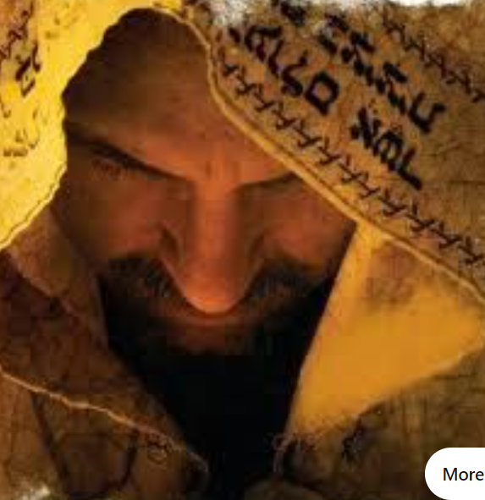

This is a nice image of Jesus where His face might be made more golden or transparent so it shows His face is giving off the brilliant light onto the book of Daniel. If so, then a separate image of the book of Daniel would be set below Him and He is looking onto it… there are plenty of images where a scroll or a open bible is positioned for this to work…

Well, that probably taps me out on the image of Jesus and the book of
Daniel presentation.

- Title – Please consider this change:

- New Interpretations
Book of Daniel

This does mean to imply the type of font or spacing or sizing of these words…That will depend on the images you use…. This is the easy part – easy to change fonts, size and location.

- Sub-title:
This also depends on the images used on the cover – one image, or
separate images. The final placement and sizing demanded by the
images inserted…

This just happens to be the “real message” of this book. There
thousands of “commentaries” of the book of Daniel – seems
like two a week, however, they essentially all comment on the
same “accepted interpretations” that have gone through the
theological community for the past 200 years. They seem to
repeat the others interpretations, offer their opinion of
interpretation A or B and publish. This commentary does not
do that… there are no less than 130 truly new interpretations
because they were found by focusing on the coming Messiah -
His first coming), and not about Babylon, Greece kingdoms,
etc. Thus, these five words MUST be emphasized somehow –
unusual font, location, color, who knows…

Below is just something I tried to look into – it is a very
different font – Torwelten. I believe it is used mostly in
sci-fi or futuristic type needs. The only reason I selected it is
because it connotes a little bit of difficulty to read or
interpret. It may catch you eye because it is different (don’t
know if it works or not, but the thought was that it played
into the same theme as the sub-title - Can you see me now..
But perhaps there are other ways to accentuate these
words….

Can you see Me now…

- This is just an image I found on the net. I did not pick this because of the writing – that would have to go. It is the shading or the gradation that seems to be so attractive. Also, it has a flat black which, to me, is so much richer than glossy black. Don’t know if you can use it but perhaps a place to write (if it doesn’t negatively affect your design) the sub-title in the same golden colors as below…

