Step #1 – Establish a background layer. Here I selected a pic from the internet that was interesting. To me, it might be used to convey Jesus’ walking or being in front of the book cover as He “coming out of heaven.” The letters and the small image of the man in this pic is not to be considered – it is the background or like it that I am trying to convey…

Original: - background could convey Jesus coming out of heaven,
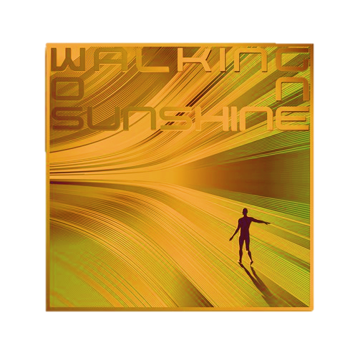
Adjusted: - depending on the image of Jesus (which will be mentioned next), the original background (above) might still be appropriate in a darker shade, or, top remains golden with bottom darker –(just depends on the image of Jesus and whether contrast is required …
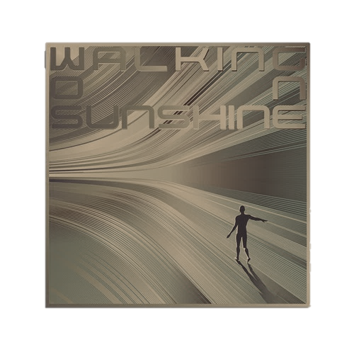
Step #2 – Image of Jesus. This might sound strange, but rather than use one of the many human faces of Jesus we have all seen in the movies / TV, etc., I was thinking to depart from this --- quite a bit. Since this commentary focuses on trying to find / see Jesus within this book and NOT focus on the 4 kingdoms (Book of Daniel) this image would be a “contradiction.” The sub-title is “Can you see Me now…”, but on the face of the cover you will NOT be able to see Him due to His face being hidden in swirls of light kind of thing.
Consequently, in my mind, I started with the golden statue that is given each year to those winning the “Oscars” in Hollywood. A beautiful golden statue (head / face) that does not really reveal their man like features but of course, you can tell it is a man.
The face of that statue would be the starting point. It would be just as brilliant and golden yet still diffused or hidden behind waves or swirls of light. (Not too much). But He would be having a white covering over Him as seen in all the images of Him in the movies. Below is a muted image of the statue -lost its brilliance trying to change it in Word… This is the idea but needs brilliance and glow, etc.

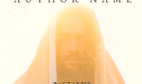

Thoughts – these are limited because I am trying to take pics from internet into Word and this application is not meant to be used by graphic designers…. Best I can try to convey using this application.
- Above is a pic of Jesus with a shroud covering His head. This might be changed to a bright white shroud perhaps with a blue edge on the shroud where there is now a white edge (this is for contrast only).
- With a white shroud around His head the picture of the golden face (Oscar statue to the upper left) was cut out and could be inserted where the face of Jesus is now … It can be further muted or difficult to clearly see (on purpose) with some kind of special effects within your application.
- The total image of Jesus wearing a white shroud would then contrast with the (step #1) which is the overall golden background mentioned above. Consequently, excluding any other items within the design, there is now a golden background like the one found above, then the image of Jesus with the white shroud and then within the white shroud there is the golden face of Jesus that resembles a face of man only to the extent of the Oscar statue face above – but again, that should be somewhat muted in itself or somewhat hidden with swirls of light, etc.
- Below is a terrific picture of the kind of swirling bright lights that can be used on the face of the book cover and / or around the face of Jesus to hide some of His features..(not completely of course). Because these brilliant swirls are also golden in color, this is where the designer will have to use his creative powers so they don’t blend into the golden background and be completely lost…



Step #3 – Jesus would be seen standing or walking and looking into the reader on the cover holding the Book of Daniel in His two hands. The book would be open and light would shine out from the words essentially giving one the understanding these words are speaking / discussing Him… Again, these are examples of just what the book might look like – it does not have to be so brilliant or glowing it is almost all white in the middle..




No words floating above the book is necessary and neither is the cross hanging below.

Step #4 – Below is an image of a pastor standing in front holding the scriptures in his hand… this is how I might imagine Jesus standing on the front of the cover – does not have to be a full body shot.. could be like this image.



Step #5 – Below is another image from the net which shows the kind of bright swirls of light that would / might not only surround Jesus but might be used to gently hide His golden face…

Step #6 – Sub-Title. This will be “Can you see Me know…”
So far, the only placement I have envisioned this is either to the left of the image of Jesus or below. Also, have only thought about the font (not colors or special effects, if any). However, I was thinking about using the sub-title also as a “play on words”. Specifically, if appropriate, use a font style that connects the sub-title to the physical words and its meaning – use a font that is NOT entirely clear. Here is just my thoughts – One can read the message, but it too is “cloaked.”
(Please also ignore the green background)


This is just to show possible placement of the words or pics… Not intended to denote colors, fonts, etc.
Also, I just used or inserted rectangles as a means to show placement.

N e w I n t e r p r e t a t i o n s

Author
Picture of Jesus goes in this area
Can you see Me now….
Book of
Daniel

