Company Name: Starla Enterprises
Starla is the name of the application
Starla is an application that consolidates multiple Applications into one to support planning, forecasting.

“Look Forward with Starla”

Draft Requirements
- I like this image but need to be modified so that it is unique to Starla Enterprise logo

- Color Palette that contains the yellow from Title Slide.
- I like a slight pattern spread throughout the deck
- Typical Slides found in a master template
  - Title
  - Tile and Content
  - Divider
  - Section Header
  - Agenda
  - Blank
  - Picture with content
  - Closing
  - Quote Slide
  - Title Only
  - Features
  - Timeline
  - Other Slides with examples of what I would be looking for in this document
    - Team
    - Problem
    - Solution
    - Starlaverse with image
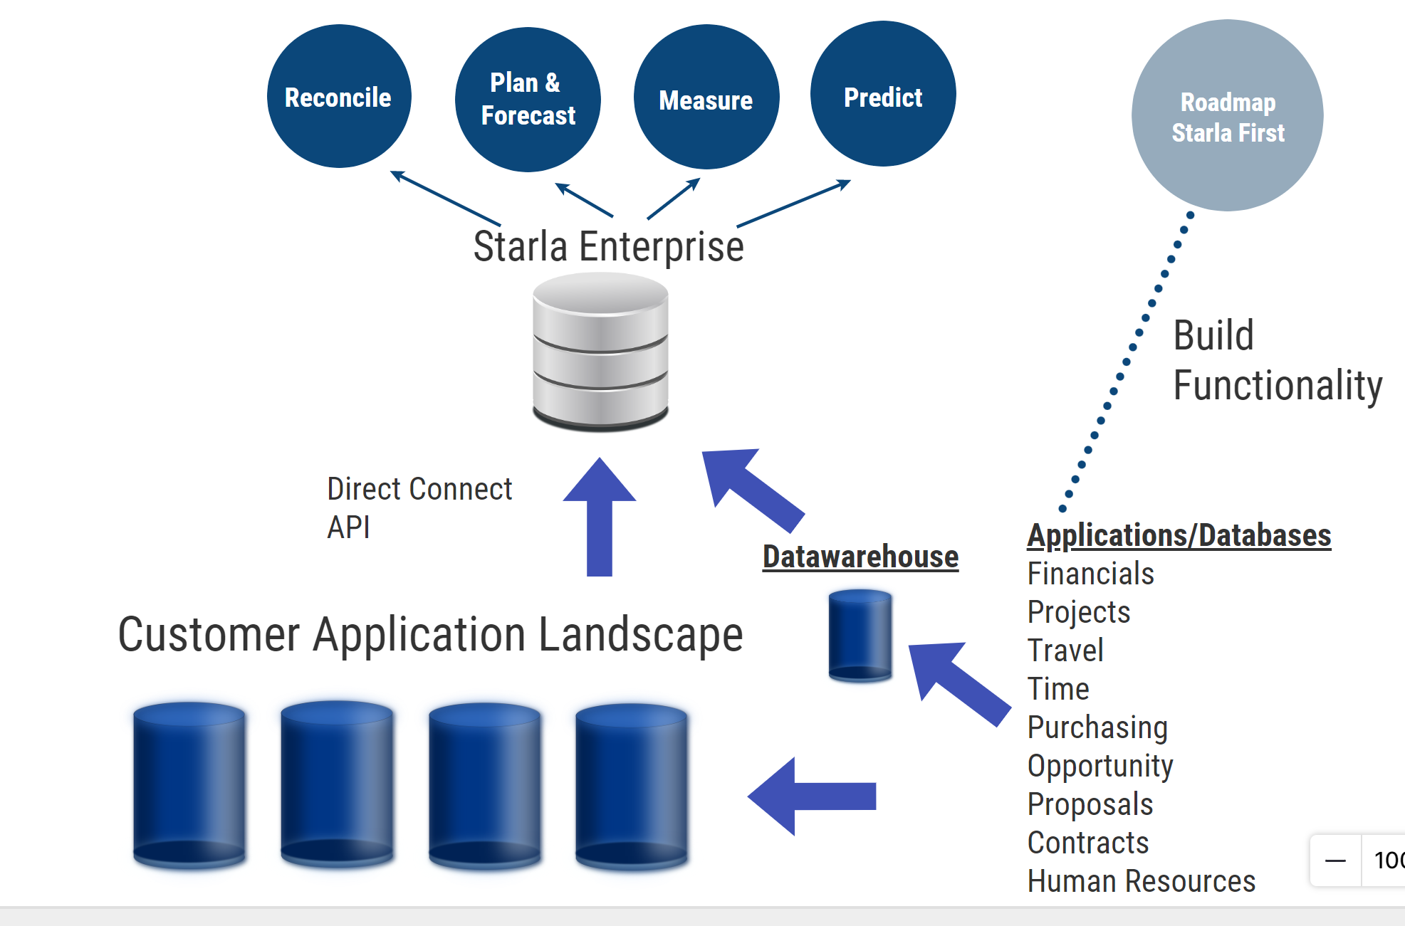
    - Modules
    - Lifecycle
    - Architecture

Title Slide


Team Slide


Problem Slides

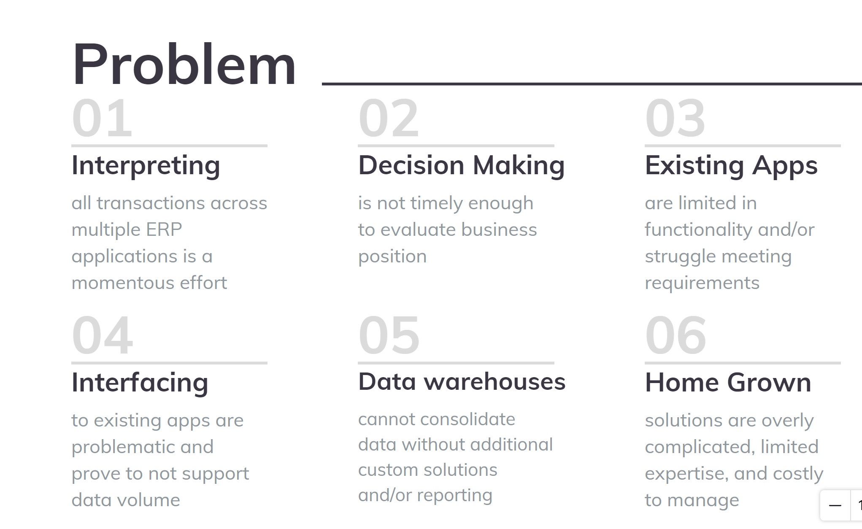

Solution Slide
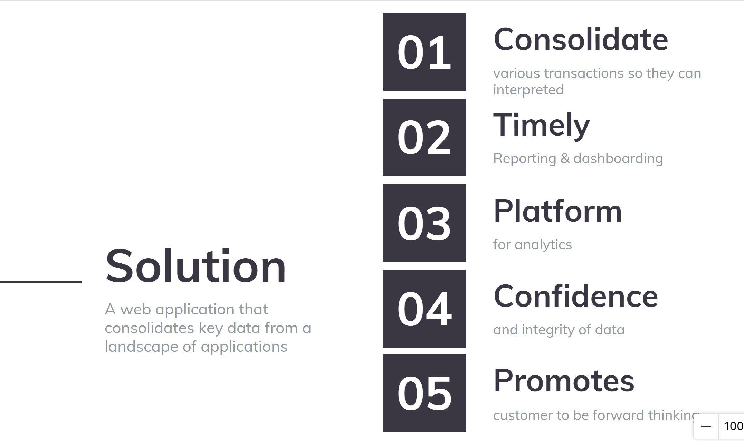

Starlaverse Slide with Image

Modular Slide with content
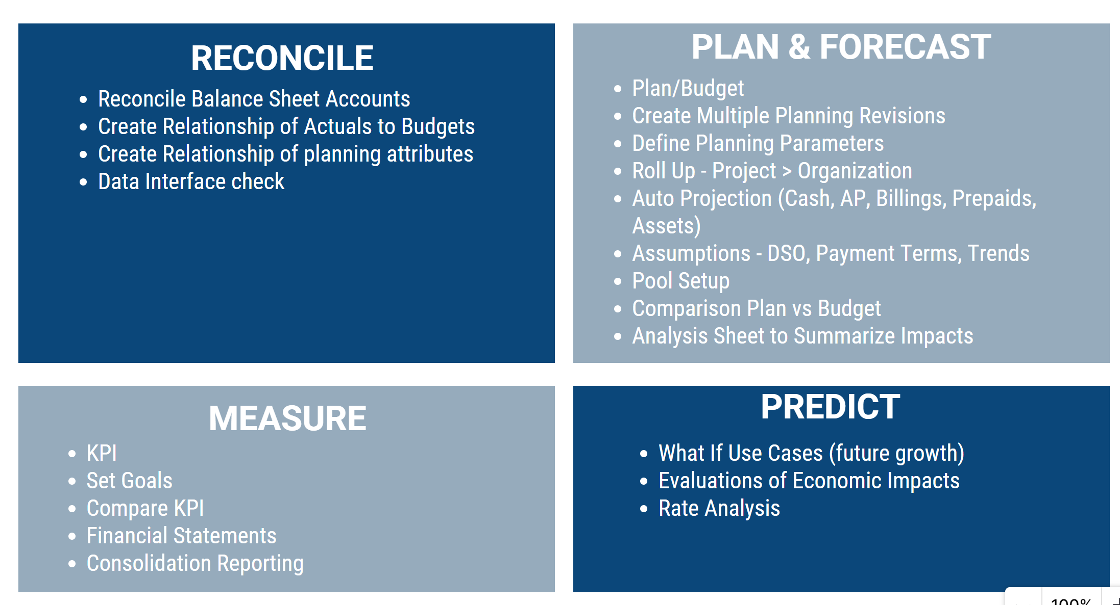

Lifecycle Slide
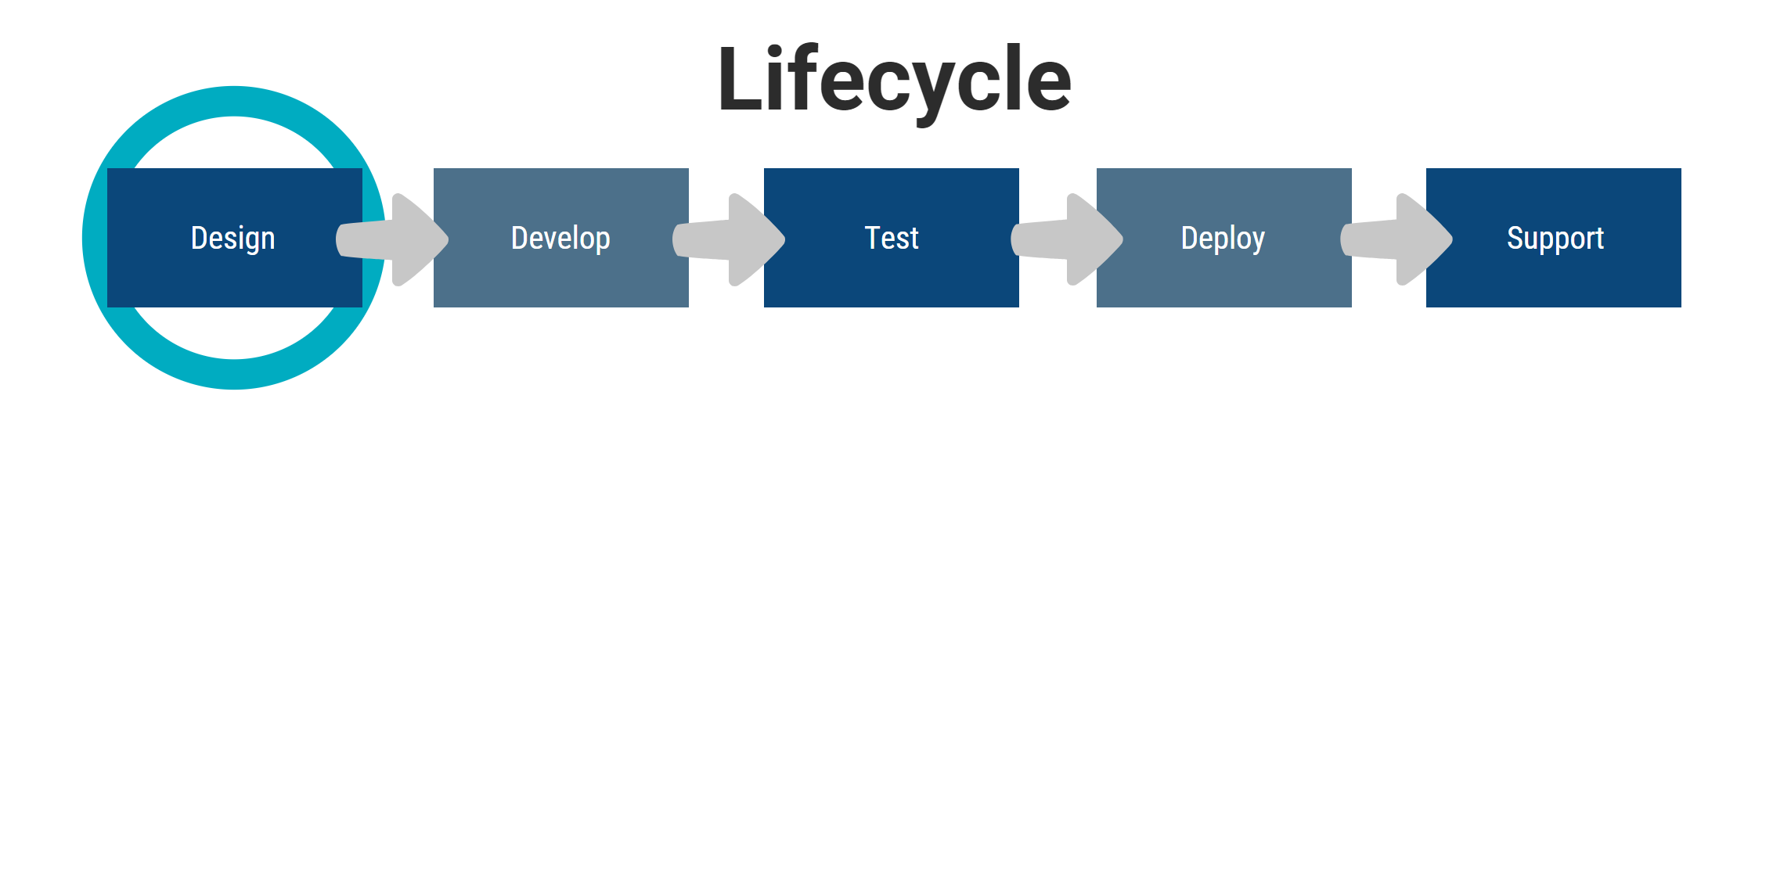

Architecture Slide Details
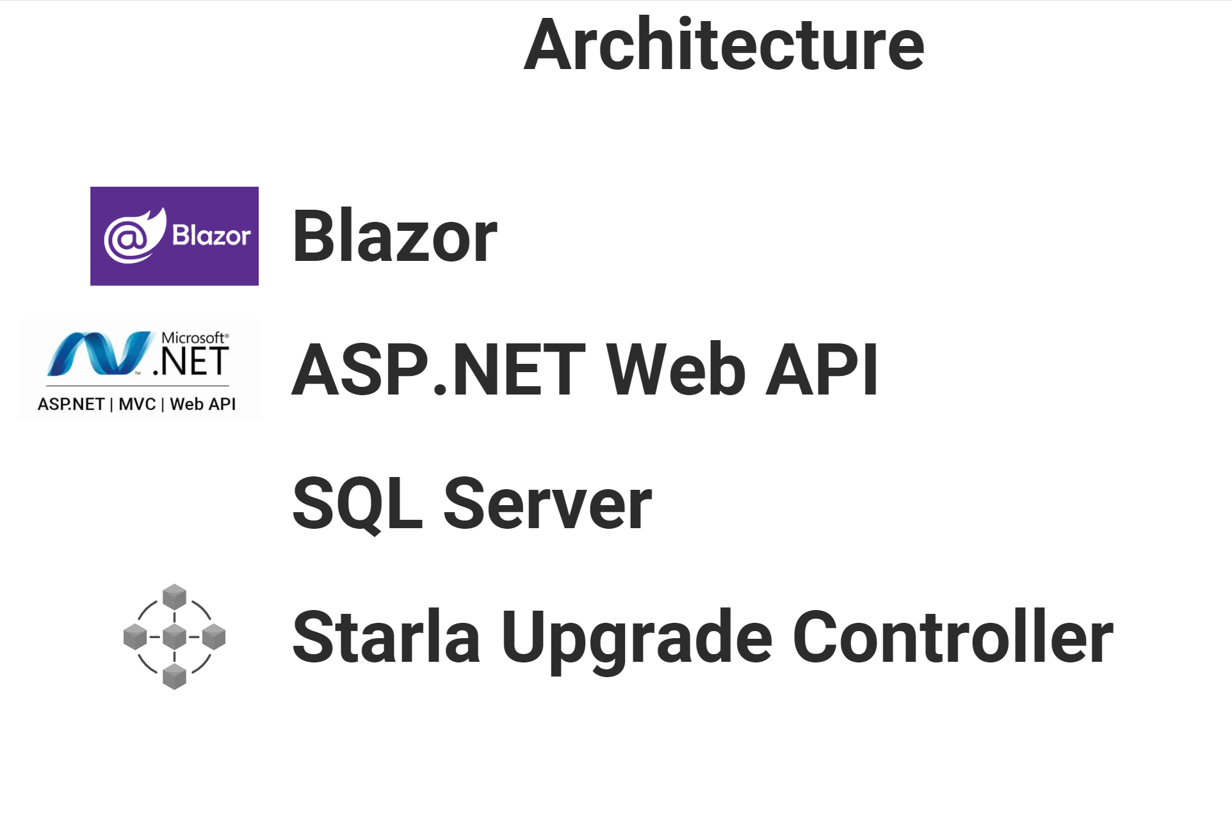
Presentation End Slide
