CyberNEX Technology PowerPoint Template Slides
CyberNEX is a digital transformation consulting firm dedicated to helping our clients securely and effectively reach their technology goals. We provide digital transformation consulting services, cybersecurity services, technology solution services and training & workshops.
Website: https://www.cybernex.io
I prefer to use the white background logo instead of the dark background logo. The design should be simple, cutting edge and stand out (not the same as other cyber companies)
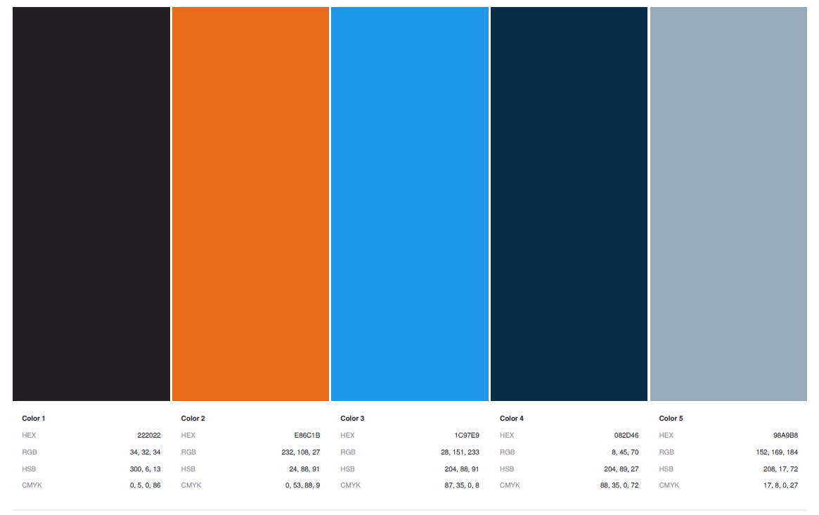
Brand Color palette

Logo: White Background

Inspiration:
Digital Transformation | Cybersecurity | Software Development

