Banner #1 – CyberNEX Technology (33” x 81”)
CyberNEX is a digital transformation consulting firm dedicated to helping our clients securely and effectively reach their technology goals. We provide digital transformation consulting services, cybersecurity services, technology solution services and training & workshops.
Website: https://www.cybernex.io
I prefer to use the white background logo instead of the dark background logo, but provided both files for reference. The design should be simple, cutting edge and stand out (not the same as other cyber companies)
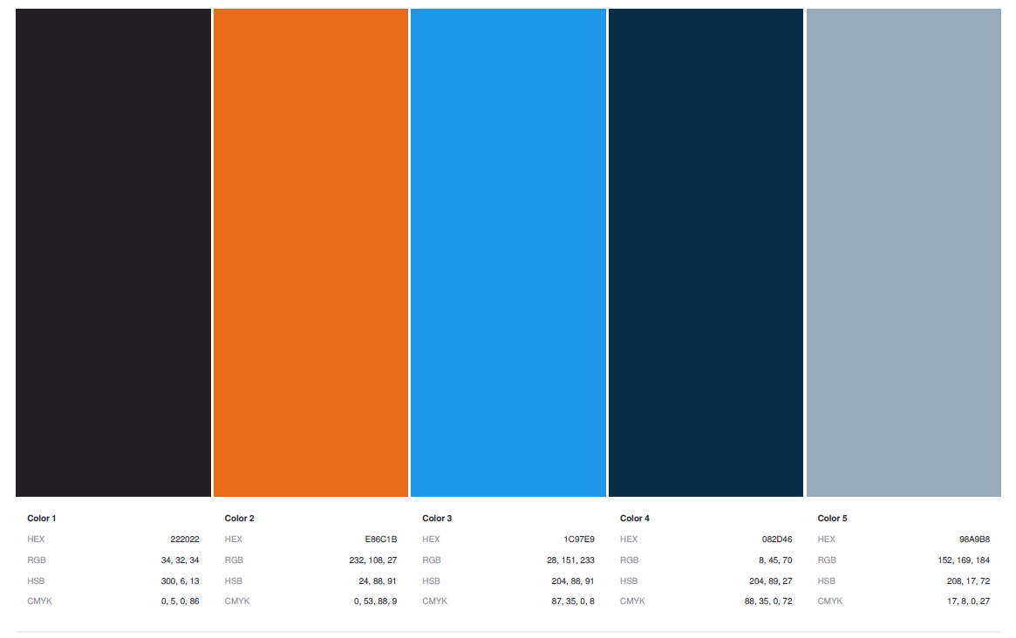
Brand Color palette
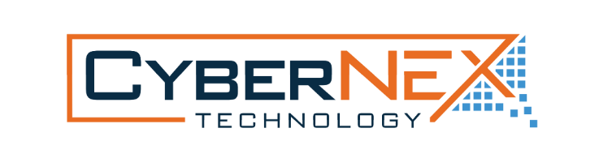
Logo: White Background
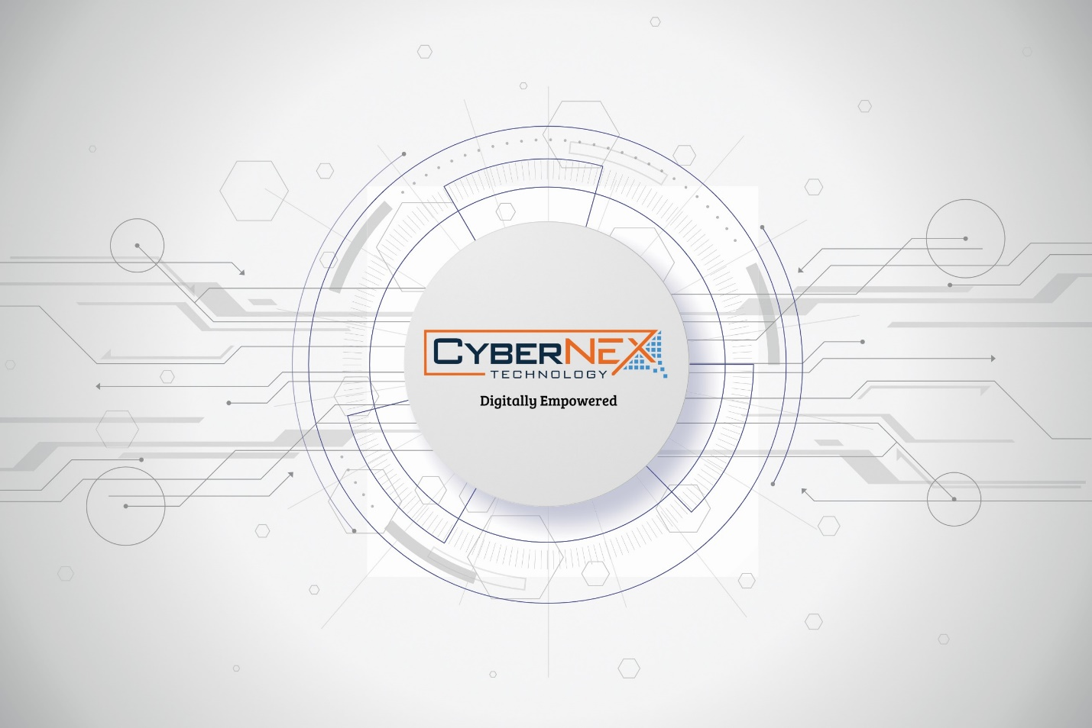
Inspiration: Instead of Digitally Empowered, it could be a list of services:
Digital Transformation | Cybersecurity | Software Development

Banner #2 – Cyync (33” x 81”)
Cyync is a software application that streamlines cyber operations. Its purpose is to help streamline and automate cyber assessments, exercises, and compliance audits.
Website: https://www.cyync.com
Cyync aims to be the go-to platform for #cybersecurity teams of all colors (#BlueTeams, #PurpleTeams, #RedTeams) to collaborate, discover and improve how they conduct cyber operations.
We created Cyync to help cyber teams maximize the impact from their cyber assessments and cyber exercises by providing a centralized platform that is geared towards capturing observations in real-time, validating data, and identifying trends so that your teams can develop actionable lessons learned that solve the right problems the first time.
The design should be simple, cutting edge and stand out (not the same as other cyber software apps)
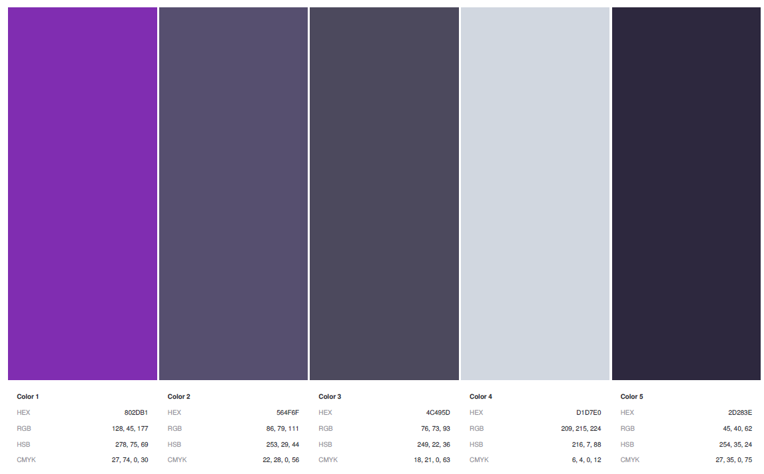
Brand Color palette

Logo
Inspiration: 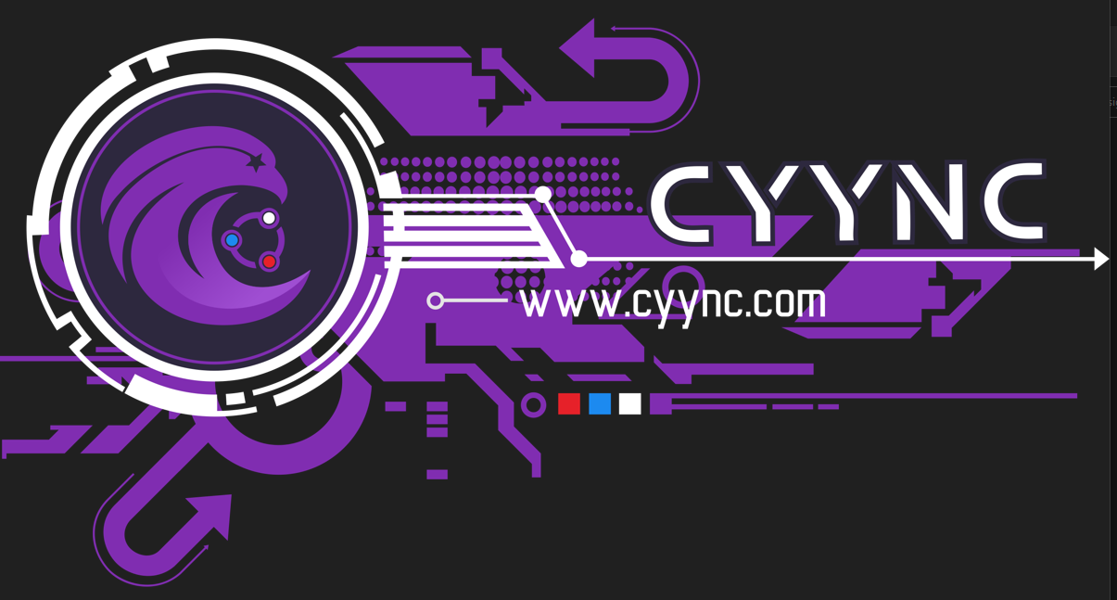
Inspiration: Shirt Design – Front Side
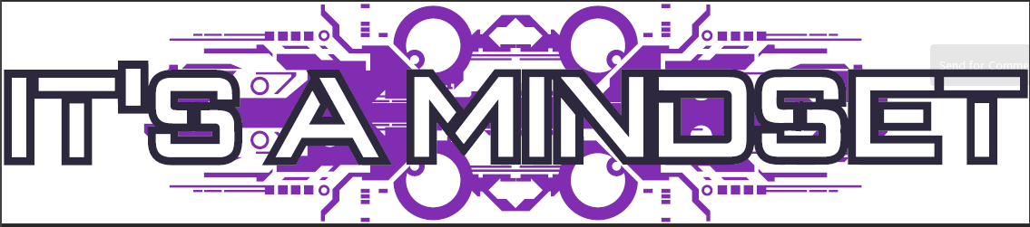
Inspiration: Shirt Design – Back Side
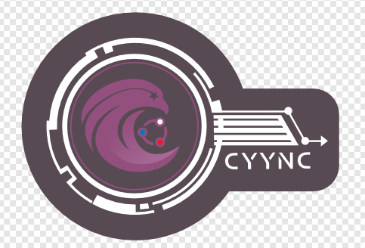
Inspiration: Sticker Design
