Select an Icon |  | Style of Property | Single Family Icon | Duplex Icon | Condo Icon
 |  |  | Townhome Icon | Mobile Home Icon | Log Home Icon
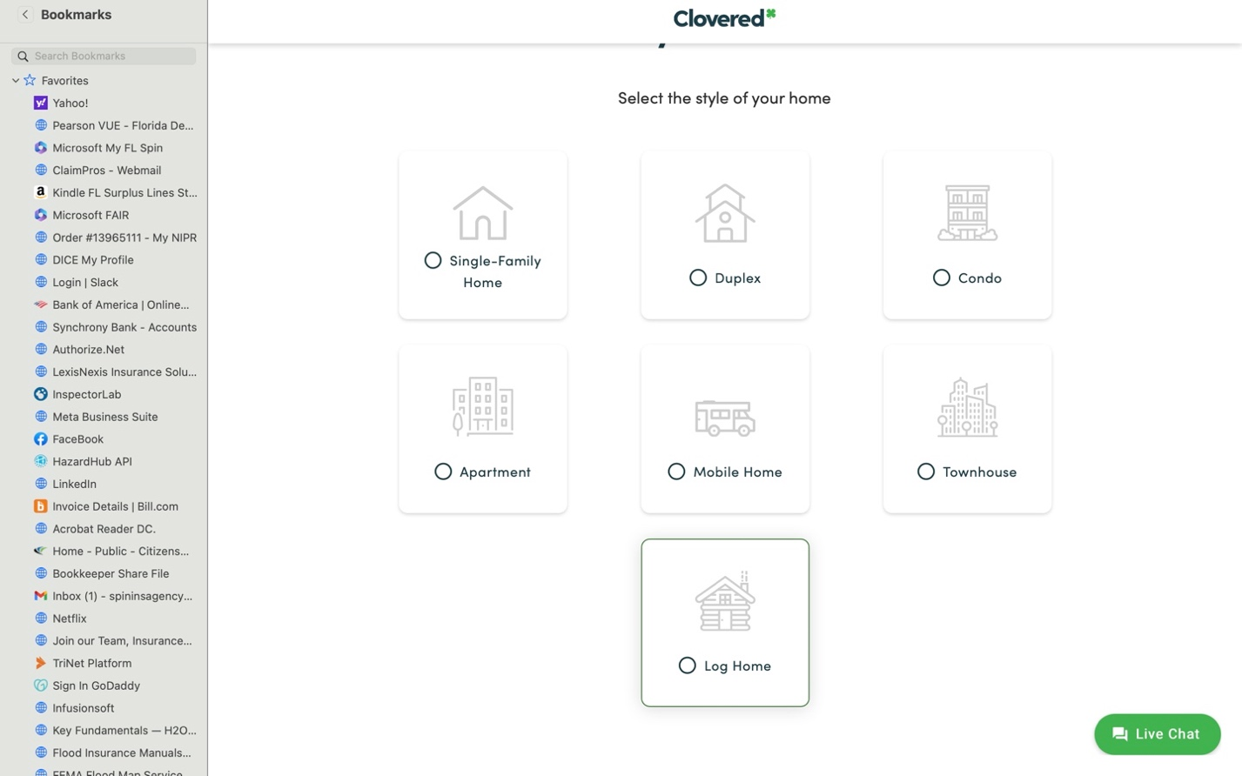
3 | Select Icon |  | Occupancy | Owner Occupied Icon | Tenant Icon | Landlord Icon
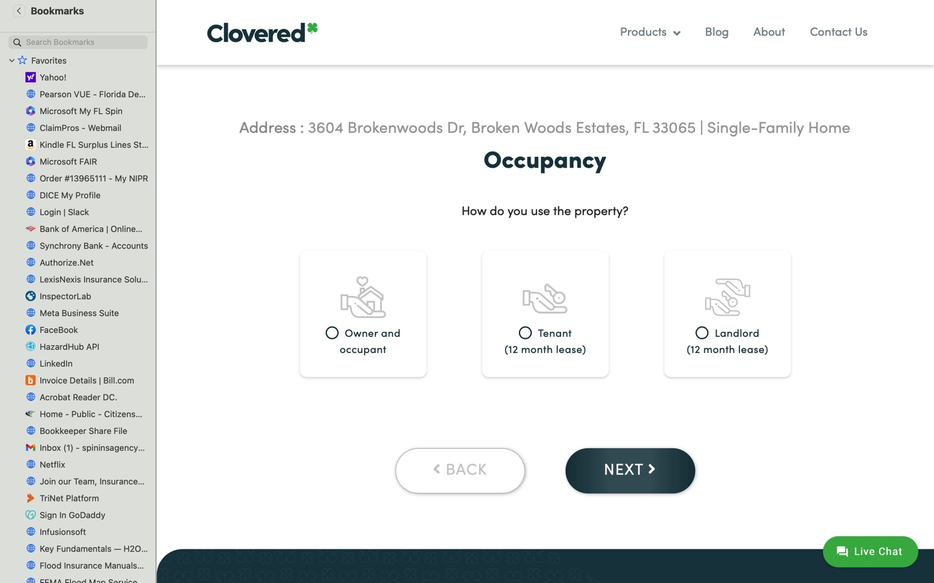
4 | Select Graphic |  | If owner occupied and tenant selected, ask - Is this your primary home? Select a graphic representing one of the following: | 1) Yes, I reside at this location most of the year | 2) No, I this is a secondary or seasonal home.
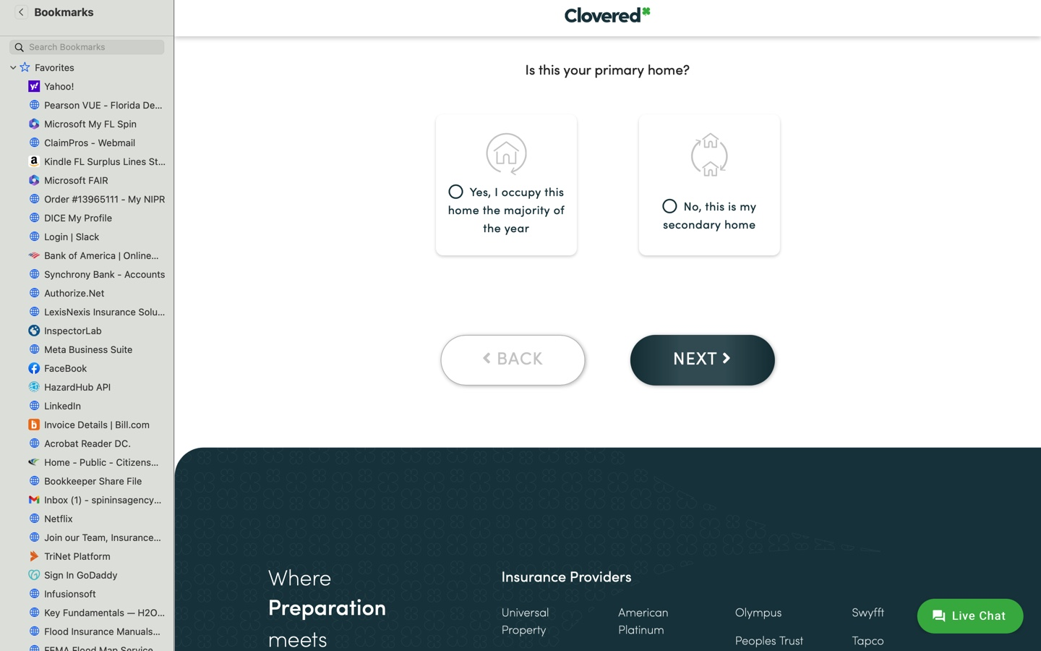
5 | Select a graphic representing one of the following Credit Rating: |  | Credit Rating (Applicant) | Credit Rating below 400 | Credit Rating between 400-650 | Credit Rating between 650-750 | Credit Rating above 750
5 |  |  | Impacts the Rating formula | Ineligible | Highest rating debit factor | No rating factor | Rating credit

9 |  |  | Background Check
9 | Select a graphic representing one of the following | Any selected are not eligible unless insured settled the lawsuit or prevailed in the litigation. | Background Check | Bankruptcy or Foreclosure (5years) | Felony (10years) | First Party Lawsuit (Ever)
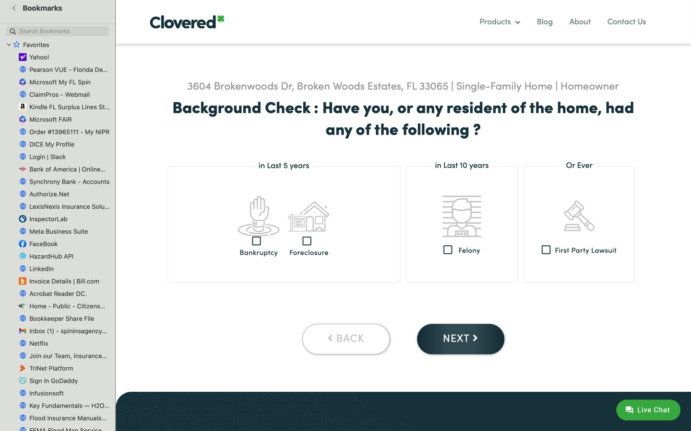
11 | Question and select Graphic Representation |  | Do you have any these pets on premises? | No | Exotic | Non-domesticed | Dangerous animal | _Wolf-hybrid | Documented history of biting
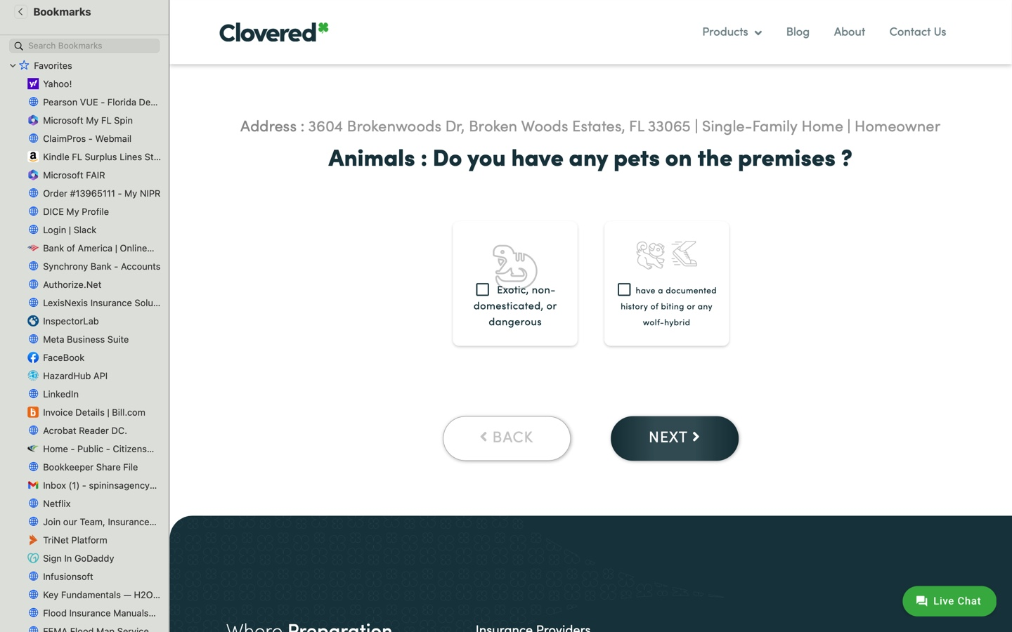
15 A | Select a graphic representing |  | Does your Home have any of these Protective Systems? | Centrally monitored fire alarm | Centrally monitored burglar alarm | Automatic sprinklers in all areas of the property including bedrooms

