BETTER HEALTH BY MEASURING MORE
LOOK AND FEEL YOUR BEST
RESET OUR HEALTH

Regular testing lets you optimize your diet and lifestyle choices so you can live your healthiest, happiest life. Discover proactive ways to improve symptoms and health risks.

We offer simple and convenient home collection of saliva, dried blood spot or dried urine samples or if you prefer lab collections can be done at our office location by one of our Registered Nurses.

Most of the lab’s Revelry Wellness use in functional medicine are not available through mainstream medicine and are done via independent lab companies.

Benefits with Revelry Wellness include and not limited to:

- Lab results are not backed up by algorithms and must be correlated with patient history (i.e. personalized interpretation).
- It takes a lot of time to interpret and review the results (which is not in line with an insurance model of efficiency)
- Many of the labs use laboratory testing techniques that are mostly found in research (and it takes at least 17 years for research to be implemented into clinical use!)
- Most of these labs are small, independent, and focus on quality over quantity.

Most of these offer a full spectrum of comprehensive functional testing including urine/saliva/stool/blood-based tests, but don’t go through commercial labs like LabCorp for blood tests

The resources we offer make sample collection easy – whether you prefer watching a video or following detailed
instructions. We also provide guidance on which patients will benefit from our testing.
Annual health Status(Learn your health status, with a yearly snapshot of your health., )
Track lifestyle changes(Track your health status monthly or as needed. Ideal for those making dietary and lifestyle changes).
Catch Problems Early (Track your health status throughout the year with specialized testing. Catch problems early..)
Your first visit starts with the Intake Form with a section on Patient Reported Symptoms, it features a list of symptoms that are common indicators of hormone imbalance, as well as a list of eight summary symptom categories. Patients
are asked to fill out the symptoms they’re experiencing and rate their severity of them. With numerous peer-reviewed studies validating that hormone test results support symptomatology, science now recognizes that hormones are a fundamental part of treating the whole body. Evidence shows that hormonal imbalances are the root cause of many chronic health issues.

Candidates for hormone testing include men and women who exhibit symptoms including:
 Hot flashes
 Night sweats
 Foggy thinking
 Sleep disturbances
 Low libido / decreased sex drive
 Vaginal dryness
 Acne
 Increased body / facial hair
 Heavy or irregular menses
 PMS / PMDD
 Fibrocystic breasts
 Breast cancer
 Infertility
 PCOS
 Chronic stress
 Chronic fatigue
 Weight gain, especially around the waist
 Heart palpitations
 Dry skin / brittle nails
 Cold hands and feet
Candidates for neurotransmitter testing include men, women and children who exhibit symptoms including:
 Anxiety
 Depression
 Chronic fatigue
 Impulsivity
 Insomnia
 OCD or ADHD
Candidates for heavy metals & nutrients testing include men, women and children who:
 Have exposure to well water or aging pipes
 Live in an older home or industrial area
 Have mercury dental work
 Consume foods like vegetables, rice and
seafood that may be tainted by heavy metals
 Smoke
DISCOVER LABS BASED ON
1. HEALTH CATEGORIES
2. ORGAN SYSTEM
3. CLINICAL CONDITION

CLINICAL CONDITION
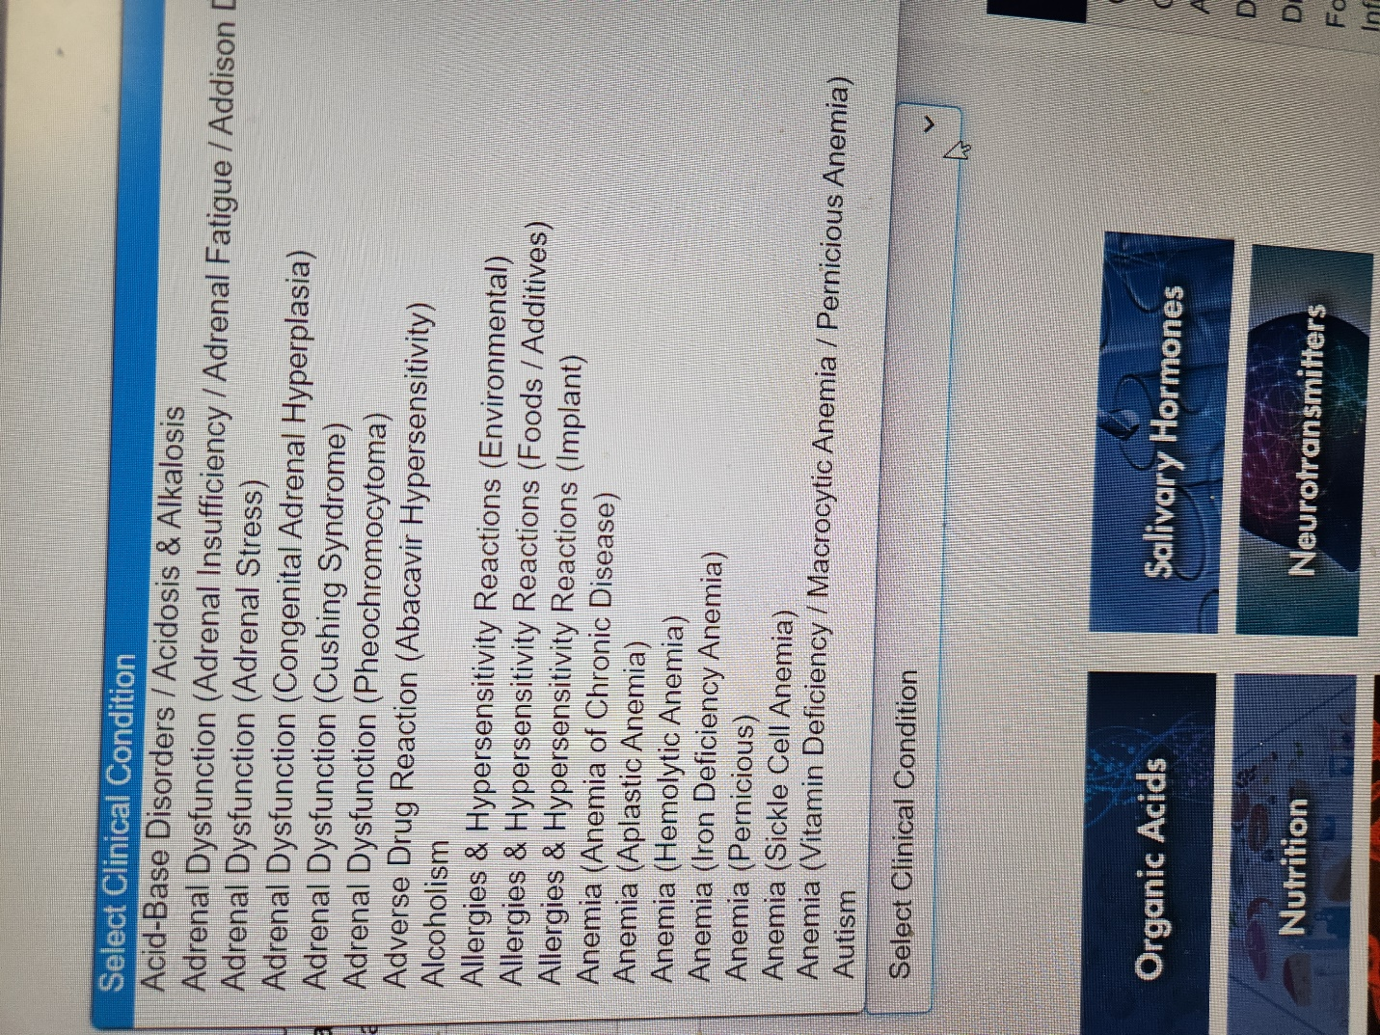

HEALTH CATEGORIES
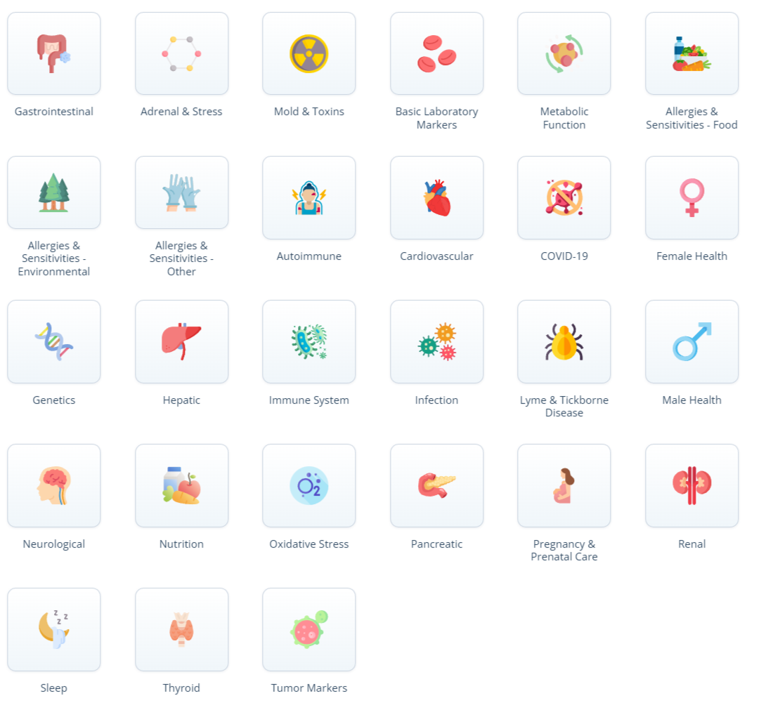

ORGAN SYSTEM
