Course Descriptions

Title: Advanced Witness Preparation: Help your personal injury client tell their story
Summary
Learn how to prepare your client to be a compelling witness at deposition and trial using state-of-the-art neurological science developed from advanced therapeutic techniques. Help your client tell the story of what happened so the jury sees, hears, and feels the depths of what the defendant did.
We will teach you how to obtain the story of the injury from your client and how to help your client present the story in its purest form during direct and cross-examination testimony. The Trial Structure Advanced Witness Preparation system will provide you with accessible strategies to transform your client into a master teller of their story.
- Turn your client into a compelling witness at deposition and trial
- Prepare your client using state-of-the-art neurological science developed from advanced therapeutic techniques
- Help your client tell their story so the jury sees, hears, and feels the depths of what the defendant did.

Title: Structuring your Plaintiff Damages Case: Turn ordinary into extraordinary

Summary
Turn ordinary into extraordinary by structuring your plaintiff injury case for voir dire, opening statement, and closing argument so the jury can see, hear, and feel the truth of what the defense did to your client. Learn how to make complex medical causation issues easily understandable for the jury and get the most out of your client’s story.

1. Focus the jury on the defendant
2. Identify what the defense will say and how they will say it
3. Use advanced linguistics to speak to the jury on a deeper level
4. How to present complex medical causation in opening

Title: Bring Your Client’s Story to Life: Persuasion and Presentation Skills

Summary
A trial is a contest of credibility. Unfortunately, plaintiff trial attorneys are labeled as "ambulance chasers," putting us at a disadvantage in telling our client’s story. By learning how to tell the right story in the right way, jurors will be more receptive to your client’s position, adopting it as their own based on the way you tell your client’s story.
We will share proven techniques you can implement to become an expert storyteller, allowing the jury to see, hear, and feel your client’s story. You already use many of these techniques to some extent. This webinar will teach you how to employ those same techniques in a more structured method that brings to life your client’s story and allows the jury to identify with their experience.
Learning objectives:
Tell the right story in the right way so jurors are receptive to your client’s position
Use images, dialogue and emotion to help the jury see, hear and feel your client’s story
Build on techniques you already use to bring your client’s story to life

Title: Dynamics pf Expert Witness Prepartion

Summary
In this discussion, you will learn step-by-step organization of the expert witness direct exam, the how-to’s of structuring cross-examination and tactics to outscore the Defense on re-direct exam to drive the true story of your case and deflect the Defense conjured-up false-narrative.
Finally, learn how to make complex medical causation issues easily understandable for the jury and cement the true nature of your client’s injury and permanent damage.

1. Focus the expert’s extraordinary knowledge
2. Identify what the defense will use as attack and how to turn it against them
3. Use advanced linguistics to help the jury “hear” on a deeper level
4. Present complex medical causation in easy-to-follow conversational testimony.

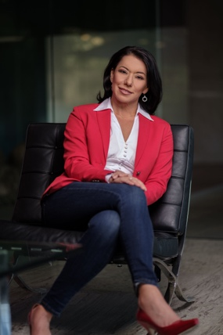
Bios of the Consultants
Ilya Lerma, for more than 20 years, has represented Plaintiffs in a wide array of complex personal injury matters including dram shop actions, nursing home negligence, insurance bad faith, civil rights abuse and discrimination, and serious auto crashes involving traumatic brain injury, catastrophic injury, and wrongful death. She has successfully prevailed in claims involving governmental entities, hospitals, multi-national corporations, heavy equipment and transportation companies, and mainline insurance carriers.

Ilya has consulted on some of Trial Structure’s most successful cases over the last few years. She routinely travels all over the United States to work with top trial lawyers on large, complex cases. Ilya has presented at the National Trial Lawyers Association in Miami, she’s presented at the American Association of Justice “Weekend with the Stars,” and she routinely instructs for Trial Structure Master Workshops when her busy trial practice in Phoenix, Arizona allows.

She is a member of the Executive Board of the Arizona Trial Lawyers Association and 2021 -2022 President of the Arizona Association for Justice and a member of the board of directors for the previous 8 years. She is a frequent lecturer and educator in business and personal liability, negligence actions and trial practice.

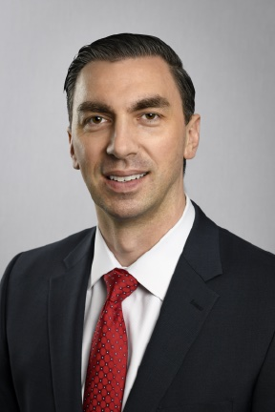
Charles Bennett is both a personal injury lawyer and a trial consultant for all types of catastrophic personal injury cases, such as wrongful death and traumatic brain damage, for trucking cases, car wrecks, premises liability, and workplace injuries. In July 2021, Charles won a $325,000 verdict in a conservative county near Dallas, Texas on a contested red light, he-said-she-said case, with less than $40k in past medical bills and a last offer of approximately $19k. In 2019, cases Charles consulted on won over $35M in 8 separate verdicts. Recently, a case he and Trial Structure’s Ilya Lerma structured won a $39M verdict in a case tried by John Garner in Northern California.

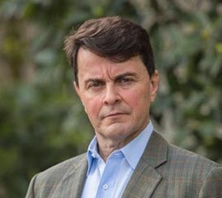
Alejandro D. Blanco is a trial lawyer with over 100 civil trials and a few criminal ones, who has “been in the trenches”.
Alejandro is intimately familiar with cutting edge trial strategy and practice. Specializing in brain injuries, he travels the country learning and teaching attorneys. He has lectured around the country in civil forums, including the Boardwalk Seminar in New Jersey, CAALA, Minnesota AJ and Alaska AJ. He was also a finalist for CAOC Trial Lawyer of the Year 2014. Best known for his ability to frame cases and trial teams to reach impossible goals, he has contributed to two of the largest verdicts for single plaintiffs in Kern County and a severe brain injury verdict in Orange County, totaling over 90 million for three plaintiffs.

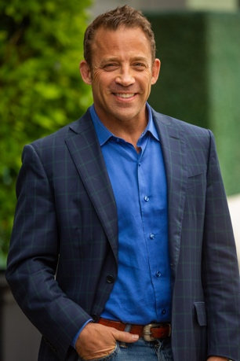
Kyle Sherman’s first exposure to great trial lawyer skills was while working for famed criminal defense attorney Roy Black in Miami, Florida. After turning his focus to Civil Plaintiff work, he graduated from the Gerry Spence Trial College, having been voted class representative and serving on the F Warrior Board for three years.
Kyle was a founding instructor of Trojan Horse Method and Trial Structure, where he has taught, presented and consulted across the country for several years.
When he is not helping other lawyers get better, he runs his plaintiff firm in Lafayette Louisiana as a partner at Brandt and Sherman, LLP.
Kyle’s is a Master Horseman, which he credits as teaching him patience, and a Black Belt in Brazilian Jiu Jitsu which teaches him to be comfortable being uncomfortable.

