Harmony Window Films and Graphics
Marshfield,WI
Finding solutions and creating Harmony through the power of film

Products and Services
Art Glass Laminate
Solar protective films
Security Films
Privacy films
Bird Safety film
Automotive Window Tint
Commercial Graphic Installation

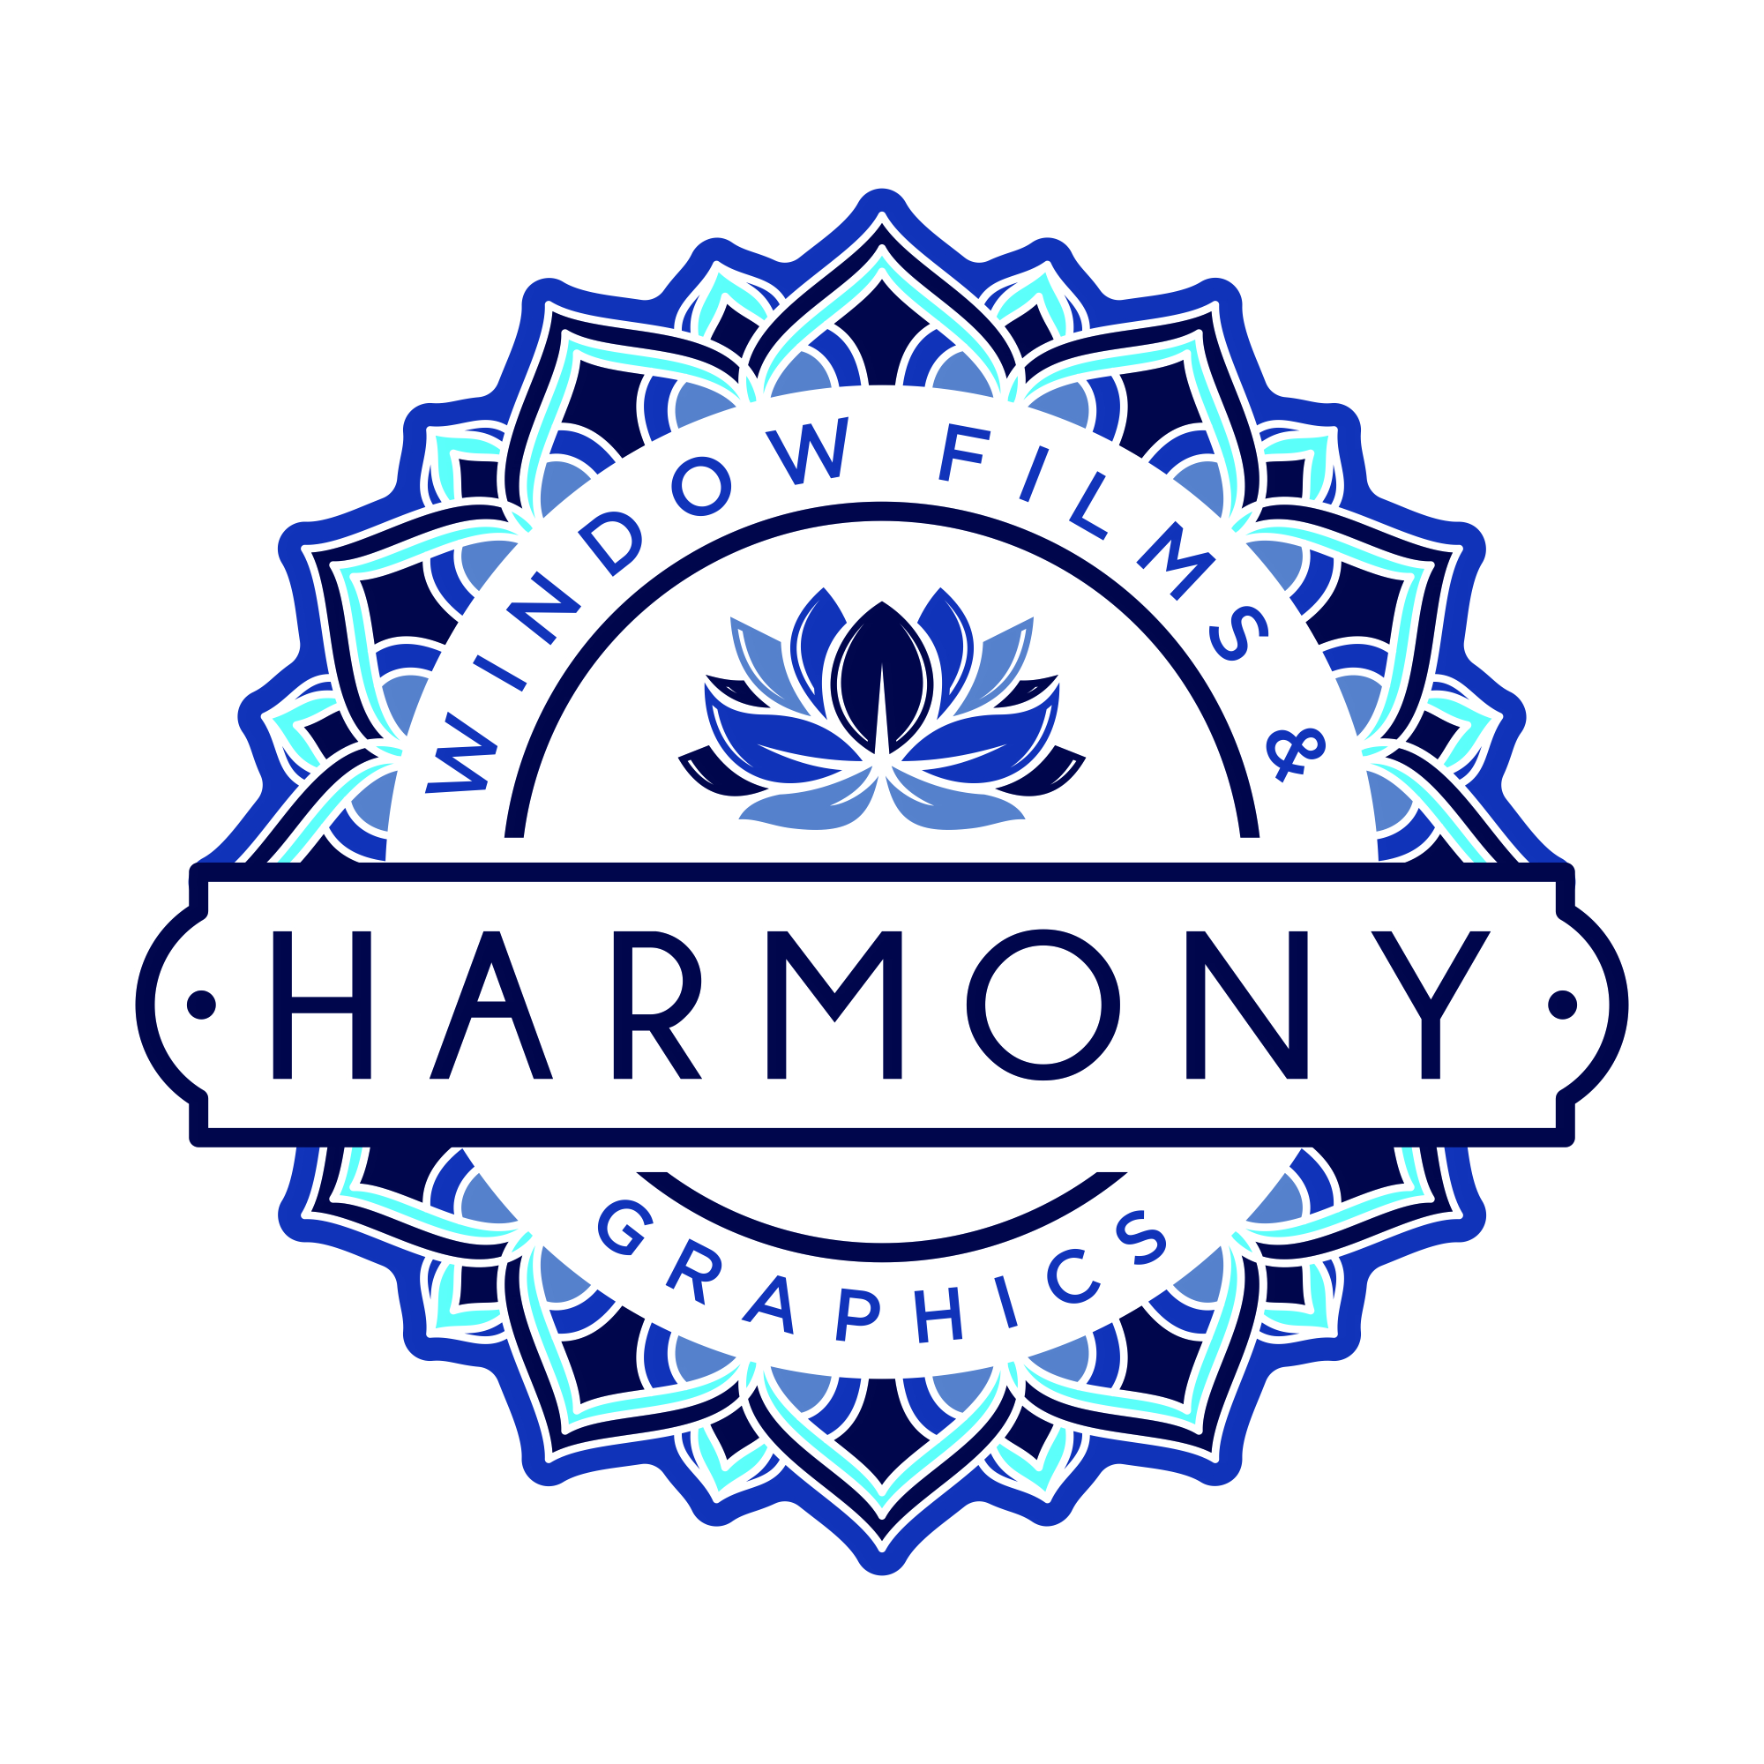

(background logo)

Services all of central Wisconsin and more!

9563 US 10 715-771-0192 HarmonyGraphicsllc.com
Marshfield, WI Harmonygraphics97@gmail.com F: Harmony Window Films and Graphics

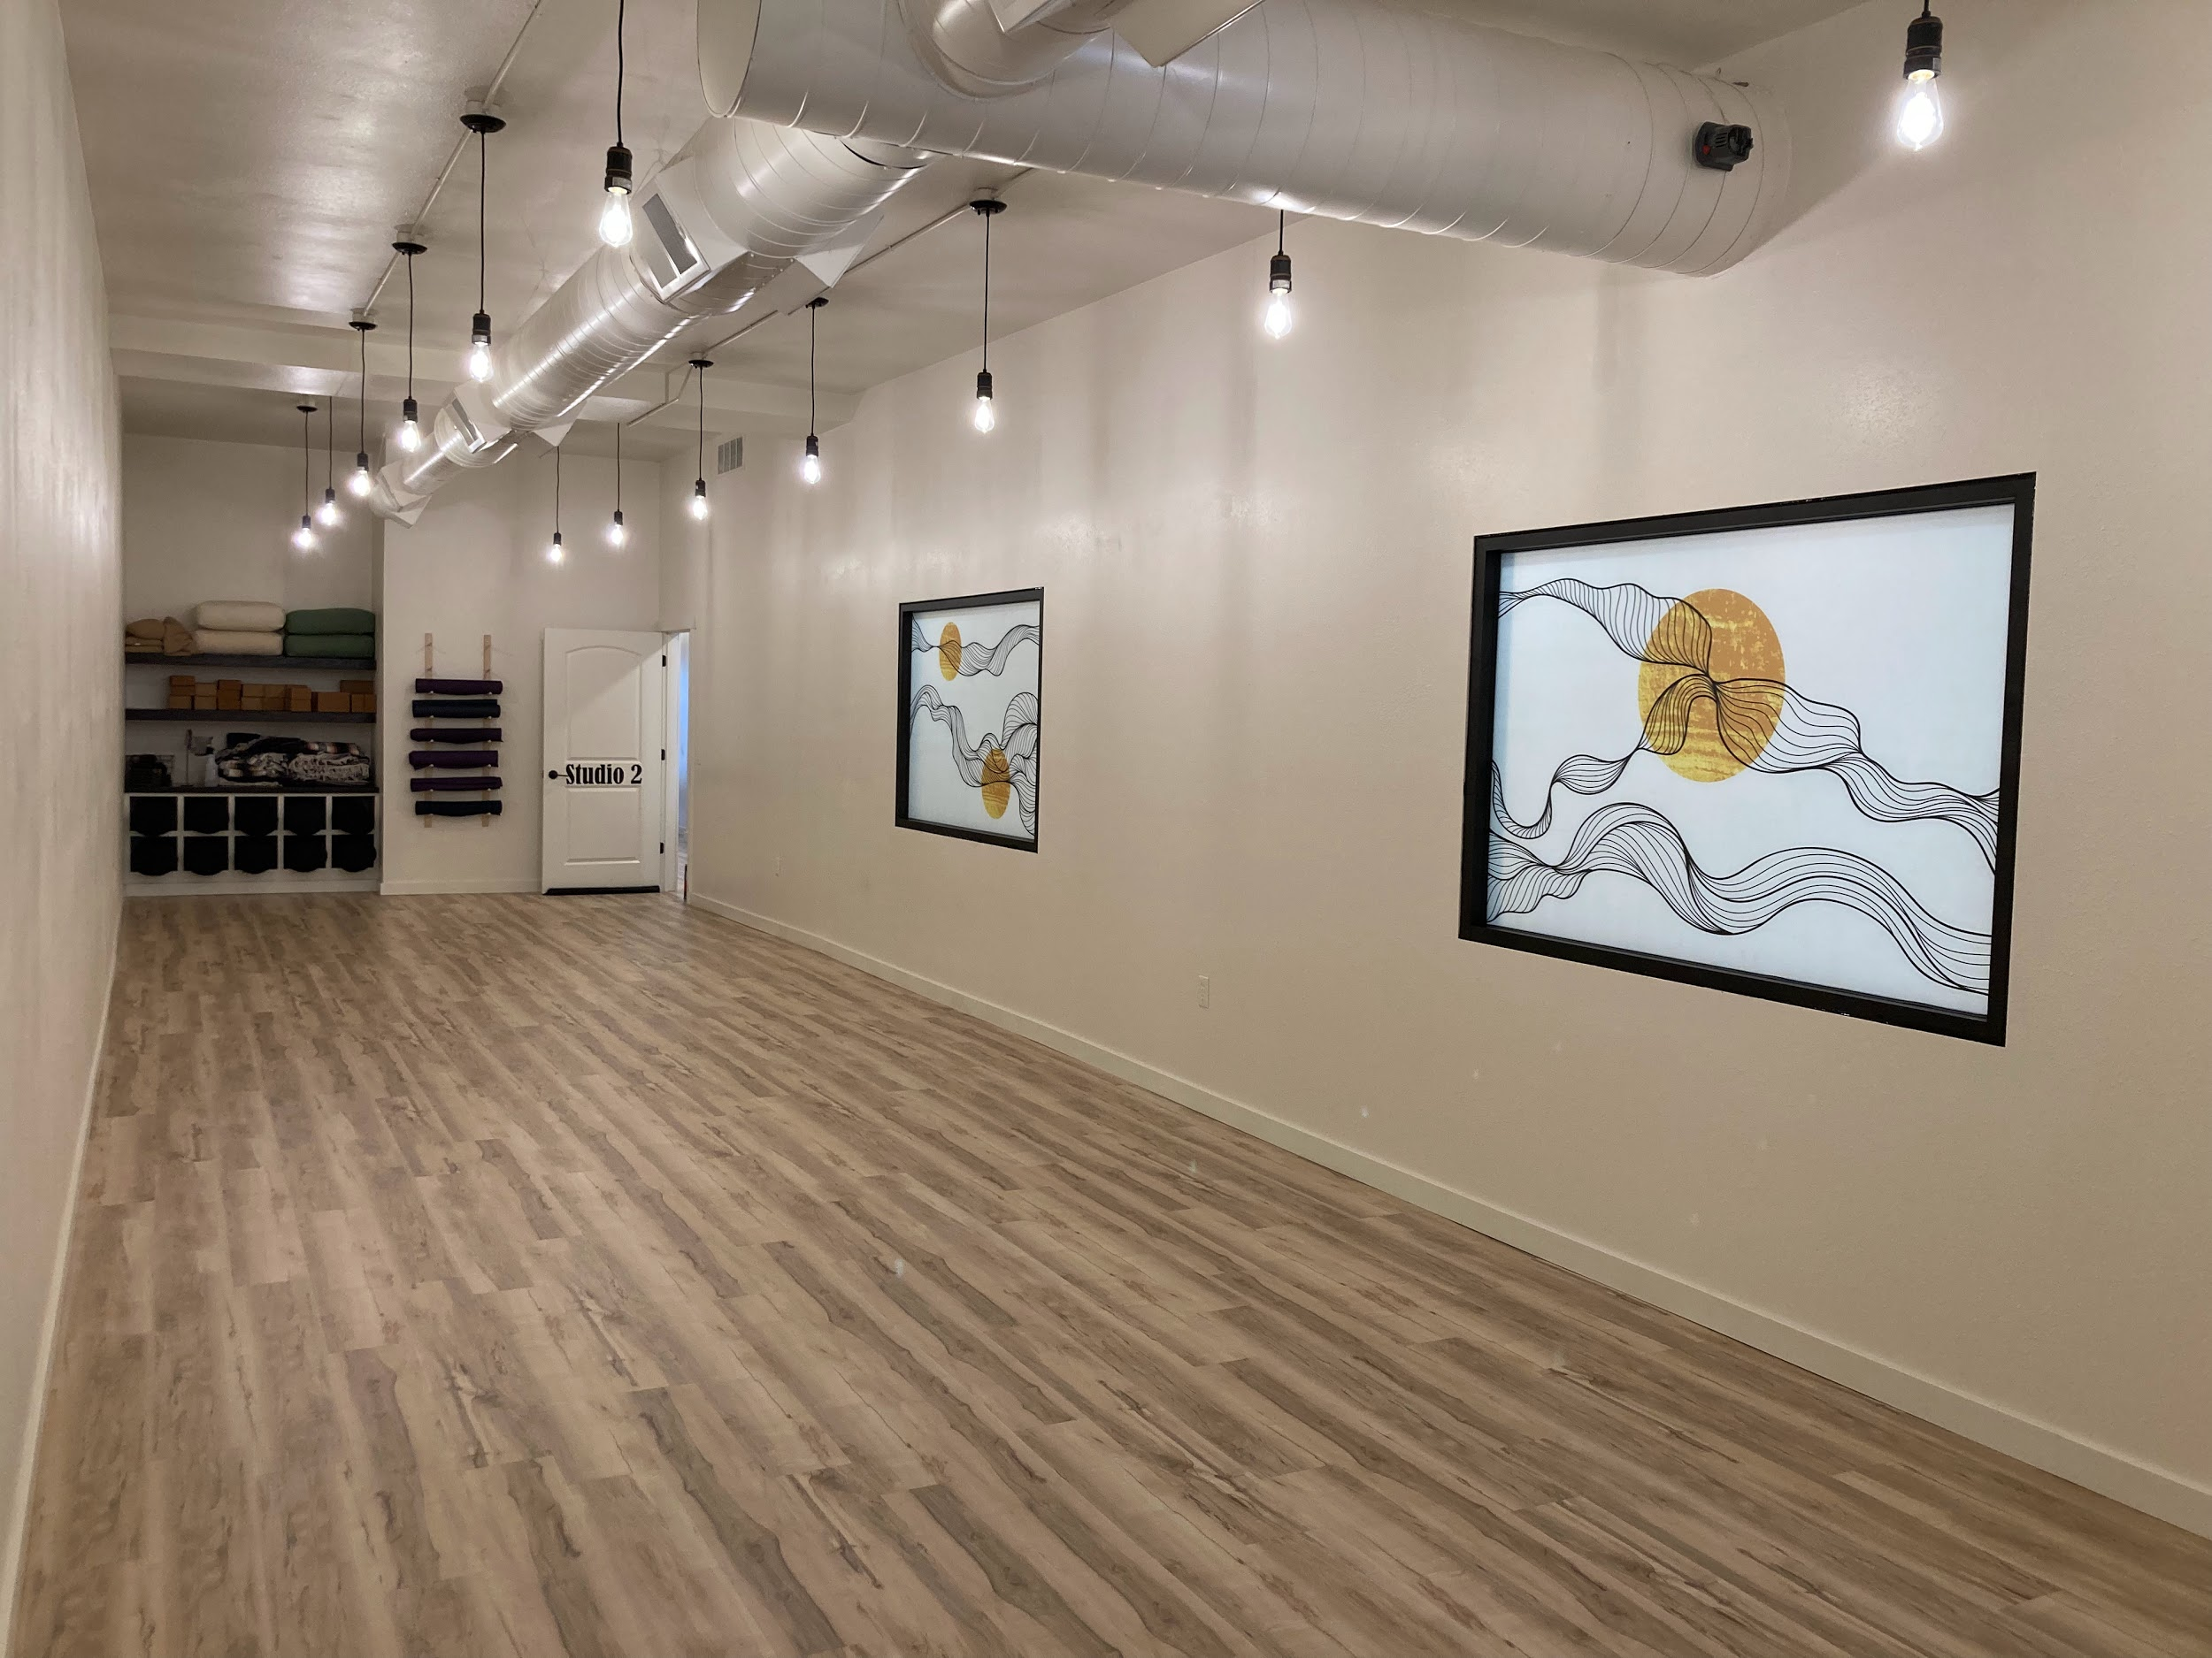
Harmony Graphics Presents Art Glass Laminate

ART GLASS LAMINATE

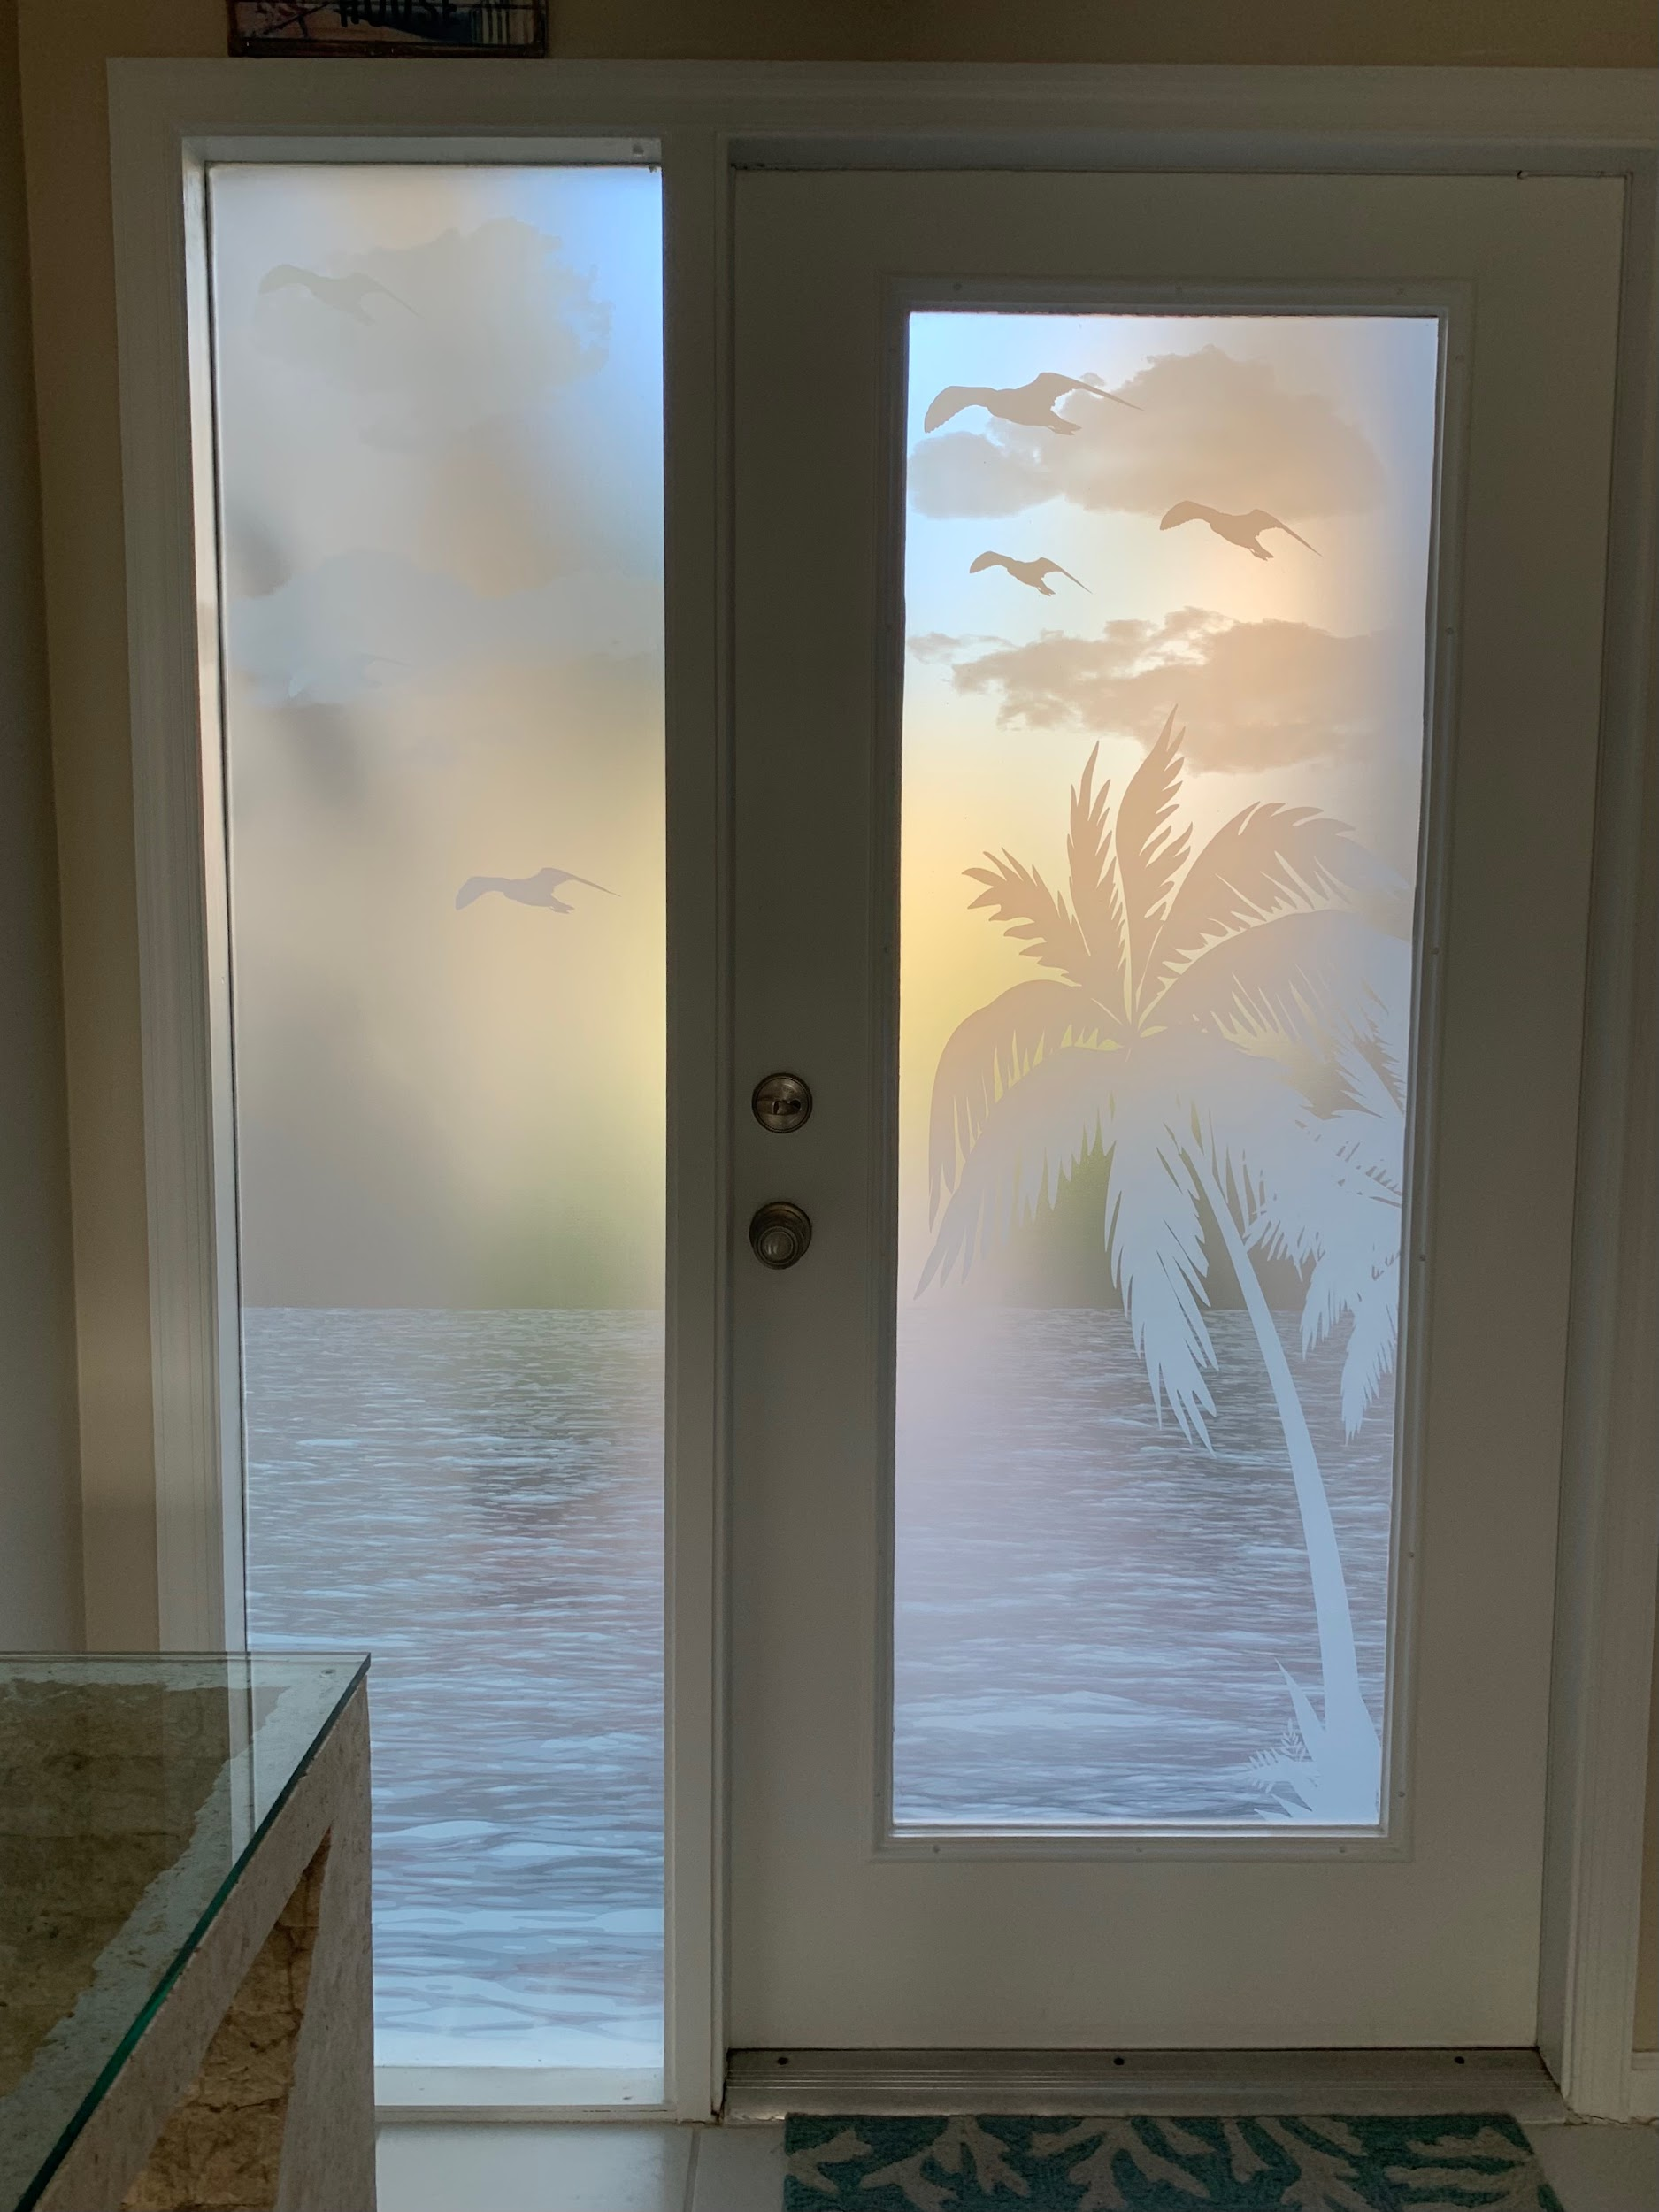
An old sage said:” glass is for light, design is for the soul”. We believe that good design plays an intrinsic part in our lives. Design is fun, designing high quality, uniquely textured, extremely cool custom film is ever better. We strive to create designs that inspire our customers. We strive to create designs that will make you happy every time you seem them. We want you ( people, designers, architects, dealers, customers, cats, dogs, all animals) to know that EVERYTHING IS POSSIBLE with ART GLASS LAMINATE and this is why we at Harmony Graphics love it and wanted to bring it to you.

YOUR DOOR YOUR STYLE

Art glass laminate comes in unlimited designs. We have some prepared but, if you are looking for something different, we got you cover, 99.9% of the time (we are humans after all). Classic, Contemporary, Victorian, MidCentury Modern, Art Deco’, Art Nouveau, Crazy, you name it, we either have it or we will make it for you. Design enriches us all.

UNIQUE LIKE YOU ARE

Most industrial film manufacturers either consider decorative film in a “corporate” way or, present geometrical repetitive patterns ready to use. We believe a permanent yet removable art glass laminate on glass is the perfect medium to EXPRESS OURSELVES, so we want you to feel there are no boundaries. We believe in your individual self expression.

We believe that YOU will be intrigued and want to know more, because beauty and design enrich all our lives.

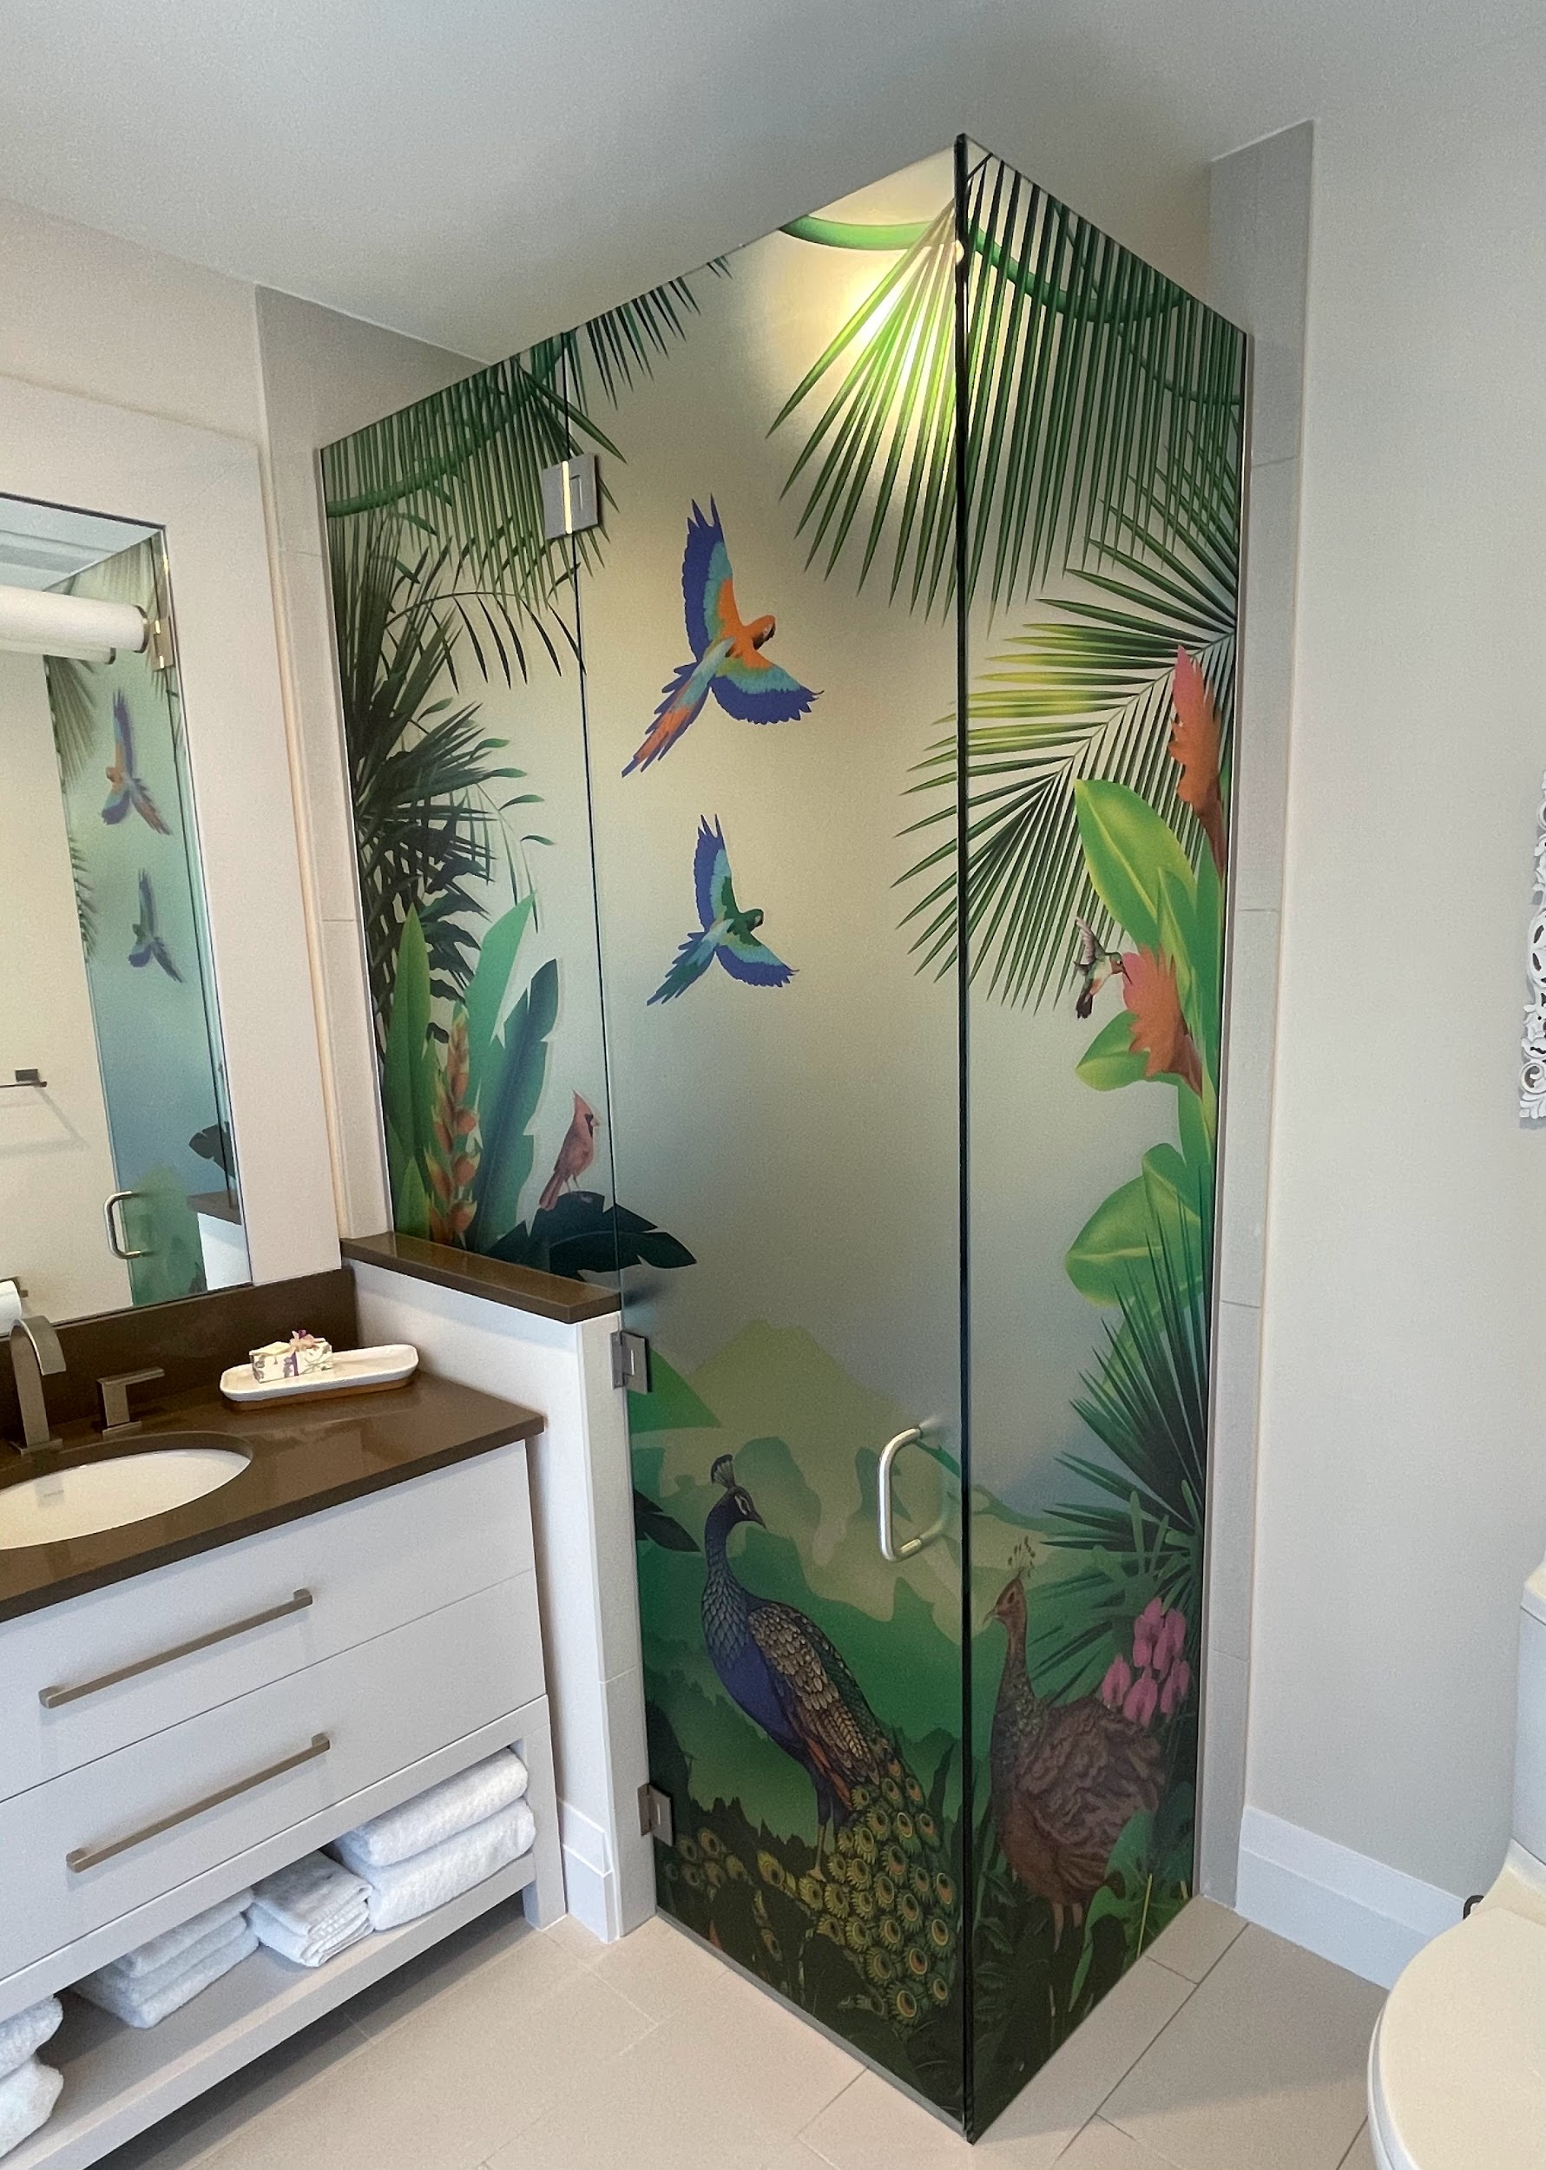
YOUR HOME YOUR STYLE

Harmony Window Films and Graphics’s Art Glass Laminate is applied to the interior side of your glass door or the exterior of a shower by our MASTER INSTALLERS.

ART GLASS LAMINATE is fully customizable in design, level of privacy and opacity. AGL’s surface is tactile. We actually advise people to feel it, like a wallpaper or a nice fabric.

AGL is always tailored to your glass, your mood, your moment in time.

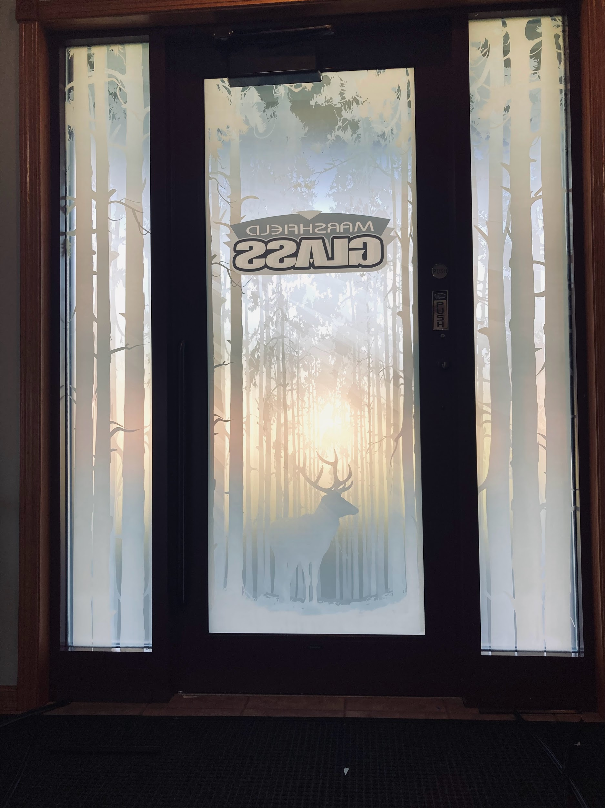
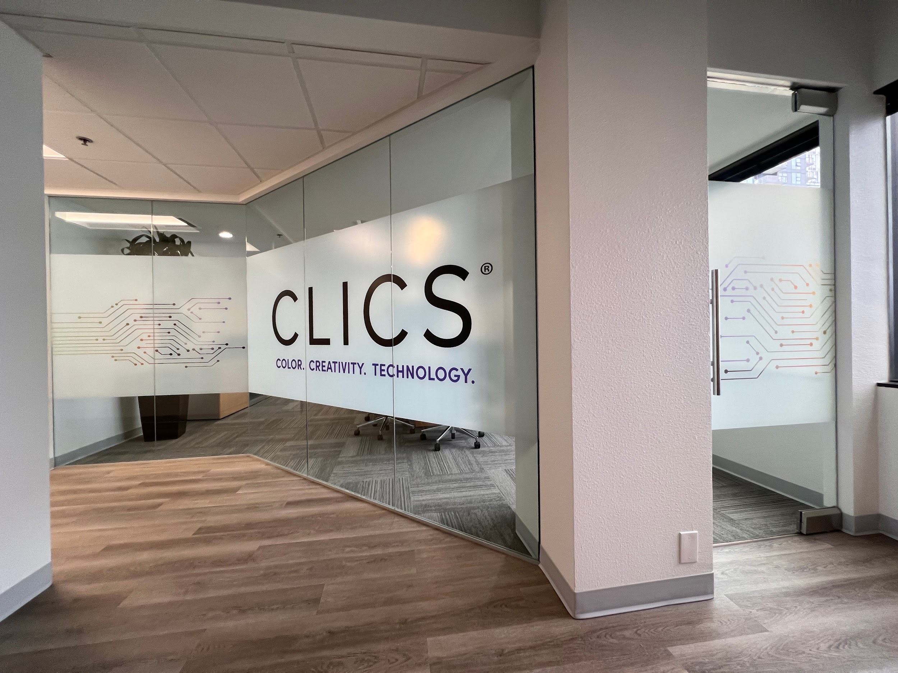
COMMERCIAL APPLICATIONS

Art Glass laminate lets your brand shine. Aren’t you tired of just frost? We get it, it is what you have seen over and over, but it is not the 2000’s anymore. Frost serves a privacy purpose, Art Glass Laminate serves your brand communication efforts in every such point where glass is present. Set your business aside with the limitless possibilities of AGL!

USE IT WHEN YOU WANT, NEED, OR FEEL

A decorated glass adds appeal and value. Harmony Graphics’s design studio will work with you to create the appeal you are looking for and the proper way for it to generate the value you are looking for. Entryways, Conference Rooms, Showers, Railings, Windows, Facades, RV, Boats & More.

Are you a door dealer? Talk to us. Are you a Shower Manufacturer? Let’s make wonderful creations. Architect? Designer? GC? Developer? Let’s talk about your project and make something people will talk about and will recognize you for. Want to impress your friends when they come over? You are talking with the right people.

WHY US?

AGL is installed like a regular window film and our dealers are the BEST.
AGL installation requires only water and baby shampoo, you have to LOVE the environment. AGL is printed with our patent pending sauce because we are as UNIQUE as you.
AGL can be frost only, frost+white, frost+color, glossy, or a 3D glossy texture you can feel. whatever YOU want, we do not judge.
AGL can have transparent areas to maintain visibility outside.
AGL is removable and it can be changed, we all have those MOMENTS.
AGL does not stop the LIGHT, only unwanted sights. AGL is affordable, but it is a PREMIUM product.
AGL is made in the USA. Most of all, AGL is FUN, SPECIAL, and our tea
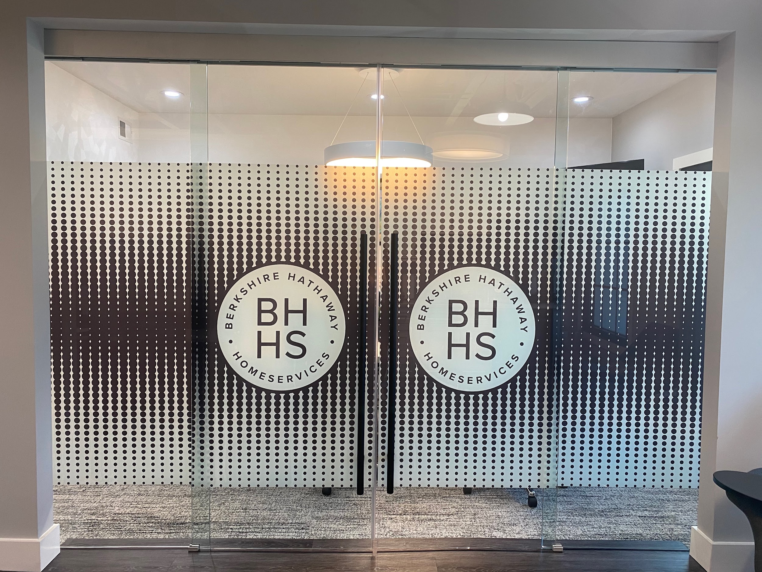
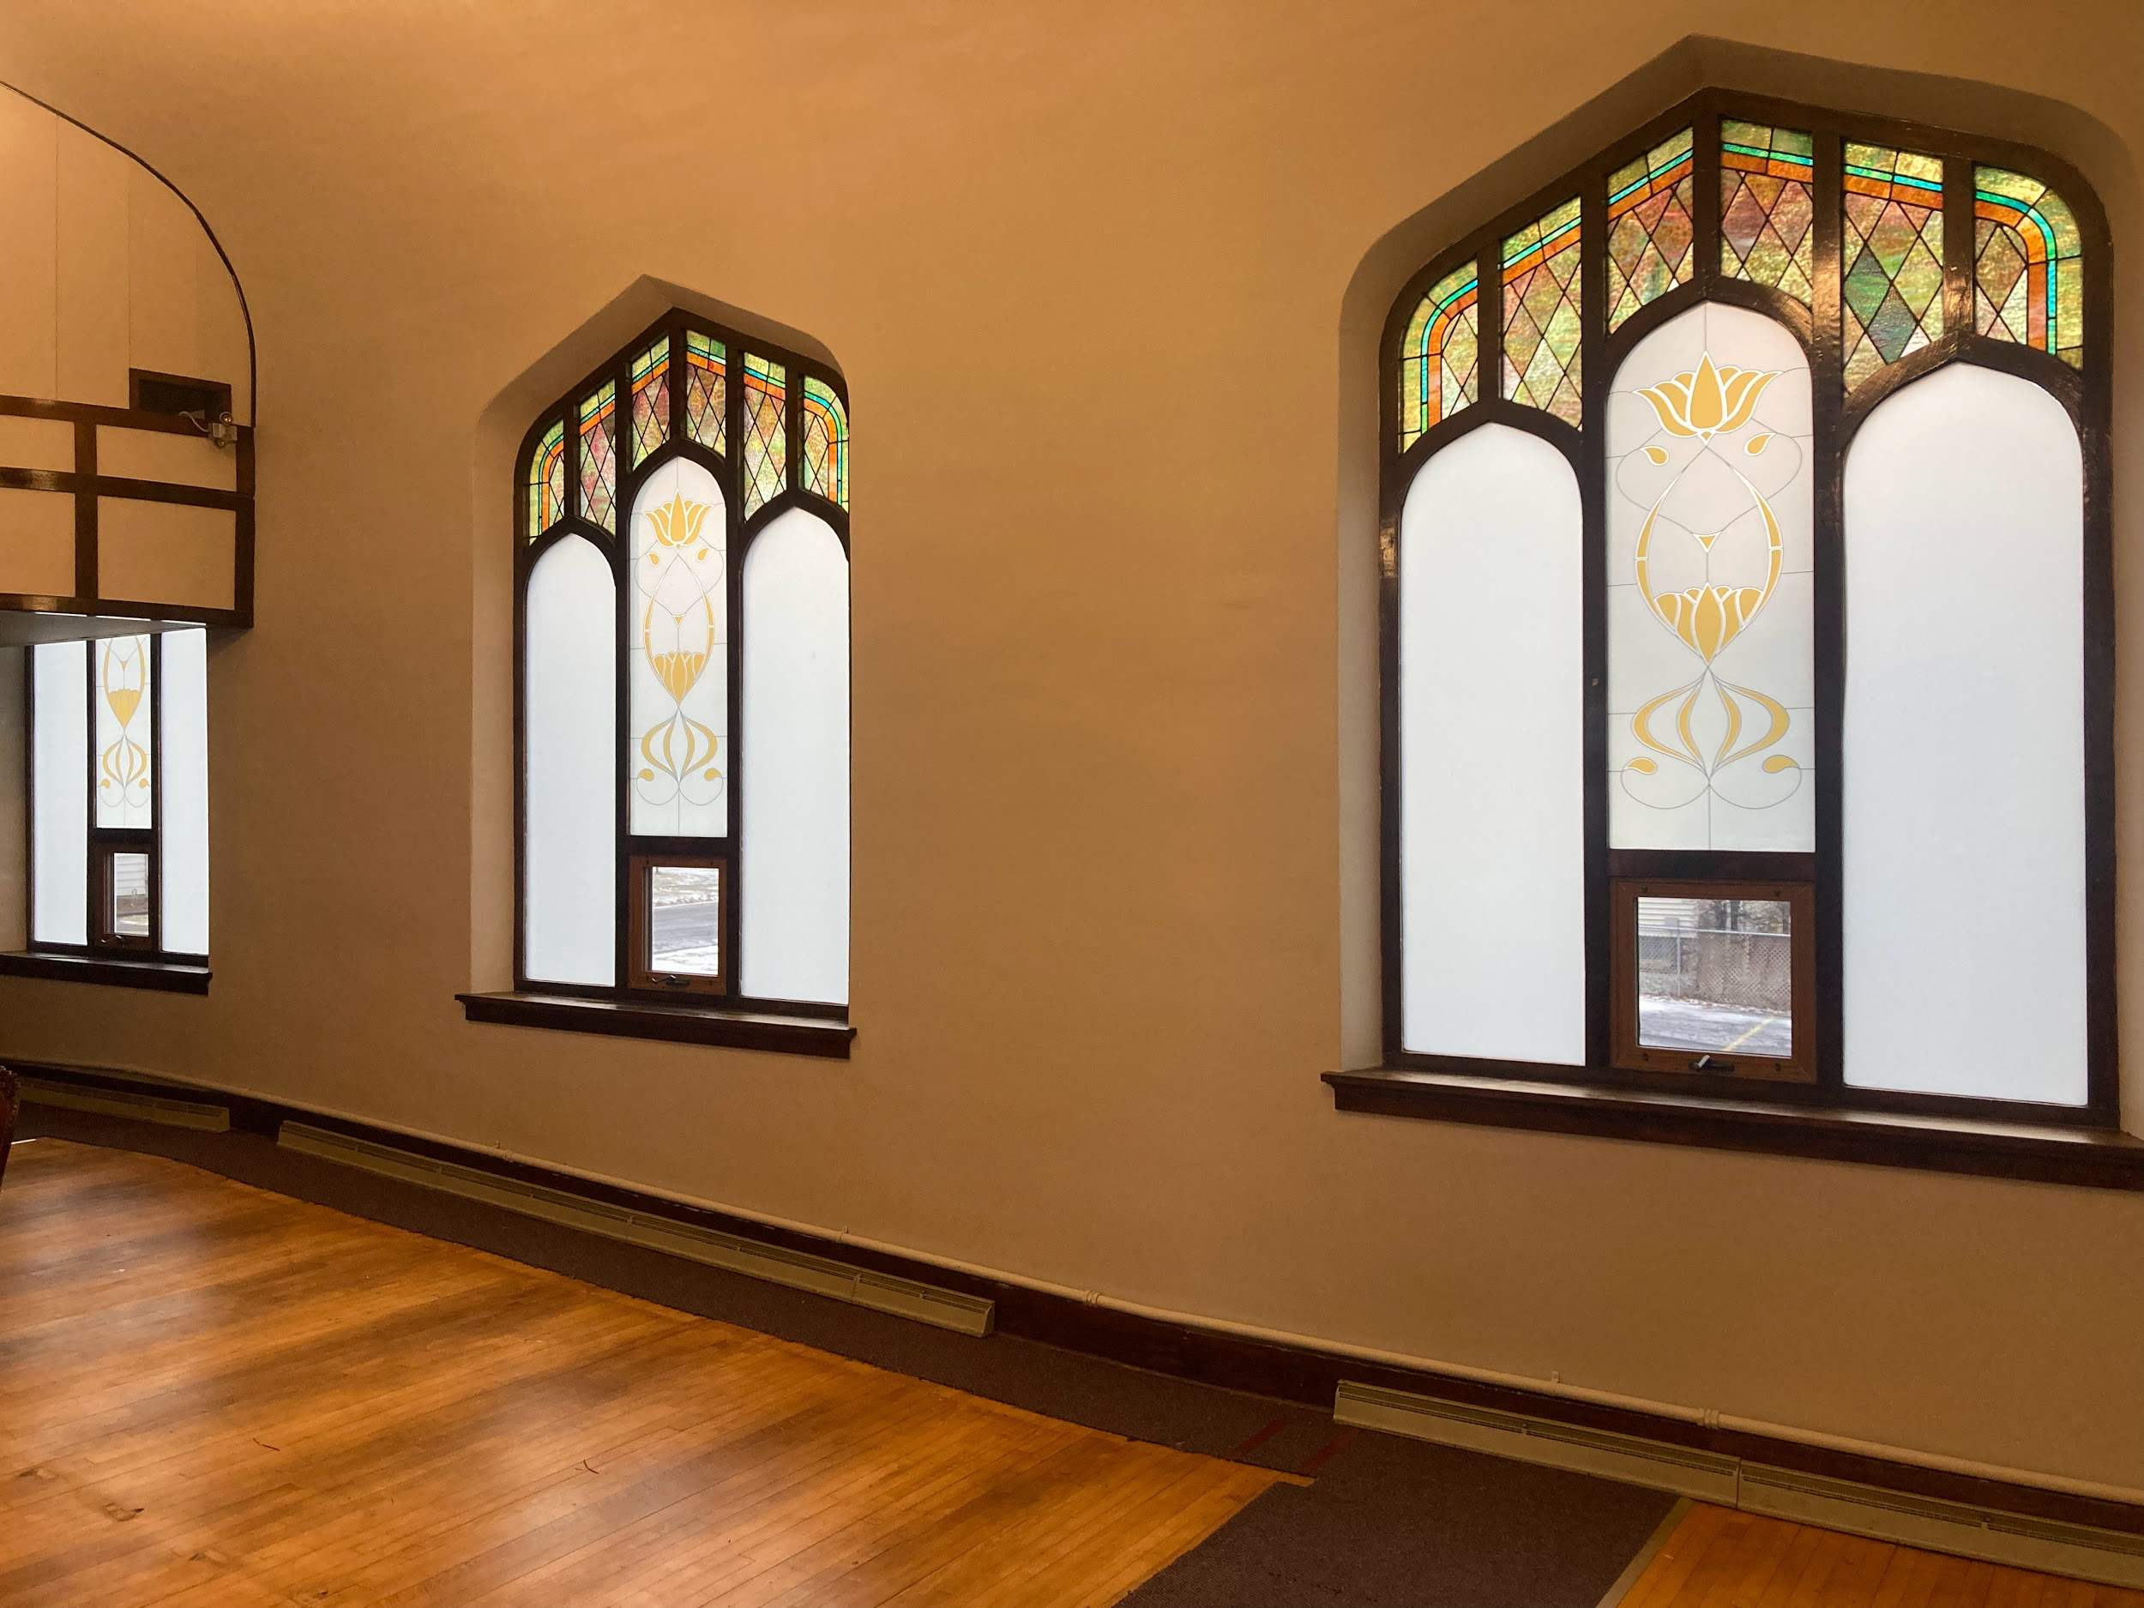
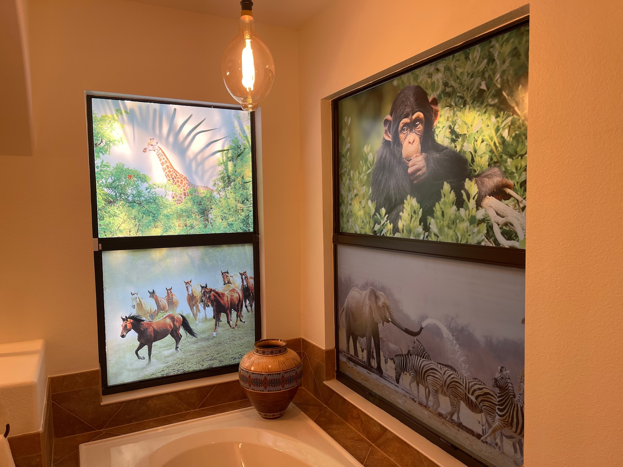
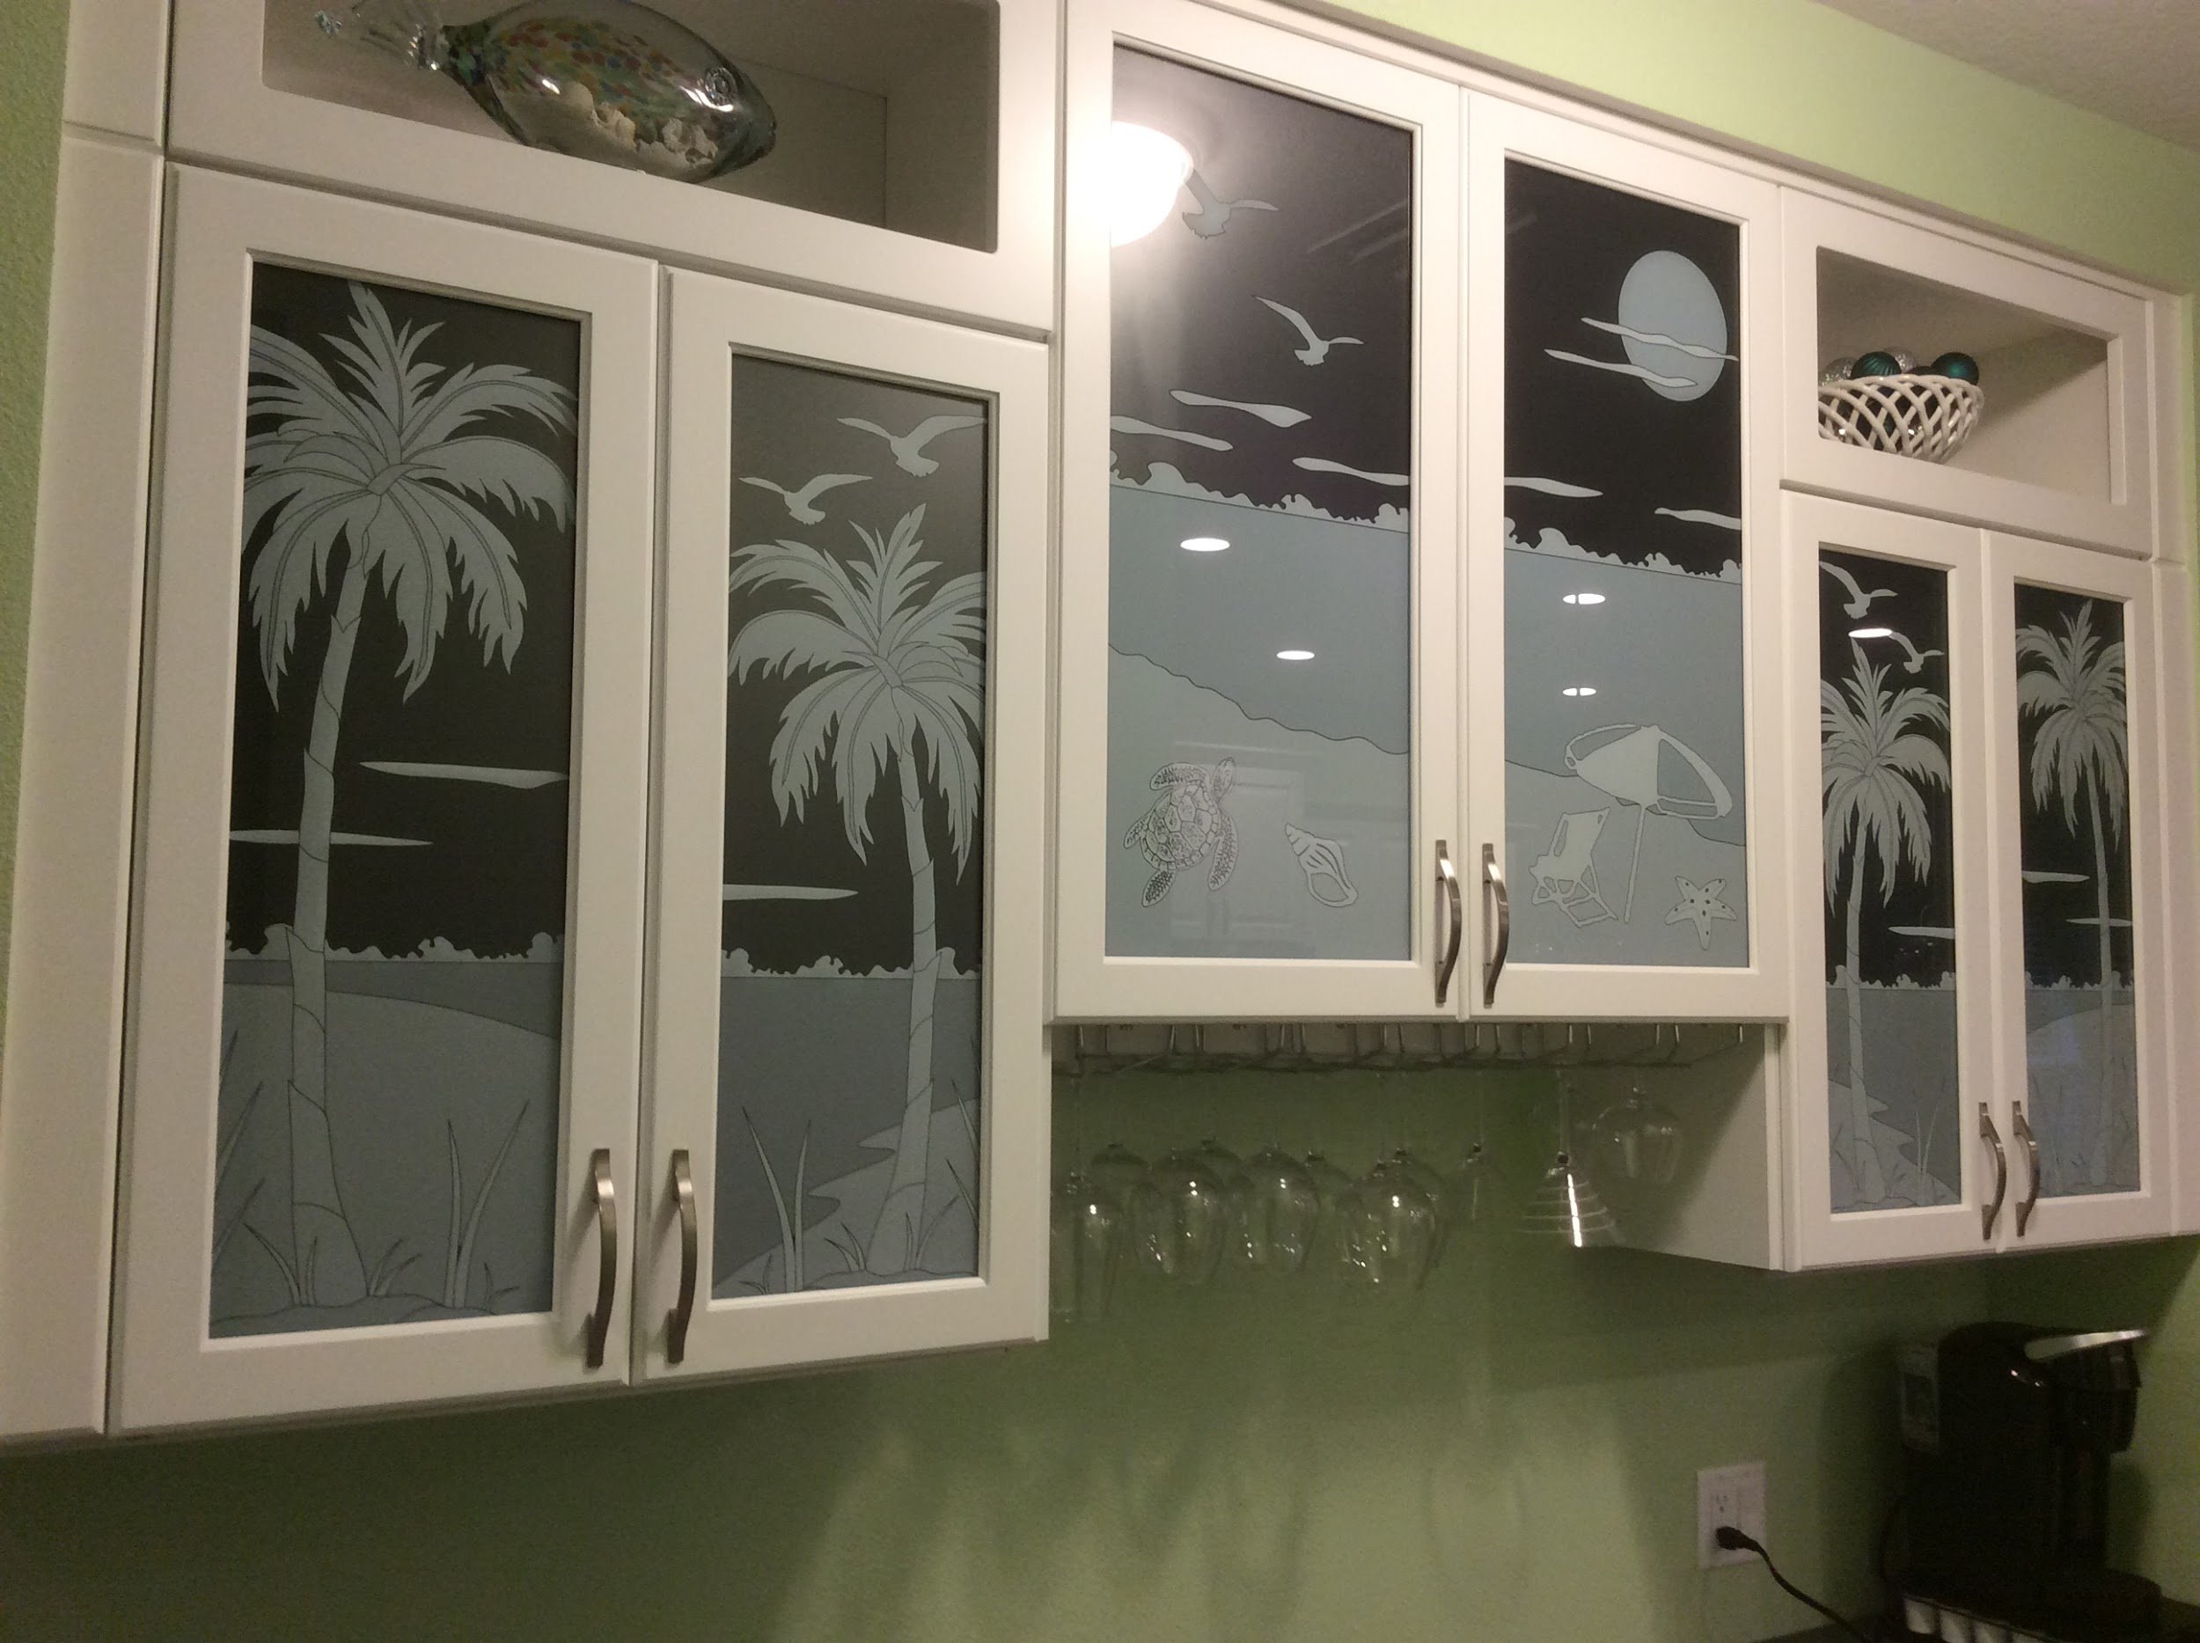
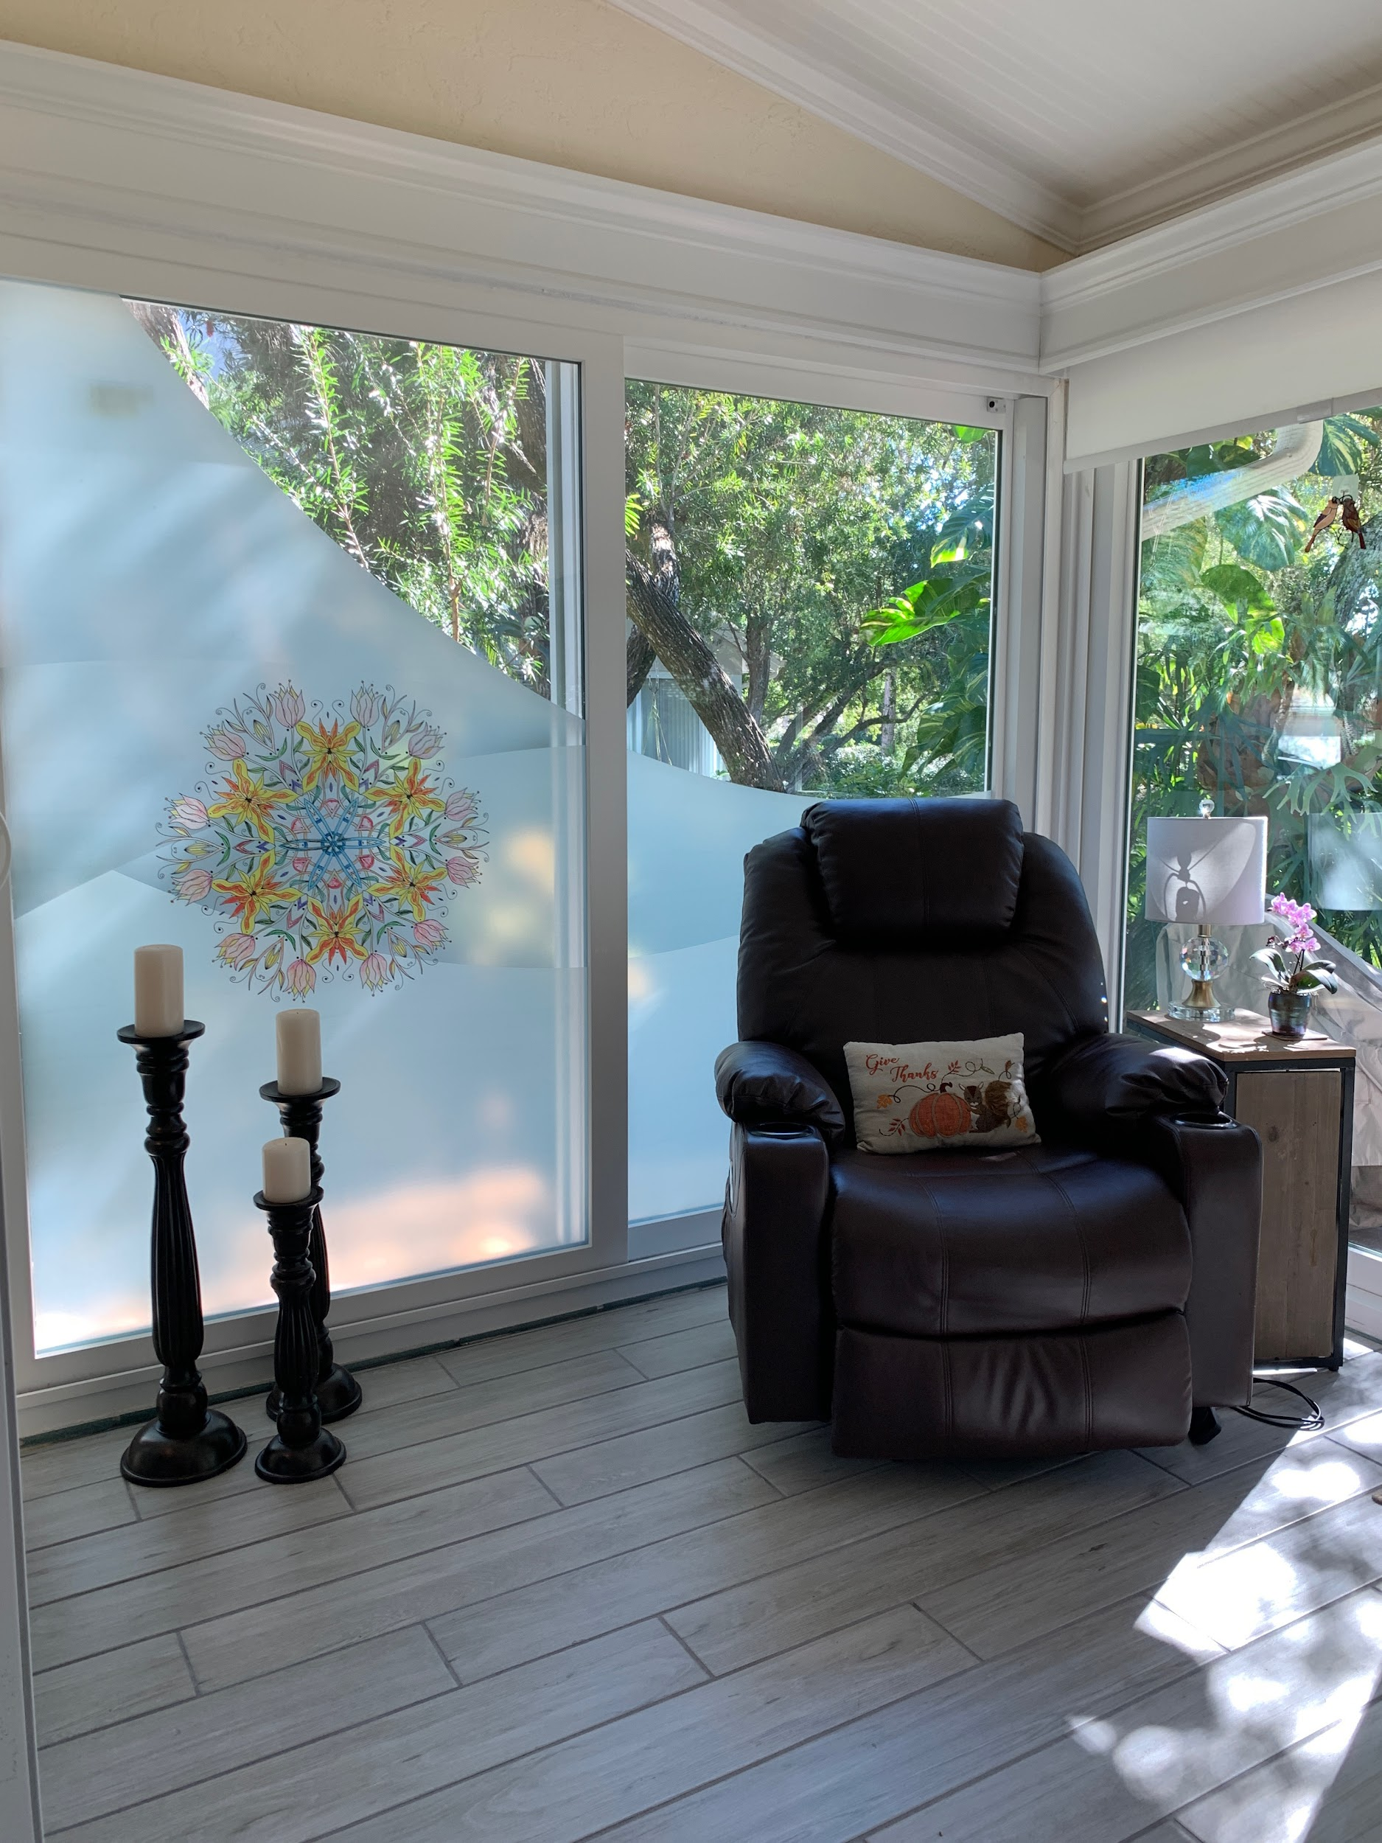

FEEL IT

In order for you to fully appreciate Art Glass Laminate, you need to see it and feel it. Like a glass insert but with a much better price point, better delivery time, and if you want, you can change it. Enjoy Design, Enrich Your Soul.

(blank square incorporated into design for real textured film placement) ->

LETS CONNECT

At Harmony Window Films and Graphics we strive to bring to our community new and exciting products. Art Glass Laminate is so exciting we look forward to showing it to you and working with you to make your project shine. We are just a phone call or email away.

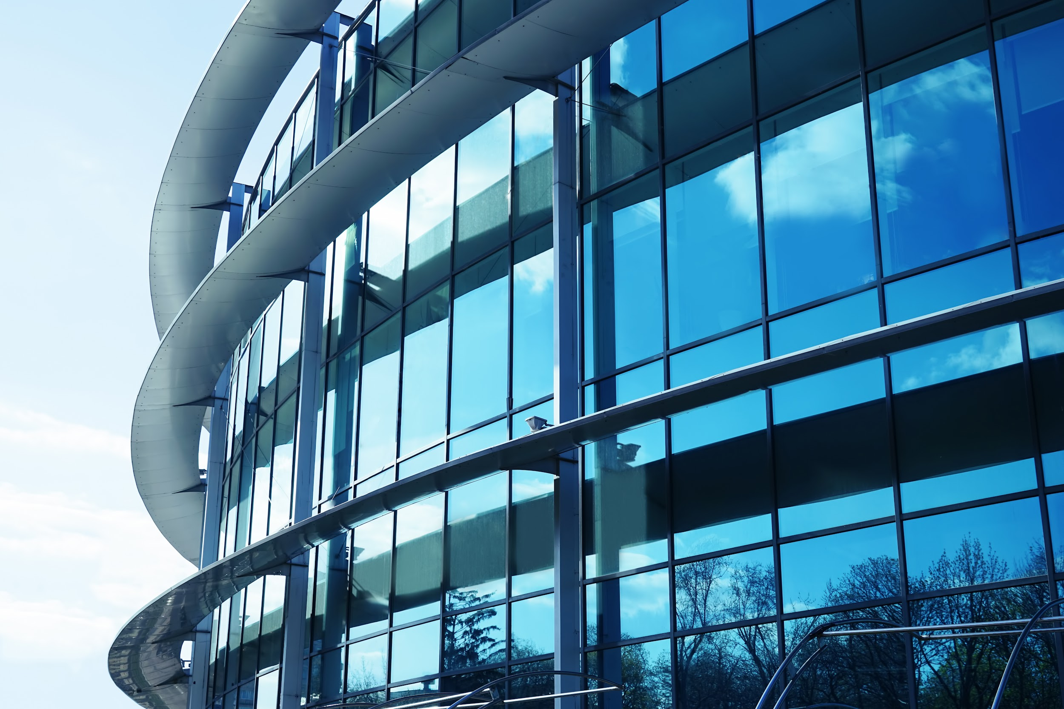

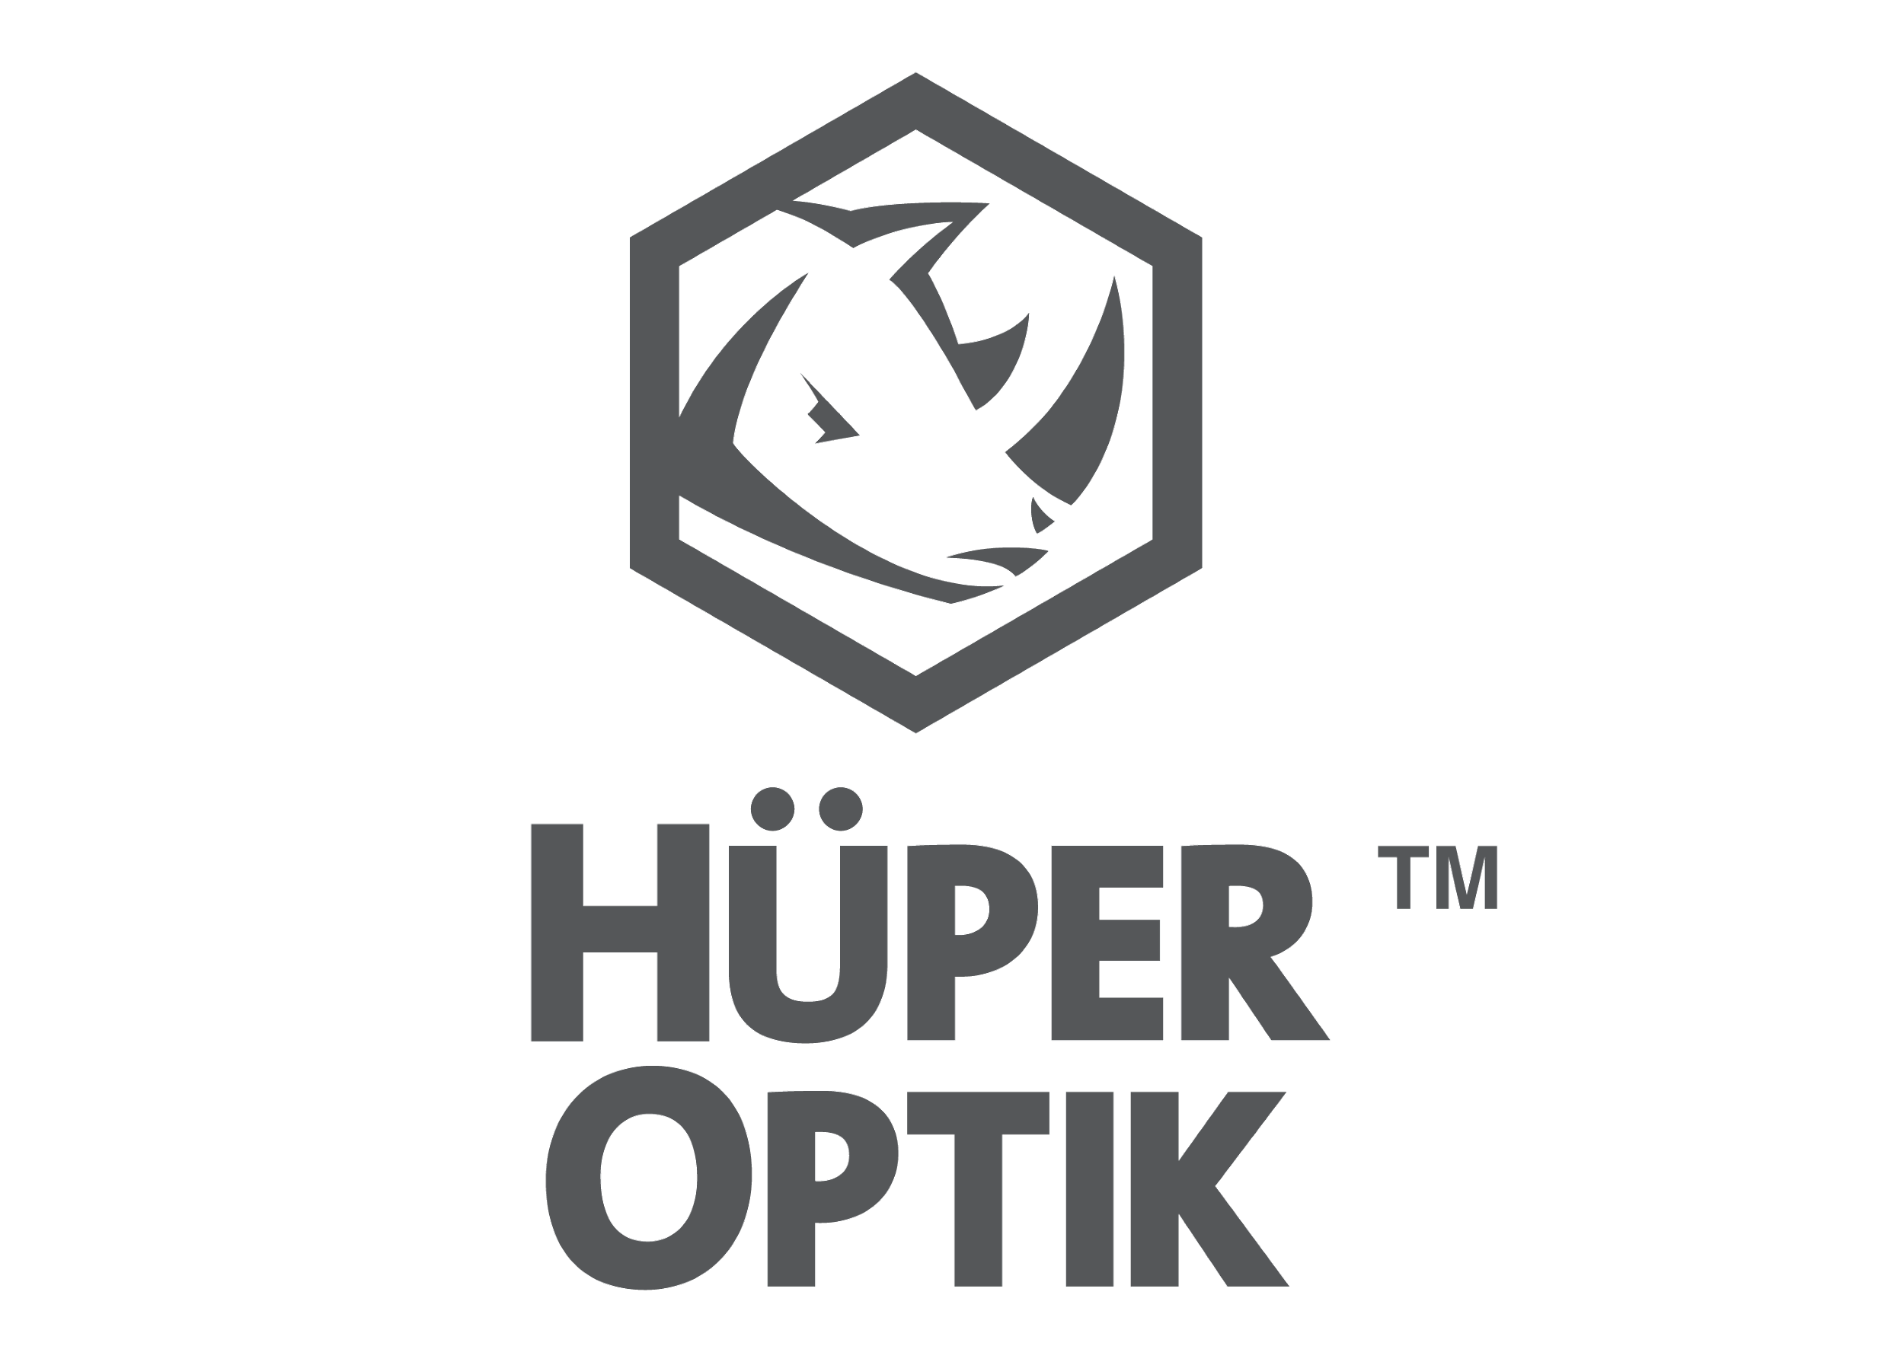
Residential/Commercial Window Films

Hüper Optik is the smarter choice for your architectural solar control needs. When you want to have comfort and UV Protection, paired with high performance and great aesthetics for your home, the choice is clear. Hüper Optik.

Hüper Optik nanotechnology architectural window films not only greatly reduce the amount of heat (solar energy) in your home, they also reject 99.9% of the sun’s ultraviolet rays. These ultraviolet rays are a significant cause of skin problems and fading of home interiors. While protecting valuable home furnishings, the nonreflective films have the added feature of low reflectivity at night so that the view is not obscured.

The layer of film also provides an additional level of safety by keeping glass fragments together in the event of accidental breakage.

Advantages of Hüper Optik

Rather than creating new problems for your
windows, Hüper Optik® films solve the existing
problems with heat, fading, energy consumption
and glare all with unsurpassed visual clarity.

• Preserves the natural view of windows, both day
and night
• Enhances overall aesthetics - no metallic or shiny
effects
• Provides a non-mirrored nighttime view
• Offers European luxury
• Reduces fading of furniture and interior
upholstery
• Blocks more than 99.9% UV light rays - the main
cause of fading
• Reduces distracting glare while increasing
comfort
• Uses advanced German technology*
• Rejects up to 98% infrared light rays** - the main
cause of heat
• Increases energy efficiency - reducing utility bills
• Increases impact protection - helps to hold
shattered glass together
• Utilizes world's only patented nano-ceramic
technology*
• Residential limited lifetime and commercial
fifteen-year limited product warranties
*Ceramic Series only
**Depending on the Hüper Optik® Smart Film selected.

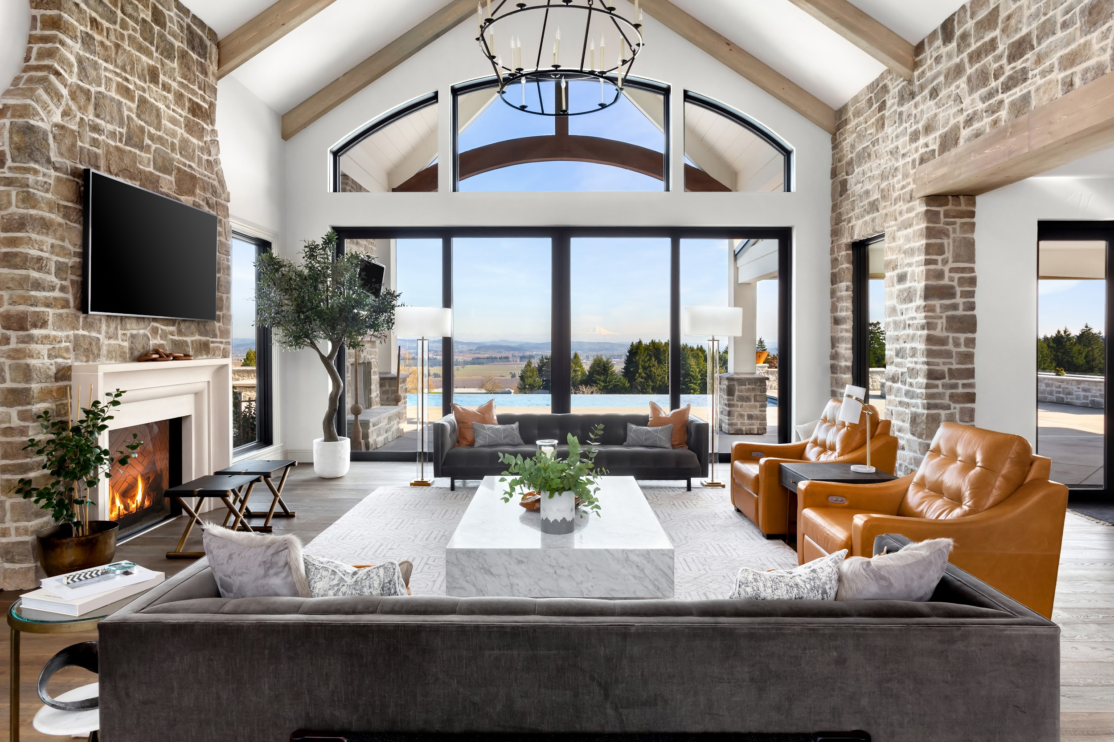
Select Series AVAILABLE FOR: AUTOMOTIVE, COMMERCIAL, RESIDENTIAL

The highest performing, non-reflective film in the world.
Hüper Optik® Select films provide maximum protection with unrivaled high heat rejection performance for your home. Due to the films' spectral selectivity, visibility is not compromised. These films help prevent hot spots, reject damaging infrared rays that cause heat and the ultraviolet light rays that cause fading, all without significantly reducing visible light entering through the glass.
Hüper Optik® Select films are also 100% dye/pigment-free and will not fade over time. Unlike conventional hybrid metallized films that use dyed polyester layers or apply dye in adhesives to tone down the metallic look, Hüper Optik® Select films offer a neutral, soft tone that does not appear metallic or shiny.

- Residential limited lifetime and commercial fifteen-year limited warranty
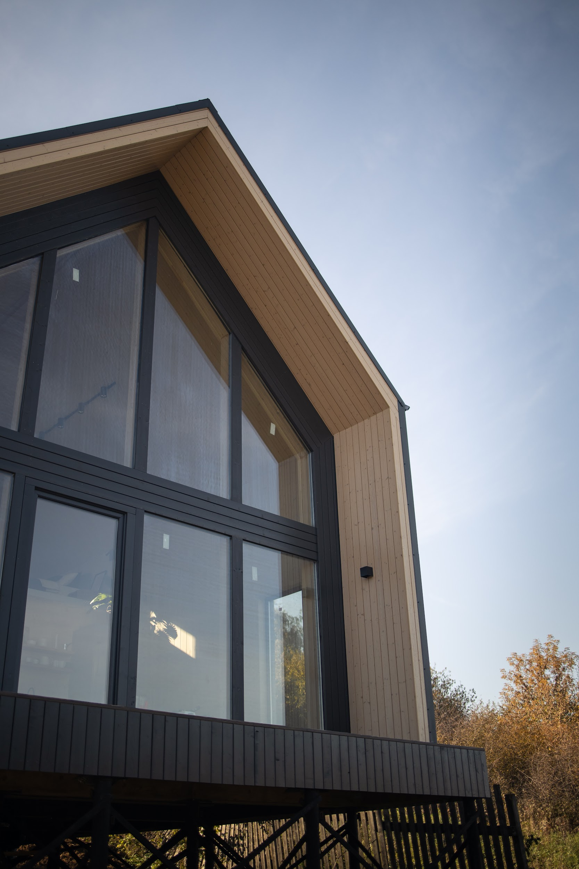

Ceramic Series AVAILABLE FOR: AUTOMOTIVE, COMMERCIAL, MARINE, RESIDENTIAL
Dual-Layered Nano-Ceramic Technology Window Film
Hüper Optik® Ceramic Films utilize German technology to create the world’s first nano-ceramic solar control films. Ceramic films are 100% metal-free, 100% dye-free and will not demetalize or fade. Unlike dyed or metallic films, Hüper Optik®‘s spectrally tuned ceramic films offer superb heat rejection properties without compromising visibility, have low reflectivity and do not appear shiny. This patented technology, unique to Hüper Optik®, enables our films to easily outperform all conventional dyed, metallic and power-coated films available today, while maintaining a clear view.

Ceramic Series benefits:
- Rejects up to 70% of Total Solar Energy
- Helps reduce the effects of fading by blocking 99.9% of UV rays
- No discoloration for the life of the product
- Residential limited lifetime and commercial fifteen-year limited warranty
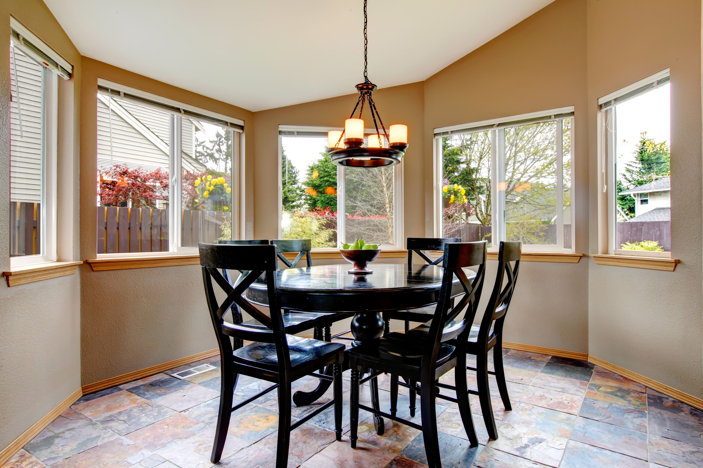

Therm-X Series AVAILABLE FOR: COMMERCIAL, RESIDENTIAL
A thermal barrier for energy efficiency.
Hüper Optik Therm-X Films use a proprietary blend of metals to create the highest performance films in their class while allowing a high amount of visible light. The Therm-X technologies create a more comfortable environment while reducing HVAC consumption. These technologies provide privacy, high heat rejection, high light transmission and great return on investment, while providing a 15 year commercial and lifetime residential warranty that will give you peace of mind.
Therm-X Series Benefits:
- Higher performance of existing glass
- High light transmission ratios for natural light
- Great return on investment

Fusion Series AVAILABLE FOR: COMMERCIAL, RESIDENTIAL
A fusion of green technology and energy efficiency.
Hüper Optik Fusion Films use a fusion of technologies of performance, aesthetics, neutral tones, and sustainability: providing the advantages of affordability and high heat rejection. Fusion Films deliver privacy, comfort and energy efficiency year round: reducing high energy bills, preventing temperature variances and hot spots, and rejecting infrared and ultraviolet light rays.
Fusion Series Benefits:
- Delivers high energy saving performance
- Protects against glare and fading
- Reduces energy loads by rejecting 77% of solar energy

Traditional Series AVAILABLE FOR: COMMERCIAL, RESIDENTIAL
High energy saving performance.
Hüper Optik Traditional series films provide energy-saving performance for commercial and residential consumers looking for reflective film properties. The Hüper Optik USA family of products includes a premier line of dual reflective films featuring energy-saving performance, a truly reflective surface, with silver and bronze products to address the aesthetic concerns of commercial environments. Put our Reflective Options series to work on your commercial buildings and realize excellent heat, glare and fade reduction. Hüper Optik’s Fusion films are manufactured using proprietary materials and contain a special adhesive formulated with ultraviolet screeners and stabilizers.
Reflective options by Hüper Optik helps make work environments more comfortable, enhances building’s appearance, increases optical clarity, and increases HVAC efficiency in commercial settings. All professionally installed Hüper Optik traditional reflective films are warranted against the following for 15 years in commercial applications:
• Bubbling
• Delamination
• Peeling
• Rippling
• Adhesive Failure
• and more

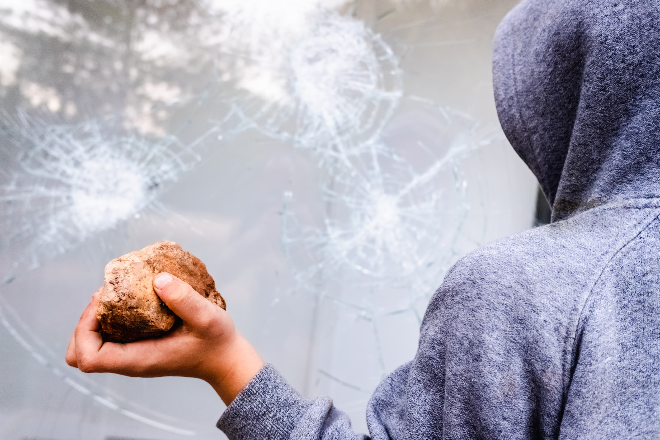

Shield Series AVAILABLE FOR: SECURITY
Hüper Optik Shield Window Films provide protection, well being, and comfort from the uncertain. They may provide protection in the event of Natural Disasters, Storms, explosions, vandalism, burglary and glass breakage. Security films provide protection and are designed to absorb the energy from wind, flying debris, intruders and shock wave. They will provide protection against flying shards of glass from the broken window and protect the occupants inside the building.
Smash and Grab Protection
With Hüper Optik Shield Film, burglars are deterred because as the glass breaks, a “spider web” of broken glass forms that will not permit the perpetrator to enter through the window, slowing down and even stopping their burglary efforts.
Storm protection
Hüper Optik Shield films provide protection and help prevent shattering or flying glass pieces by holding the glass together.
Blast protection
Hüper Optik Shield Film provides a protective shell to glass that may be the only thing between you and harm’s way. Once the glass has been breached, a “spider web” of broken glass forms. However, the films which range anywhere from 4mil to 14mil will not permit the blast or debris to penetrate the glass.
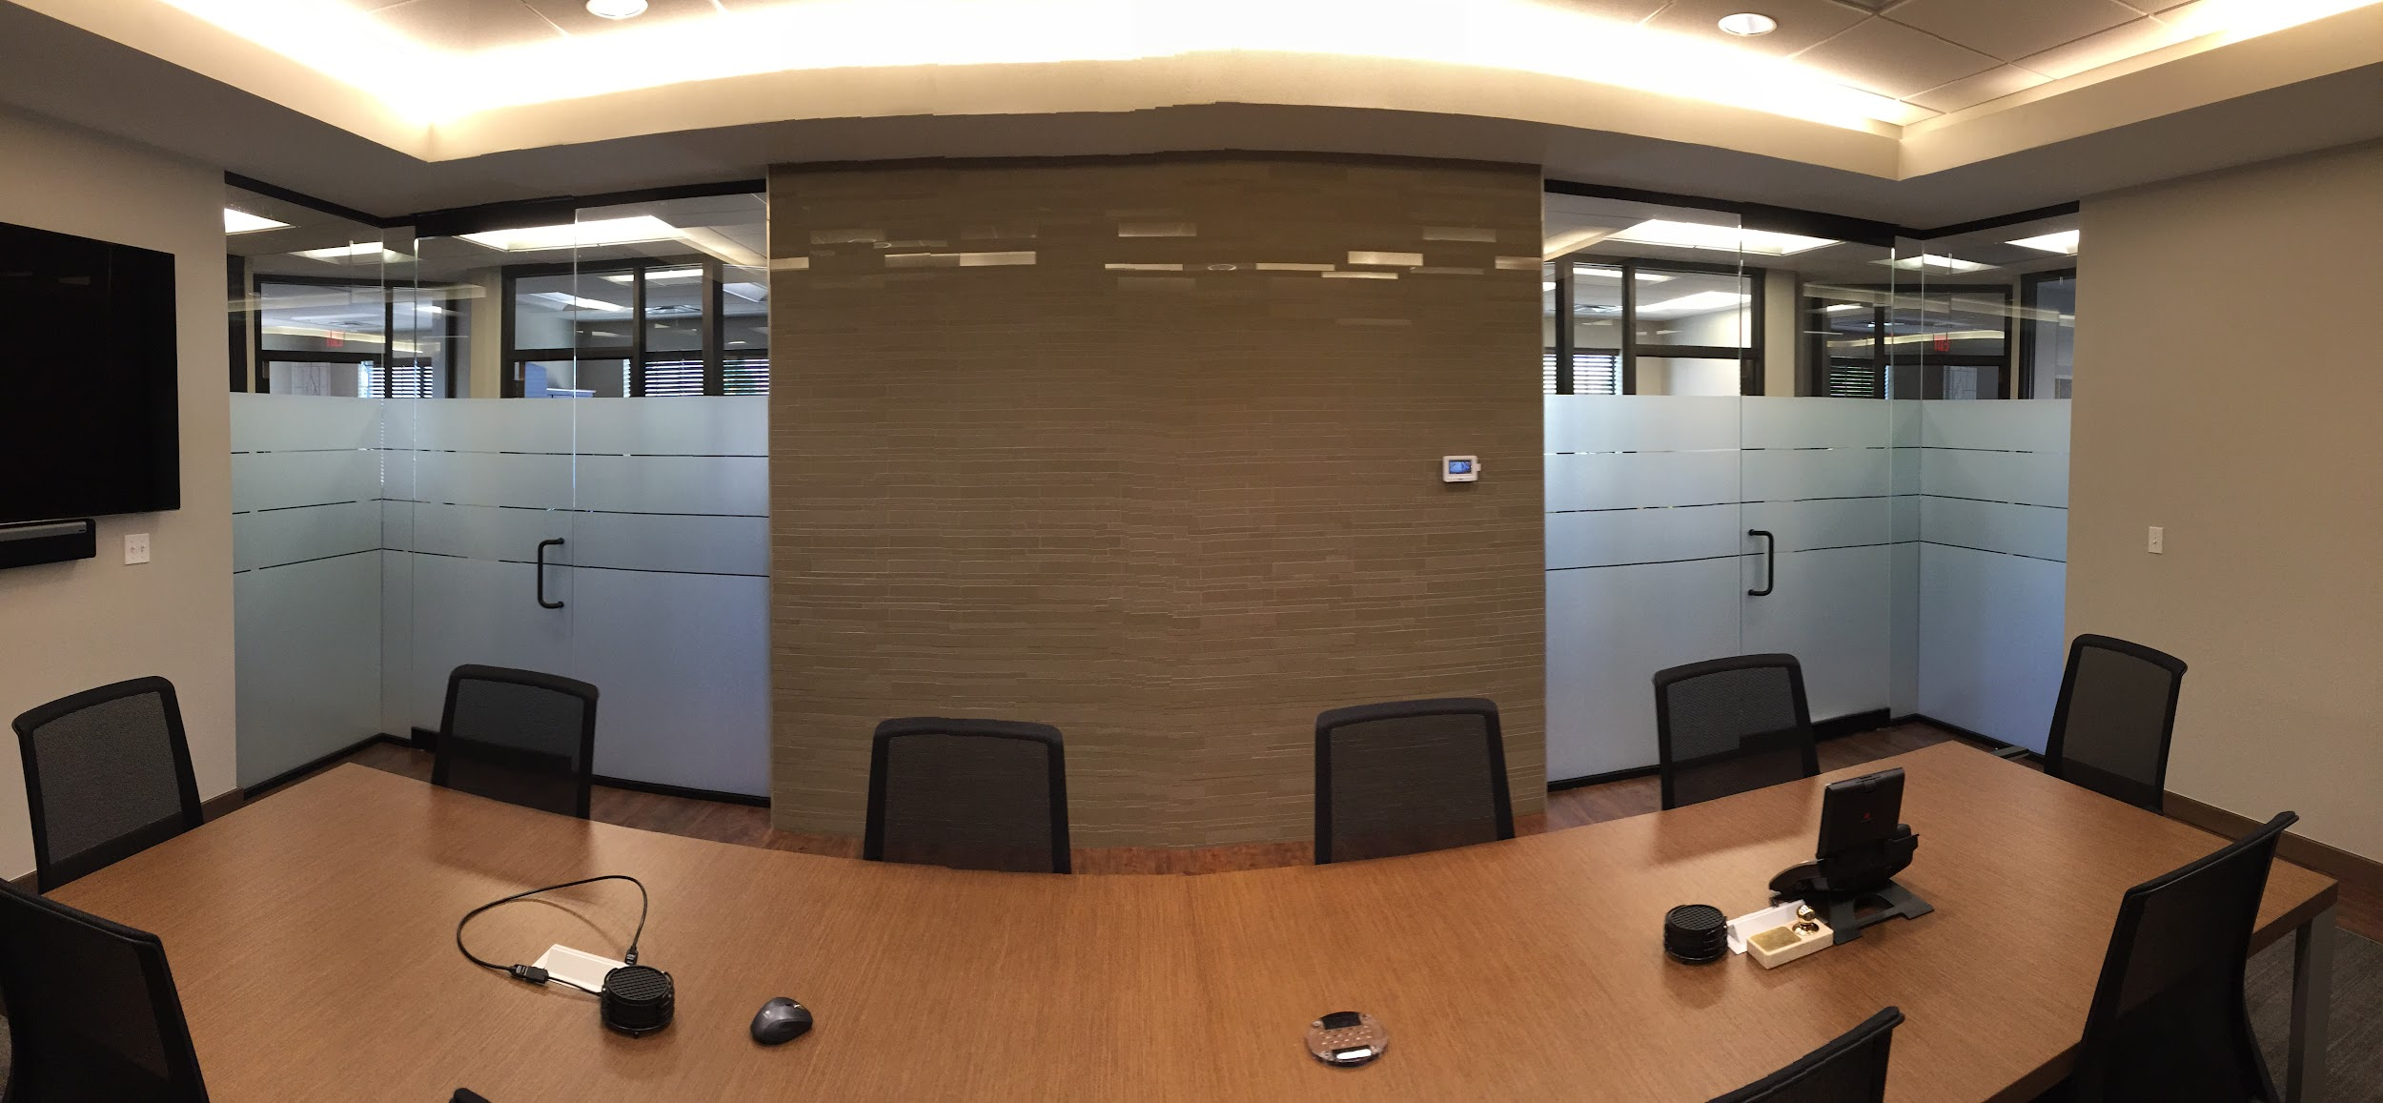

Dekorativ Series AVAILABLE FOR: COMMERCIAL, DECORATIVE, RESIDENTIAL
Hüper Optik Dekorativ films can provide your home or office a fresh and amazing new look and feel to your environment. These films are made from a polyester based material that mirrors the appearance of etched glass. Huper Optik Dekorativ films applied to your entry doors, bathroom doors and windows, office glass, restaurant, hospitality or healthcare glass for privacy and/or decoration can make a significant difference in ambiance, and look for your commercial or home environment.

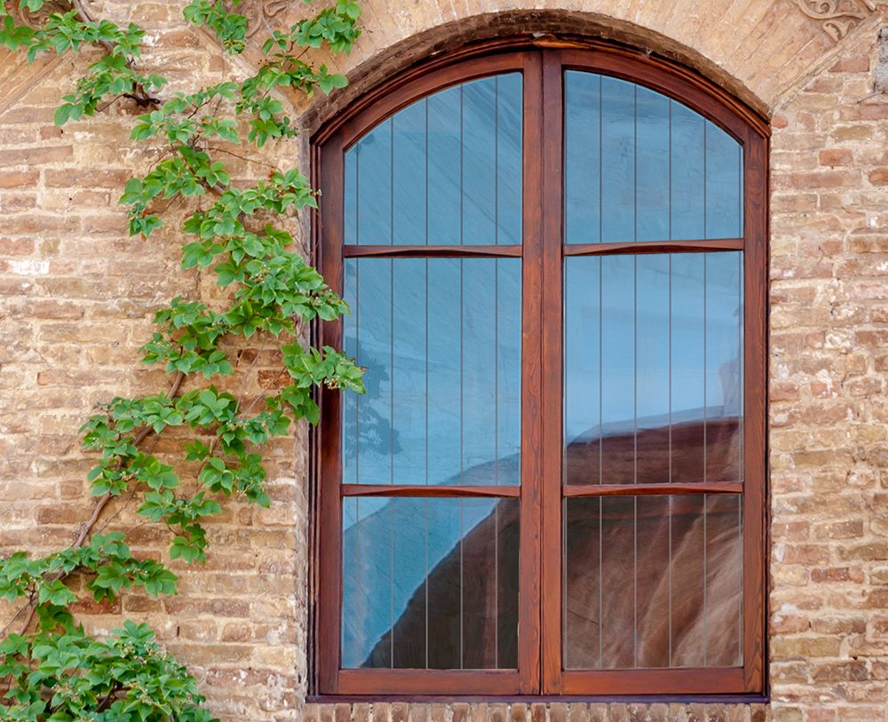
Solyx Bird Safety Film
Solyx Bird Safety film is designed to deter birds from flying into reflective glass, thus suffering an injury or death and causing potential damage to property. Our Bird Deterrent film is the best way to stop birds from flying into windows once and for all. Bird strikes are a common problem today in residences and our Bird Strike films have been shown to help control birds from hitting windows
The hard truth is birds colliding into windows cause nearly 1 billion deaths/injuries each year to these beautiful animals. If you are a bird lover, or simply want to find a solution to birds flying into your windows ask us about Bird safety film. Solyx Films currently come in 6 different pattern options to meet the visual needs of clients.

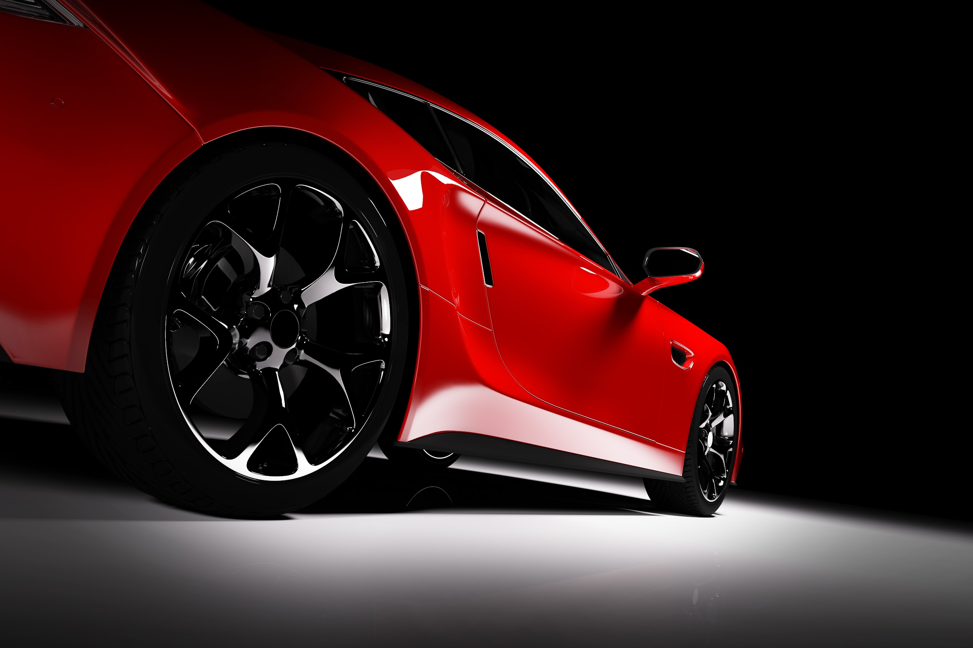
Automotive Window Films

At Harmony Window Films and Graphics we pride ourselves in working with the industry leading film provider Autobahn. Not only do they offer high quality durable films with amazing performance qualities. Autobahns products are backed by their second to none warranty that offers clients a one time no fault replacement!
(Autobahn logo )

BLACK
Blending Aesthetics & Performance
The autobahn Black line offers a sophisticated style through a blend of aesthetics and value in mind. Black is a color-stable deep-dyed film – second to none in color stable dye technology on the market.
Of course Black also causes no interference with radio frequencies or electronic control systems.
- Total Solar Energy Rejected 43%
- Ultraviolet Rejection 99%

BLACK CERAMIC
Nano-Ceramic Technology
Built on proven nano-ceramic dispersion technology, autobahn Black Ceramic offers virtually no low-angle haze present in some other ‘large particle’ dispersion films as well as contains a blend of type and size of ceramics that provide broad-spectrum infrared rejection rather than a simple technology that may have high infrared rejection but only within a narrow bandwidth.
- Total Solar Energy Rejected 63%
- Infrared Rejection 60%
- Ultraviolet Rejection 99%

AIR CERAMIC
Maximum Clarity and Visibility
With the addition of autobahn Air Ceramic, you may now have the high light transmission, low reflectivity, and high heat rejection you need in certain circumstances within the industry-best warranty by autobahn.
While being virtually clear when applied on glass, autobahn Air Ceramic 80 nano-ceramic technology eliminates nearly all UV radiation and almost half of the Total Solar Energy!
- Total Solar Energy Rejected 44%
- Infrared Rejection 68%
- Ultraviolet Rejection99%

CERAMIC i3
Perfect Blend of Performance, Durability, & Clarity

The latest innovation in Nano-Ceramic Technology! i3 Ceramic provides excellent heat rejection, color, and clarity.
i3 Ceramic is a multi-layer Ceramic and is backed by autobahn’s™ lifetime No-Hassle Warranty.
- Total Solar Energy Rejected 71%
- Infrared Rejection 93%
- Ultraviolet Rejection 99%

“NO HASSLE” Lifetime Warranty:
Autobahn™ Performance Films, (the Product) is sold with a limited lifetime warranty backed by the Film Manufacturer against discoloration, cracking or crazing, blistering, bubbling, peeling, demetalizing and delamination when installed by an authorized autobahn™ Dealer. In the event the Product is found to be defective as covered under the warranty conditions it will be replaced at no charge to the vehicle owner by an authorized autobahn™ Dealer. It is the responsibility of the vehicle owner to provide the vehicle at his/her expense to the facility of the authorized Dealer. The Warranty Card and proof of purchase showing the type of film and date of purchase must be presented to the Dealer to obtain service. Autobahn™ products are to be used in compliance with all applicable state laws in which the vehicle is registered. Window film installed illegally is not covered by warranty for any reason. It is the sole responsibility of the vehicle owner to ensure the film is in compliance with all state or provincial laws should vehicle registration location change at any time. The Dealer and autobahn LLC disclaims all other warranties expressed or implied including without limitation, any warranty of merchantability, quality or fitness for any purpose whatsoever other than described herein.

No Fault Warranty:
If you are the original purchaser of this autobahn window film installation, and should ever experience any accidental damage to your autobahn window film, you may exercise your one time ‘No Fault’ warranty option. If for any reason you should need to replace damaged window film, contact your local authorized autobahn Dealer for service, or call the toll free number on this card for a Dealer nearest you. This warranty entitles the original autobahn purchaser up to $75.00 retail value towards the replacement of one damaged window. Any costs in excess of $75.00 will be the responsibility of the vehicle owner.

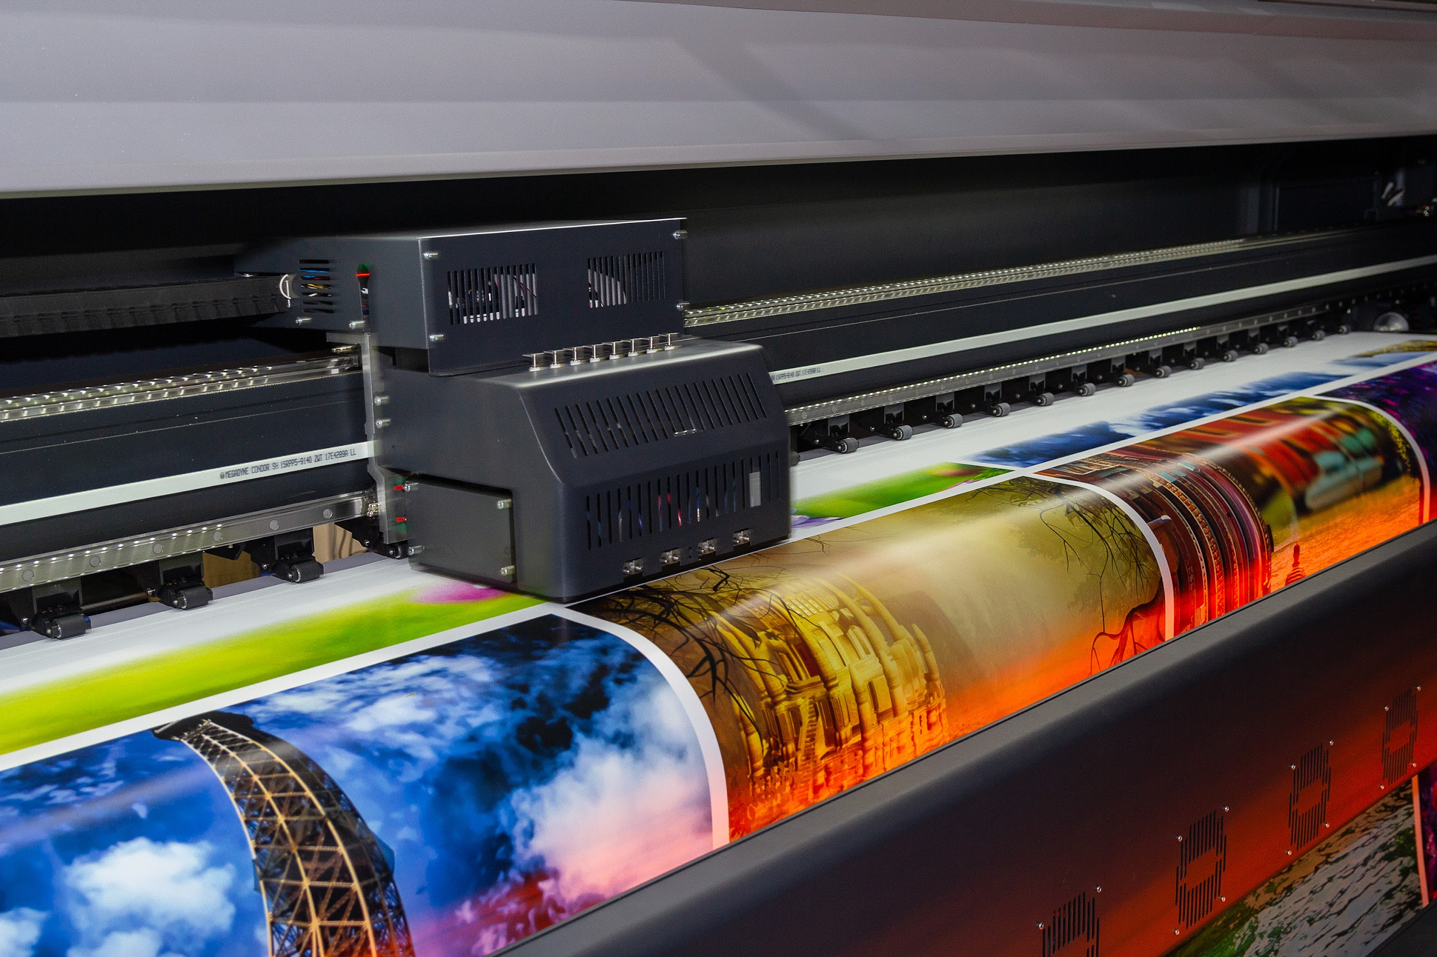

Commercial Graphics Installation

We have specialized in commercial graphic installation for over 6 years. Our lead installer is a 3m preferred installer, with a very high standard of quality to ensure your wraps last. Branding your business can be done in several ways. From wrapping your fleet vehicles to laying graphics on the windows, walls, or floors of your facilities.

Fleet Wraps
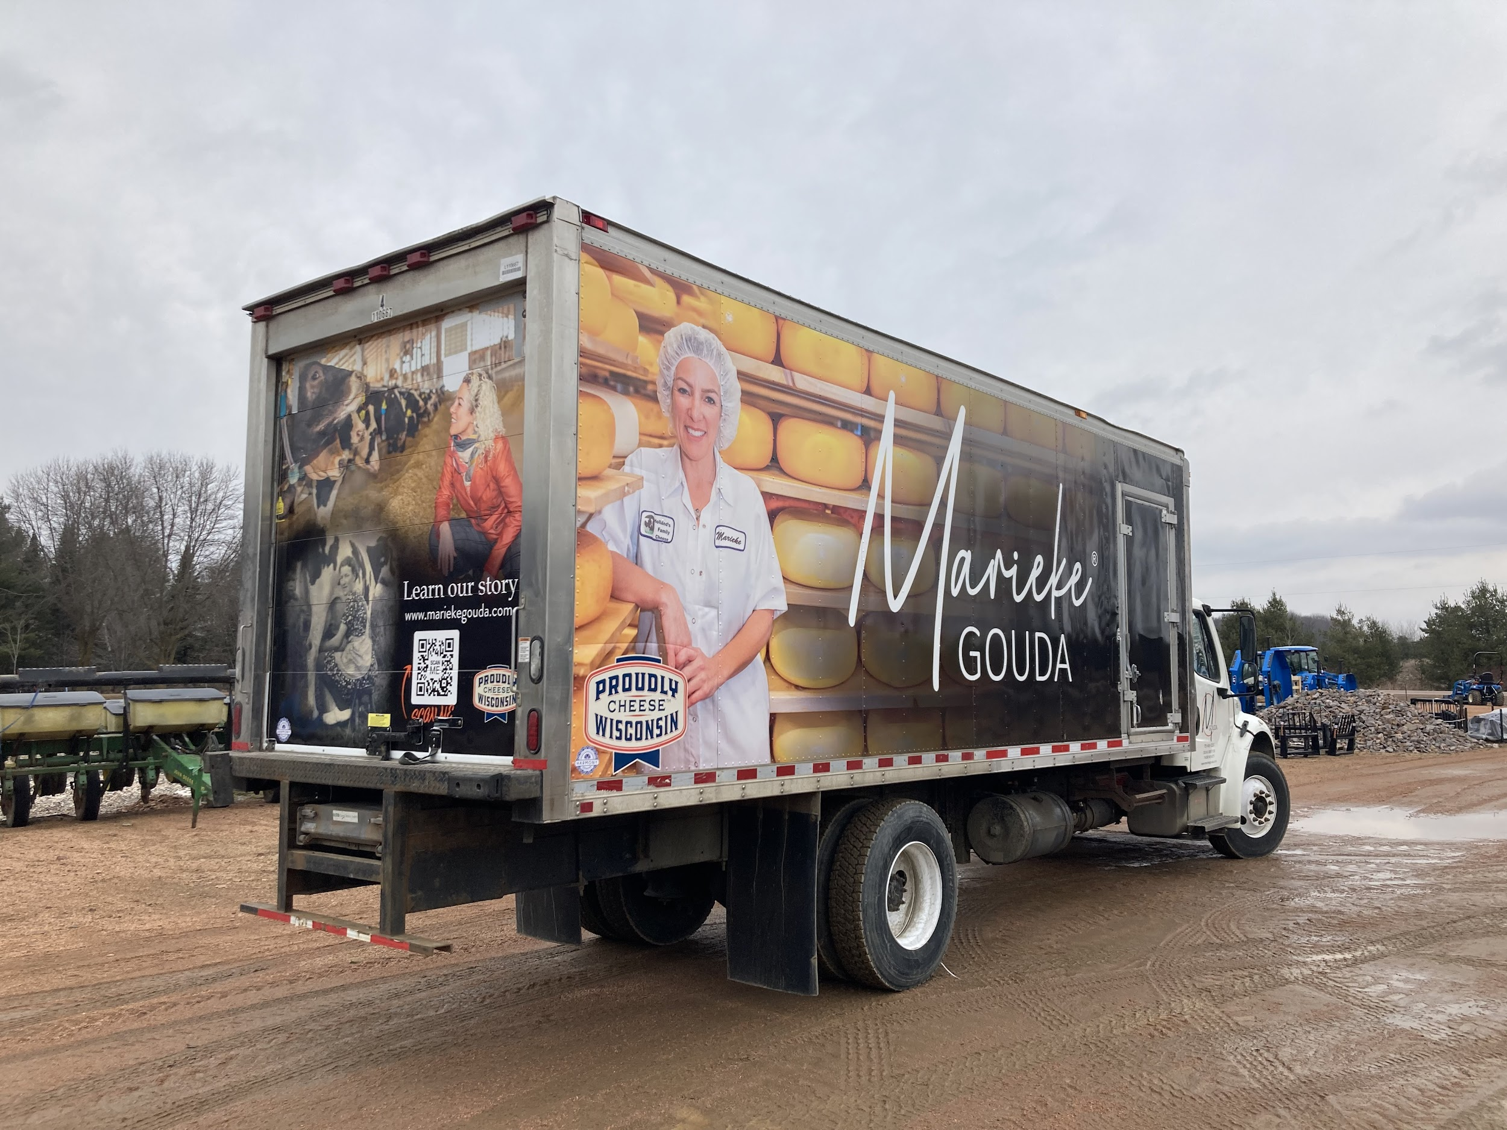
Wrapping your fleet vehicles are by far one the best marketing investments you can make for your business. The number of impressions you can make on a daily basis are second to none.
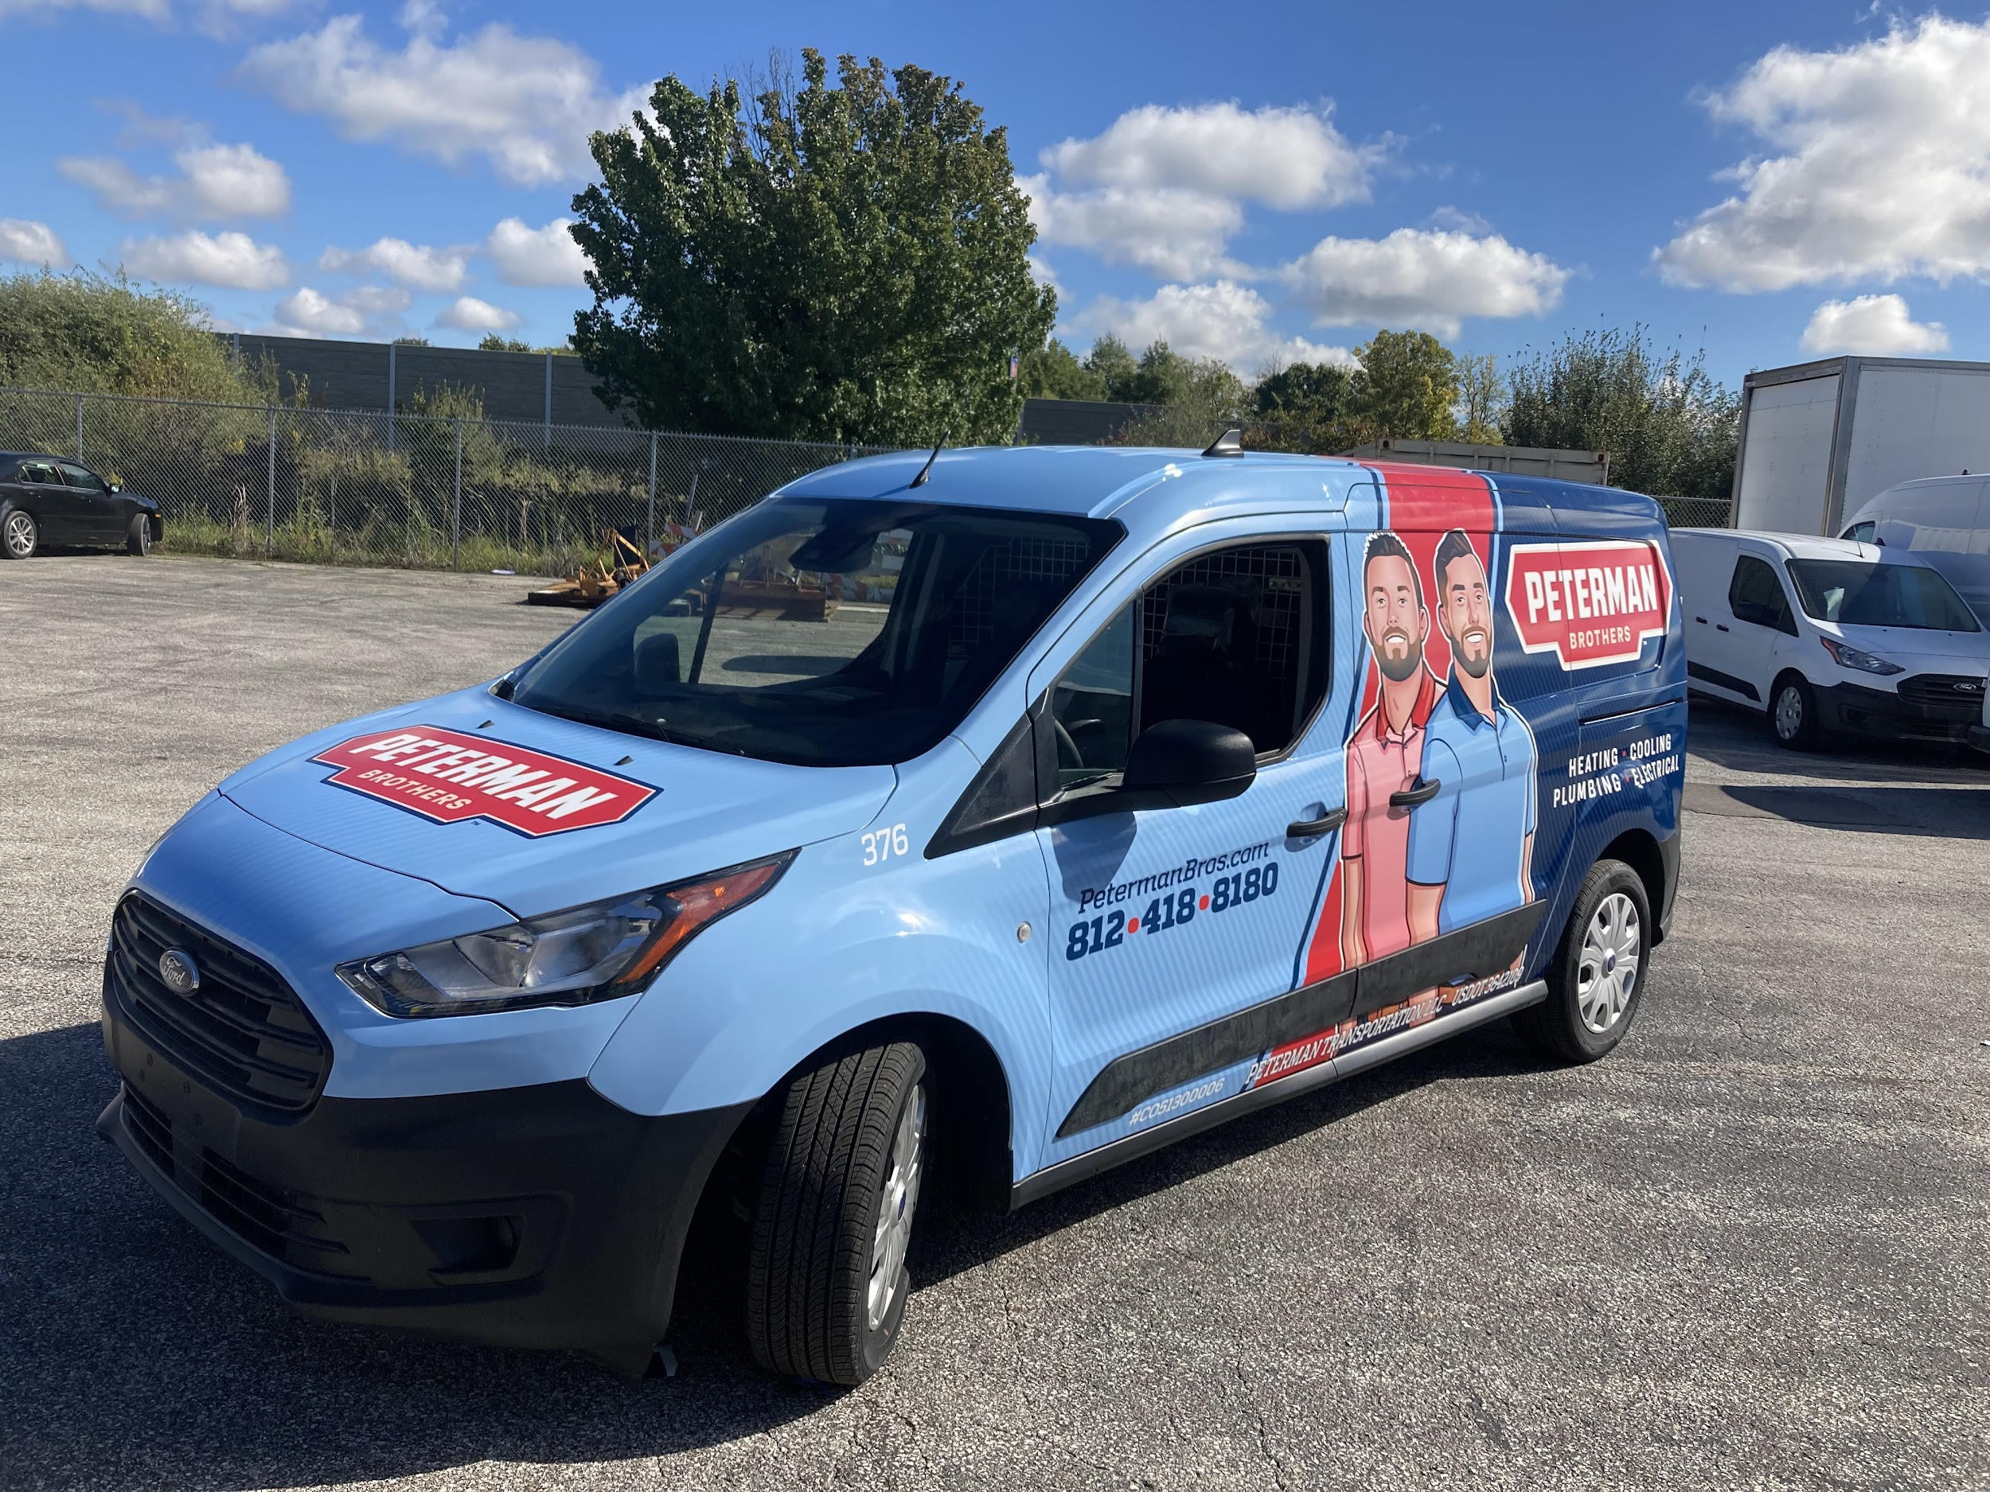
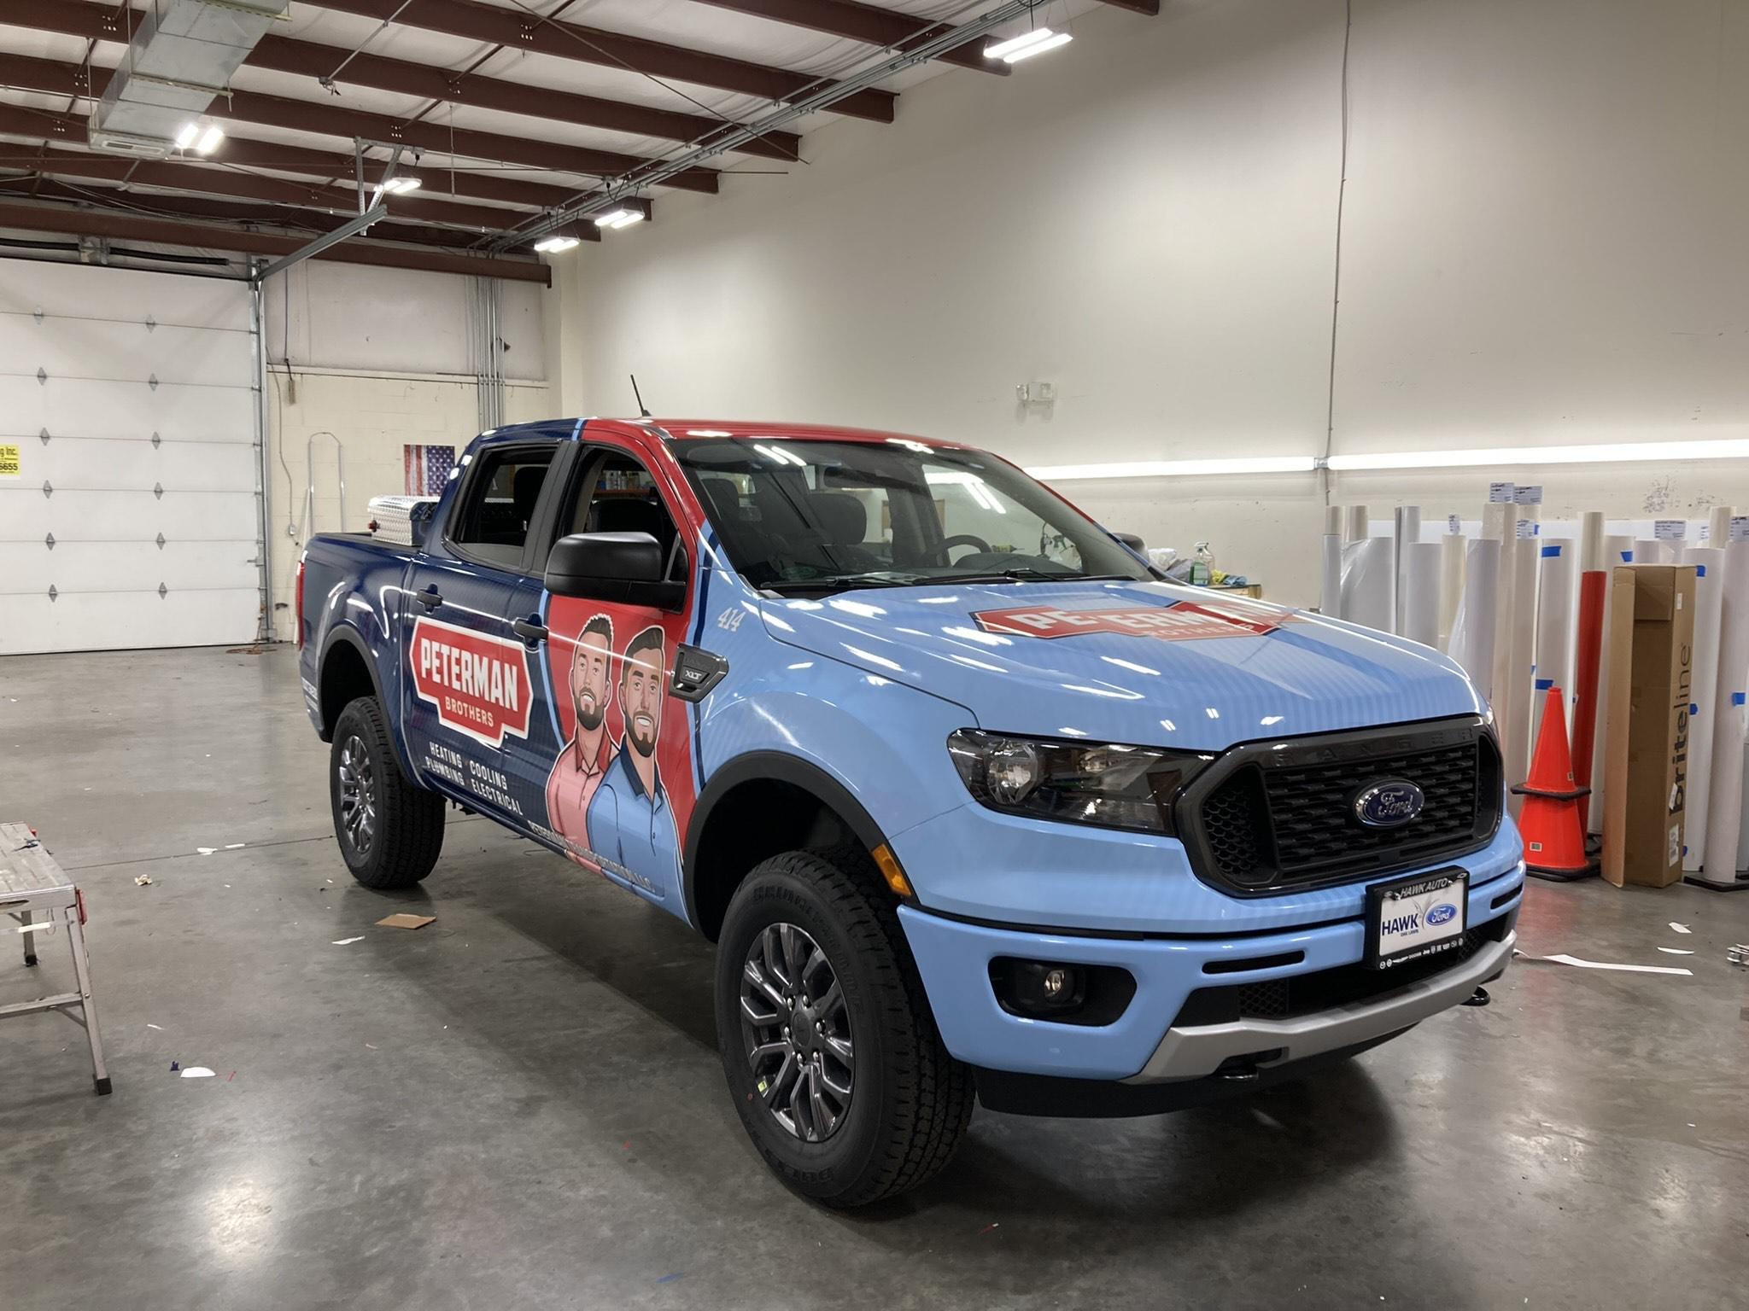

Imagine you’re working on a home in a nice neighborhood. You always have observant neighbors looking to see what's going on. They see you parked at your clients house with a beautifully wrapped vehicle with all of your immediate information on it. Even if the neighbors do not need that immediate service. They are now much more likely to trust you as they know your name and know that you’ve already worked in the neighborhood. It only takes a few jobs for a vehicle wrap to pay for itself and eventually start making your company money for you!

Windows, Walls, and Floors

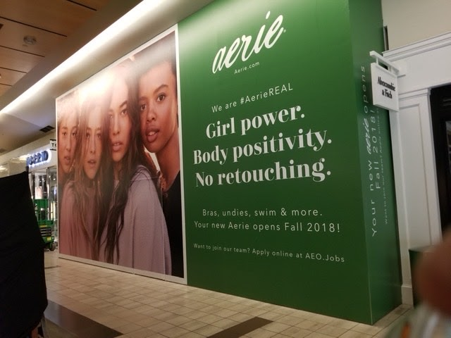
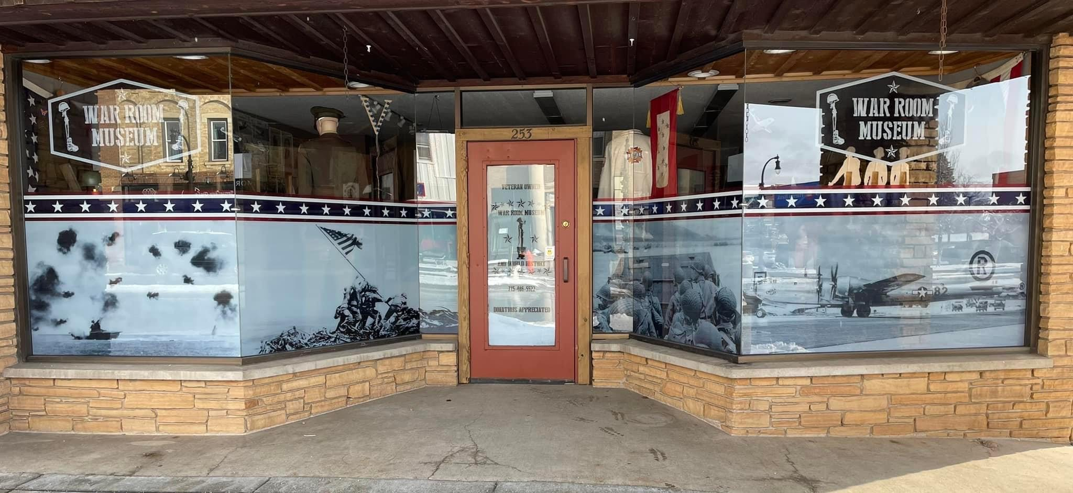
When it comes to adding graphics to your facility. It can be a great addition to serve many different purposes. Interior/exterior graphics can be used to deliver a message to your clients, highlight current or upcoming promotions, direct attention to a specific area of your facility, add some character/color to your location, or even simply create some privacy on windows.

Window walls and floor graphics produce loyal customers. Our window, wall, and floor signs make the most of the seldom-used real estate within your business environment.
Custom graphics can simply feature your company logo to promote general awareness, or can include messaging (including promotions and other offers). Ask us about different levels of surface applications – from long-lasting, permanent graphics to low-tack, easily removed temporary graphics.
The following list includes some of the specialty graphics we can create for your business. If you have additional questions, or don’t see exactly what you need, call us to discuss additional possibilities.
- Barricade graphics
- Clear window decals and graphics
- Concrete graphics
- Customized floor graphics
- Die cut decals
- Directional floor graphics
- Double sided window decals
- Hardwood floor graphics
- Perforated vinyl decals and graphics
- Removable floor graphics
- Smooth floor graphics
- Slip-resistant floor graphics
- Static window clings
- Store window graphics
- Tile floor graphics
- Vinyl window graphics
- Vehicle Decals

LOCAL BUSINESSES WE RECOMMEND

Rear Cover

THANK YOU
I thank all of my past, present, and future customers who continue to support my business. Without you I could not have experienced the growth I have in such a short amount of time. Thank you for your trust, your patience, and your appreciation for the hard work and dedication I put in to deliver the best experience possible. Lastly for those who do not know me I’d like to share a summary of what led me to where i am today.

Chris Huml
My name is Chris Huml, I spent the last 4 years traveling throughout the US searching for new adventures. I grew up in Stratford, Wisconsin and graduated from Stratford High School in 2015. I started working in this industry here in Wisconsin in 2016. After working as a graphic installer for almost 2 years, life led me in a direction which took me all the way to Seattle, WA. I lived there for about 10 months, in that timeframe I worked as both a painter for a sign company and a graphic installer. Seattle is where I got my first opportunity to work as a subcontractor. It was an amazing opportunity that showed the benefits of putting yourself out there and becoming your own boss. I eventually came back home to Wisconsin for a few months before getting deployed with the AmeriCorps NCCC. This program was a 10 month commitment to community service, serving the local needs of the places we were stationed. In the first 2 months after training, I was stationed in Hannibal, Missouri. While here I worked with Douglass Community Services to collect toys and set up the warehouse for their Toys for Tots program. My next service was stationed in Denver CO working with Habitat for Humanity. Due to COVID, my service term got cut 4 months short. I was then sent back home which a year later led to me deciding to take the skills I’ve learned in this industry and open my own business. My hopes for my business are that it will allow me to do something I love, and continue traveling the world as I do it! The purpose behind naming my company Harmony Window Films and Graphics is that peace and harmony in my life is something I’ve been searching for since I can remember. Moving forward with this dream has been a leap of faith that is bringing me closer to living a more harmonious life.

