
Put Capitalize’s 20+ years of Governance experience to work for you. Our comprehensive Alteryx Lifecycle Governance service allows your team have the right blend of control and organization while still maintaining the powerful self-service / citizen development strengths of Altery
What is Lifecyle Governance?
Due to the nature of Alteryx being primarily a self-service tool, it can create some potential governance challenges that are more complex than standard IT technology deployments. As your organization’s use of Alteryx increases and becomes a more prominent line of business system, we feel it is important to consider thinking through the different Alteryx components and their “lifecycles” across people, processes and technology in order to appropriately mitigate risks and proactively avoid issues before they occur. After observing this need across our 100’s of clients Capitalize is now offering Alteryx Lifecycle Governance services developed from our unique deep experience with Alteryx and our company's deep knowledge in developing such methodologies.

Why Alteryx Lifecycle Governance Services?

As our Alteryx clients begin building and executing more complex workflows from multiple data sources and for multiple departments, they commonly finding themselves asking a wide array of questions across the people in the organization, the processes that they currently employ and the complimentary technologies that are leveraged:
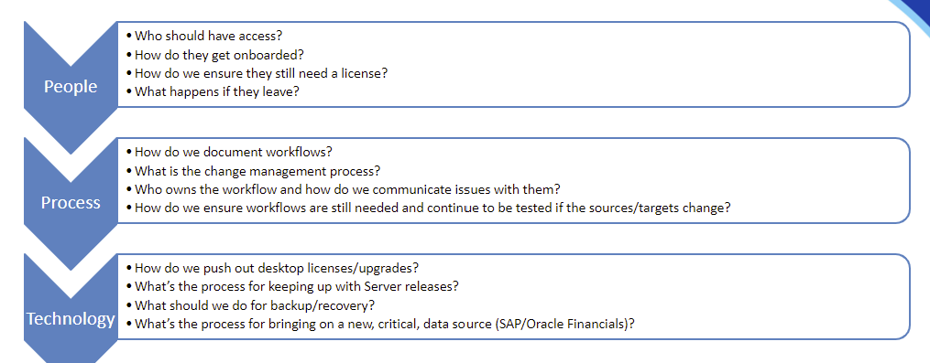
This is just a small subset of the questions we ask in order to gain a better understanding of your organizations Alteryx maturity and the dependencies that Alteryx has. This allows us to tailor a unique solution to our clients that is targeted to improve the governance of Alteryx in the categories that we mutually agree will be most beneficial.

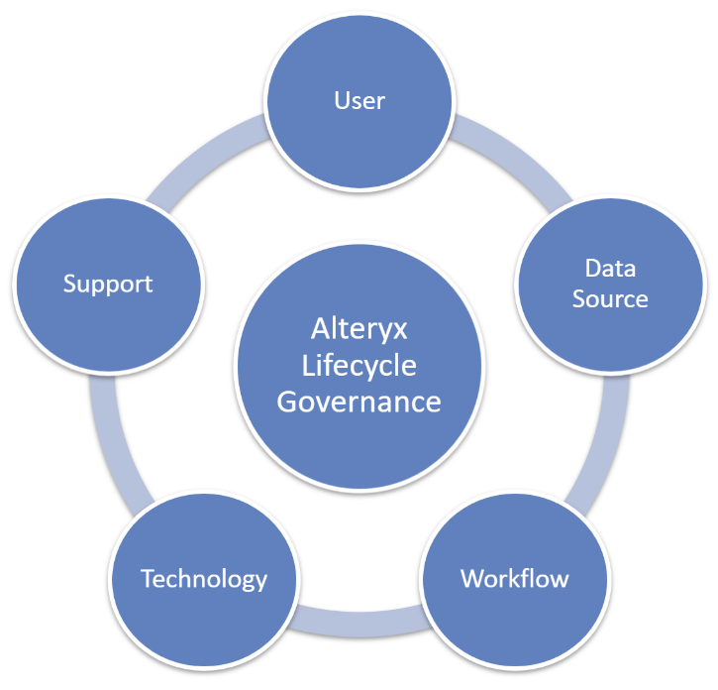
There are five key areas that make up Lifecycle Governance with Alteryx:
- Users – Alteryx developers and administrators as well as individuals that are upstream and downstream of the Alteryx workflow
- Data Sources
- Support – integrating with existing support and ensuring feedback loops for errors, questions and issue resolution
- Workflows – identification of need, how to get started, deployment
- Technology – Includes both Alteryx Designer and Alteryx Server

Our team examines each Lifecycle area to identify where you are today and make recommendations on where you should be tomorrow. These recommendations are developed in concert with client to ensure alignment on Alteryx governance goal and agreement on priorities with your organization.
The primary objective of the outcome is ensuring a “Right Sized” governance model to provide order, consistency, and oversight to ensure that you are getting the most out of Alteryx without creating unnecessary overhead.

Below we have outlined the different Alteryx Lifecycles, which is a high-level view of the functional areas that we cover in our assessment and program planning.

Lifecycle of a User
The lifecycle of a user begins with onboarding and training and goes all the way to role change/separation. Onboarding and training are complex and time-consuming processes. Each new hire requires function-specific training and access to relevant data and analytic tools. It can be difficult to organize, especially when onboarding large groups at a time.
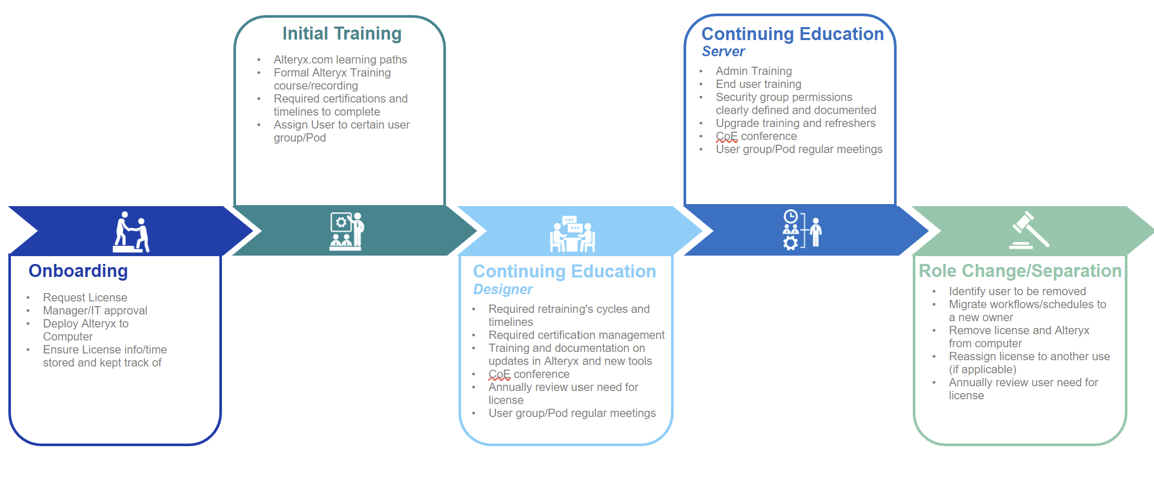

Lifecycle of a Data Source
Data has become the life blood of most organizations and every organization manages their data differently. Leveraging a plan of governance is key to eliminating rework and removing added complexity while adhering to client security standards. The number of use cases and functionality where Alteryx can be leveraged is quite large, so it is important to clearly map out where it will be used in your organization and technical infrastructure. We cover evaluating data sources, publishing data, security and access requirements, and decommission / migration of data sources

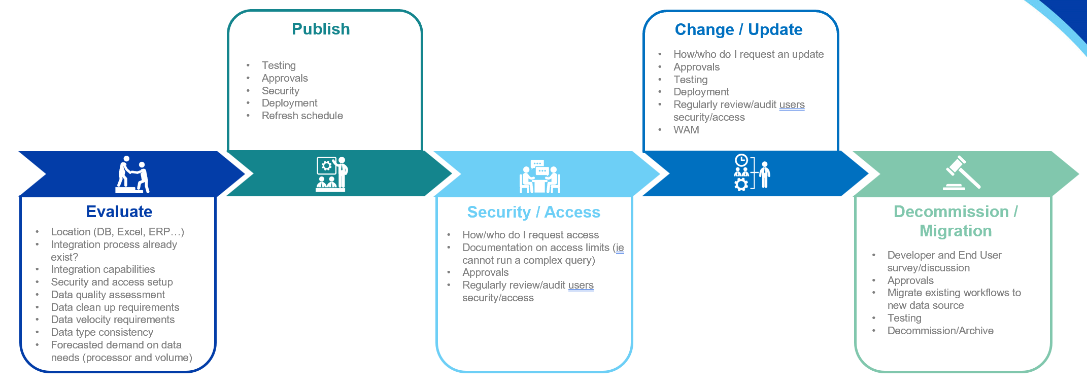

Lifecycle of a Workflow
Determining the value of an Alteryx Workflow can be very subjective, but from idea inception we track Hard and Soft ROI metrics to feed a simple business case for development. We have idea ingestion and specification templates, requirement / mockup templates, best practices and recommendations on Workflow development, testing, deployment, monitoring and support.

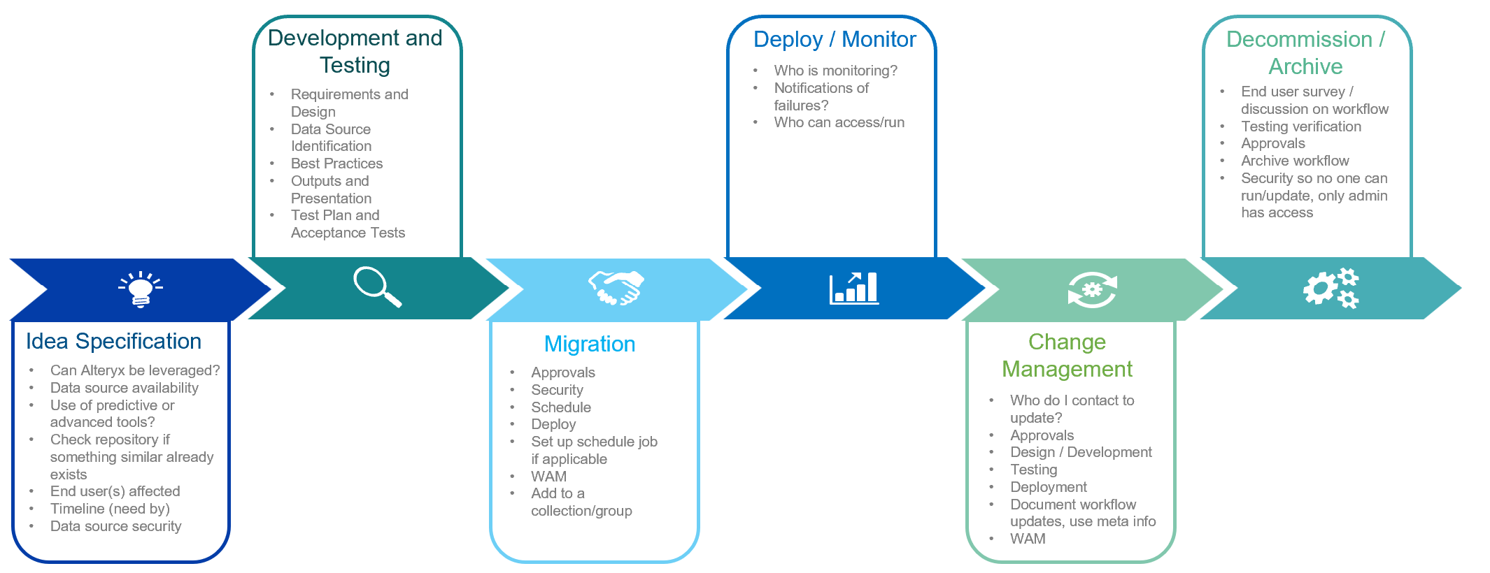

Lifecycle of Alteryx Designer
When it comes to allocating a Designer license to an individual, we can help to assess the need, guide through the installation procedures, and recommend appropriate enhancements. Combining this with the Lifecycle of a User ensures users are armed with appropriate knowledge and training.

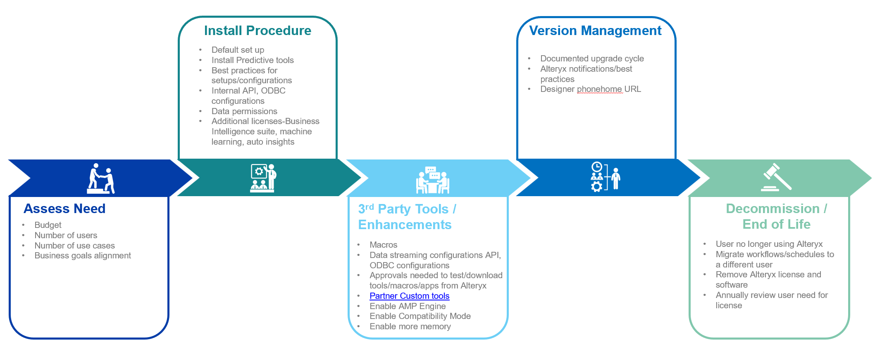

Lifecycle of Alteryx Server
Similarly with Alteryx Designer, we can help you assess the need and value of Alteryx server, optimize its configuration to your environment as well as provide guidance on monitoring and version management.

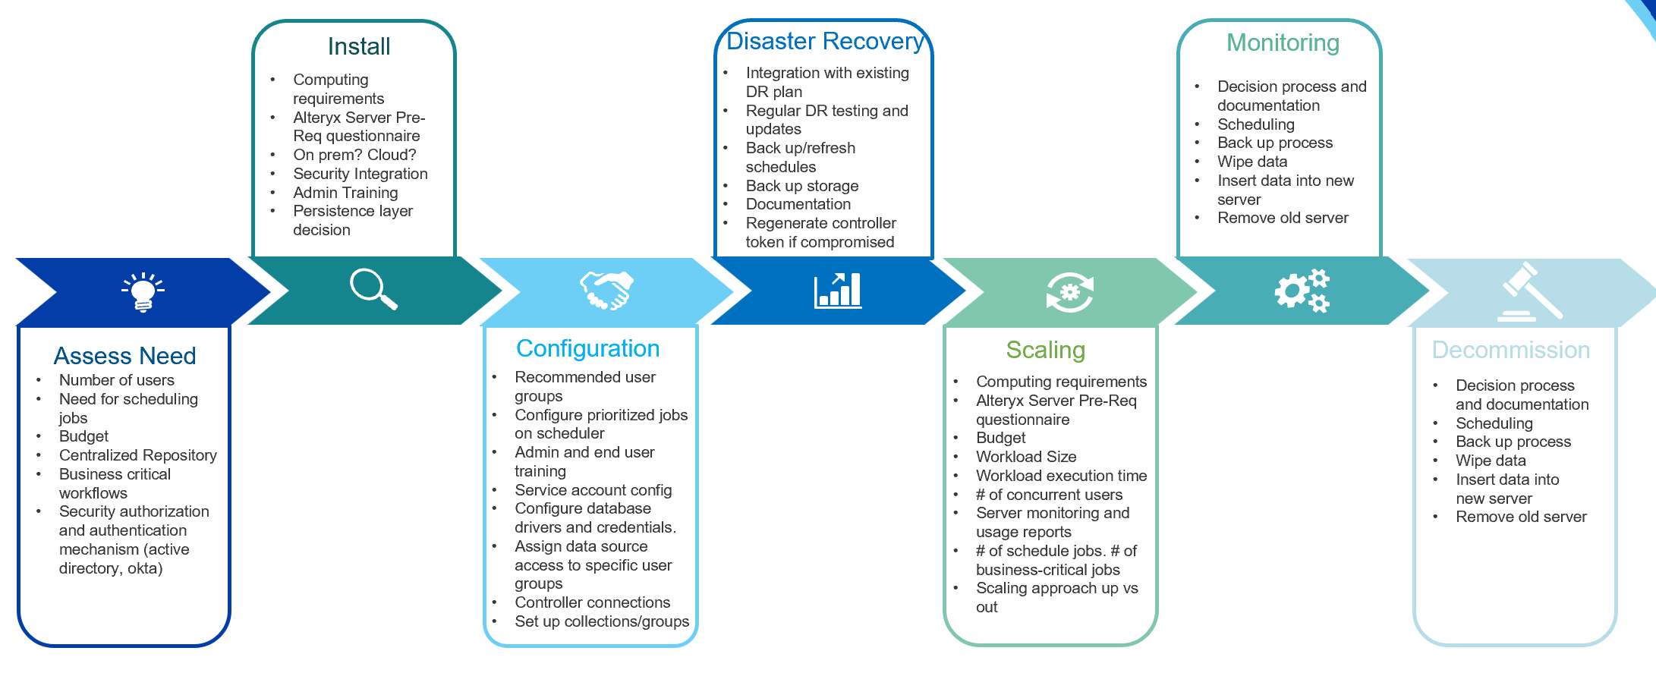

Why is this important?
Lifecyle Governance is a system of checks and balances that provide a long-term program roadmap of everything from training to troubleshooting role changes and change requests. It prioritizes future objectives, while ensuring that no steps are missed that could potentially alter the functionality, productivity, or security of your Alteryx environment.

Talk to us

Ready to Start Your Lifecycle Governance Journey?

Think of Lifecycle Governance as being similar to the steps we take to obtain a drivers’ license. There are rules in regulations that we all have to adhere to or else there will be mass chaos and everyone will crash into each other. our governance service offers your users, data sources and workflows protection from the unknown, and ensures the correct regulations are in place, no matter what obstacles arise.
Eric Soden, Managing Partner

