Family Chiropractic & Wellness, along with Dr. Jason Ellis, D.C is excited to introduce you and offer brand new services to our patients from our new partner Revelry Wellness.
We are hoping that you can join us for our Vallentine Day party on _________(date), at ______________(location) for some food and drinks and hear more about this exciting new service line. Please call us/or send us a text message at ____________________ if you have any questions or would like to learn more about this great new partnership.
Welcome to Revelry Wellness., an integrative health and wellness organization that emphasizes the enhancement of health over the treatment of illness. Revelry Wellness is focused on prevention and wellness, resulting in a more dynamic life through middle age and beyond.
Revelry Wellness helps men and women reclaim lost energy and vigor, sharpen thinking, improve memory, decrease body fat and transition their bodies to more lean muscle. Through our innovative therapies and EVIDENCE-BASED MEDICINE, our patients get better with age: they experience clarity of mind and vitality of body that they felt in past years, even decades prior.
As part of your initial intake and examination, we pride ourselves on getting the big picture and collecting as much personal data on your biometrics as possible to ensure no stone is left unturned. We have partnered with the latest technology and state-of-the-art laboratories to analyze your complete biome all of which can be done on-site at the clinic or at home.
As modern technology continues to evolve every day, it Is imperative that the way we analyze our overall health evolves too. It is no longer appropriate to rely on a general physical or checkup to get a good sense of how well our body is performing. We provide cutting-edge testing to give our patients a look under the hood to see what is really going on, and what we need to do to ensure their quality of life in our later years.
Revelry Wellness uses in-depth consultations and comprehensive blood testing to develop individualized, customized treatment plans. Get access to over 6000 individual tests, test panels, and test kits. We work with the world’s leading laboratory providers to ensure you get the industry’s most advanced diagnostic services. The Specialized tests can determine the root cause of your health issues.
Revelry Wellness offers Office Appointments, Telemedicine, and Concierge (come to your location) to offer you a convenient and the most comfortable way to enhance your health and wellness routine easily and fit it with your busy schedule best. Based on the variety of services, some can only be offered in Office Setting, while others we are able to accommodate through Telemedicine or coming to your location. We are excited to meet you and to tailor your specific treatment plan to your best and preferred way.

Revelry Wellness offers a full array of services to help you LOOK, FEEL AND BE BETTER; please click on a treatment below to indicate your interest and submit a survey. This will be used as a signup sheet for our Valentine’s Day event and will give us an opportunity to prepare material specific to your interests to offer you more information and answer any questions you might have about Revelry Wellness services.
You can also visit our website: https://revelrywellness.com/, and review more information and complete the intake form by selecting start now. We require an intake form before we can start services.

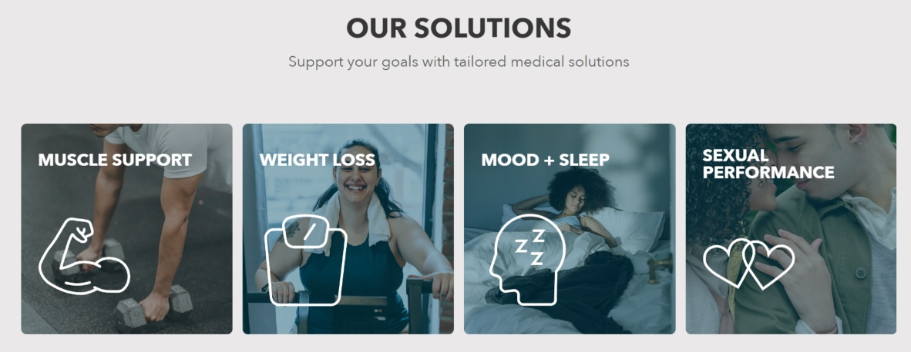
OUR FEATURED SERVICES






Your Name:
Your Phone Number:
Your Email:
What way do you prefer to be contacted for any updates or additional information about the event:
Text you, Call you, Email you, all of the above
I plan to attend the Vallentine Day Party on ________date, __________time
How many will attend, including yourself? _________

