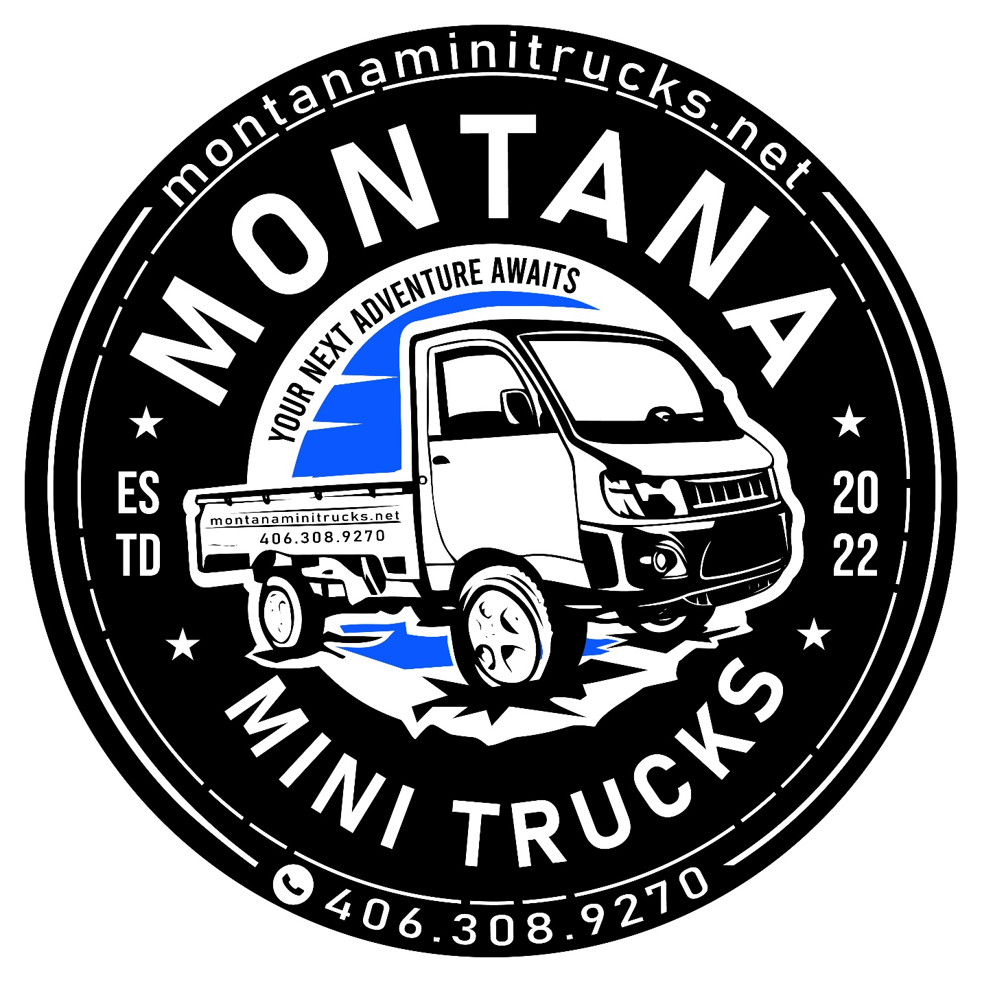

Daihatsu Hijet Deck Vans are an unusual shape compared with your typical Japanese mini trucks. Neither the traditional pickup style, nor the full-enclosed van style. The deck van is a crew cab body with a deep rear load area. Yes, it’s 4×4 like all the other mini trucks here at Mini Truck Depot. Yes, it can go off-road with the best of them, with lifted suspension and 23-inch knobbly tires. Yes, it has a comfortable, full-weatherproof cab.
But it does have some tricks up its sleeves: A rear load area that makes up in depth what it doesn’t have in terms of length. Seating for four on proper seats with seat belts. The ability to flip down those rear seats to make space to haul stuff out of the elements in addition to that space in the rear bed.
So who’s going to be interested in a Deck Van? Here’s a few ideas. Flip the rear seats down, slide open the doors, and your dogs can jump aboard. Or keep the seats up, and take your grandkids with you to “help” around the ranch. (With the proper seats and seat belts, you can even slot in car seats for smaller kids to keep them safe as you drive around the farm.) There’s sure to be more ways to use your Deck Van, but this gives you some ideas to be going on with.
But before we go any further, let’s have a quick look at a couple of Deck Vans so you can see what these particular mini trucks look like. First of all, an older 2017 white Deck Van:
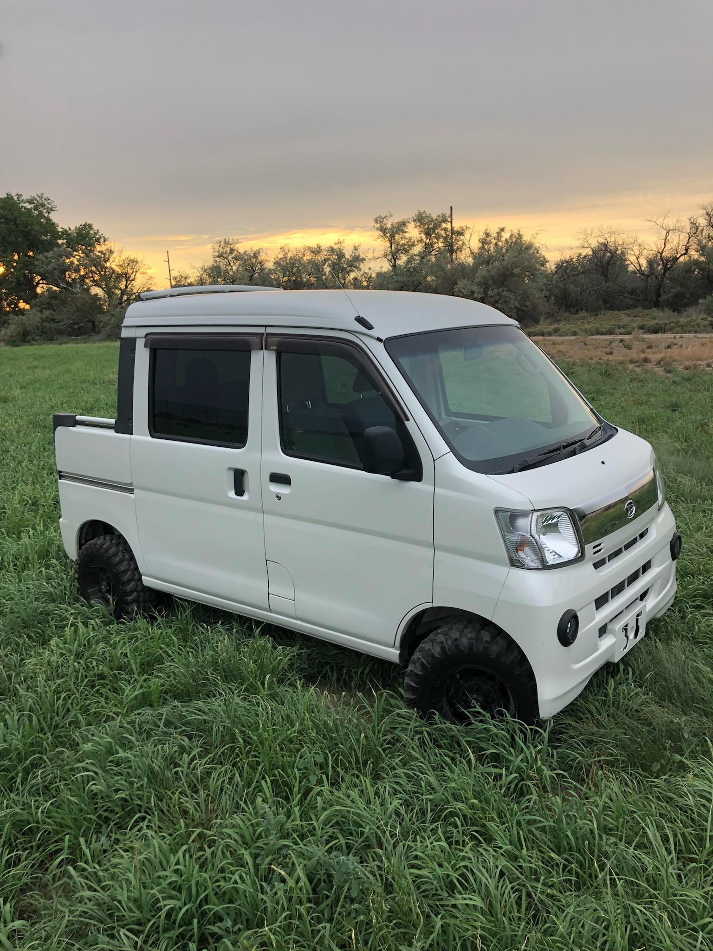
And here’s a newer 2020 model in the popular Green (Khaki) Metallic body color, this time on a beach. This one has some extra accessories fitted, including the large extra roof rack (surfboards, anyone?) and the light bar at the front.
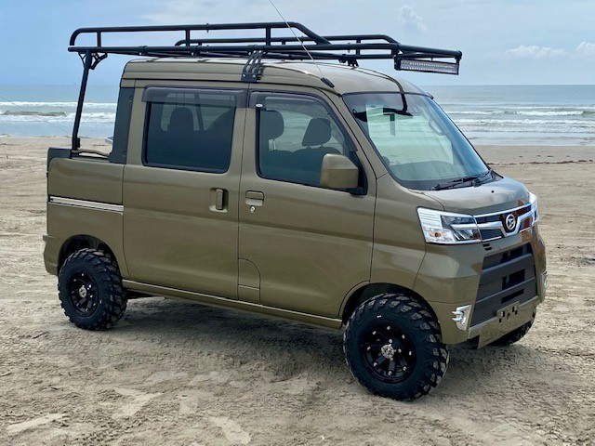
So they’re great little machines that really look good on the outside. But let’s step inside so you can see what a comfortable, versatile, and functional interior they have.

DAIHATSU HIJET DECK VAN INTERIOR
These Deck Vans also have a proper steel safety cage for their fully-weatherproof cabs. And — doors! Yes, unlike UTVs, where proper doors, windows and other basics seem to be considered “luxury” optional extras, mini trucks all come fully equipped with these kinds of (obvious) basic items included.
Now, with that out of the way, let’s first take a look at the front seats. First up, here’s what it looks like inside a 2016 automatic Deck Van:
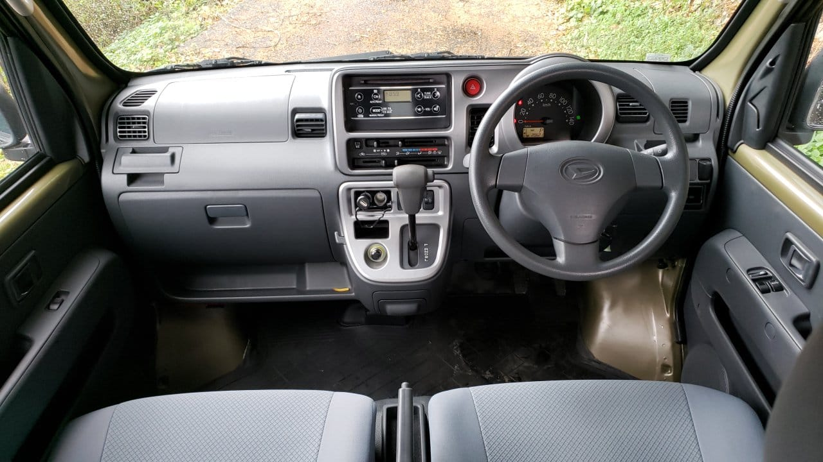
Now, here’s the front seats in a 2020 manual Deck Van model:
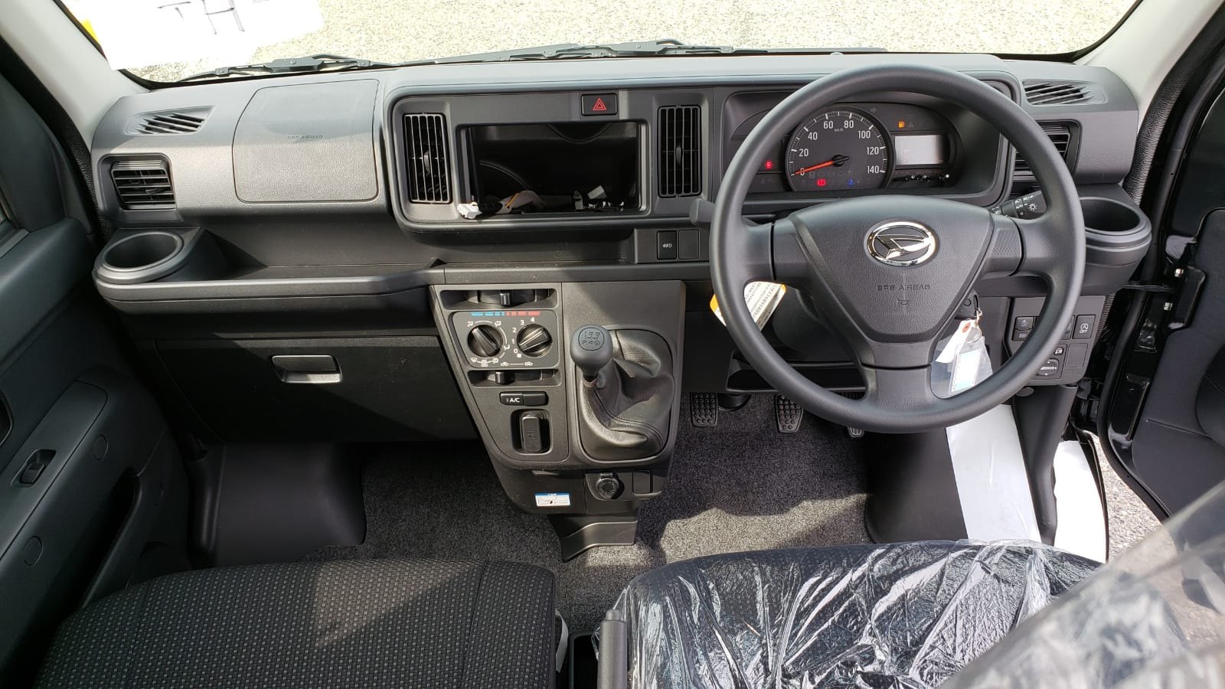
The main thing to spot here is that whether its a manual or automatic model, the gear selector is built into the dashboard, meaning that there’s nothing on the floor between those front seats. So whether you want to slide across to exit from the opposite door, or you just need a little more space for your legs, having this gear selector out of the way is a real boon for both comfort and flexibility.
Before we go on, and for the sake of completeness, let’s throw in a similar photo of a new 2022 Deck Van so you can see the latest evolution of this interior.
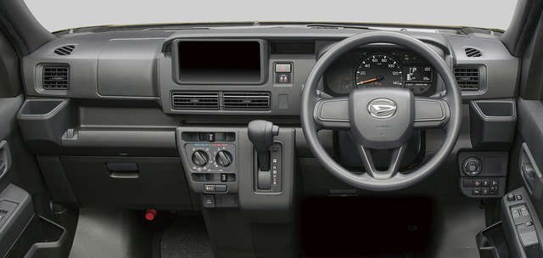
Now let’s take a look at those front seats in particular. After all, it’s one thing to have convenient cup holders, useful door pockets, handy sun visors, and other well-thought out features, but if you can’t get comfortable in the seats, then you won’t want to spend a lot of time in your mini truck.
And what great seats they are. I mean, look at the these photos of the interior of a new model Hijet Deck Van G. If you didn’t know it, you would think those front seats in particular were from a regular car, rather than an off-road only UTV-alternative. With all the adjustability you would expect, getting into a good driving position isn’t a problem.
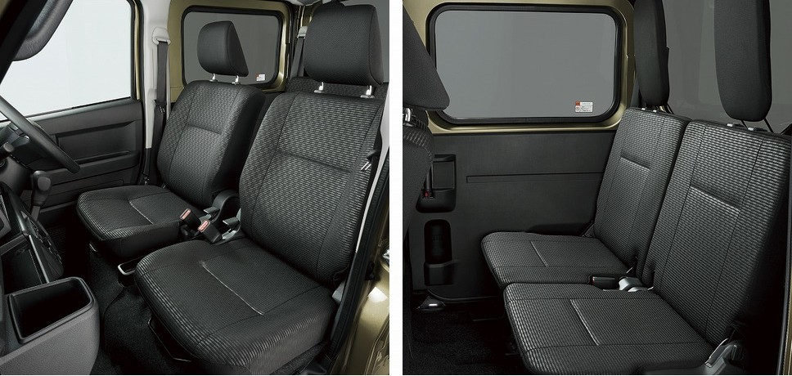
Those rear seats aren’t bad either. Sure it’s more like a bench back there, but they’re still good, hard-wearing seats with real headrests. Plus they have a party-trick that is another reason that makes this Deck Van an even more flexible model.
First, the full-court press. Yes, flip the rear seats down and you have a great place for your four-legged friends to climb aboard, or you have some extra space to haul stuff that you need to keep out of the elements.
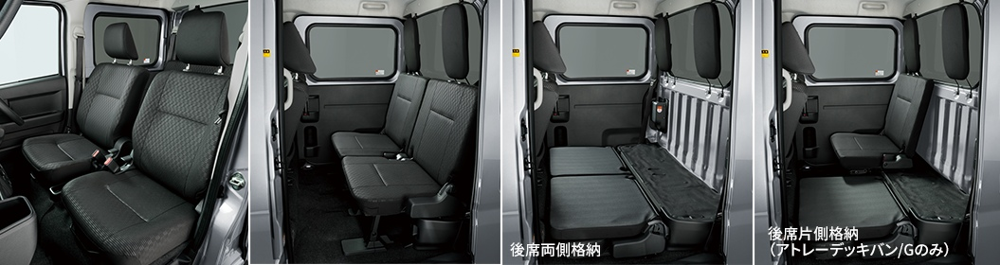
Did you spot it? Now, this feature isn’t available on all Deck Van models — in fact it’s only available on the G model of the latest version that launched at the end of 2021 — but, as you can see, the rear seat actually splits. With other versions you can have the rear seat fully down or fully up; there’s no in-between. But now, with this particular model, there’s this extra option to put one of those rear seats down. Very flexible!
Getting in and out is a cinch, too. Whether you’re sliding into the driver’s seat through that wide-opening door, or helping your kids jump aboard through the sliding doors in the back, getting everyone into your Deck Van is an easy job. Just take a look at the gaping mouth’s of these rear sliding doors. Big dogs can just hop up and in. Little kids have no problem climbing up, and getting them strapped into their car seats isn’t a problem either as you can easily reach in.
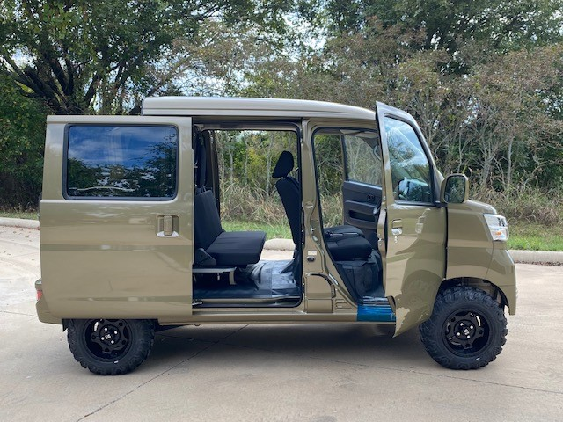

HIJET DECK VAN CONVENIENCES AND AMENITIES
There’s just so much that could be written about all the little features that make the Deck Van such a great vehicle, but let’s focus on the highlights. (Remembering that not all vehicles of all ages will have this exact mix of equipment, so make sure you check out the details of any particular Deck Van you decide to buy).
- AC and heat (don’t worry, all Deck Vans have this!)
- Power door locking (central locking)
- Keyless entry
- Push button starter
- Fuel cap opener
- Power steering
- Door mirrors
- Power windows
- Corner sensors
- Door pockets
- Glove box
- Cup holders

HIJET DECK VAN BODY COLORS
Of course, what your Deck Van looks like on the outside isn’t everything. After all, you’ll be spending more time inside it looking out than you will outside looking at it. But there are some great colors that will make you really proud of your Deck Van, so let’s take a look at those options.
First, the previous generation that was on sale until the end of 2021:
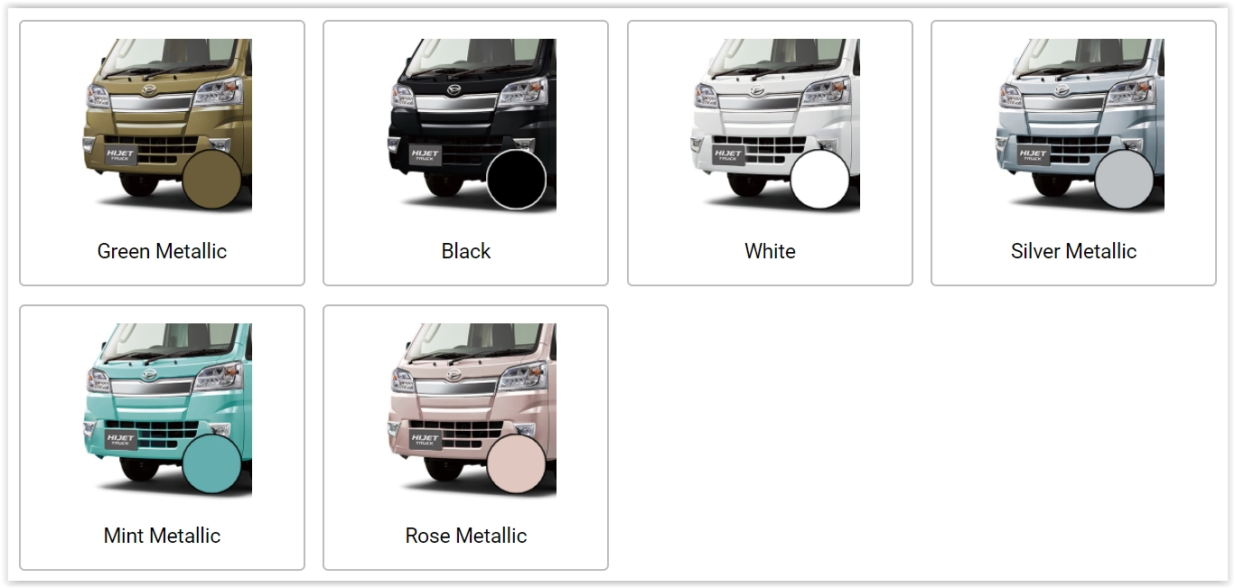
It would be safe to say that the Green Metallic color was the most popular of these options, with White and Black coming in close behind. That’s not to say that colors like Mint Metallic and Rose Metallic aren’t striking in their own way — and if you did get a Deck Van in either of those colors, then you would have a vehicle that was rarer than a typical limited edition Ferrari hypercar in the US.
With the launch of the latest Hijet at the end of 2021, the color options changed. Let’s take a look at what you can get on a brand-new Deck Van now:
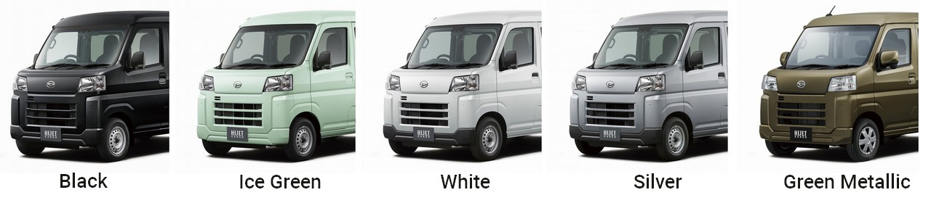
Okay, so in some ways it seems like there’s been a bit of a downgrade. Ice Green isn’t going to be a big favorite, I don’t think. But at least the most popular colors, particularly that Green Metallic (which is also called Khaki), are still there.

HIJET DECK VAN ENGINE AND TRANSMISSION
Deck Vans are incredibly flexible quirky-but-cool mini trucks — particularly if you have kids or others you want to take off-road with you. But now let’s look at how these kei trucks get you off-road. We’re turning our attention to the engine and drivetrain.

ENGINE
The engine is the same engine you find in all the Hijet body styles (for example, the Hijet regular cab model). It’s Daihatsu’s KF-type 3-cylinder water-cooled engine with electronic fuel injection, a compression ratio of 10.8, producing its maximum power at 5,700 rpm, but with max torque coming in at a lower 4,000 rpm. Lots of good pulling power to keep you moving and hauling over difficult terrain.
With the max capacity regulated by Japanese law to 660cc, Daihatsu hasn’t made fundamental changes in the design over the years, but has evolved it gradually to make it ever more efficient. For example, the latest 11th generation models have start-stop technology incorporated in them which stops the engine wasting fuel unnecessarily when idling. The 10th generation Hijets were already able to get about 50% better fuel consumption than their UTV counterparts. With the addition of this start-stop tech, the Hijet mini trucks have pulled even further ahead, with the auto models in the latest generation Hijets now getting 25% better fuel economy than the already frugal previous generation ones.
Despit being off-road only vehicles, these Deck Van mini trucks are built to the NVH (Noise Vibration Harshness) standards that are much higher than what you would normally expect for such a vehicle. It’s not something you will notice all the time, but a smooth, quiet engine means less fatigue when you’re out and about working on your property all day.
Having said that, they are pretty easy to maintain. Need to fill up with gas? They take your normal regular gasoline. Need to replace air or oil filters? No problem, the parts are readily available and fitting them isn’t difficult. Have particularly cold winters? Make sure you use anti-freeze just as you do with any of your other vehicles. These Hijets aren’t some kind of thoroughbred hypercar for rich people, so you’ll find that it isn’t rocket science and you can do all the regular maintenance yourself.
And where is the engine? Well, as you may have been able to guess from the body style, the Hijet Deckvan engine is mounted, giving these Deck Vans an excellent weight distribution and low center of gravity — all adding to the safety and off-road performance of the vehicle.
The final point to mention about the engine is that the engines in these Hijet mini trucks for sale in the US are all naturally aspirated. Now, there is a version of this Deck Van that is available in Japan called the Atrai Deckvan which does have a turbo engine, but (unfortunately) those engines don’t comply with EPA regulations, so cannot enter the US.
Here’s a cutaway of that KF engine showing its inner workings.
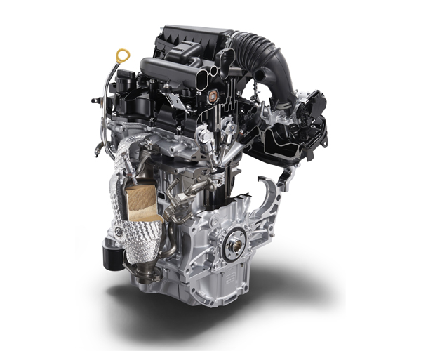

TRANSMISSION
The previous generation Hijet Deck Van 4×4 models had a couple of different transmission options:
- 5-speed manual
- 4-speed automatic
With the introduction of the brand-new generation model right at the end of 2021, things have become a little more complex. Basically, which transmissions are available depends on the exterior color. Unfortunately, if you want a manual model, it means that things are a bit limited:

MANUAL TRANSMISSION MODELS
- Deck Van L in White
- Deck Van L in Silver

AUTOMATIC (CVT) TRANSMISSION MODELS
- Deck Van L in White or Silver
- Deck Van G in White, Silver, Green Metallic, Ice Green, or Black
With the CVT transmission and latest engine, the Hijet regular cab has 25% better fuel economy than the previous 4-speed auto model, in addition to the unquantifiable benefits of the smoother power delivery, so we can expect a similar step improvement for the Deck Van models as well.
Here’s a cutaway showing the inner workings of that very CVT transmission:
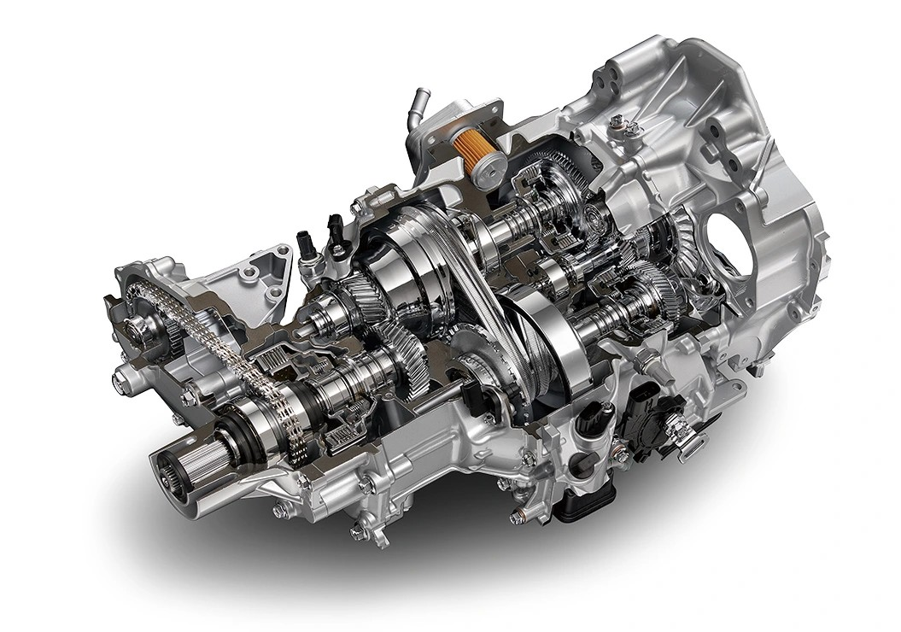

4WD SYSTEM
First let’s be really clear about something: Since all the mini trucks for sale at our independent dealers are for off-road use only, they all have 4WD, even though 2WD mini trucks are sold in Japan. (For the Hijet experts out there, previous generation 4×4 Deck Vans had the designation S331W and for the current generation it is now S710W.)
The basic 4WD system has only changed slightly in recent years, and that was with the introduction of this latest model. With earlier generation models there’s a button on the dashboard allowing you to turn the 4WD system on and off. Why would you want to do that? Well, powering all four wheels takes more energy than just powering two, so switching into 2WD allows you to save gas. If you’re driving down a dry gravel track, 2WD is more than up to the job, so click the button to turn off 4WD. Drive off that same track onto a muddy field and a click of the button brings the 4WD system into life for better grip.
Here’s where you find that button on the center dash console of the previous generation model:
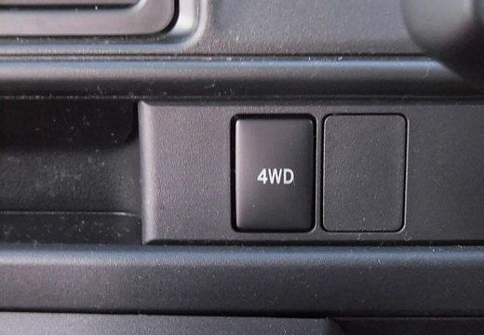
Once again, the latest Hijet Deck Van takes this to the next level: Now, instead of you having to reach for a button every time you want to switch into 4WD or back again, the auto CVT model has a new “Auto 4WD” model. What this means is that under normal conditions, you can just leave the mini truck to make its own decision about whether 4WD is needed at any particular moment or not. If it decides it’s not needed, it will automatically drop it into the more fuel-efficient 2WD setting. Only if you are doing some really strenuous off-road work will you feel tempted to use the “4WD Lock” override switch to force it to use 4WD all the time.
But, in all honestly, it sounds like this is like the manual model on your camera: Sure, the ad will sell you on all the ways you can take control of the photo-taking experience to make minute adjustments to get just the right shot, but the reality is that after playing with it for 5 minutes, you put it back into auto mode and let the camera do all the work. You may fiddle with this “4WD Lock” button a couple of times, and then just leave it in auto and enjoy letting your Hijet figure it out while you get on with what you need to get done.
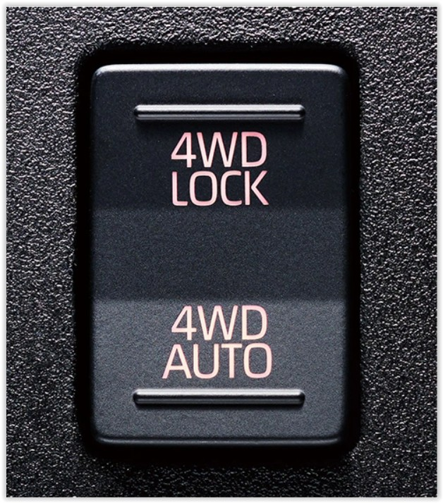

HIJET DECK VAN LOAD BED
The Deck Van load bed is inevitably pretty different to its pickup body stablemates. After all, the main crew cab has space for four people, so since these mini trucks have to conform to the same dimension rules, it’s not surprising that the Deck Van load area loses a lot in length. But that doesn’t make it useless. What is lost in length is gained in depth. And with a rear gate that folds down for very easy loading, this is still a very practical space when it comes to hauling.
These are the stats for the latest S710W model, but they will be very similar to those of the previous generation S331W model as well.
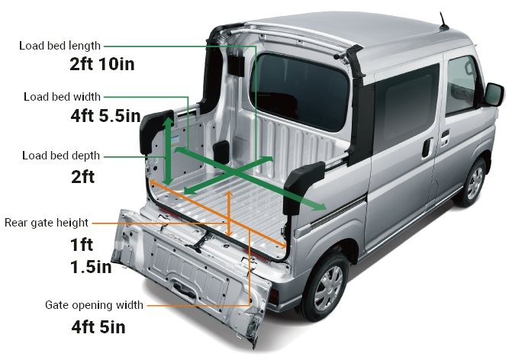
So, what can you do with this space? Well, first here’s a closer look so you can get a feeling about just how deep and wide it is:
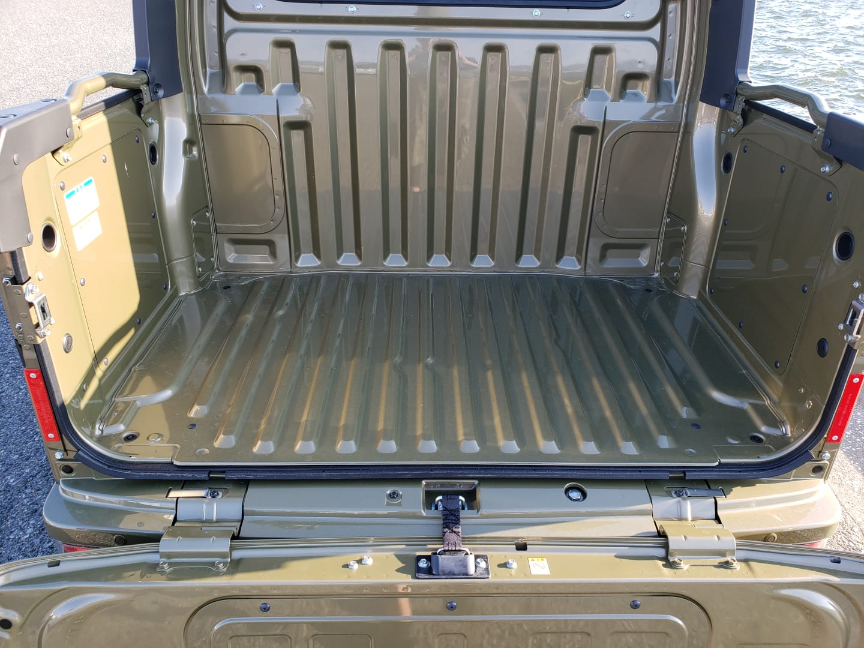
Let’s take a look at what you can do with that space if you’re out working on a ranch, for example:
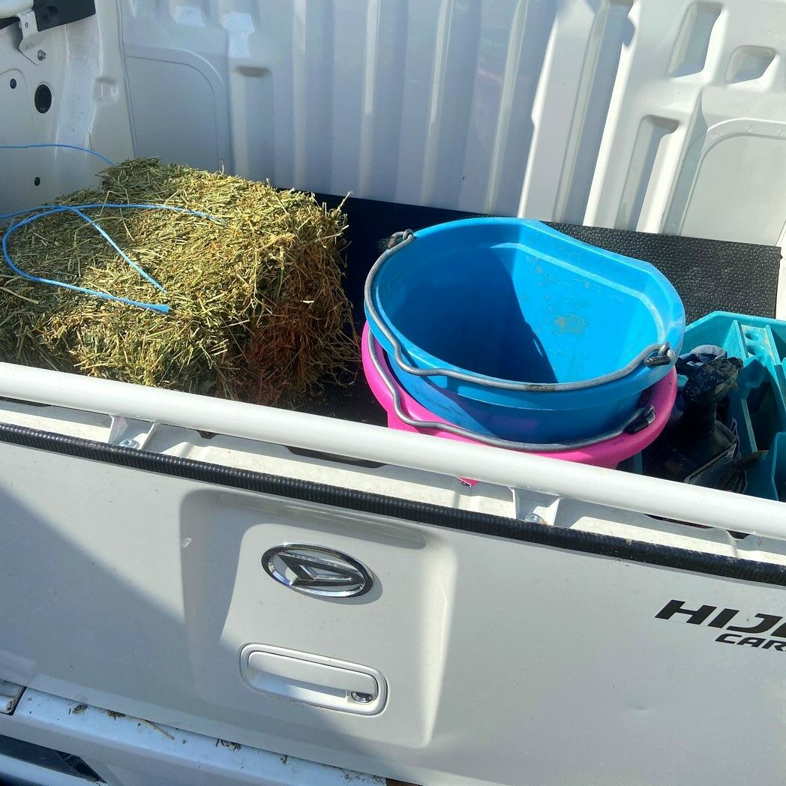
As you can see, the Hijet Deck Van is an incredibly versatile 4-passenger Japanese mini truck that puts equivalent UTVs to shame. If you want to take family or friends off-road with you, or you just need to have an extremely flexible vehicle for your work, the Deck Van is really hard to beat.

