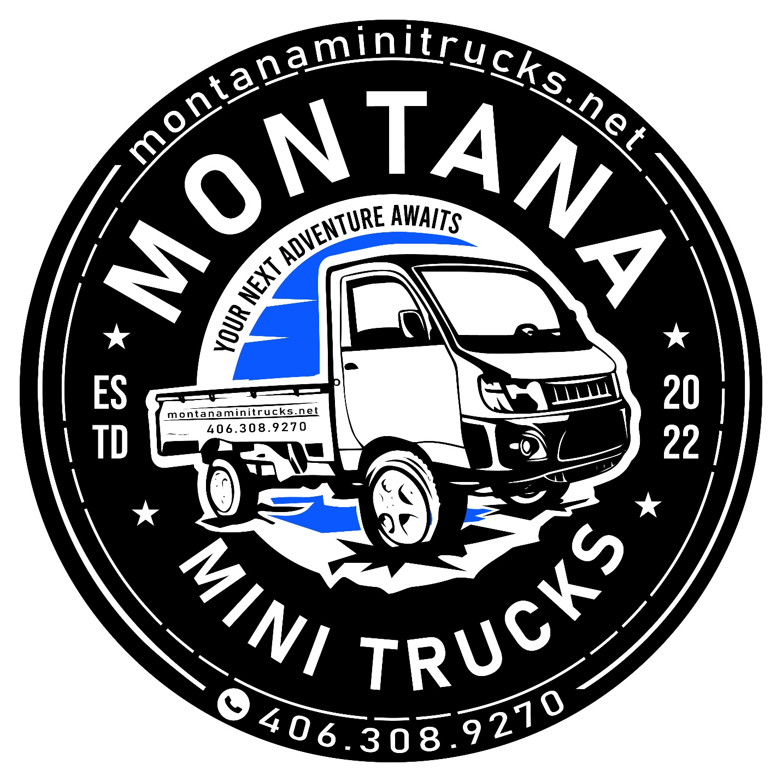Daihatsu Hijet Jumbo models are the second most popular Daihatsu pickup-style model after the regular cab Hijet in Japan. In the US, they are often preferred by customers because of the more spacious nature of their “jumbo” size extended cabs. And we’re going to explore more about them… but before we do that, here’s a couple of pictures of the 10th generation (top) and 11th generation (bottom) Hijet Jumbos so you can see what they look like.
First up is this lifted 10th generation Jumbo with a 3″ lift and 25-inch 10 ply tires in the ever-popular green (khaki) metallic color.
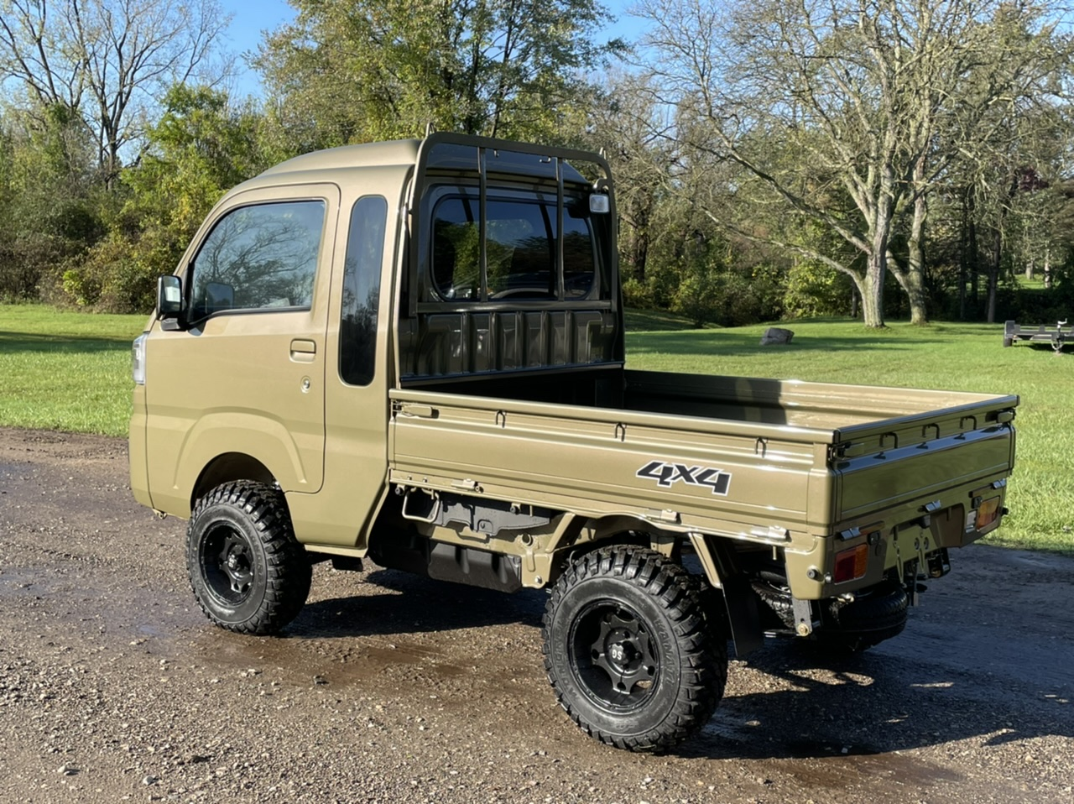
Now, here’s the 11th generation Hijet Jumbo. This one is in the new and rare red metallic color. As you can see, this particular one has the original JDM (Japan Domestic Market) wheels and tires that these mini trucks are sold with over there. Of course, for the off-road US market, the kind of lift, rims and tires combination you see on the green one above is going to work better.
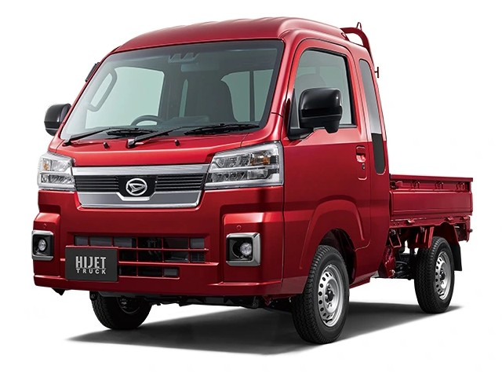
What you’ll notice on both of these Hijet Jumbos, and with the previous generation models as well, is the extra vertical window on the side at the rear of the cab, and the slight bulge in the roof. Compare this to the regular cab Hijet and you will see the contrast right away.
So, there’s more space in the cab (including extra headroom), but let’s explore in more detail and go inside of the Jumbo cab model.

DAIHATSU HIJET JUMBO CAB INTERIOR
Before you even enter the full-weatherproof cab you’ll notice a couple of things which make living with a mini truck so much more pleasant than running a UTV. Take a look at this view of an orange Hijet Jumbo and see if you can spot them:
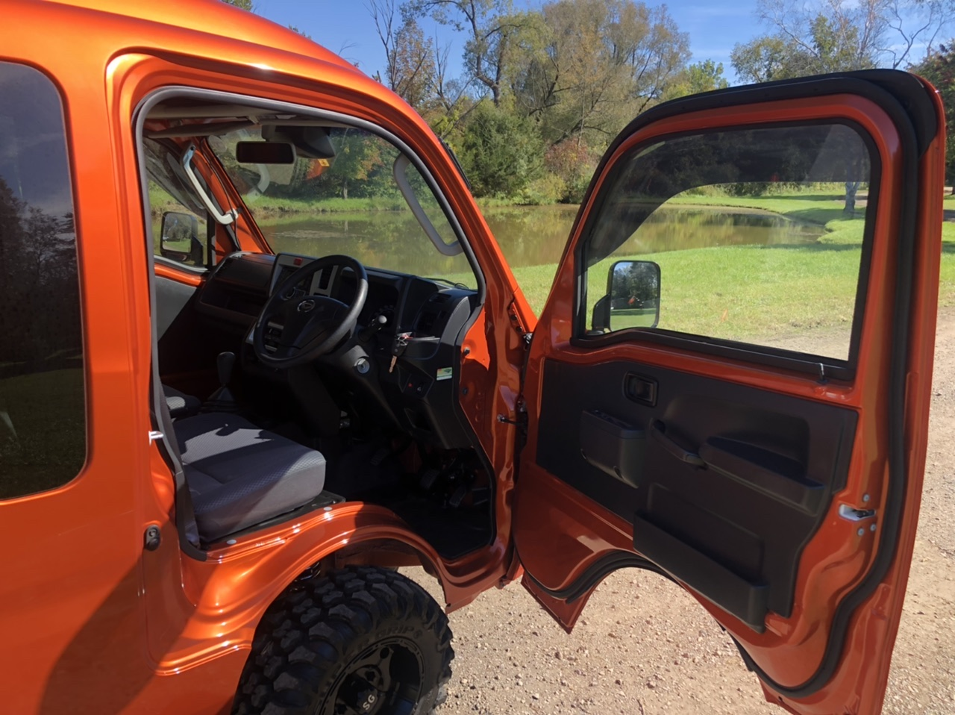
That’s right. The cab is pretty high, giving an excellent view of the surrounding terrain, but the step up is relatively low. Plus you have these doors that swing a long way out to create a nice, wide opening for you to climb aboard — and there are convenient grab handles to make the process even easier. So before you even start driving, you’re already comfortable. And this is very important, especially if you need to be getting in and out a lot as you do jobs around your ranch or farm.
So, now we’re in there, what do things look like from the inside? First of all, what makes this Hijet Jumbo a “Jumbo”? That would be the bigger cab. More room behind the (backrest adjustable) seats:
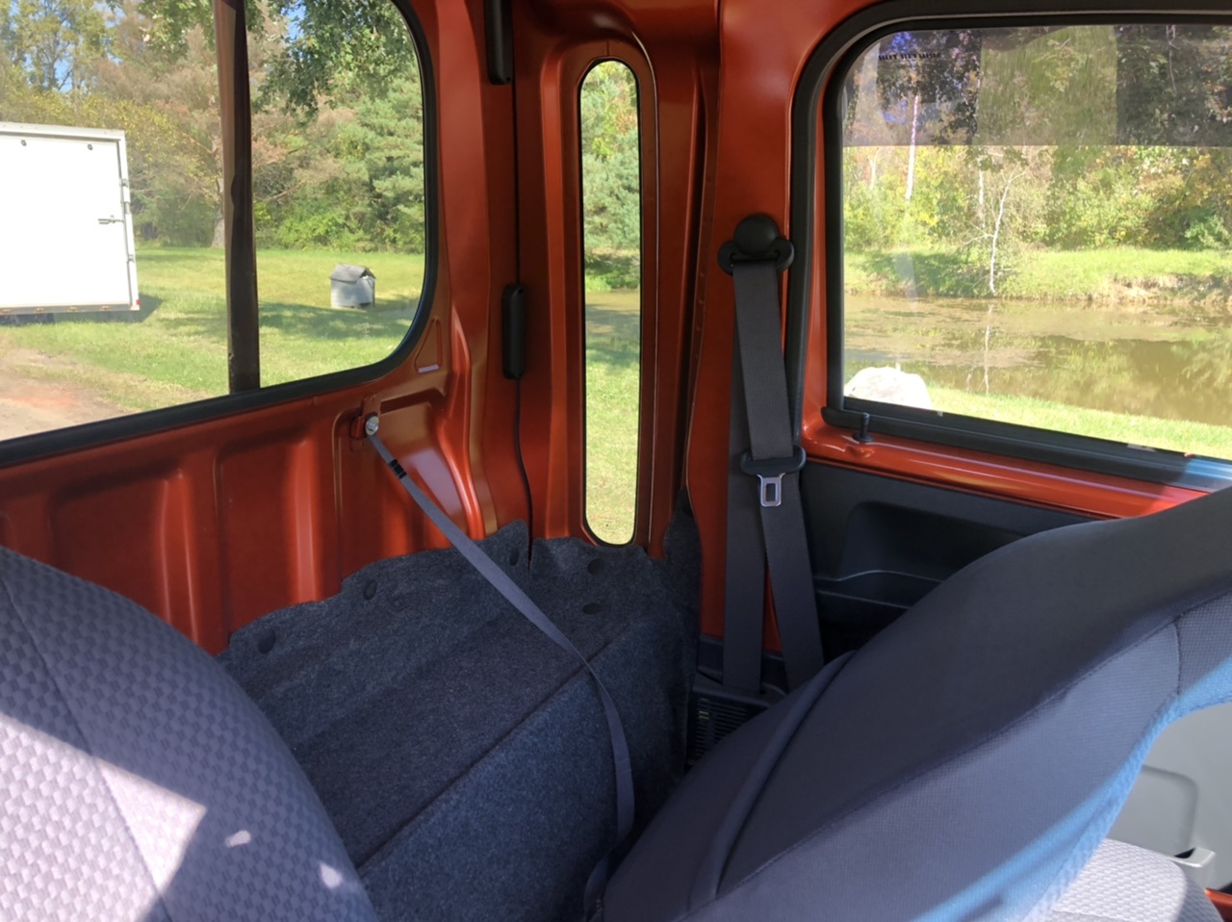
As you can see, it’s not a huge amount of extra space, but that doesn’t mean it’s useless. Slip a bag or two back there. Or some tools you need to keep to hand and don’t want out exposed to the elements in the rear bed.
Then check out the extra headroom. If you’re over 6 feet, this alone makes the Jumbo worth considering. (Don’t forget to notice the lined roof either. That’s more what you would expect from a proper full-size pickup built to automotive standards. Yes yet another way in which mini trucks outpace their UTV opponents.)
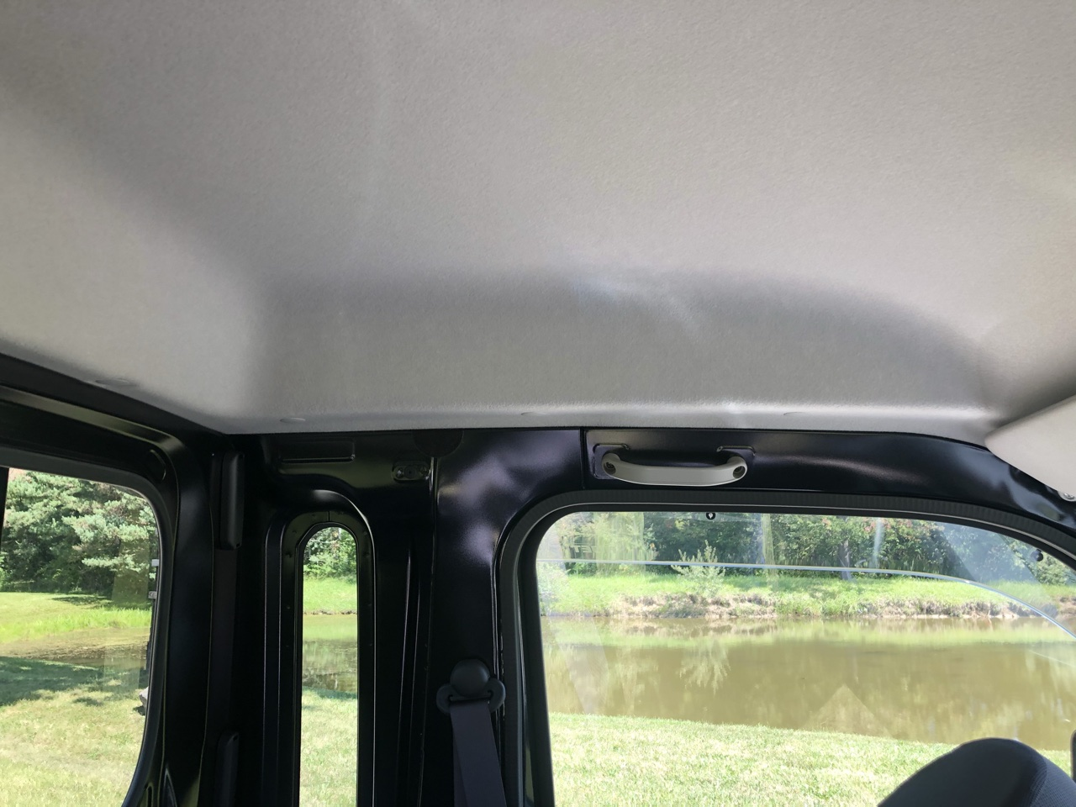
You climb in and settle yourself into the seats. You notice how similar they are to the seats in your car — properly formed and comfortable. This is your first time in the cab of a Daihatsu Jumbo, so you unconsciously reach to adjust the seat — and again you find the adjustment exactly where you would expect it to be, allowing you to get into the perfect driving position within seconds.
Unlike the regular cab model which only allows adjustment of the seat base fore and aft, these 11th generation Jumbo models allow you to shift the driver’s seat back and forth by up to 5.5 inches (the passenger seat can also move, but only up to 4 inches). Plus, since the Jumbo cab has the extra space behind the seats, Daihatsu have been able to add a reclining function as well. There’s lots of range of movement to ensure almost anyone can get comfortable in short order.
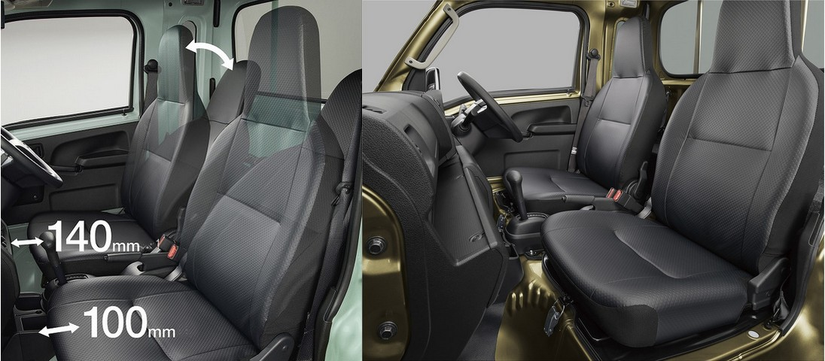
The Hijet Jumbo’s interior’s about more than just the comfortable seats, although that’s definitely important. As mentioned above, there’s valuable additional storage space behind those front seats. And you can also find places to stow your stuff above your eyeline as well. That’s right, that extra bulge in the roof isn’t just good for extra headroom. It also has a built-in shelf to keep those odds and ends (your gloves, hat, a tissue box — the possibilities are endless) that you’re going to need to keep to hand, but you don’t want cluttering up the main part of the cabin. Of course, you won’t be stuck for places to keep stuff there, too. There’s the glove box, door pocket and places for your phone and other gear. And, of course, you don’t want to go out without your beverage of choice to keep you warm and awake in the winter, and cool and hydrated in the summer, so there’s also drink holders for those as well.
Take a look at this view of the 11th generation Hijet Jumbo interior and see just how well thought out it is, with lots of practical places to put stuff, as well as attractive but durable plastic to make it a pleasant place to be:
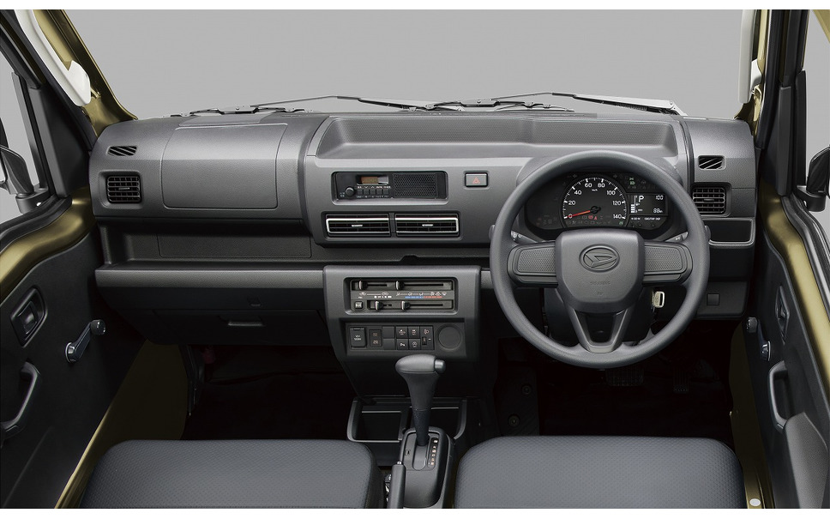
This one’s an auto (CVT) model, and you can see it has wind-up windows. But remember that you can also get the Jumbo with power windows, and you will find many Daihatsu Jumbos for sale here which have the power window upgrade.
Now, here’s that handy overhead shelf that was mentioned above.
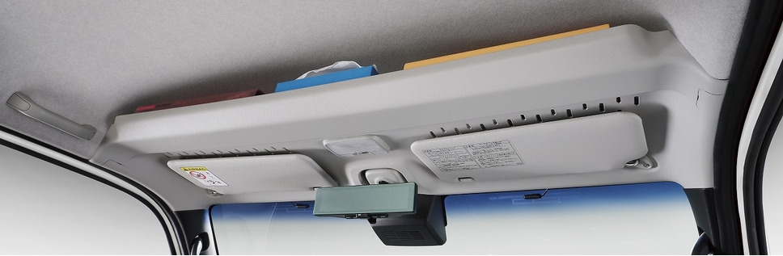

HIJET JUMBO BODY COLORS
Let’s try not to get whiplash here (there’s seatbelts and headrests in every Hijet to minimize that), but let’s step out of the Jumbo, through one of those wide-opening doors, and take a look at the exterior — in particular the colors. You see, Japanese mini trucks in general, and these Hijets in particular have such a great personality that the paint color options really help bring out. Let’s face it, your mini truck may be a work vehicle, but it’s your office on wheels that you’re going to spend a lot of the day in. It’s an extension of you. So why not push the boat out and get it in a color you’ll love?
First up, here are the colors the 10th generation Hijet Jumbo was available in:
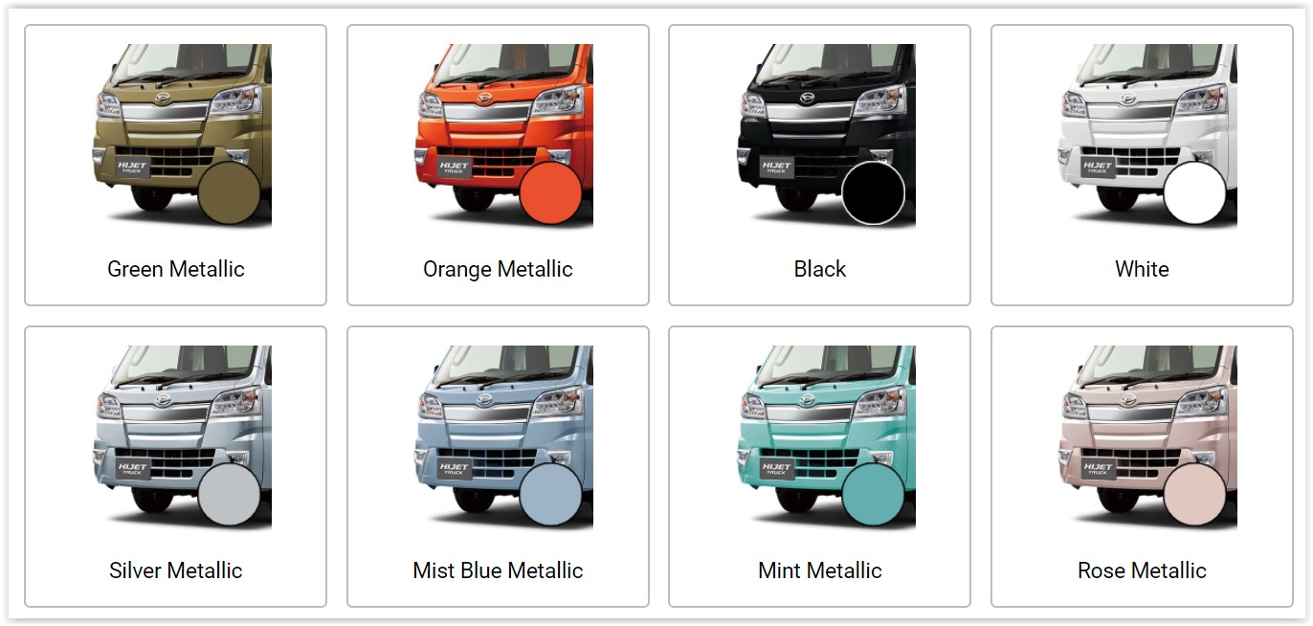
Now with the arrival of the 11th generation S510P iteration of the Hijet Jumbo, the color palette has changed slightly. Sadly, the very striking (and very rare) Mist Blue Metallic and Mint Metallic colors are now gone, being replaced with the rather dubious Ice Green. Hmmm. Of course, it’s all a matter of taste, and perennial favorites Green Metallic, Orange Metallic and Black still remain. Silver Metallic is also rather underrated. It may seem like a rather boring metallic option, but the very slight bluish tinge combined with its sheer brightness makes this a good choice also.
Here are your color choices for the 11th generation Hijet Jumbo:
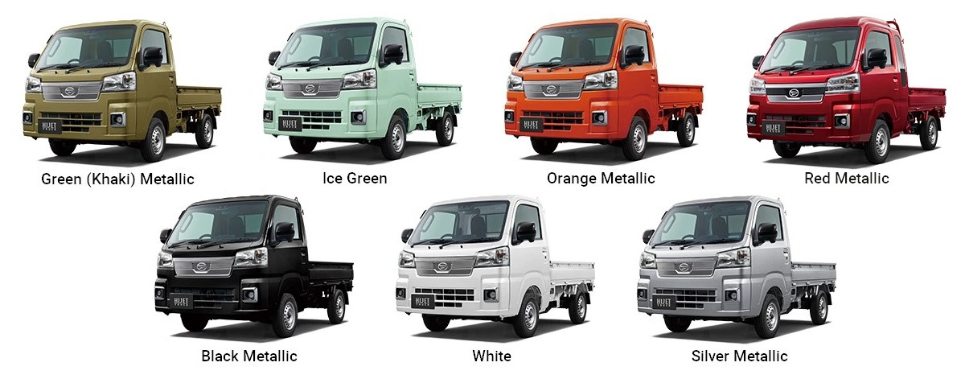
The eagle-eyed among you will immediately spot a couple of things: First of all, that only one of these mini trucks is a Jumbo (the rest are regular cab Hijets, but just ignore the shape and enjoy the colors) and that the only difference with the regular cab model is the addition of the Red Metallic color (or, to give it its full name translated straight from the Japanese — “Fire Quartz Red Metallic”).
You’re not going to see many in this red color either. Firstly, because the most popular color for Jumbos in the US is the Green Metallic, but secondly because it’s only available on the top-of-the-range Jumbo Extra, and it’s hard to see someone wanting to spend so much … extra just for that special color. Anyway, for the sake of completeness, there it is: 7 colors to choose from — from boring old white, to the polarizing Ice Green. Whatever way you look at it (and with the Ice Green, you may want to do that through squinting eyes), there’s going to be a color there for everyone.

HIJET JUMBO CAB ENGINE AND TRANSMISSION
So you can see how these Hijet Jumbo models are great-looking vehicles and a comfortable “office” for you when you’re out in the fields around your farm or ranch. And that’s all well and good. But how does your Jumbo get you out to those fields and get you around while you’re there? Let’s look a the powertrain.

ENGINE
The engine is the same engine you find in all the Hijet body styles (for example, the Hijet regular cab model). It’s Daihatsu’s KF-type 3-cylinder water-cooled engine with electronic fuel injection, a compression ratio of 10.8, producing its maximum power at 5,700 rpm, but with max torque coming in at a lower 4,000 rpm. Lots of good pulling power to keep you moving and hauling over difficult terrain.
With the max capacity regulated by Japanese law to 660cc, Daihatsu hasn’t made fundamental changes in the design over the years, but has evolved it gradually to make it ever more efficient. For example, the latest 11th generation models have start-stop technology incorporated in them which stops the engine wasting fuel unnecessarily when idling. The 10th generation Hijets were already able to get about 50% better fuel consumption than their UTV counterparts. With the addition of this start-stop tech, the Hijet mini trucks have pulled even further ahead, with the auto models in the 11th generation Hijets now getting 25% better fuel economy than the already frugal 10th gen Hijets.
Mini truck engines are built to the NVH (Noise Vibration Harshness) standards you would be more used to expecting from an on-road vehicle. It’s not something you will notice all the time, but a smooth, quiet engine does mean less fatigue when you’re out and about working on your property all day.
Having said that, these mini trucks are pretty easy to maintain. Need to fill up with gas? They take your normal regular gasoline. Need to replace air or oil filters? No problem, the parts are redily available and fitting them isn’t difficult. Have particularly cold winters? Make sure you use anti-freeze just as you do with any of your other vehicles. These Hijets aren’t some kind of thoroughbred hypercar for rich people, so you’ll find that it isn’t rocket science and you can do all the regular maintenance yourself.
And where is the engine? Well, as you may have been able to guess from the body style, the Hijet engine is under the cab, mounted low just behind the location of the seats, giving this Hijet regular cab model an excellent weight distribution and low center of gravity — all adding to the safety and off-road performance of the vehicle.
The final point to mention about the engine is that the engines in these Hijet mini trucks for sale in the US are all naturally aspirated. In Japan you will find there are some kei mini truck or van models that have turbo engines, but (unfortunately) those engines don’t comply with EPA regulations, so cannot enter the US.
Here’s a cutaway of the KF engine showing its inner workings.
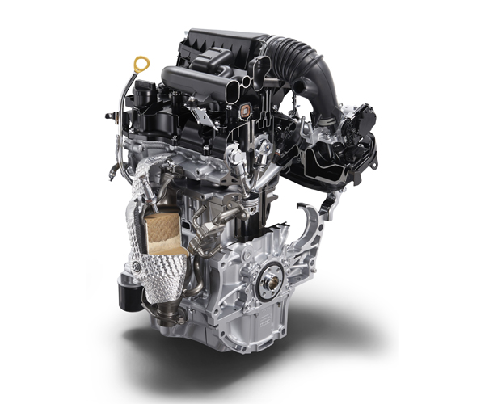

TRANSMISSION
The 9th and 10th generation Hijet regular cab 4×4 models had a number of different manual and automatic transmission options:
- 5-speed manual
- 5-speed manual with hi-lo range and locking rear differential (referred to as the “Farming Package”)
- 4-speed automatic
With the introduction of the 11th generation model at the end of 2021, there were some major changes in the possible configurations:
- 5-speed manual
- 5-speed manual with hi-lo range and locking rear differential (referred to as the “Farming Package”)
- CVT with rear differential
With the CVT transmission and latest engine in the 11th generation, the Hijet with the regular cab has 25% better fuel economy than the previous 4-speed auto model, in addition to the unquantifiable benefits of the smoother power delivery.
But there’s something else you will spot which is new for automatic mini trucks — the fact that you can now get the rear differential with the automatic transmission with this new 11th generation model. With the previous generations, only the 5-speed Farming Package had this. So, now, unless you really need every tool at your disposal for the most extreme off-road work, you won’t need the hi-lo range, and so the Hijet regular cab with the CVT transmission becomes a very good choice.
Here’s a cutaway showing the inner workings of that very CVT transmission:
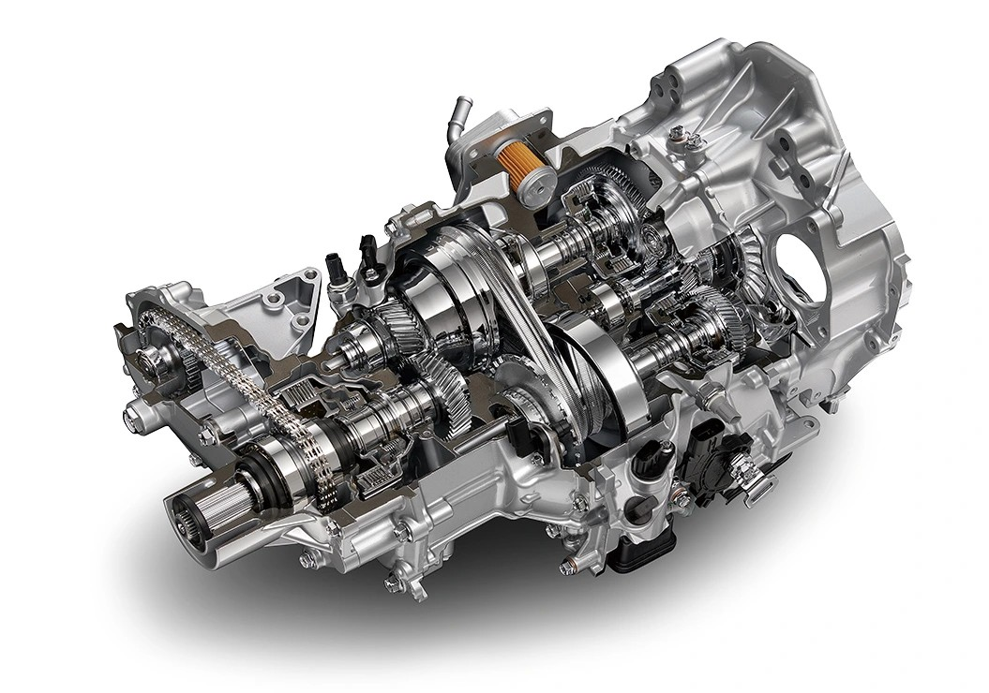

4WD SYSTEM
First let’s be really clear about something: Since all the mini trucks for sale at our independent dealers are for off-road use only, they all have 4WD, even though 2WD mini trucks are sold in Japan. (For the Hijet experts out there, the 10th and 11th gen Jumbos with the 2WD transmission have the S500P designation, but these ones that our dealers sell are the 4WD ones with the S510P designation.)
The basic 4WD system has only changed slightly in recent years, and that was with the introduction of the new 11th generation model. With earlier generation models there’s a button on the dashboard allowing you to turn the 4WD system on and off. Why would you want to do that? Well, powering all four wheels takes more energy than just powering two, so switching into 2WD allows you to save gas. If you’re driving down a dry gravel track, 2WD is more than up to the job, so click the button to turn off 4WD. Drive off that same track onto a muddy field and a click of the button brings the 4WD system into life for better grip.
Here’s where you find that button on the center dash console of the 10th generation model. As you can see, this model is an automatic:
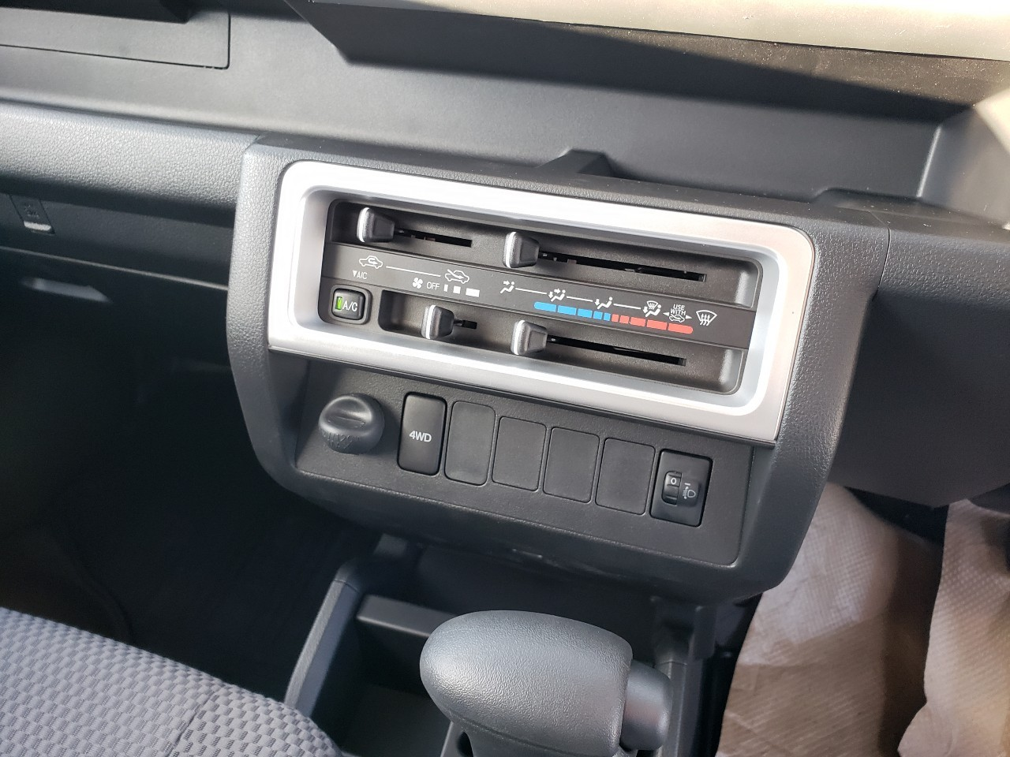
Once again, the 11th generation Hijet takes this to the next level: Now, instead of you having to reach for a button every time you want to switch into 4WD or back again, the auto CVT model has a new “Auto 4WD” model. What this means is that under normal conditions, you can just leave the mini truck to make its own decision about whether 4WD is needed at any particular moment or not. If it decides it’s not needed, it will automatically drop it into the more fuel-efficient 2WD setting. Only if you are doing some really strenuous off-road work will you feel tempted to use the “4WD Lock” override switch to force it to use 4WD all the time.
But, in all honestly, it sounds like this is like the manual model on your camera: Sure, the ad will sell you on all the ways you can take control of the photo-taking experience to make minute adjustments to get just the right shot, but the reality is that after playing with it for 5 minutes, you put it back into auto mode and let the camera do all the work. You may fiddle with this “4WD Lock” button a couple of times, and then just leave it in automatic mode and enjoy letting your Hijet figure it out while you get on with what you need to get done.
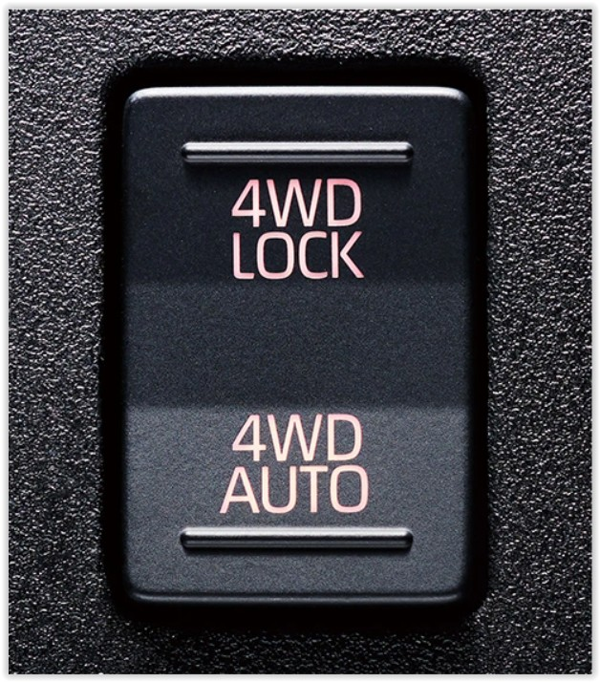

HI-LO SWITCHABLE RANGE
If you’re going to go for a 5-speed manual model, this is likely to be the reason why. I mean, why get the manual unless you’re going to do the most serious kind of off-roading in the most extreme conditions? It’s just a whole lot of extra work for no real reward otherwise. And if you are going to need that extra something to climb that ridge or negotiate that steep incline, then the hi-lo switchable range is that extra tool in your tool box to make sure it happens. The regular cab Hijet models that have this ultra-low range are the ones that have the “Farming Package”. So keep your eyes peeled on our mini trucks for sale page here, and you’ll be sure to find quite a few of them.
So, what does it do? It’s really very simple. It just gives you a couple of extra ultra low gears to either magnify the engine power when climbing, or the engine braking when descending. Think of it as giving you lower gears below the first gear and you’ve got it.
Most of the time you won’t need it. It will make your mini truck painfully slow if you’re just driving along a gravel path. But go off the beaten track a ways and you’ll be glad your Hijet has the extra trick up its sleeve when you need it. And when you do, it’s so easy to operate with this little lever near the parking brake.
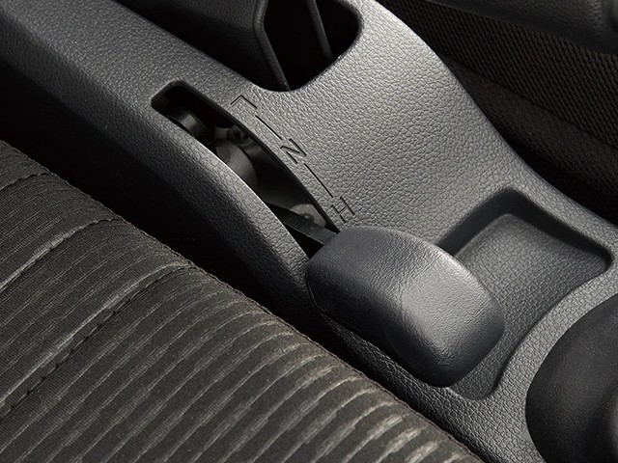

HIJET PICKUP JUMBO CAB LOAD BED
Let’s see how good you are at spotting the difference. There’s something unusual in the Hijet Jumbo load bed that you just don’t see in the same part of the regular cab model. Take a look. First the Hijet Jumbo:
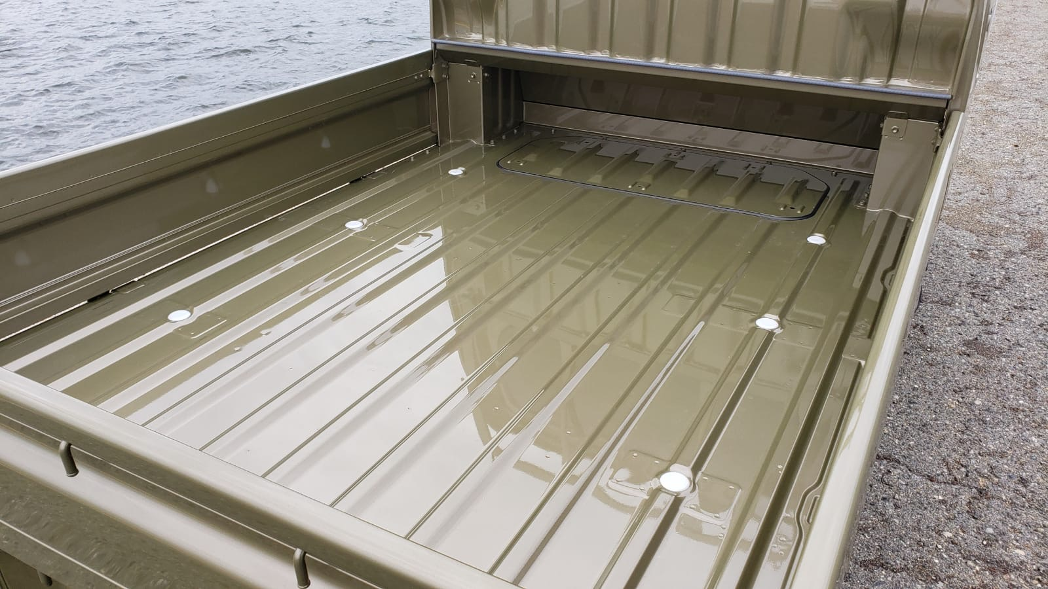
Now the regular cab Daihatsu Hijet. Same generation. Slightly different load bed design. Can you see what it its?
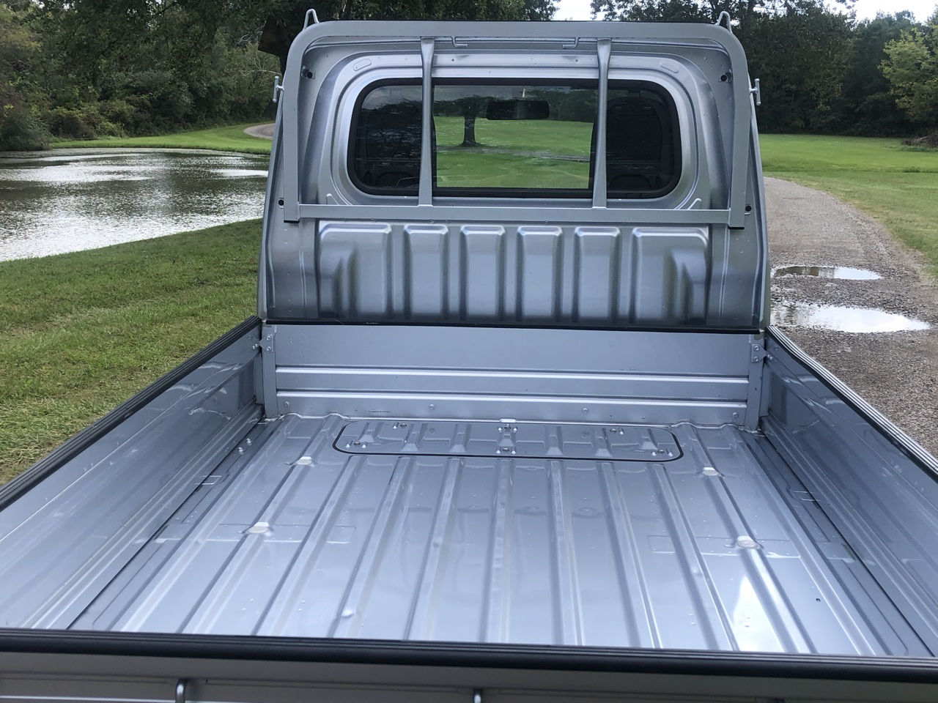
Yes, that’s right. The Hijet Jumbo has a notch at the bottom of the cab to create a longer load bed floor than would be possible with a flat rear panel on the cab. So, even though the cab is deeper and so, inevitably, does eat a little into the load area, the designers have tried to minimize that loss with this ingenious design.
Let’s look at the dimensions, because they’re still pretty impressive:
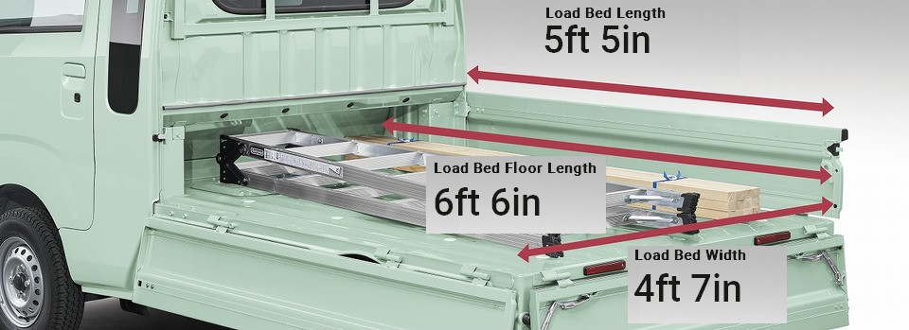
Not only is that a real UTV-beating load space (to haul up to 1700 lbs of stuff!), but it has some nifty features to make on- and off-loading less cumbersome, and easier on your back. Take another look at the photo above and see if you can spot them.
That’s right. Not only does the tail gate fold down for lip-free loading at the rear, but also both sides can be flipped down as well so you can make full use of the long load space without having to stretch from the back to reach things that are further in. It’s another of those design features to have evolved over 60 years and over 7 million mini truck sales to make life easier as you go about your work.
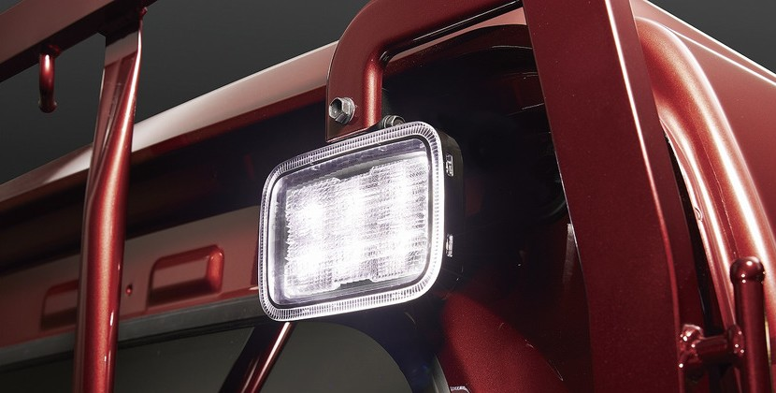
And if it’s dark out there, don’t worry. You can still get things done with the load area lamp turned on. That’s it on the rear of the cab. A quick flip of the button by the wheel, and the LED lighting gives you a clear view of whatever you need to do back there.

