PROFILE & ACHIEVEMENTS
CHRISTIAN STANGIER
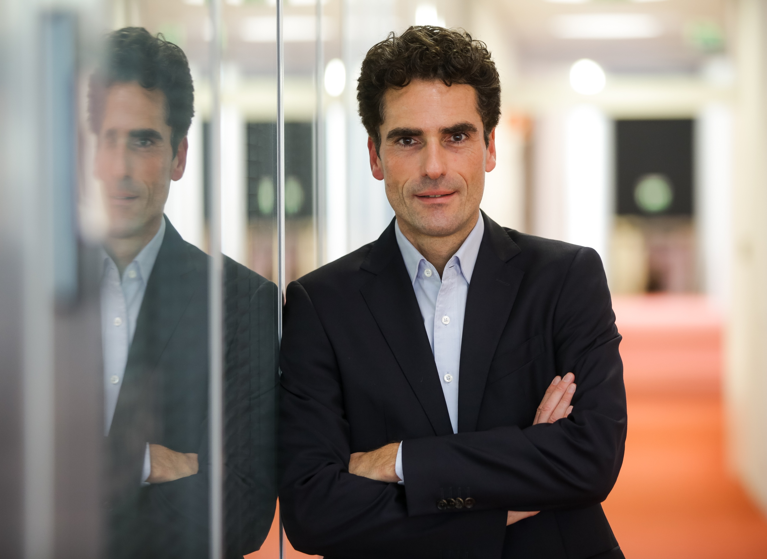
GUIDING ENTREPRENERIAL INNOVATIONS
- Define a way forward for Mavenir’s Messaging business
- Shape a venture for ABB in the eMobilty segment
- Build a joint venture of Deutsche Telekom and Zeiss for the development of connected smart glasses
LEADING GLOBAL PARTNERSHIP NETWORKS
- Overcome strategic objectives and form an alliance of Google and Mavenir in Messaging
- Position Deutsche Telekom as first choice for Apple smartphones with a purchase volume of more than 2 billion euro
PERSONAL INFOS
- Create exclusive advantages for Deutsche Telekom customers through partnerships with major innovators like Apple and Amazon

DELIVERY-ORIENTED PRODUCT LEADER
Christian.Stangier@gmail.com


- Manage the roll out of new GSM-R Units to >5000 vehicles for Deutsche Bahn AG in logistics and technical integration
Vivatsgasse 4-6
53111 Bonn, Germany
- Open the door for IoT business of Sequans to access European telcos
04.12.1967

- Develop a consistent Magenta@home experience and build the corresponding device portfolio supporting DSL, TV, Smart Home
www.linkedin.com/in/christianstangier

EXPERIENCE (exemplary)
QUALIFICATIONS
SENIOR ADVISOR (self-employed)
10/2020 – Present
Excubate Corporate Startups
- Venture building (e.g. with ABB and DT)
- Derive a product strategy and go to market plan
CORE COMPETENCIES
- Passionate Digital Transformation Leader with track record of launching and growing business
- Entrepreneurial background with network to global innovation hubs
- Strong Product & Innovation competence with a clear understanding of market needs
- Track record in driving partnerships into highly successful collaborations

ACCOMPLISHMENTS
- Mentor at Intel’s Ignite program for start-ups
- Crash Course in Data Science at
The John Hopkins University
- Intro to Blockchain Technology at Insead
- PSM 1, Certified Scrum Master, Scrum Alliance
- Leadership Excellence Program at
IE Business School

Key Success:
- Successful start of Panion, the ABB eMobility venture
08/2021 – Present
Sequans Communications
- Define a strategy how to approach telco carriers
- Evaluate business models to engage with distributors
Key Success:
- Growth through new distribution channels via carriers
04/2021 – 04/2022
Mavenir
- Evaluation of the global messaging business
- Define a new strategy for messaging in Mavenir
- Implement a new independent business unit for SaaS
Key Success:
- Successful start of the new business unit
10/2020 – 12/2022
mm1 Consulting
- Steering of a group wide exchange of GSM-R equipment
Key Success:
- Improvement of the mobile connectivity experience for
customers of the Deutsche Bahn AG
DEUTSCHE TELEKOM AG, BONN
UNIVERSITY
Executive Leadership Development Program at Stanford Graduate School of Business (2016)

Diploma in Electrical Engineering at
Technische Hochschule Aachen (RWTH)
(1987-1994)

LANGUAGES
- German Native
- English Full professional proficiency

ACTIVITIES
- Sport: Skiing, Tennis, Hiking, Yoga
- Music: Classical Piano
- Travelling: Europe, Africa, America

REFERENCES
- Timotheos Höttges, CEO Deutsche Telekom
- Michael Hagspihl, SVP Global Strategic Projects and Marketing Partnerships, Deutsche Telekom
- Yves Maître, formerly CEO HTC Corporation

08/2011 – 07/2020
Senior Vice President Connected Devices
- Management of the global partnerships with Apple, Google, Samsung
- Board member of Tooz Inc, a JV of DT and Zeiss AG
- Driving the entire portfolio of devices for the DT group including Wearables, Voice Controlled Devices and Virtual Reality Glasses

Key Successes:
- Managing a turnover of more than 3 billion euros with devices across the Deutsche Telekom group
- Development of the first Magenta Voice Speaker
- Foundation of the Tooz joint venture
Vice President Product Management Mobile
04/2008 – 07/2011
- Introduction of the international portfolio of mobile phones in Deutsche Telekom
- Project lead for key initiatives, e.g. introduction of Android

Key Successes:
- Successful introduction of the first Android phone in an exclusive partnership with Google and HTC
- Development of the DT App portfolio for iOS and Android

T-MOBILE INTERNATIONAL, BONN
Head of Client Integration/ISP Products
09/1994 – 03/2008
- Conception and development of a T-branded mobile phone
- Transformation of product management from voice-centric into mobile internet business
Project Lead Personal Communication Services
- Project lead of the first FMC product combining fixed and mobile communication on one bill with one device and one service
Project Engineering
- Project lead “Short Message Service Center”
- Voice quality assurance: Design of a new measurement system and implementation in C++
- Audits of system technology suppliers
Bonn, 03.01.2023

