THE STORY - OUR TEAM

Building a house should not be stressful – we believe it should be the happiest and one of the most rewarding experiences in your lifetime.
So we set up our Happiness Brains Trust to troubleshoot how to remove the stress, delays and unexpected costs from building.
The key problems our HBT came up with…and needed to solve:
- Lack of tradesmen…and when you find them they can be VERY expensive.
- Lack of supply …. The waiting time on timber, widows, doors, etc is generally months or longer
- Lack of Communication – Getting all the tradies and suppliers to talk to each other and coordinate in a timely manner can be impossible and ends up costing months of delays.
After several beers (I mean hours/days/weeks) we came up with the solution. Why don’t we get all the trades, materials, engineers, Quality controllers and inspectors in the one location – then if they have a question, they can ask face to face. No delays in waiting for materials as they are all in the one factory where the materials com from.

The best part of this plan is it saves time….which saves cost.
When you buy your house, the price in GUARANTEED

When you buy your house, the completion date is GUARANTEED

When you buy your house, we say go on a holiday for a month (with all the savings you have made buying through Foldabl) and we will have your house ready for delivery on your return.
Chris Jones - Builder (Co-founder)
Chris has been in construction industry for over 30 years. Starting out as an apprentice builder right after high school, he's learned how to build a house from the foundation up. Eighteen years ago he turned his passion into a business that focuses on the long-term goals and satisfaction of his clients.
Jason Zhang - Architect
Jason is the wizard that brings all the modules together. His design enables the home owners to design their housing like lego. Every component has universal connections that is the key to fast and affordable installation. Jasons inspiration has come from studying the European designs.
Renee Bolter - Structural Engineer
Renee works very closely with Jason and our prefab team to ensure the design and vision of Chris & Jason are created in a structurally sound construction that surpass Australian standards. Every project is signed off to the standards set by Renee and that is how we offer the longest guarantee in the marketplace.
Greg Jonas - Plumbing Engineer
Gregs job is to make sure that not only is all the plumbing up to scratch, but also that it is visually pleasing to the home owner. Greg works with Julie to create the best bathrooms, kitchens and laundries.
Matt Stakes - Electrical Engineer
Matt has worked with Chris for 20 years. His job is to make sure that all electrical is not only up to regulation but to design the connectors that enable services to be joined and signed off according to the safety regulations of Australia & New Zealand
Julie Wzang - Interior Designer
Julie was born in Singapore, studied in Beijing and Berlin then moved to Australia 15 years ago. She has worked with the worlds best in modular design. Whilst Julie mainly works with our engineers to improve the flow of all plans, she also love to work with Chris vision and European influence
Sally Peterson - Logistics Director
Sally has over 20 years in logistics and makes sure that everything arrives as expected - this type of building is only as good as the logistic manager planing....and sally is the best.
Mark Kopolakis -Finance Director
Whilst we laugh, Marks job is to pay the bills and pay the wages....His real passion is making the "Australian Dream" of affordable housing for everyone. Marks dream is to enable evey person in Australia to become a home owner for under $199 per week
Frank Hill - Project Manager
Frank has worked with Chris for the last fifteen years. He has a degree in Business that focused on Construction Science and a knack for delivering a project on time and on budget. He's all about the details and loves adding those finishing touches that bring a project together.

THE PRODUCT - WHY CHOOSE FOLDABL HOMES?

What is a Folabl home
It is simple through very clever engineering we build your full house in our factories including all electrical, plumbing, shelves, benches, lights, fans, window, doors….and even the kitchen sink. Once we have completed construction, we cleverly fold it up ready to ship.
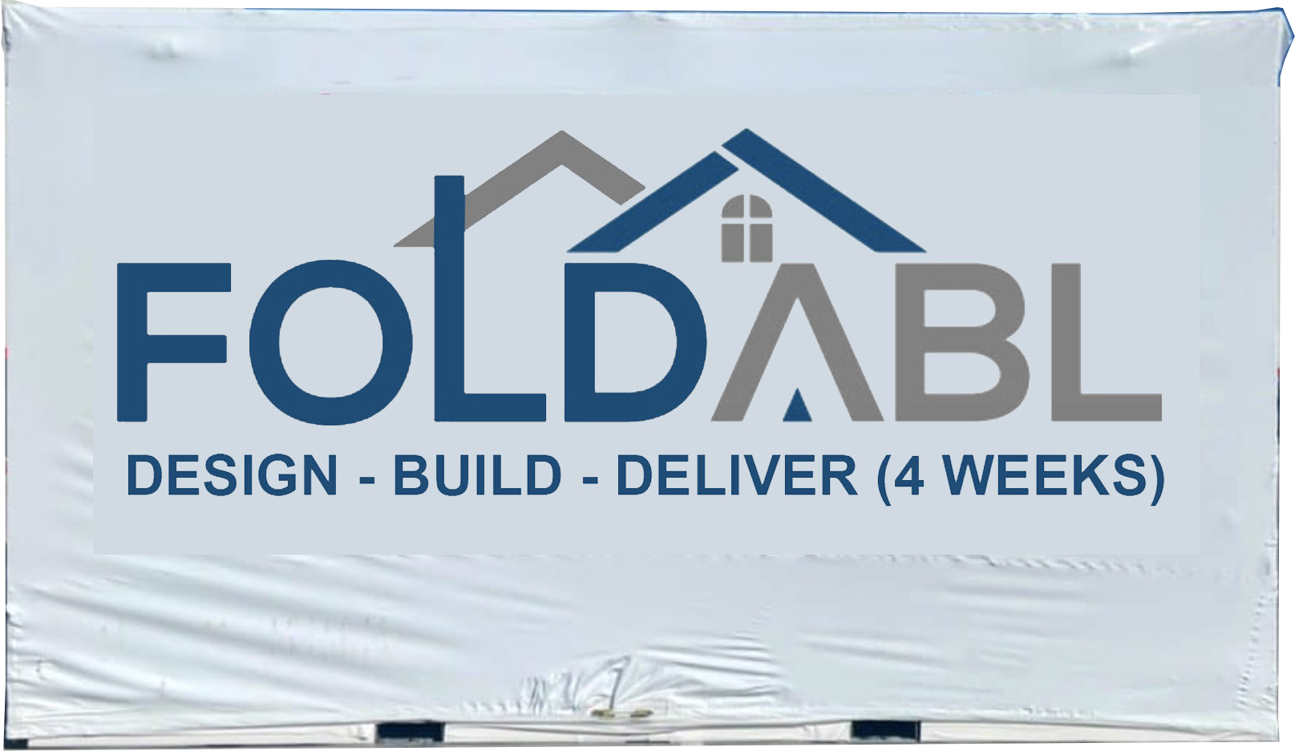 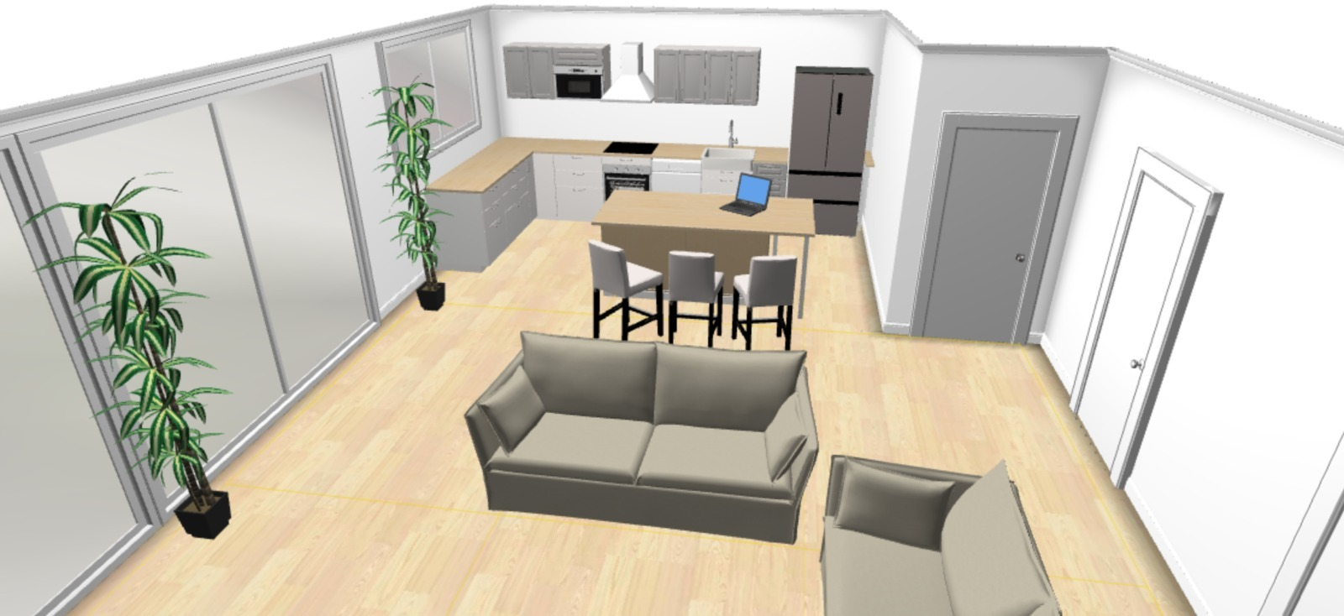

Once it arrive at your property, within hours you can have it unfolded and ready to move in to – it is that easy

Every design is Unique
Use our easy online tools to design your own unique home with different colours, kitchens, bathrooms, flooring, etc – every design is Unique
Fast Construction
Within 24 hours of designing your house, our busy elfs will start construction on your dream – In under 4 weeks we will have your construction complete and at the port ready to ship to you anywhere in the world.
Reliable Shipping
Our shippers are fully insured and we shrink wrap for safe travel. Shipping can take 1 – 4 weeks (depending on your location)
Minimal Permits
Every local government can have different bi-laws, but as our core construction is pre-engineered in our factories and signed off prior to delivery - this means less bureaucracy – in in most countries permits are not required.
Affordable
You can own your own home from just $9990. If you calculate that over a 10 year period, that is under $20 per week. You supply the land - we will supply the house.
10 Year Guarantee – New for Old replacement
In most jurisdictions, government regulations require builders to give a 7 year builders warranty. We are so confident in our structures we will give you 10 years structural Guarantee - new for old replacement.
Quality fit-out
We have sourced the best quality local and imported products to ensure you the highest quality. If we don't have what you are after our buying team will source it. Our job is to make your dream come true.
Stress free building
We have a team of specialists to help you through the very exciting design, build and move in phases of your journey. We have engineers, tradesman, designers and support team to enable you to realise your dream your way!!!!
Licensed Contractors
As a company dedicated to providing premier customer service, it is important to us to deliver unparalleled workmanship on every assignment.​ We are accredited, licensed, bonded, and insured. With our experience and expertise, we can provide the support your project needs.
On-time Completion
We will work with you to meet deadlines and coordinate with other related projects. We will maintain open communication with you to keep you up to date on the status of your job. We do this to guarantee that the project is completed according to your preferences.
Great Service
We combine our industry knowledge, the highest quality building supplies and equipment, and our dedication to deliver exceptional service to our clients. We will stay in touch, keeping you up to date on both the paperwork and renovation process.

Designs: Standard - US$9,995
Each module is 6.0m x 5.0m (30 sqm)
The yellow section of each module can be interchanged
The white area is open plan and you can add partition walls.
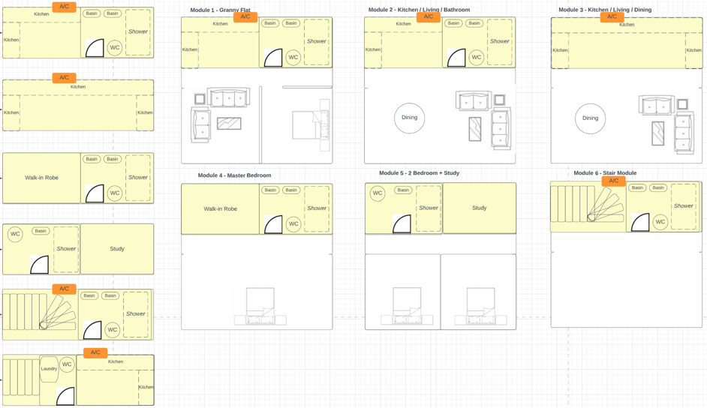

You can add 2 (or more) modules together for larger housing (60sqm)

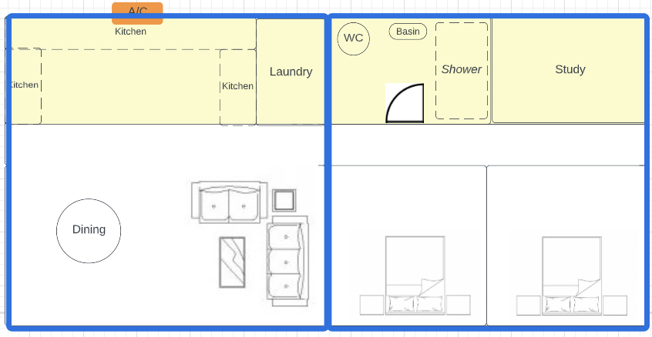

Or go double story (60sqm)
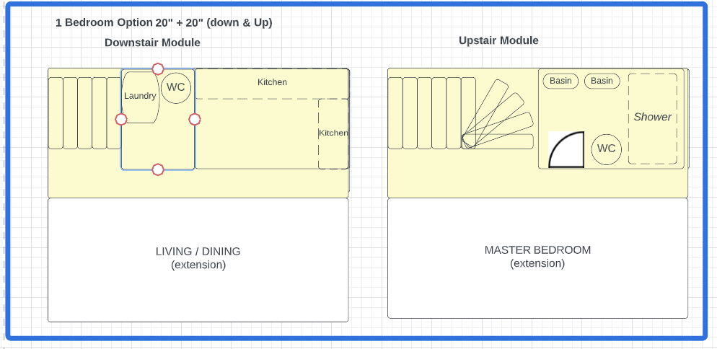

Designs: Upsize - US$18,995
Each module is 6.0m x 5.0m (30 sqm)
Or you can upsize to our larger models that are 60sqm each eg. Add 2 together and you have 120sqm
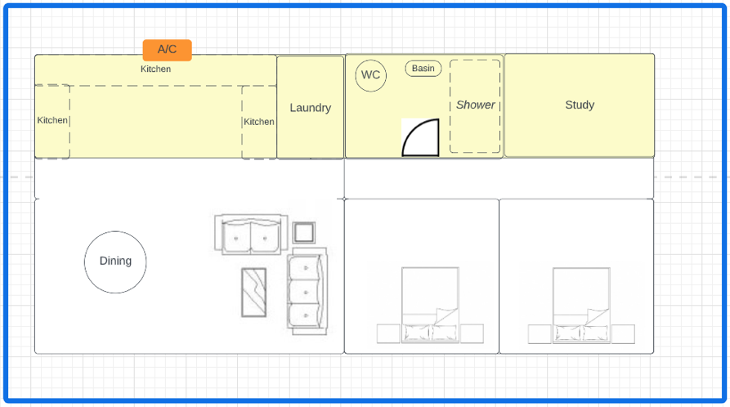

PRE REGISTER

To kickstart we are offering our first 1,000 houses for US$9,995

All you need to do is give you name and email and you are registered.

[insert – pre registration form (including embedded payment form)]
Then you have 2 options:
Option 1: In under 20 words tell us why you deserve to be one of the first 1,000 people in the world to get a Foldabl home.

Or

Option 2: Introduce 5 people to Foldabl and get INSTANT approval.
You will be asked to pay a $100 refundable deposit.
When we give you a start date on the build, you will need to pay a 50% deposit. The balance is due once it is Quality tested and wrapped for shipping
Once they have registered, they will get a message.
Whilst our factories and staff are ready to start building – to offer this house so cheap, we require crowdsourcing of the first 1,000 pre-registration.
So please add this link to your:
[*&^(*&((^(*^&(^(((&^^(^^(] Facebook
[*&^(*&((^(*^&(^(((&^^(^^(] Instagram
[*&^(*&((^(*^&(^(((&^^(^^(] TikTok
[*&^(*&((^(*^&(^(((&^^(^^(] Twitter
[*&^(*&((^(*^&(^(((&^^(^^(] LinkedIn

Or email out to your address book.

PRIVACY POLICY
Foldabl Pty Ltd is committed to protecting the privacy of our customers and website users. This privacy policy explains how we collect, use, and share information about you when you use our website or otherwise interact with us.
Information we collect
We collect information about you when you use our website or otherwise interact with us. This information may include:
Personal information: This is information that identifies you as an individual, such as your name, email address, or phone number.
Payment information: If you make a purchase through our website, we may collect payment information, such as your credit card number and expiration date.
Usage data: This is information about how you use our website, such as the pages you visit, the actions you take, and the search queries you enter.
Device information: This is information about the device you use to access our website, such as the type of device, its operating system, and its internet protocol (IP) address.
How we use your information
We use the information we collect about you to provide, maintain, and improve our website and services, and to develop new products and services. We may also use your information to communicate with you, such as to send you updates or to respond to your inquiries.
How we share your information
We may share your information with third parties in the following circumstances:
With service providers: We may share your information with third parties that provide services on our behalf, such as hosting, data analysis, payment processing, and customer service. These service providers are required to use your information only as necessary to provide the services they are contracted to perform.
For legal reasons: We may share your information if we believe that it is necessary to comply with a legal requirement or to protect the rights, property, or safety of ourselves, our users, or others.
With your consent: We may share your information with third parties if you have given us your consent to do so.
Your choices and rights
You have certain choices and rights with respect to the information we collect and how we use it. These include the right to access, correct, delete, or object to the processing of your information, as well as the right to withdraw your consent to the collection and use of your information. You can exercise these rights by contacting us using the contact information provided below.
Data retention
We will retain your information for as long as necessary to fulfill the purposes for which it was collected, or as required by law.
Data security
We take reasonable precautions to protect your information from loss, misuse, and unauthorized access, disclosure, alteration, and destruction. However, no internet or email transmission is ever fully secure or error-free, and you should take this into account when communicating with us.
Compliance with General Data Protection Regulation (GDPR) and Payment Card Industry Data Security Standard (PCI DSS)
We are committed to complying with the GDPR and PCI DSS in the collection, use, and storage of your information. This includes taking appropriate technical and organizational measures to protect your information from unauthorized access, disclosure, or misuse.
Changes to this privacy policy
We may update this privacy policy from time to time to reflect changes to our practices or for other operational, legal, or regulatory reasons. When we update the privacy policy, we will revise the "last updated" date at the top of the policy and post the updated policy on this page. We encourage you to review the privacy policy whenever you access our website to stay informed

TERMS AND CONDITIONS
[Add details]

INVESTMENT
[Add details]

MEDIA
[Add details]

NGO & GOVERNMENT
[Add details]

