

2023 KENYA Tour Guide
Hosted by: The Global Foundation for Education & Economic Mobility, Inc.
(A USA 501c3 nonprofit charity) and Social Impact Tourism-Kenya (A Kenyan-American Company)
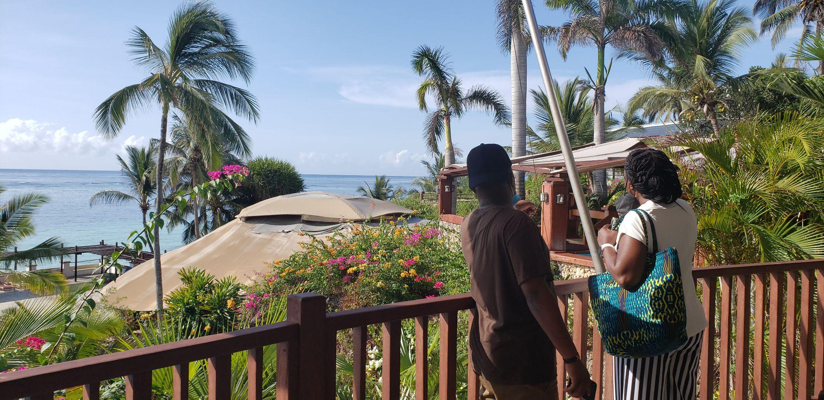
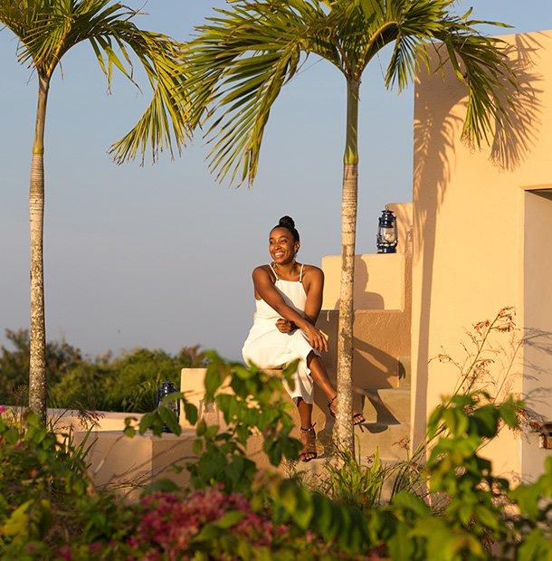

2023 TOUR DATES
February [February 4-14, 2023] * Just added *
June [May 28-June 10, 2023]
August [August 4-14, 2023]
Reserve your Dream Retreat today!
Special, Hosted Events and Tours
March- Manda Shivanga Medical Camp in Western Kenya [March 12-20]
October- Power Tribe Women Retreat and East African Tour [Oct 9-19]
September- Private Celebrity Golf Tournament and Film Industry Summit

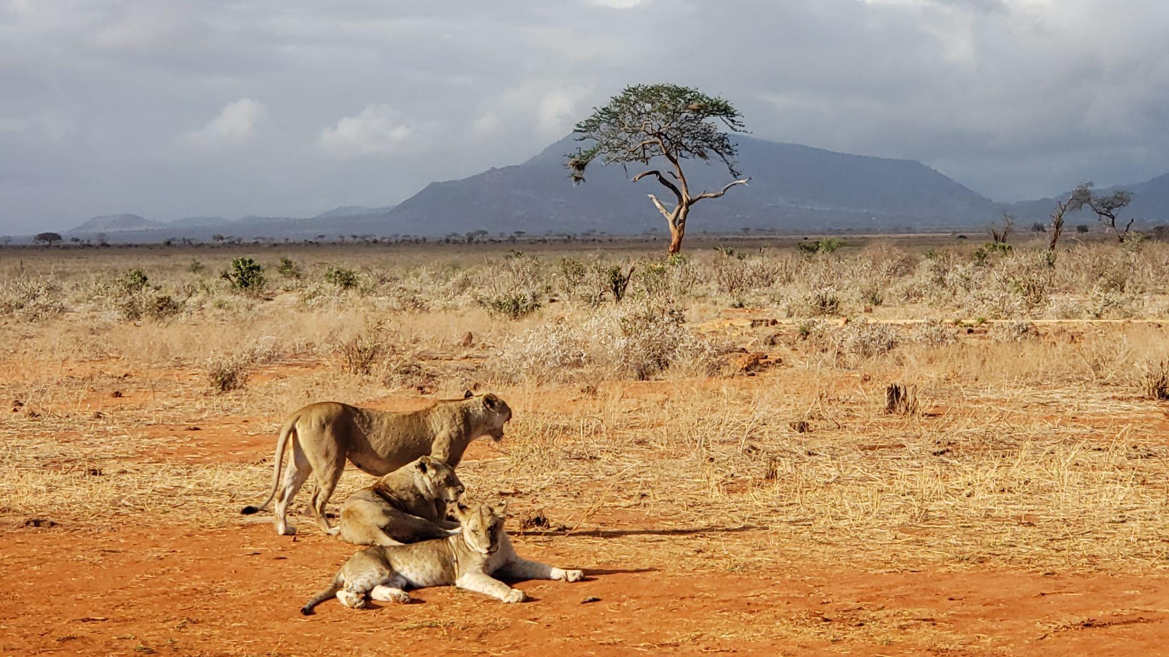
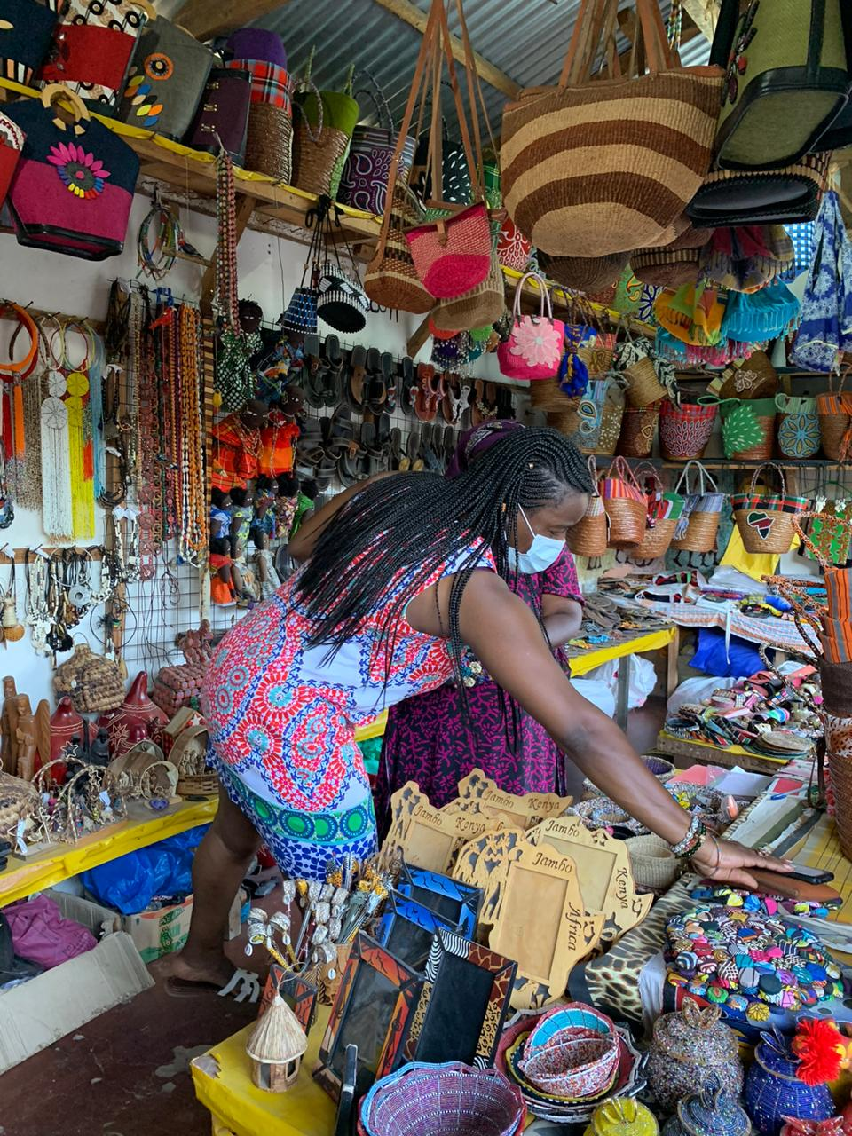
WHAT WILL YOU DO IN KENYA?

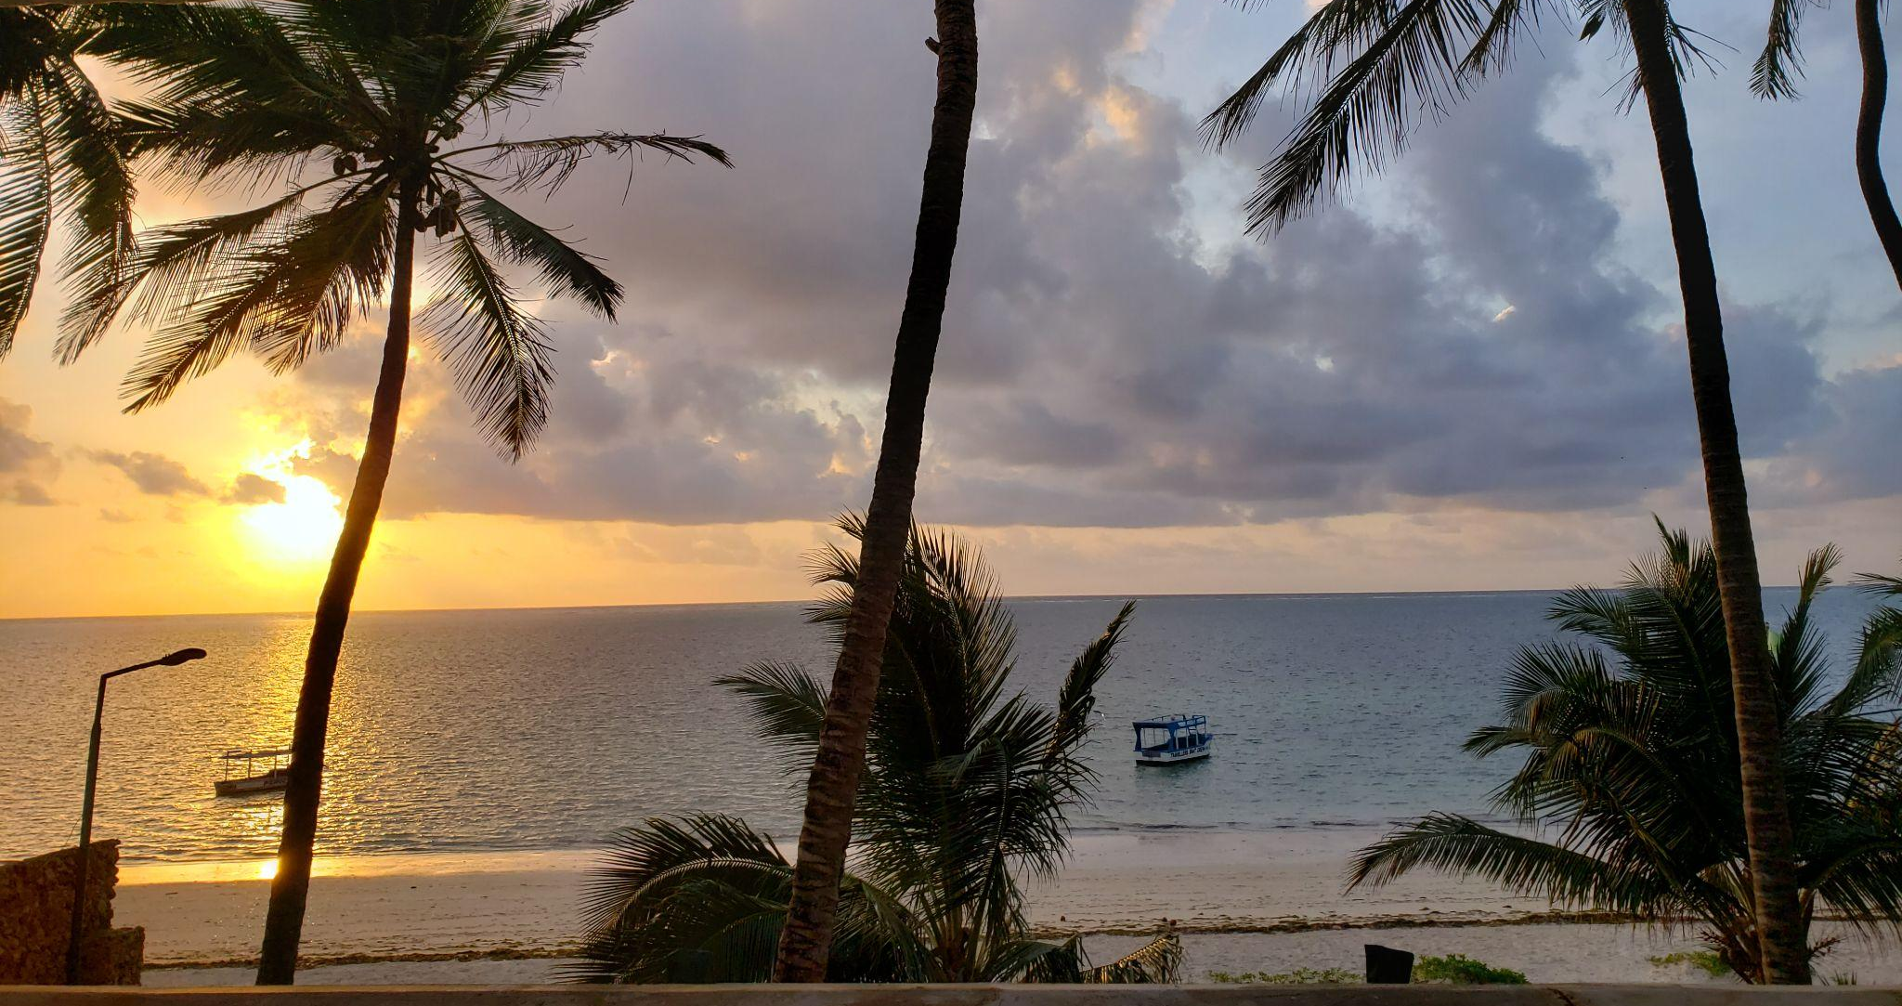

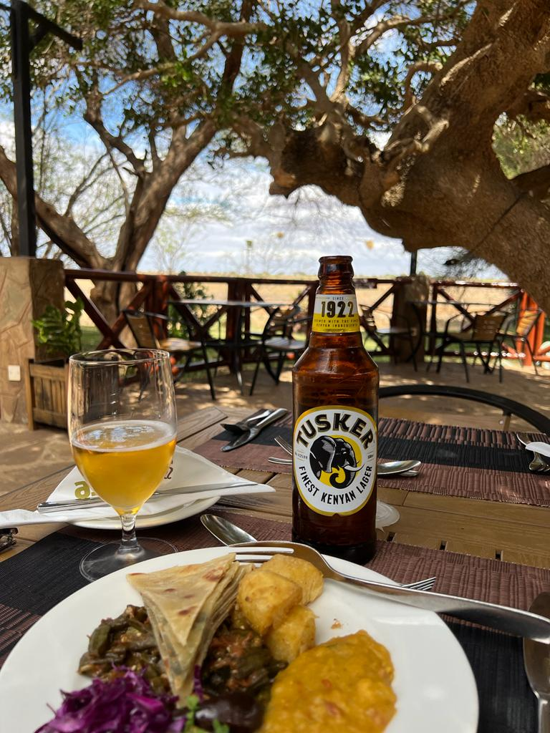

OUR TOUR GUIDES AND TRUSTED TRAVEL PARTNERS INVITE YOU:
- Private chauffeured vehicles with professional guides
- Great food and fare: International and local Swahili cuisine
- 4-5 star hotel accommodations in Nairobi, Western Kenya (Kisumu) and Mombasa
- A private guided African wildlife safari in a national animal reserve park
- Cycling: Explore Vipingo Ridge on two wheels by cycling paths within the estate
- Morning Yoga with resort trainers
- Private African Tailoring
- Spectacular views, water sport activities and animal reserve safaris on the coast at Africa’s only PGA branded course and academy.
- Beauty/Hairdressing
- Classic horseback riding on beautiful nature trails within the secure estate
- Snorkeling, kayaking and stand-up paddleboarding. on the best coral gardens on the Swahili coast.
- Hiking adventures along nature trails and through wild terrain.
- Tennis on all-weather courts
- Spa/ Massage by trained professionals
- Skydiving over the incredible sights of Vipingo Ridge and landing on our beautiful beach in front of the Beach Club

Reserve your Dream Retreat today!
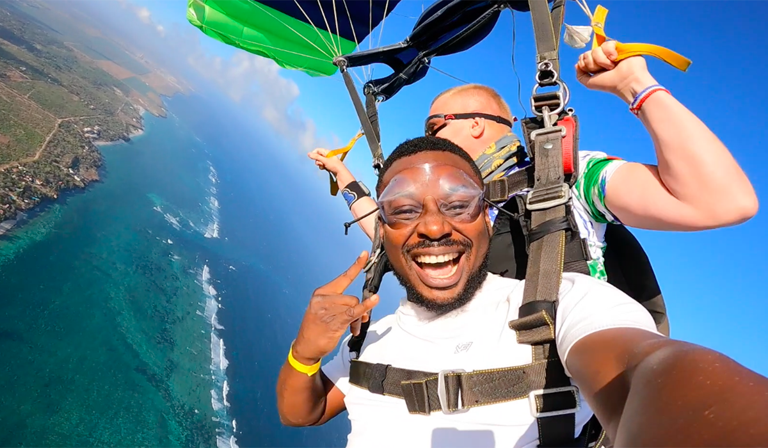
Check out our photo gallery to get a sneak peek
What is the tour schedule?
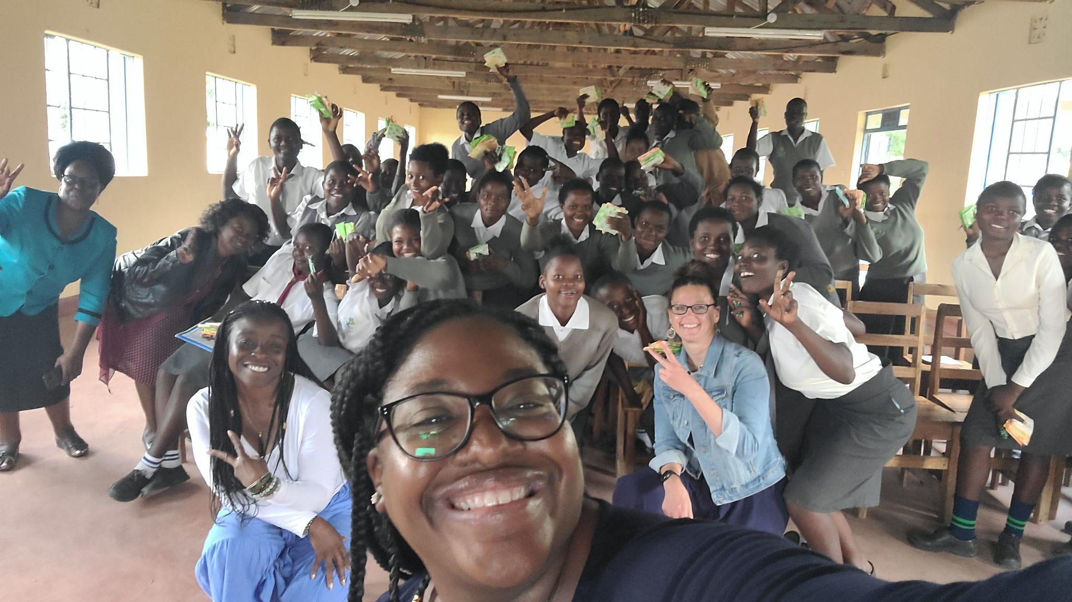
You will depart from Atlanta, Georgia and New York (JFK), landing in the capital city of Nairobi for three days of (re)introduction to African and Kenyan history, culture, food and lifestyle. Then, we will embark, via national commercial airlines, to the coastland beaches of Mombasa, Kenya for four days of retreat, relaxation and reflection at the luxurious Vipingo Ridge Resort. Our tours include the unique privilege of social impact, through the donation of Personal Care Packages and K-12 Scholarships to exceptional Kenyan girls.

TRIP ITINERARY
Board Flights from New York (JFK) or Atlanta, GA (ATL)
Day 1  Tues, 10th | Arrive at Jomo Kenyatta International Airport in Nairobi, Kenya  - Private Car to The Social House Hotel (Single Occupancy)  - Received at airport by Kenyan Hosts with Jubilation
Day 2  Wed, 11th | Welcome to Kenya!  - Breakfast at The Social House @ The Living Room  - Nairobi shopping for clothing, jewelry and keepsakes  - The PTW ‘Karibu’ Dinner and Happy Hour, at the the PepperTree Lounge  - A themed cocktail and welcome bag gifted to all guests
Day 3  Thurs, 12th | Cultural Reconnection and Reflection  - A day at the Bomas to explore the indigenous tribes of Kenya, Swahili cuisine and arts  - Spa retreat at the Kempinsky Hotel Spa  - Bespoke Scrub or Massage included  - Dinner at The Social House rooftop restaurant, Inca
Day 4  Fri, 13th | - Breakfast at The Social House @ the Living Room  - Re-Connecting to Your Sovereignty- Group Meditation Session  - @ the Social House Board Room with Kenya Dunn  - “DO EVERYTHING & Nothing” Day  - Sundown ‘Asante Sana’ Meditation and dinner at the Revolving Restaurant at the Movenpick Hotel
Day 5  Sat, 14th | - 1-hour commercial flight to Mombasa (MOI) to arrive at Vipingo Resort (Kilifi Country)/  - Check in to Villas | Poolside rest and fellowship  - Sundown Meditation and dinner at the Vipingo Clubhouse with Kenya Dunn and Quinetha Fraiser
Day 6  Sun, 15th | Vipingo Resort (Kilifi Country)  - Organized events
Day 7  Mon, 16th | Vipingo Resort (Kilifi Country)  - Organized events
Day 8  Tues, 17th | Vipingo Resort (Kilifi Country  - Guided Tour of the city of Mombasa | Local Shopping  - Donation of Girl’s Care Package to Mikandani (Royal School)  - Private Beach Party and ‘Rafiki Circle’ Bonfire
Day 9  Wed, 18th | - Fly back to Nairobi on commercial airline  - Check into Palacina Suites and lounge at the Pool;;  - “Do Nothing and Everything” Day  - Enjoy Dinner at Palacina in Garden with facilitate group reflection
Day 10  Thurs, 19th | - Breakfast and Travel Affirmations in the Garden of Palacina Suites  - Day in Nairobi for last minute shopping/errands  Depart for US at 8pm for 11pm flight

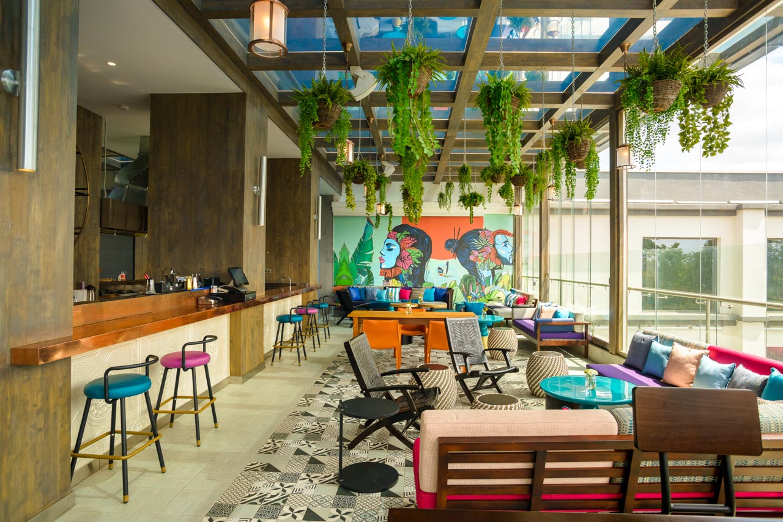

Your Investment (In your SELF!)

All interested travelers are welcome to pay a lump sum or start a payment plan to pay for the PRIME TRAVEL PACKAGE (Per Person): $6,250.

The Package price will increase to $7,000 after January 30, 2023. A Deposit (nonrefundable) of $1,000 must be received before a travel profile is created by SITK/GFEEM.
Reserve your Dream Retreat today!

Kenya Entry Requirements

- A valid US passport with at least two blank pages, six months’ validity, and a visa are required to enter Kenya
- Single-entry visas are available online and upon arrival at Kenyan airports; We will schedule time with you to apply for your Visa.
- Proof of Yellow Fever Immunization- you may be denied entry without it. Passport Health has nationwide locations that provide the vaccine. (Trusted Provider: Paula Orr, MD at the Charleston Women’s Wellness Center in Charleston, SC
- COVID vaccination card or (multiple) PCR test
- *You will be offered Travel & Health Insurance by our trusted partner

Kenya Quick Facts

Official Name: Republic of Kenya
Official Language(s): English, Swahili (English is commonly spoken)
Capitol: Nairobi
Location: East Africa- Kenya borders Uganda, South Sudan, Ethiopia, Somalia and Tanzania
Currency: Kenyan Shillings ($1USD= KSh124) We will take you to exchange currency at the best rate while in Kenya
Tipping: Tipping varies on service you receive. Tip around 10% in restaurants and 200-500 shillings for hotel staff
Tourism: Kenya has many national parks and wildlife reserves, with safaris featuring large animals; lions, buffalo, leopards, elephants and rhinoceros.

Discover Kenya Video and Mombasa

Culture Facts (for better cultural awareness):
- Kenyan Time is flexible. Culturally, the pace of life is slower. Don’t expect people to be in a rush the way Americans often are
- Tea is commonly served with every meal and during social gatherings
- Must go through metal detectors before entering any building/complex
- Kenyans value politeness and aren’t rude or aggressive people. Always greet people enthusiastically, smile, and be mindful to not be curt

Reserve your Dream Retreat today!

Images
Please create a photo gallery (thumbnails) from images provided and from websites of travel partners:
Vipingo Ridge Resort
Palacina Suites
Peppertree Lounge
Social House Kenya
Kenya Airways
Jambojet Airways
Bushking Tours

Reserve your Dream Retreat today!



