Front side ideas:
Logo

No Cost SEO Analysis
(see back for details)

Why is ranking high in search so important for OEMs & Contract Manufacturers?
90% of people don't go past the 1st page of results... If you are on the 1st page you get more chances to quote new business!

Note: Need a Graphic depicting the same data with a different title: Manufacturing Related Searches -Click Through %
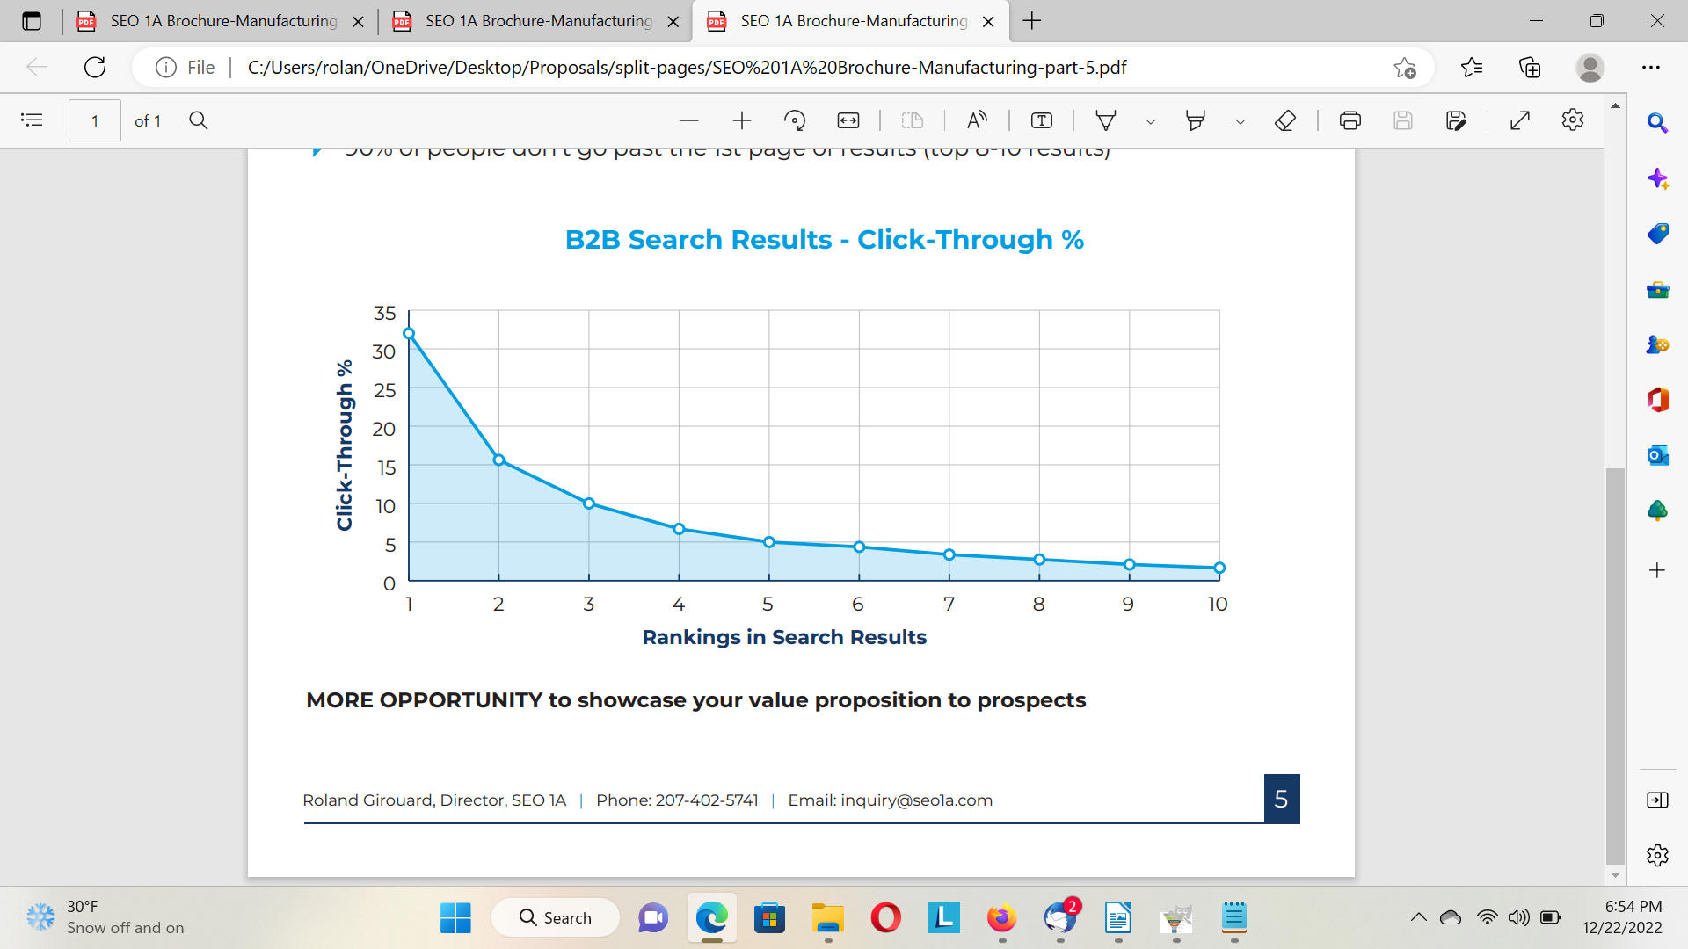
Footer has website, email, phone (https://SEO1A.com, inquiry@seo1a.com,
+1 646-389-7095

BACK SIDE IDEAS
Option 1 – Free, No Cost SEO Analysis
We will review some of the major factors that affect your rankings in search engines & provide you with a report that you can use to make improvements.

Option 2 - Detailed SEO Analysis & Road Map for Improvement
We will meet with you to gain a good understanding of your goals. We will then give you a quote to perform a detailed SEO analysis. This analysis will be coupled with a road map for improvement that your company can use to improve your results.
Your cost for this depends on: Number of languages & Geo-targets, how many competitors you’d like us to review, how many different products / services you are selling.

History: Manufacturing SEO expertise since 1995, 'before Google'
- Our customers have had 100,000+ top 10 rankings in search engines
- Exclusive microdata about 20 million electronics manufacturing searches. No other SEO company has this.

Ask some of our customers for references!



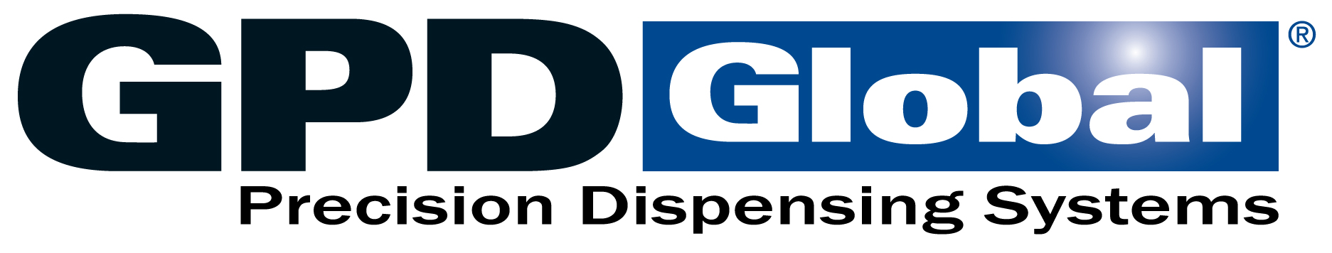





Footer has website, email, phone (https://SEO1A.com, inquiry@seo1a.com,
+1 646-389-7095

