PHYTWELL Label Design- 2 Products: Daily Health and Restore + Relief

******Notes on 1/19:
- I like this version below.

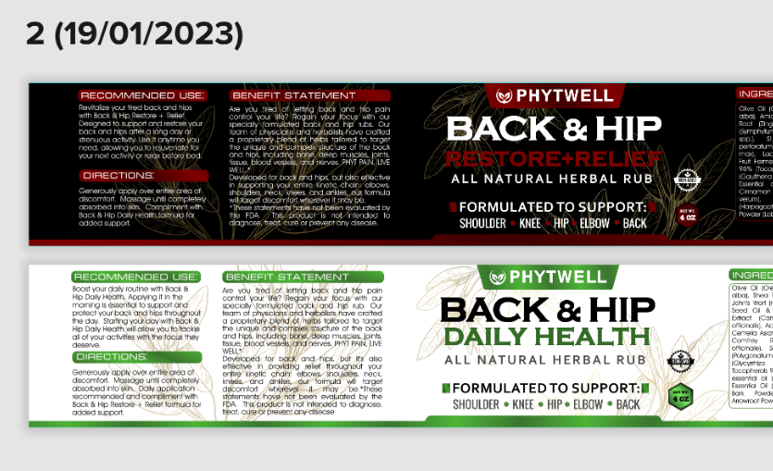
- Can you update the “Formulated to support shoulder, knee, hip, elbow, back” to look just like this below in terms of the layout, style, font, font size: But it needs to say “Formulated To Support” (next line down, similar to how it is structured below) Muscle Joints Tissue Bones Nerves (just as it is laid out below with those shapes in between the words, so a shape between Muscle/Joints, Joints/Tissue, Tissue/Bones, Bones/Nerves )



- On the white container I’m thinking the background plant imagery may need to be silver, like you originally had it. When you start to look on the back, such as on the benefit statement as shown below it is hard to read with the gold color. Open to your final thoughts on this.
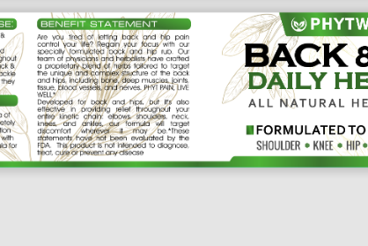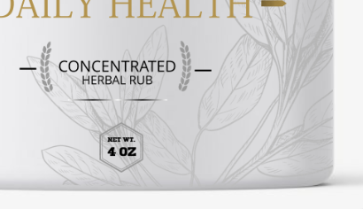

- For the ingredients you have a box around it, but you don’t have that for the other copy. Was that intentional? I would be okay if you put the box around each section of copy or remove it on ingredients.
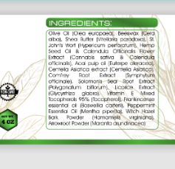

- We like this lid option for the “Phyt Pain, Live Well”

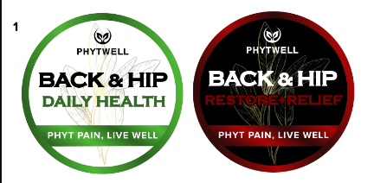

Thanks again for all of the changes

***End of Notes for 1/19

BACK & HIP +, Daily Health (was Back & Hip Rejuvante)
Container & Lid Color- White
Font Color- Black + Color
Font Style- Phytwell logo font should remain the same as in the files. I’m open to the style and boldness of the other text.
Product Style: Masculine, Premium, Matte finish, Metallic accents (hot foil stamp)
Label Need- 1) Wrap around container 2) Top circular label for lid
Background/Texture: To add texture or contrast, I was playing with the idea of incorporating a leave vein pattern behind everything, which could be mild or semi-transparent to not take away from the hero content. This could be in mettalic finish. Would also need to explore how that looks or interacts with the plant image behind Phytwell.
Examples of leaf veins:

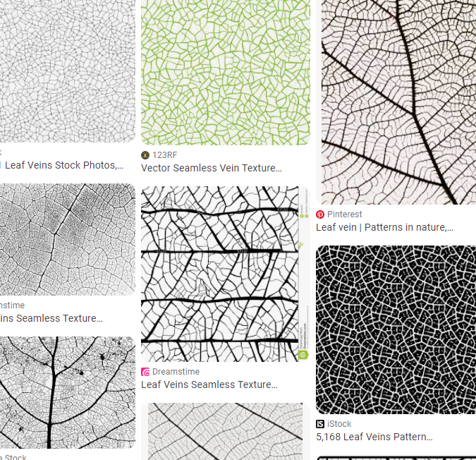

See Lid and Container Label Specs/Dims below
*Not necessarily design, scale, size or content wanted, just as an example of container color.
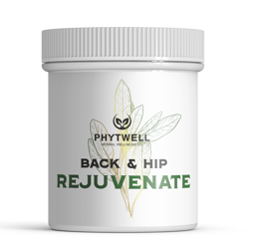

(Front of Pack)
PHYTWELL (Brand- smaller)
BACK & HIP + (Larger)
Daily Health (Largest)
Add: Actives- St. John’s Wort, Hemp Seed Oil, Frankincense, Calendula, Witch Hazel (doesn’t have to be listed just like this. Be creative, could be bulleted or more vertical)
Concentrated Herbal Rub (smaller font)
Add- below- somewhere on the front, be creative with listing, arrangement or fonts

Add- perhaps going vertical on one of the sides, doesn’t need to be arranged like this, please take creative liberties:

Net Wt. 4 Oz

(Benefit Statement)
Are you tired of letting back and hip pain control your life? Regain your focus with our specially formulated back and hip rub. Our team of physicians and herbalists have crafted a proprietary blend of herbs tailored to target the unique and complex structure of the back and hips, including bone, deep muscles, joints, tissue, blood vessels, and nerves. PHYT PAIN, LIVE WELL*
Developed for back and hips, but it's also effective in providing relief throughout your entire kinetic chain: elbows, shoulders, neck, knees, and ankles, our formula will target discomfort wherever it may be.
*These statements have not been evaluated by the FDA. This product is not intended to diagnose, treat, cure or prevent any disease.

(Usage)
RECOMMENDED USE: Boost your daily routine with Back & Hip Daily Health. Applying it in the morning is essential to support and protect your back and hips throughout the day. Starting your day with Back & Hip Daily Health will allow you to tackle all of your activities with the focus they deserve.

(REJUVENATE Ingredients- Listed in descending order, list as paragraph )
INGREDIENTS: Olive Oil (Olea europaea), Beeswax (Cera alba), Shea Butter (Vitellaria paradoxa), St. John's Wort (Hypericum perforatum), Hemp Seed Oil & Calendula Officinalis Flower Extract (Cannabis sativa & Calendula officinalis), Acai pulp oil (Euterpe oleracea), Centella Asiatica extract (Centella Asiatica), Comfrey Root Extract (Symphytum officinale), Solomon's Seal Root Extract (Polygonatum biflorum), Licorice Extract (Glycyrrhiza glabra), Vitamin E Mixed Tocopherols 95% (Tocopherol), Frankincense essential oil (Boswellia carterii), Peppermint Essential Oil (Mentha piperita), Witch Hazel Bark Powder (Hamamelis virginiana), Arrowroot Powder (Maranta arundinacea)

(Address)
Manufactured in the U.S.A for:
Tactical Herbs LLC Meridian, ID 83646
www.phytwell.com

(Caution)
CAUTION: Avoid contact with eyes. For external use only. Stop if irritation occurs. Store in a cool, dry place.
(Direction)
DIRECTIONS: Generously apply over entire area of discomfort. Massage until completely absorbed into skin. Daily application recommended and compliment with Back & Hip Restore + Relief formula for added support.

(UPC Dimensions)
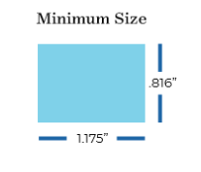

BACK & HIP +, Restore + Relief (Was Back & Hip Pain Relief)
Container & Lid Color- Black
Font Color- White + Color
Product Style: Masculine, Premium, Matte finish, Metallic accents (hot foil stamp)
See Lid and Container Label Specs/Dims below
Label Need- 1) Wrap around container 2) Top circular label for lid
Background/Texture: To add texture or contrast, I was playing with the idea of incorporating a leave vein pattern behind everything, which could be mild or semi-transparent to not take away from the hero content. This could be in mettalic finish. Would also need to explore how that looks or interacts with the plant image behind Phytwell.
Examples of leaf veins:

*Not necessarily design, scale or size wanted, just as an example of container color.
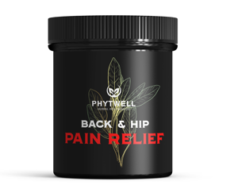
(Front of Pack)
PHYTWELL (Brand- smaller)
Back & HIP + (Larger)
Restore + Relief (largest)
Concentrated Herbal Rub (smallest font)
Add- “Actives- Arnica, Capsaicin, Willow Bark, Comfrey, Camphor” (doesn’t have to be listed just like this. Be creative, could be bulleted or more vertical)

Add- below- somewhere on the front, be creative with listing, arrangement or fonts

Add- below copy, perhaps going vertical on one of the sides:

Net Wt. 4 Oz

(Pain Relief Ingredients- Listed in descending order)
INGREDIENTS: Olive Oil (Olea europaea), Beeswax (Cera alba), Arnica Oil (Arnica montana), Ginger Root (Zingiber officinale), Comfrey Root (Symphytum officinale), Willow Bark (Salix spp.), St. John's Wort (Hypericum perforatum), Glycine Soja Seed (Glycine max), Lactobacillus/Capsicum Frutescens Fruit Ferment, Vitamin E Mixed Tocopherols 95% (Tocopherol), Wintergreen Essential Oil (Gaultheria procumbens), Camphor Wood Essential oil (Cinnamomum camphora), Cinnamon Essential Oil (Cinnamomum verum), Devils Claw Powder (Harpagophytum procumbens), Lobelia Powder (Lobelia inflata)
(Benefit Statement)
BENEFIT STATEMENT: Are you tired of letting back and hip pain control your life? Regain your focus with our specially formulated back and hip rubs. Our team of physicians and herbalists have crafted a proprietary blend of herbs tailored to target the unique and complex structure of the back and hips, including bone, deep muscles, joints, tissue, blood vessels, and nerves. PHYT PAIN, LIVE WELL.*
Developed for back and hips, but also effective in supporting your entire kinetic chain: elbows, shoulders, neck, knees, and ankles, our formula will target discomfort wherever it may be.
*These statements have not been evaluated by the FDA. This product is not intended to diagnose, treat, cure or prevent any disease.
(Usage)
RECOMMENDED USE: Revitalize your tired back and hips with Back & Hip Restore + Relief. Designed to support and restore your back and hips after a long day or strenuous activity. Use it anytime you need, allowing you to rejuvenate for your next activity or relax before bed.

(Address)
Manufactured in the U.S.A for:
Tactical Herbs LLC Meridian, ID 83646
www.phytwell.com

(Caution)
CAUTION: Avoid contact with eyes. For external use only. Stop if irritation occurs. Store in a cool, dry place.

(Directions)
DIRECTIONS: Generously apply over entire area of discomfort. Massage until completely absorbed into skin. Compliment with Back & Hip Daily Health formula for added support.

(UPC Dimensions)

Top of Lid Label both products
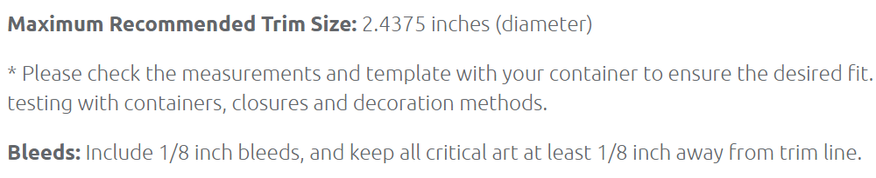

Black PP plastic 70-400 smooth skirt lid with foam liner (containerandpackaging.com)

White PP plastic 70-400 smooth skirt lid with foam liner (containerandpackaging.com)

Container Die-Lines
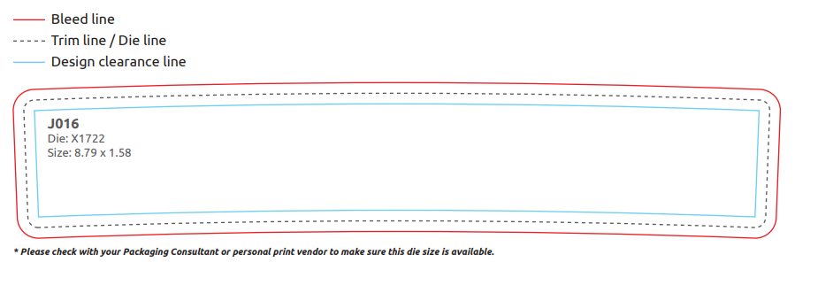
4 oz white PP plastic double wall straight base jar with 70-400 neck finish (containerandpackaging.com)

Other Brands I like for inspiration:

ONNIT: I like the premium look, the color striping at the top or bottom. The plant or images in the background and the mix of fonts and colors to make the content stand out.
https://www.onnit.com/supplements/

Cornbread farms: I like the premium look with matte black background and mettalic pops. And the subtle use of color on the trim to distinguish between the formulas.
https://www.cornbreadfarms.com/collections/hemp-cream

Heart&Soil- I modeled my brand logo(PHYTWELL) off of this brand. I like how they have a mix of artistic drawing with the Bull in the background(for me it is the plant) plus a modern and simple. They have good arrangement of their content and I like how they used fonts style & size to make each piece of content stand out.
https://shop.heartandsoil.co/collections/build-your-stack

