Pur Sang Avion

916 Sierra Slope
Hewitt, Tx 76643

916-956-8556

scott@pursangavion.com

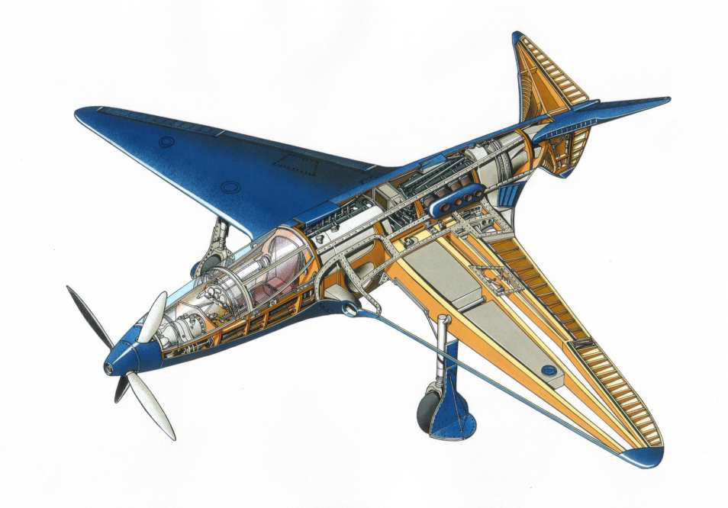
Original concept .cutaway For reference. I don’t want to use a cut away
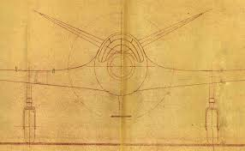

Partial front view blueprint from 1936

Simplified frontal view (unfinished left wing)

Simplified top view

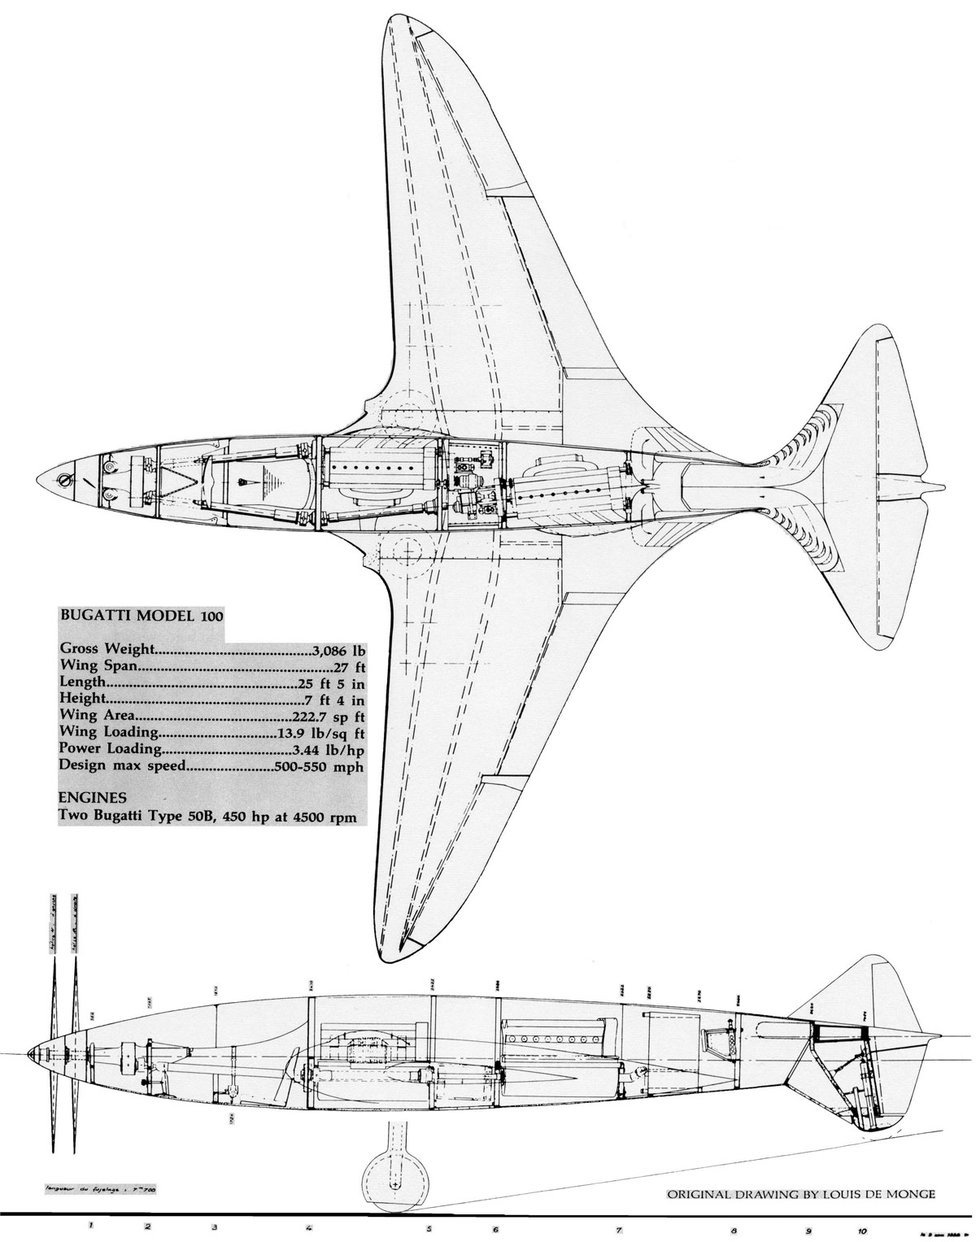
Original top & side views

Sample font styles Simple, elegant, art deco






