- 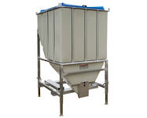
- 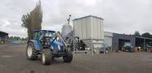
- 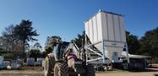
- 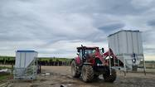
- 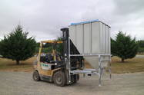
- 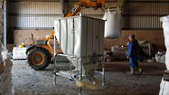
- 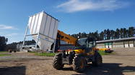

Smart Stakka 2000L
The 2000L unit is great for finer feeds / powders as it has much steeper discharge angle for better flowability.

Description
The Smart Stakka is an easy portable silo/hopper designed for the safe controlled storage and discharge of bulk dry granular products for all purposes and offers a more flexibility and ease of operation. With the steel reinforced frame the Smart Stakka is the strongest silo in this configuration.
Features
- 2000L / 1.5T (Wheat) capacity
- Multi Storage
- Clean and easy discharge
- Food and health grade rated
- Top quality (no rust, fully UV stabilized)
- 4 way fork lifting pockets
- Large removable lid
- Affordable value
- Adjustable legs - giving height variations
- Stackable
- Foot plates
Technical Information
Length (mm) | 1330
Height (mm) | 2100
Width (mm) | 1220
Outlet opening (mm) | 160 x 190
Top opening (mm) | 1080 x 950
Weight (empty) | 225kg
Hopper Thickness (mm) | 7
Capacity (tonne) | 1.5 (Wheat)
Capacity (ltrs) | 2000
Fork Pocket Size (standard) | 150 x 75mm (overall), if your forks are any wider than 135mm larger pocket sizes (200 x 100mm) can be ordered on request.

