Stationary Systems

- ROTOLOAD is available in the following standard sizes: 50lb, 150lb, and 300lb (convert to Kgs) capacity units. Any size capacity can be custom built to accommodate your facility.
- Integral and Central configurations are standard and come in Mild steel, enamel-coated standard construction (Stainless Steel option available).
- ROTOLOAD uses SIEMENS PLC controls
- Each ROTOLOAD device is equipped with three (3) load cell mounting, for stability
- Each ROTOLOAD system is designed as Integrated isolation dispense hoppers.
- Mobile Systems are configured for facilities with advanced ceiling infrastructure or low ceilings, and are based on pressure systems and are not vacuum powered.
Integral Filling rate
Up to 20 lbs/min (app. 1000 lbs/hr)
​
Central Filling Rate
Up to 80 lbs/min (app. 5000 lbs/hr)
​
Gravity Discharge/Dump Rates
50 lb – 3” – 2 lbs/sec
150 lb – 4” – 4 lbs/sec
300 lb – 6” – 8 lbs/sec

Mobile Systems

Single and Double Mobile Unit Features
- Cart Mounted Units
- Accurate Dispense of small quantities of Resin/plastic powder
- Pressure System for filling mold with Resin and/or Plastic Powder
- 50-100LBS material capacity
- Integrally Loaded (double unit)
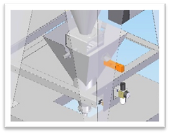
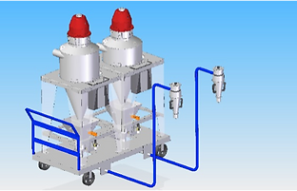
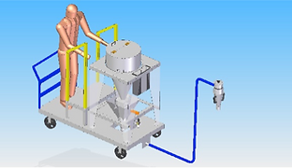

Custom Systems

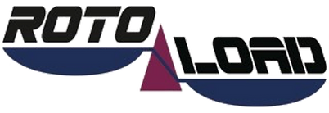

Custom Engineering
Not all facilities are designed the same. Therefore, each ROTOLOAD system is flexibly designed to accommodate the needs of your facility. ROTLOAD can be adapted to meet special requirements:
- Single and Double Mobile Units - great for facilities with pre-existing jib cranes or other overhead infrastructure.
- Pressure Systems (Standard units are vacuum systems)
- Larger Shot weights (Standard sizes for ROTOLOAD are 50, 150 and 300 LBS. Need a bigger size? ROTOLOAD will customize the hopper size to your needs without increasing the foot print of the device.
- Multi-Unit Systems - ROTOLOAD can save your facility time and money by integrating into large-scale systems.
