FUNCTIONAL PRINCIPLE

FLEDBAG® EASY

for returnable big bags
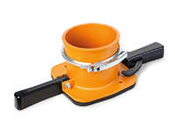
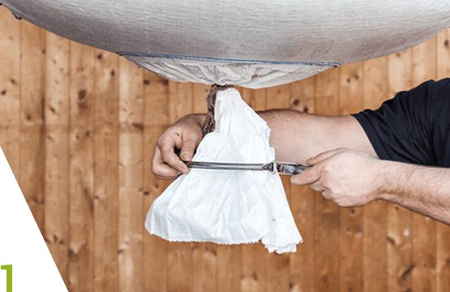
Open the first knot on the big bag outlet and push the tensioning ring onto the protruding discharge hose.
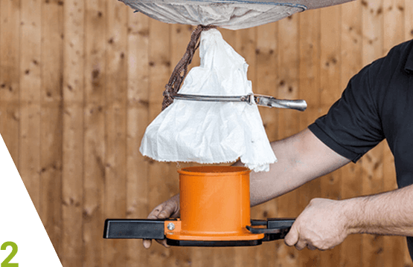
Position the FLEDBAG® Easy on the discharge hose from underneath.
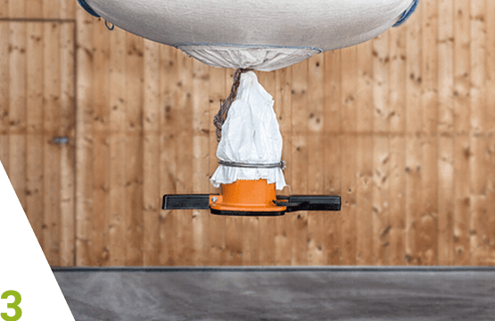
Pull the tensioning ring down, and fasten the tensioning ring with the discharge hose on the FLEDBAG® Easy. Do not attach the tensioning ring at the top edge, but along the neck of the FLEDBAG®.
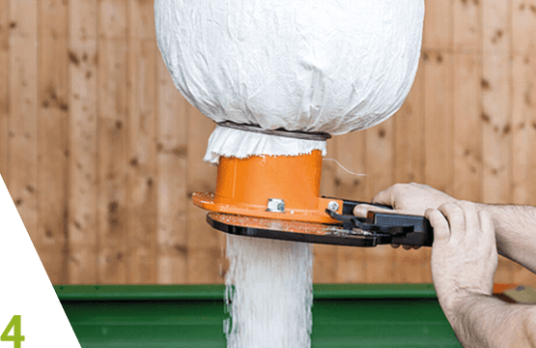
Open the second knot on the outlet so that the content can run into the FLEDBAG® Easy. Open the slide to empty.

