Current Website: https://www.demandsideanalytics.com/

Structure
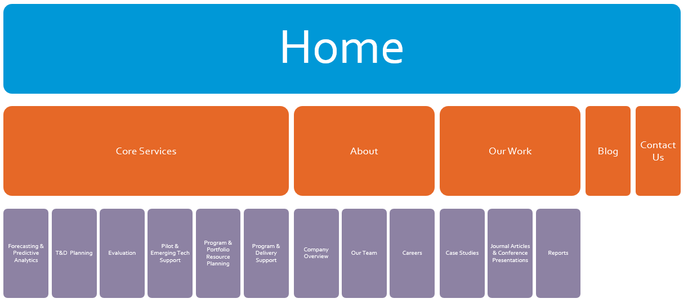

Color Scheme
"0 152 215" // Cyan blue
"0 152 215" // Cyan blue
"153 153 153" // Gray
"230 104 39" // Orange
"141 130 163" // Purple
"128 190 37" // Green
"0 112 159" // Dark Cyan blue
"115 115 115" // Dark Gray
"181 78 21" // Dark Orange
"104 94 125" // Dark Purple
"97 142 28" // Dark Green
"77 202 255" // Light Cyan blue
"193 193 193" // Light Gray
"240 166 125" // Light Orange
"186 180 199" // Light Purple
"182 227 113" // Light Green

"0 152 215" // Cyan blue
"153 153 153" // Gray
"230 104 39" // Orange
"141 130 163" // Purple
"128 190 37" // Green
"0 112 159" // Dark Cyan blue
"115 115 115" // Dark Gray
"181 78 21" // Dark Orange
"104 94 125" // Dark Purple
"97 142 28" // Dark Green
"77 202 255" // Light Cyan blue
"193 193 193" // Light Gray
"240 166 125" // Light Orange
"186 180 199" // Light Purple
"182 227 113" // Light Green

Content

Home

Home Page Statement
(Original)
Demand Side Analytics was formed in 2016 to help utilities and regulatory agencies navigate the technical, economic, and policy challenges of building a smarter and cleaner energy future. Through cutting edge research design and analysis methods we provide DSM program administrators with data-driven insights into how various technologies and interventions affect the way homes and businesses use energy.
(Proposed Shortened)
Demand Side Analytics is a consulting company that helps utilities and regulatory agencies navigate the challenges of building a smarter and cleaner energy future.

Services
- Predictive Analytics and Forecasting (Link to page)
- T&D Planning (Link to page)
- Evaluation (Link to page)
- Pilot & Emerging Tech Support (Link to page)
- Program Portfolio & Resource Planning (Link to page)
- Program Delivery Support (Link to page)

Our Services

Predictive Analytics and Forecasting
- Distributed energy resource integration into planning and operations
- Granular analysis (8760) and forecasting of distributed energy resource adoption and impacts on the grid, including solar, battery storage, electric vehicles, demand response, energy efficiency, and time varying pricing.
- Time-varying pricing analysis and planning
- Granular DER potential for utility, transmission area, substations, banks, or feeders selected
- We have a proven track record of developing state-of-the-art analytical frameworks and models. We develop models that link user-friendly interfaces to large databases and complex analyses, including Excel-only models, Analytica models, models that connect to statistical computing engines (or databases), and online tools (linked to databases and statistical computing engines).
- We have analyzed large volumes of data, including feeder data, from Supervisory Control and Data Acquisition (SCADA) measurements and customer billing datasets. We have developed tools to detect and correct data errors, and constructed 8760 profiles for representing customer segments and all DER technologies.
- We have extensive experience with electric vehicle analysis. In specific, in New York, we analyzed the 11 million registered vehicles to analyze vehicle turnover, age, and green vehicle adoption (hybrid, plug-in electric vehicles, and full electric vehicles). The data was used to develop, adoption propensity scores and vehicle forecasts over time, which were combined with 8760 electric vehicle loads, distributed solar, and energy efficiency in order to assess the impact on individual substations and feeder circuits. We currently implementing the granular vehicle forecasts and grid impact analysis in California, as part the Caliifornia PUC Integrated Resource Plan team. In 2014, we also developed tools to allow PG&E to assess the impact of electric and solar penetration on each of its 3,000+ feeders and 800 substations and developed algorithms to identify electric vehicles using smart meter data.

T&D Planning
- Location specific, probabilistic forecasting for system, transmission and distribution planning (electric and gas)
- Non-wire alternative and non-pipe alternative project assessments and optimization
- Expert testimony
- Our team members have analyzed hourly SCADA data for all feeders and substations at PSEG Long Island, ConEdison, Orange & Rockland, Consumers Energy, and Pacific Gas & Electric. The T&D analysis has included developing granular load growth forecasts, locational value studies, Non-wire solutions, identifying high value locations for battery storage, and assess the impact of distributed solar, electric vehicles, and energy efficiency on local peak loads and T&D planning.
- Our process and code for forecasting growth and estimating location specific deferral value has been standardized and tested in multiple settings with extensive scrutiny from planners, utilities, distributed generation stakeholders, and regulators. It enables us to implement comprehensive and high-quality locational value studies swiftly and efficiently.

Evaluation
- Demand Response evaluations
- Behavioral program evaluations
- Energy Efficiency evaluations
- Time-varying rate evaluations
- Process and outcome evaluations
- Pilot research design and evaluation
- Ability to provide real-time evaluation
- Expertise in demand response evaluations. Our team members are at the forefront of significant developments in DR pilots and studies across the U.S. Demand Side Analytics owners Jesse Smith and Josh Bode have performed dozens of full-scale program evaluations and evaluated dozens of pilots for new technologies and demand management strategies over the last decade. We have extensive experience with the array of techniques used for DR evaluations, know how to identify the best approach, and know how to implement each technique with deftness and precision. Our general philosophy is to use the simplest, most transparent method to produce defensible, accurate results at the least cost, and we pride ourselves on selecting the right tool for the job at hand.

Pilot & Emerging Tech Support
- Design and implementation of pilots and controlled deployments
- Pilots generally designed to assess distributed energy resource adoption and impacts on the grid, including battery storage, electric vehicles, demand response, energy efficiency, and time varying pricing

Program Portfolio & Resource Planning
- End-use/load profile studies and research
- End-use saturation and baseline studies
- Market potential studies
- Our Team has performed more than 35 energy efficiency (EE) and demand response (DR) technical potential studies for 26 clients that helped utilities and state agencies plan and allocate more than $8 billion toward cost-effective demand side management (DSM) programs over the past decade.
- Our potential study work spans multiple technologies including electric vehicle adoption, electrification of heating and water heating, battery storage, energy efficiency, and demand response. Our work includes all customer classes and multiple states, including California, New York, Pennsylvania, Texas, Michigan, Indiana, and Maine.

Program Delivery Support

Research and Analysis

Case Studies

Case Study 1, 2, 3, 4, 5, 6

Journal Articles and Conference Presentations
Links to relevant published journal articles and conference presentations

Published Reports
Links to published reports

About

Company Overview
Demand Side Analytics (DSA) was formed in 2016 to help utilities and regulatory agencies navigate the technical, economic, and policy challenges of building a smarter and cleaner energy future. Our research focuses on impact analysis as well as predictive and causal analytics. We deliver data-driven insights into how various technologies and interventions affect the way homes and businesses use energy and how those in turn affect grid and system planning. We have a proven record for conducting high-quality, accurate, and unbiased analysis and are meticulous about ensuring that research is useful for policy decisions, operations, and implementation.
We offer extensive expertise in evaluation measurement and verification (EM&V), distributed energy resource integration, transmission and distribution system planning, targeting analytics, and benefit cost analysis. The strength of our team is that we provide true access to true experts. Our team includes data scientists, applied statisticians, economists, public policy experts, and engineers. Demand Side Analytics experts have implemented over 60 large scale studies.

Our past work (Link to Research & Analysis):
Note, I want to convert this into a stats format similar to what is used on the AEG website:
- Work for 40+ utilities and regulatory agencies
- Analyzed billing data from 30+ million sites
- Analyzed hourly and sub-hourly smart meter data from over 10+ million sites
- Completed 60+ large scale studies
- Implemented some of the first and largest randomized control trials
- Drafted protocols for advanced M&V, behavioral evaluations, sampling and uncertainty, and DR load impact evaluations.

We excel at:
- Data driven research and insights
- Assessing how technologies and interventions affect energy use
- Analyzing how changing load affects system and T&D planning
- Causal inference and predictive analytics
- Building scalable tools that can be integrated into operations and planning

Our Core Services Include:
- Predictive Analytics and Forecasting (Link to page)
- T&D Planning (Link to page)
- Evaluation (Link to page)
- Pilot & Emerging Tech Support (Link to page)
- Program Portfolio & Resource Planning (Link to page)
- Program Delivery Support (Link to page)

Our Team
We attract, motivate, and develop highly dedicated team members. All our staff is trained on research methods and analysis of AMI, end-use, and SCADA data specifically related to the electric and gas sectors. Our staff is mainly comprised of data scientist, statisticians, economists, and public policy experts. Most staff is in Atlanta, with additional staff in California, Colorado, and New York.
(For team member bios same content as current website, maybe make just pictures of everyone with click to view more detail so less scrolling is needed)

Careers
At DSA, we are driven to help create a smarter and cleaner energy future, and we are always looking for talented professionals who share our passion for achieving this goal. We are a transparent organization where you will have the opportunity to work directly with our senior energy experts. Our employees get to work on a wide variety of projects and develop new skills so that they are well equipped to interact with our clients find effective ways to solve our clients’ problems. The work is not easy, but the rewards of working with senior experts and the opportunities for growth will be worth it.
We are growing fast and are looking for candidates with strong quantitative skills and demonstrated interest in working at the intersection of analytics, data, energy, policy, and economics. If you are looking for a team that will welcome your ideas and provide opportunities for growth, we would love to hear from you.

View openings
Application Process Summary

Contact Us
Add a link to our LinkedIn page

Proposed Case Studies for Each Core Service:
- Predictive Analytics and Forecasting
- T&D Planning – PSEG or Central Hudson?
- Evaluation – SCE? SDG&E? Different state?
- Pilot & Emerging Tech Support – Ag DR Study? PG&E Battery Pilot?
- Program Portfolio & Resource Planning – PA Work?
- Program Delivery Support – CEPC?

Sample Web Page Structures that we like:

Home Page
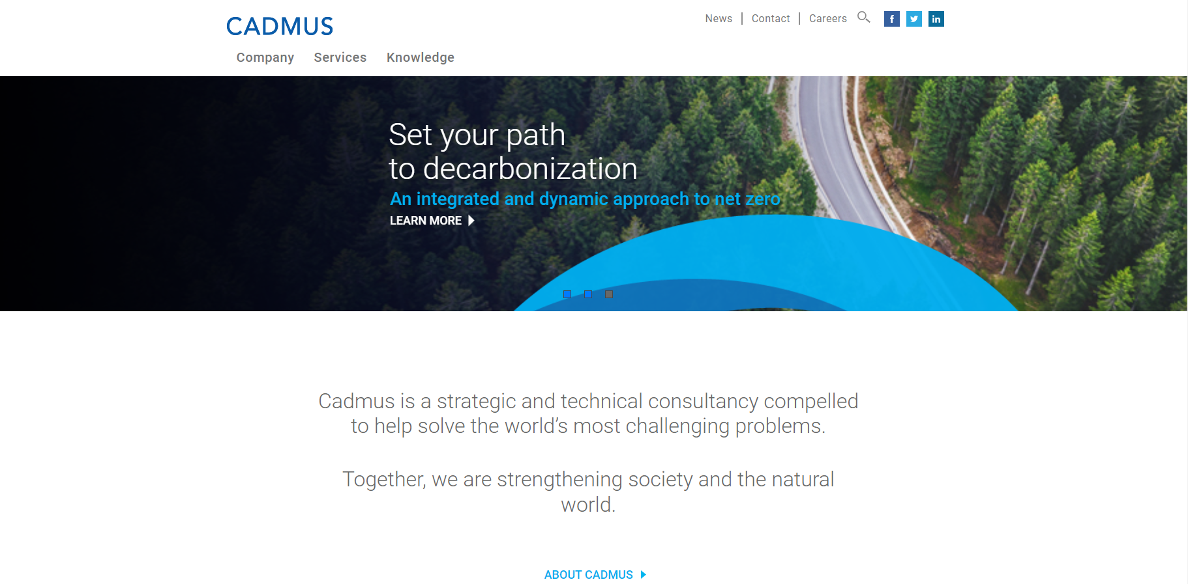
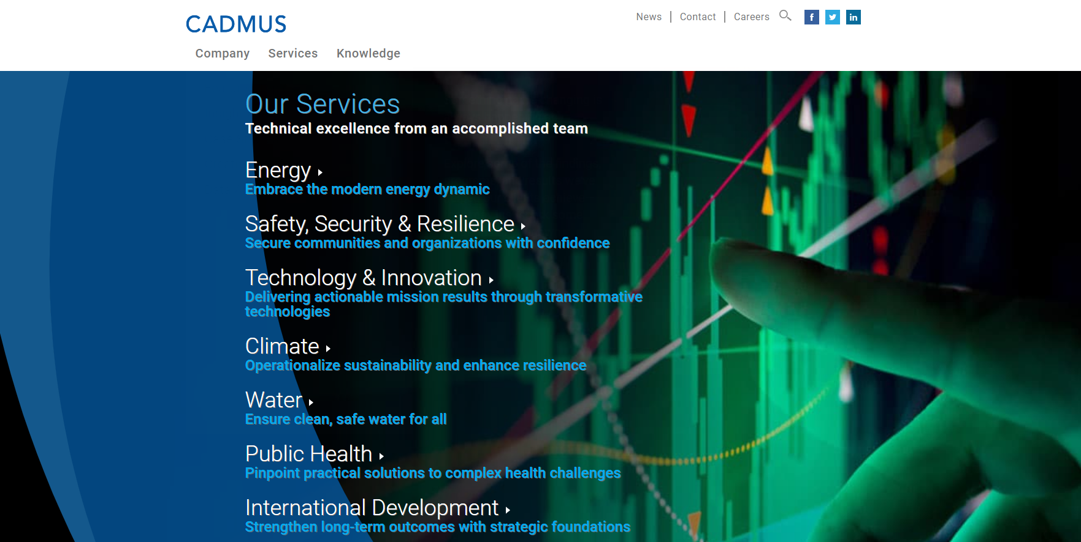
Career page (Application Process Summary): 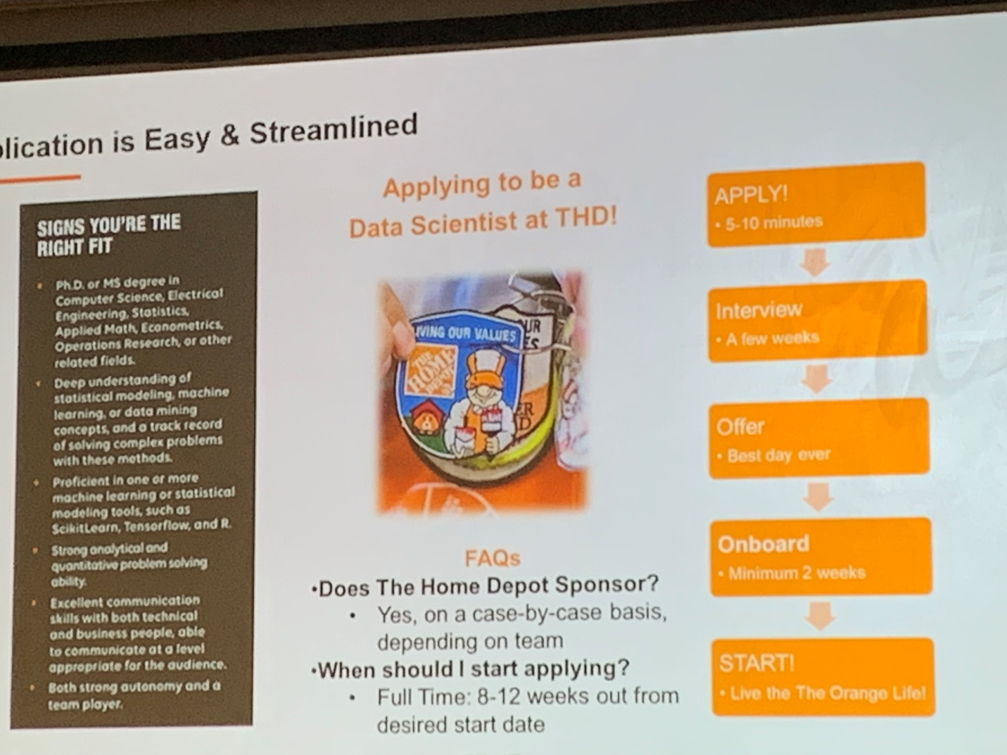

Case Study Sample Structure:

Client
PG&E

Project
PG&E Wattersaver Pilot

Key Research Questions/Objective
Assess the ability to use smart heat pump water heaters and control devices to operate as a battery and shift load daily from the 4pm-9pm TOU peak.
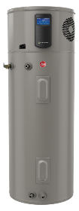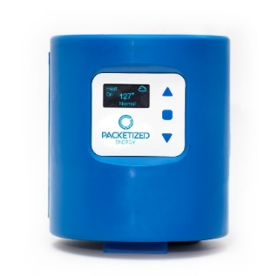

Approach
- Randomly assigned participant to four groups
- Rotated the operations strategy across 3 modes:
  - Baseline
  - Efficiency only
  - Efficiency + storage
- Analyzed both end use and AMI data
- Automated the quality checks and analysis, producing results and updates quickly and regularly
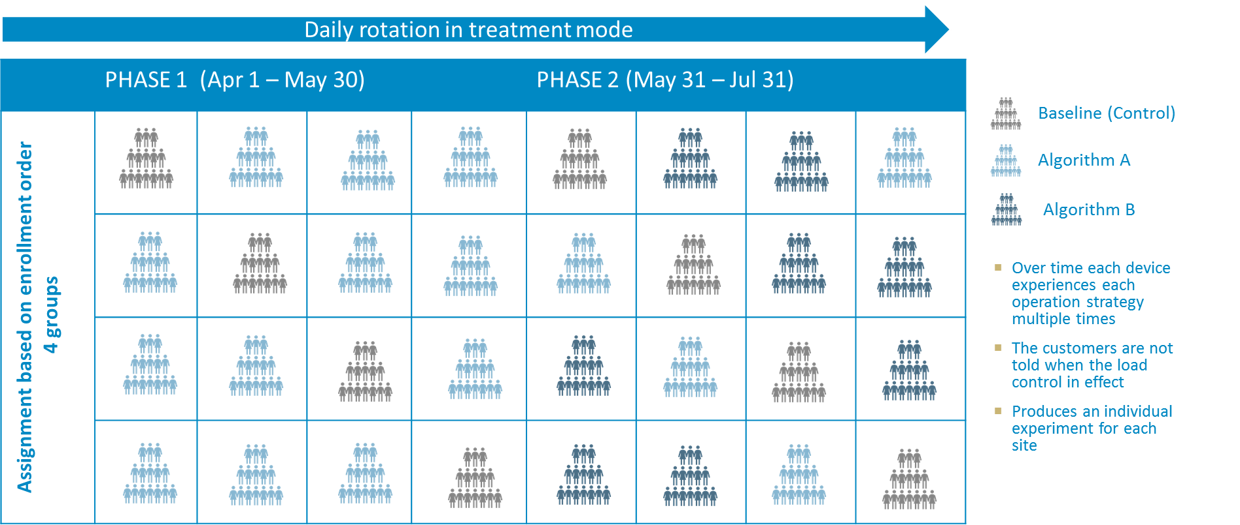

Results
Detected impacts from both efficiency and efficiency + storage algorithms. Able to update client with regular results so they could observe progress of study in real time.