Website reworking 2022/23
From wireframe ideas w. storyboard ideas for placement

RapidFunnel Home page
https://rapidfunnel.com/

Headers are based on a split screen design idea, which would then stack to fit together on one screen for mobile.
Main (overarching) header for Home Page @ top:
We make it easier for anyone, anywhere to connect, share and build their business

Split screen headers each section:
for Network Marketing
Explode Prospecting & Recruiting
20%+ is our guarantee

for Coaches, Trainers & Consultants
Build better, own your niche
2x MRR is our guarantee

Sample home page layout:
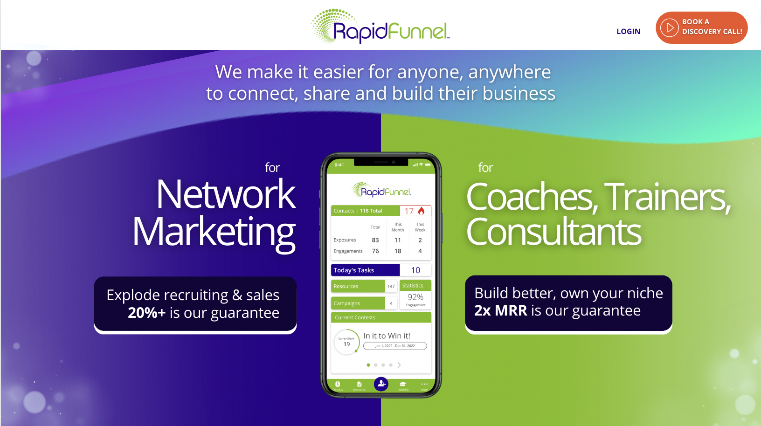

Sample mobile split:
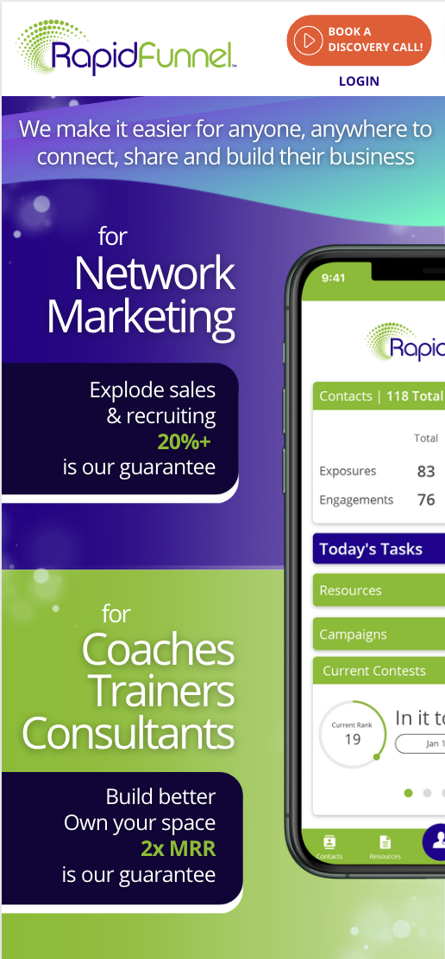

~~~~~~~~~~~~~~~~~~~~~~~~~~~~~~~~~~~~~~
~~~~~~~~~~~~~~~~~~~~~~~~~~~~~~~~~~~~~~

MLM Page
https://rapidfunnel.com/mlm/

Top section

Headline
for Network Marketing

Subhead
Explode prospecting & recruiting
20%+ is our guarantee

Suggested Bullets:
help them tell the company story better, more often

increases warm market connections and conversions

instantly duplicatable

built by experienced industry leaders

Sample top section desktop:
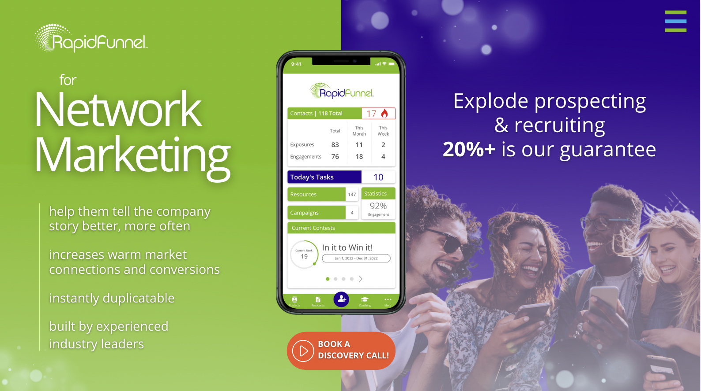

Sample top section mobile:
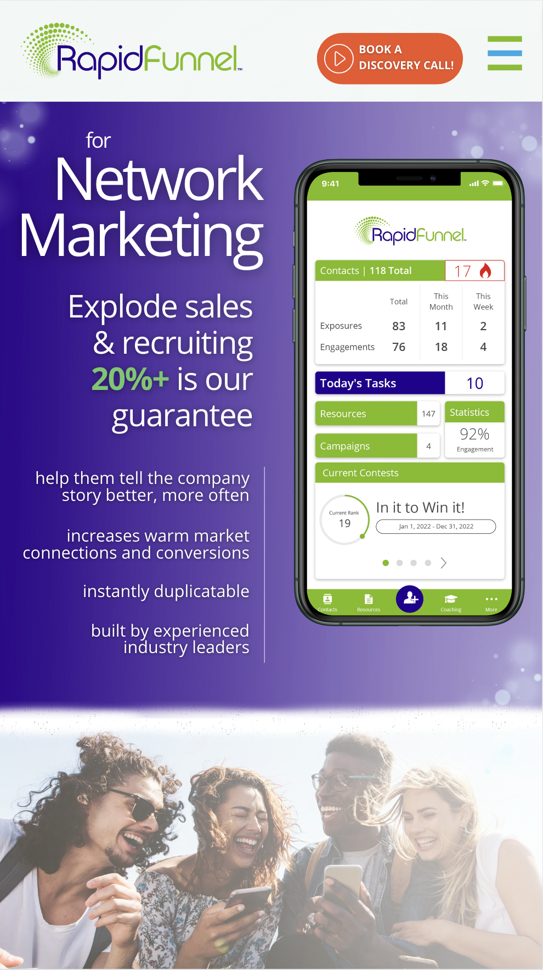

~~~~~~~~~~~~~~~~~~~~~~~~~~~~~~~~~~~~~~
~~~~~~~~~~~~~~~~~~~~~~~~~~~~~~~~~~~~~~

What we achieve for clients/app screens section w. rotating Apps at side

Headline
Adding this technology increases productivity 20%+ for the clients we work with

Blurb/client results what we achieve for clients, etc.

Seamless onboarding - simple startup Wizard

Increase in prospecting & recruiting - App makes it simple to connect anywhere

Focused training workshops

Standard version is free - helps all reps compete without barriers

Sample client section desktop:
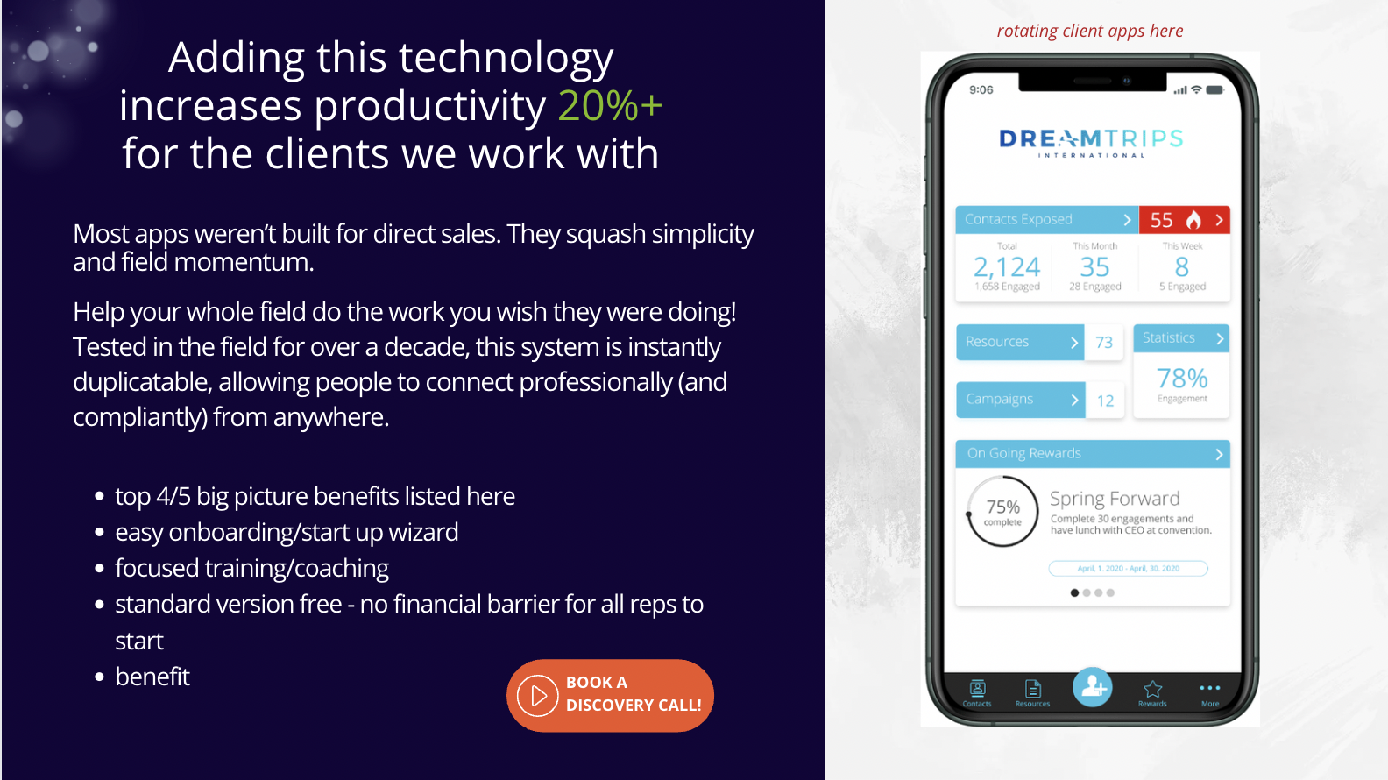

~~~~~~~~~~~~~~~~~~~~~~~~~~~~~~~~~~~~~~
~~~~~~~~~~~~~~~~~~~~~~~~~~~~~~~~~~~~~~

What people say about RapidFunnel section (client quotes rotating)

Headline
Trusted by top leaders and world class organizations

Sample of desktop testimonial section w. Case study idea:
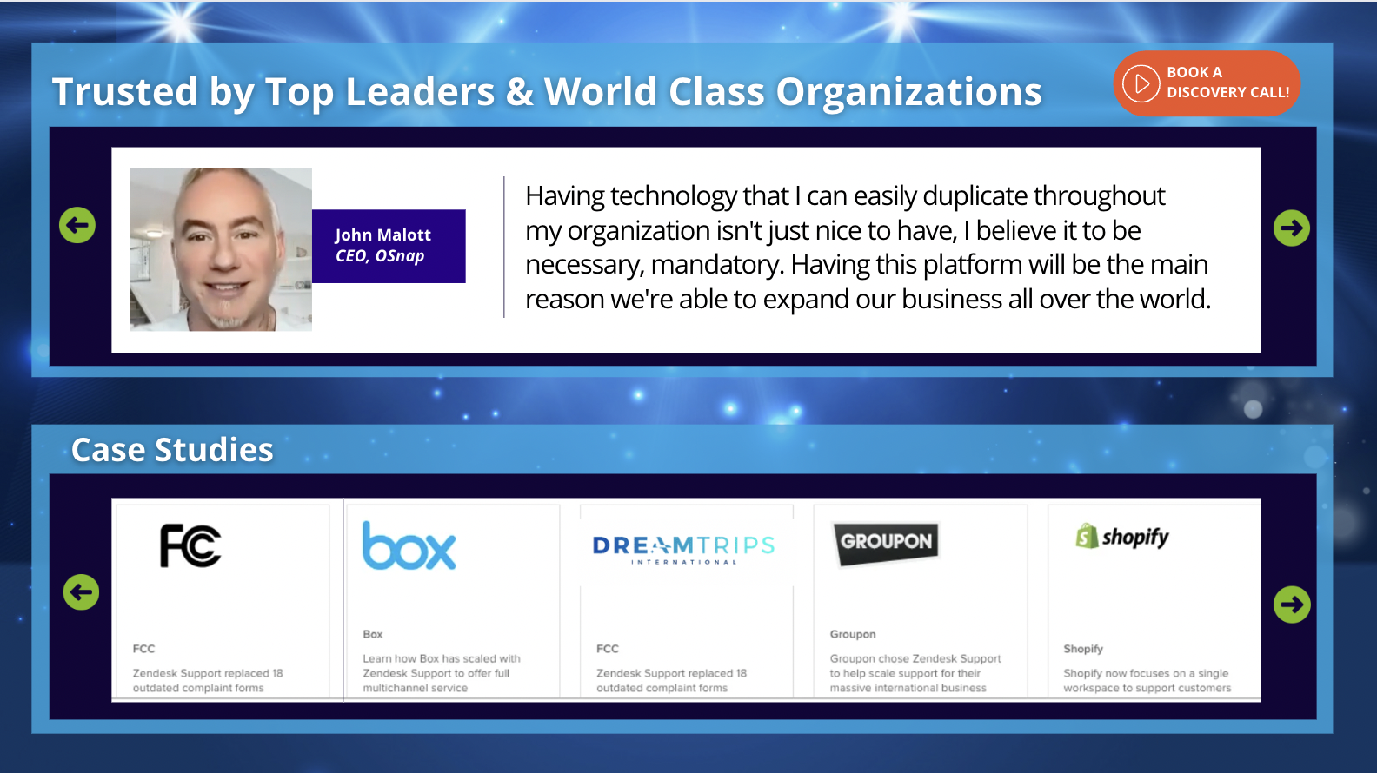

~~~~~~~~~~~~~~~~~~~~~~~~~~~~~~~~~~~~~~
~~~~~~~~~~~~~~~~~~~~~~~~~~~~~~~~~~~~~~

Why Good Tech is Not Enough section

Headline
The Best Tech Is Not Enough…

Subhead
Technology is only as good as its execution

Something like: RapidFunnel’s experienced Launch and Client Success Teams onboard and support our clients at every step. They also partner in making sure your field is fully trained and offer 24/7 support right from the App.

Sample onboarding/training support section:
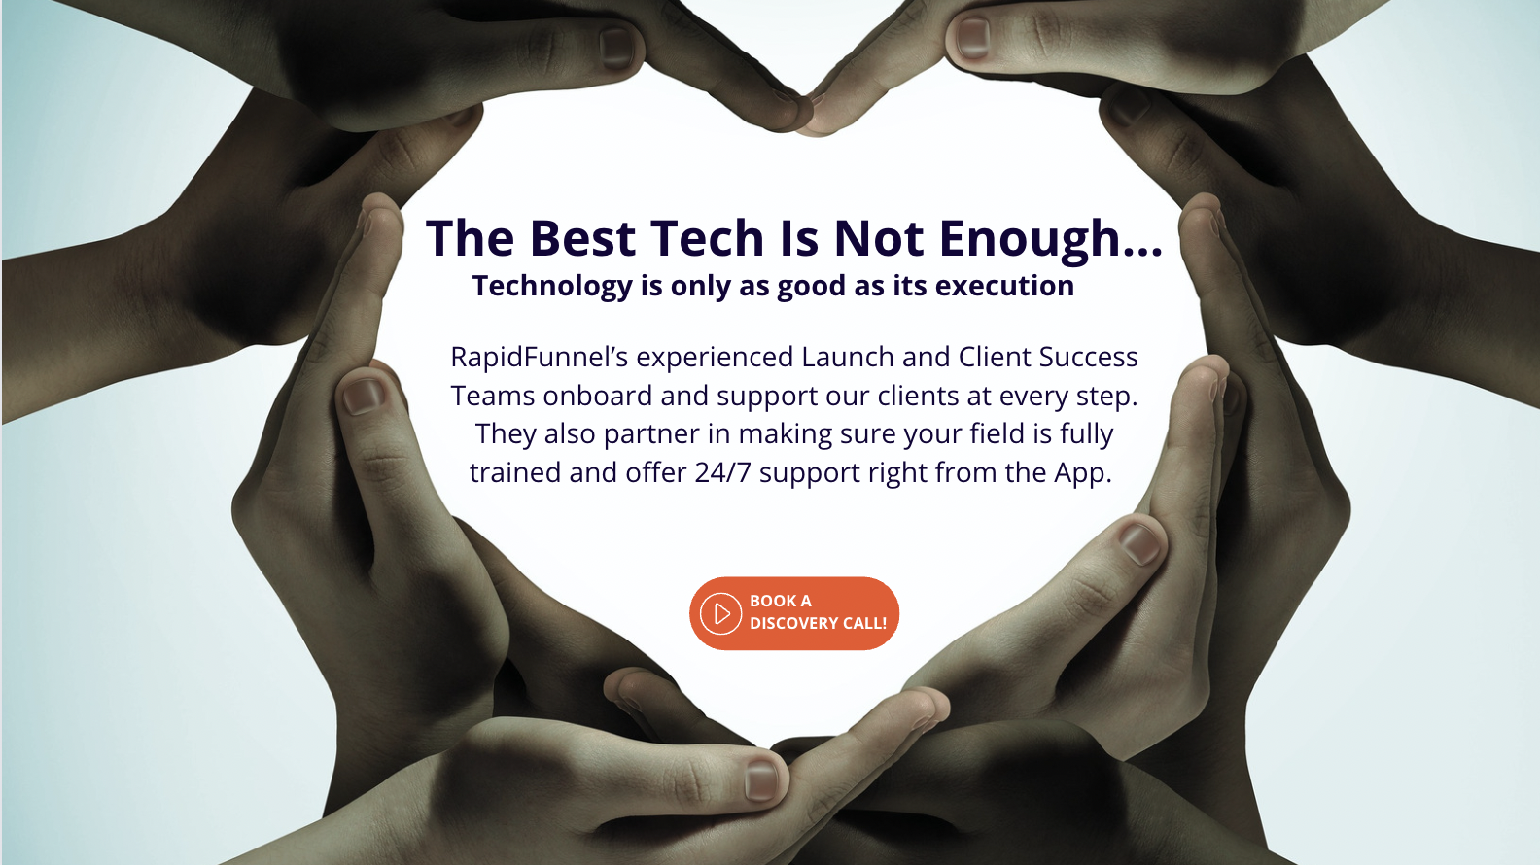

~~~~~~~~~~~~~~~~~~~~~~~~~~~~~~~~~~~~~~
~~~~~~~~~~~~~~~~~~~~~~~~~~~~~~~~~~~~~~

How RapidFunnel Came to Be section

Headline
The Story Behind the Technology

Something like: Build to solve a problem, developed for network marketers by experienced industry leaders, tested in the field for over a decade, biographical story opening, then “read more”

Sample behind the technology section:
