FiberCablesDirect (FCD) has been a leading supplier of fiber optic cables and accessories since 2005. We are unique in the fact that we have over 6,000 SKUs and have provided cables to some of the largest data centers and government agencies in the world. FCD has an established brand that is connected to a superior quality product with a competitive price and is always readily available.

With five combined warehouses in Southern California, FCD's niche in the data communications market is Variety. Innovation and Availability (VIA). VIA means "through" and we believe that all clients, big or small eventually come "through" FiberCablesDirect for their cable needs.

VARIETY

FCD carries fiber cable lengths from½ to 300 meters and we're the only known U.S. fiber supplier who carries such a Variety of lengths. We stock fiber cables in all types including multimode (OM1, OM2, OM3, OM4. OM5), single mode (OS2). In addition, we have indoor/outdoor cables, MTP cables, armored cables and TAA compliant, plenum cables which are commonly used in education, government and military sectors.

INNOVATION

FiberCablesDirect has to be lnnovative in order to remain on the forefront of the ever-changing data center market. With the introduction of our unique, best-selling products such as the SimpleGrip™ fiber pulling eye, the AnyAngle™ fiber cable and the "Spotless II™" fiber cleaner, we have established ourselves as a premier innovator.

FCD is constantly developing new products and in the coming months we will be introducing our Armored Xtreme™, an extremely durable, outdoor fiber cable that can withstand temperatures ranging from
-58 to +158.

AVAILABILITY

With over one million cables in our Corona location, we know that Availability is often the most critical part of our business. Our clients typically need their cables "yesterday" and we know that cables are the last thing needed to connect their equipment!

Our goal is to ship all orders the same day, often times we can even ship as late as 6:00 pm eastern time due to the
three-hour time difference. If we don't have the exact cable requested by our client, we are able to custom build to order and typically ship within1·2 days depending on the quantity

SUPERIOR QUALITY

All of our cables arc UL listed and tested in accordance with EIA/TIA·455·171A standards. We use Corning glass and ceramic ferules for every fiber cable and each one is individually packaged with test results. All of our cables have a lifetime warranty. II we can’t stand behind our products, we can’t expect you to.

SKU’S Available:
FCDUS418 - SMART CLICK - LC FIBER OPTIC CONNECTION CLEANER - UP TO 800 CLEANINGS
FCDUS222v2111 - 3 MTR LC/LC OM4 MULTIMODE DUPLEX 50/125 FIBER OPTIC CABLE WITH CORNING GLASS & CERAMIC FERRULES
FCDUS222v11725 - 1.5 MTR LC/LC OM4 MULTIMODE DUPLEX 50/125 FIBER OPTIC CABLE WITH CORNING GLASS & CERAMIC FERRULES
FCDUS343 - SMARTCLICK - SC/ST/FC FIBER OPTIC CONNECTION CLEANER - UP TO 800 CLEANINGS
FCDUS46v1 - 1/2 MTR LC/LC OM3 MULTIMODE DUPLEX 50/125 FIBER OPTIC CABLE WITH CORNING GLASS & CERAMIC FERRULES
FCDUS70v485a - 1 MTR LC/LC OS2 SINGLEMODE DUPLEX 9/125 FIBER OPTIC CABLE WITH CORNING GLASS & CERAMIC FERRULES
FCDUS405 - SIMPLEGRIP PULLING EYE - USED TO PROTECT CONNECTORS WHEN PULLING CABLES THROUGH CONDUIT OR WALLS
FCDUS72v8512 - 1/2 MTR LC/ST OS2 SINGLEMODE DUPLEX 9/125 FIBER OPTIC CABLE WITH CORNING GLASS & CERAMIC FERRULES
FCDUS70v487 - 3 MTR LC/LC OS2 SINGLEMODE DUPLEX 9/125 FIBER OPTIC CABLE WITH CORNING GLASS & CERAMIC FERRULES
FCDUS351 - SPOTLESS II - FIBER OPTIC CLEANING CASSETTE - CLEANS LC/SC/ST/FC/MU AND MTP CONNECT0RS - UP TO 500 CLEANINGS
FCDUS408v11701 - ANYANGLE - 2 METER - LC/LC OM4 PLENUM FIBER CABLES WITH BENDABLE BOOTS FOR EASY INSTALLATION INTO TIGHT SPACES

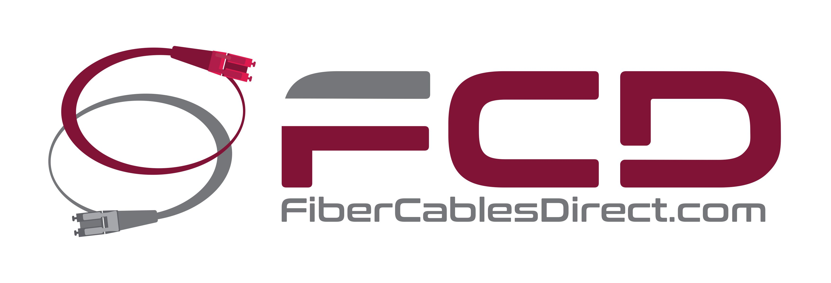
(866) 933-4237

