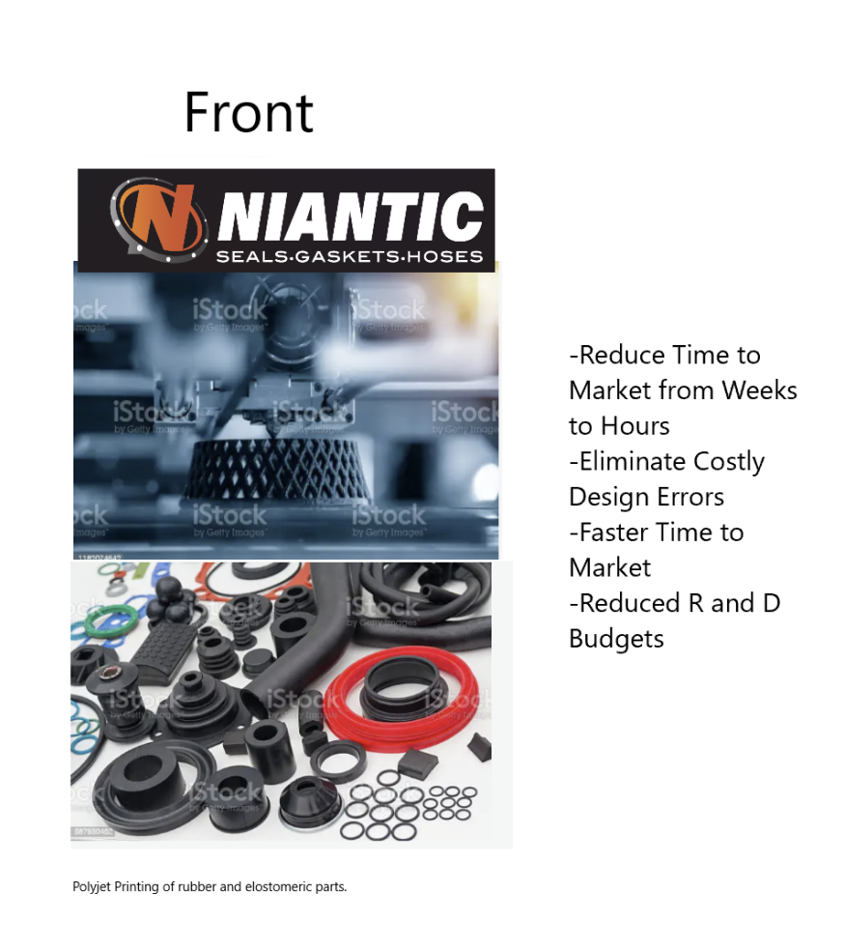
Content examples only. Not for final design!! Bullet points are key points to hit.

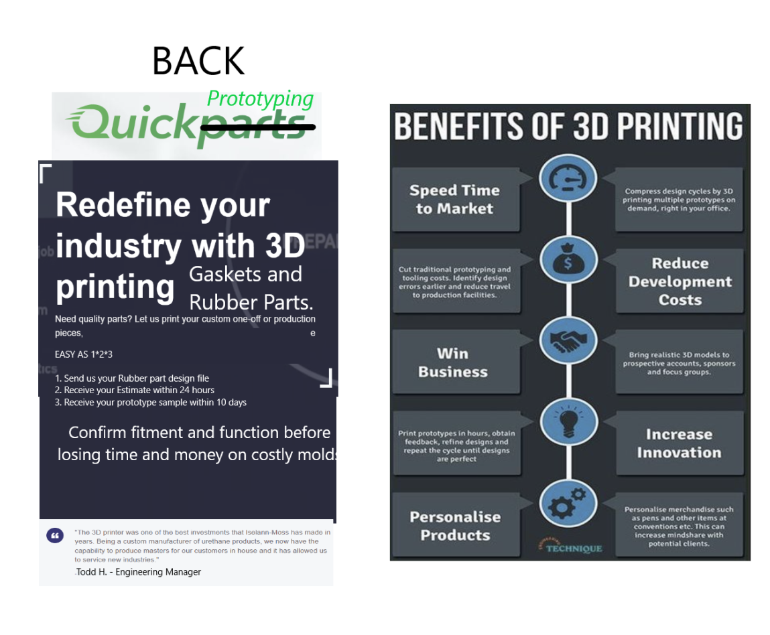
Backside concept text and message. It should define the process a customer will follow to work with our company.

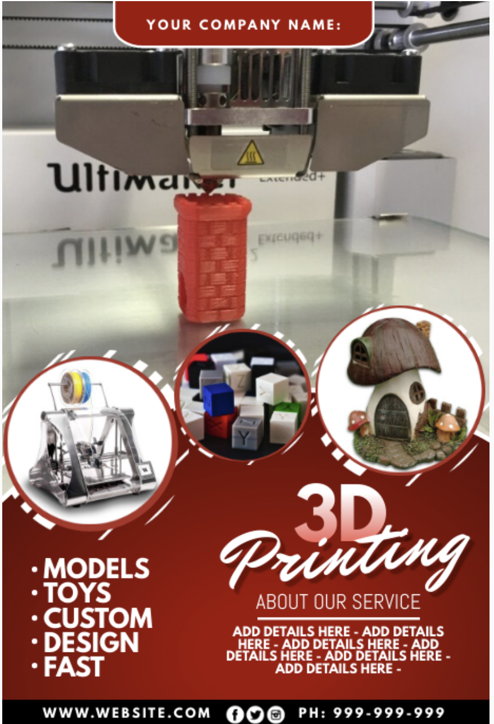

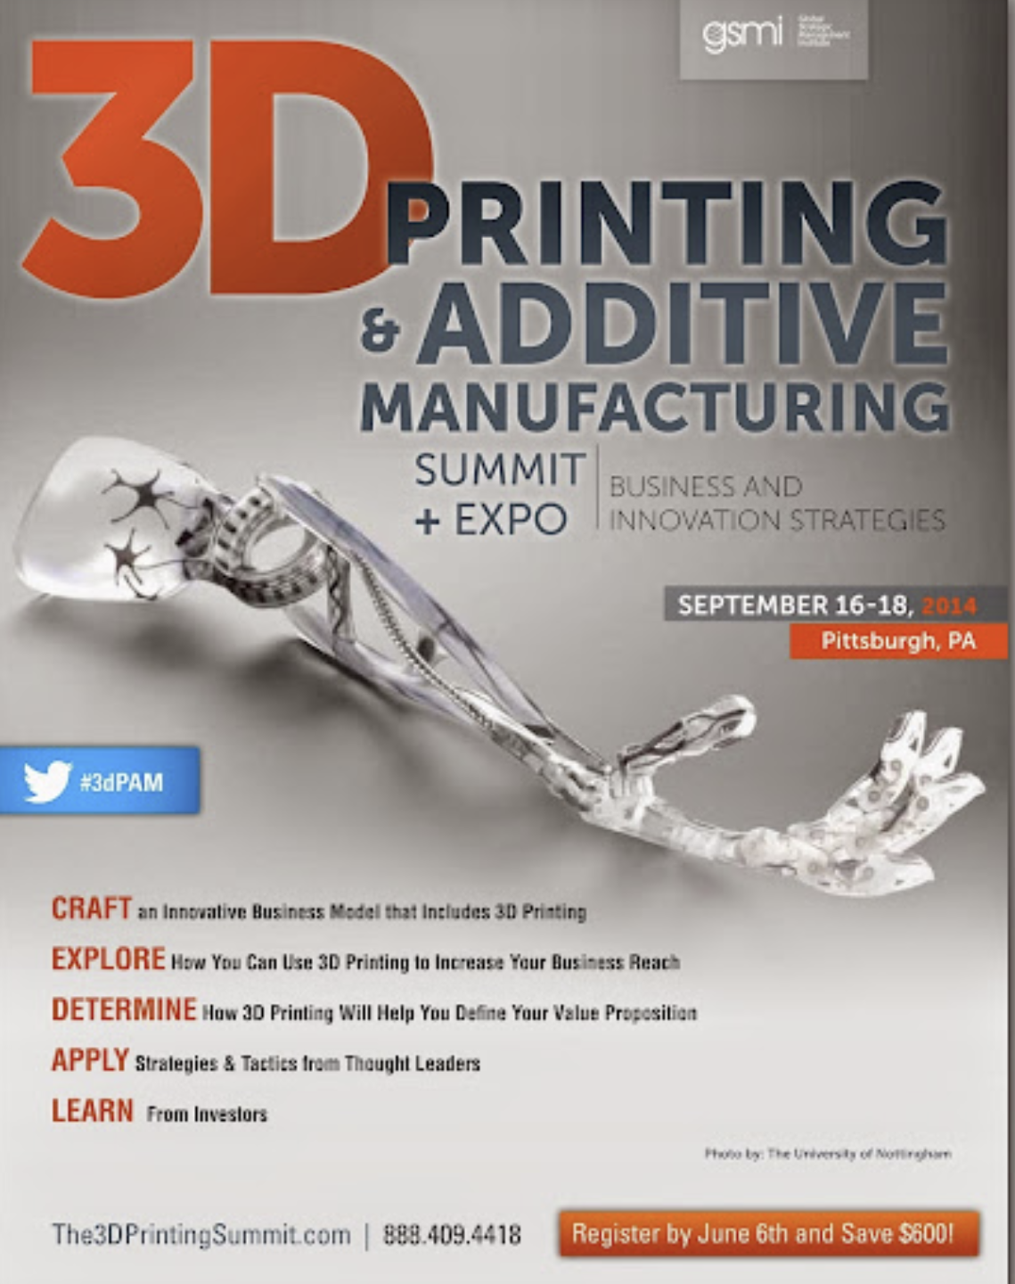
We like the balance of this but not the overall design. The front should contain the message of what we do. The focus of our 3D printing service is on Rubber Parts for the medical and Military fields primarily. But overall its about rubber parts only and not plastic parts.

The second important message is that we take this from prototype to production quickly. Interim steps are to create cast molds for working short run parts OR injection molds for high volume parts. The return is quick and our turnaround is fast. Taking design from months to weeks. Prototypes from weeks to hours.

