LTC Properties, Inc.

Inaugural Sustainability Report

People. Planet. Purpose.

[Incorporate the phrase: “Est. 1992” somewhere into the cover page graphic.]

Draft 3

Current Date: November 21, 2022

Table of Contents
A Message from Our CEO
About LTC Properties, Inc.
Who We Are
What We Do
LTC: By the Numbers
LTC’s ESG Strategy and Goals
Strategy and Goals
- Environment
1.1 Managing Climate Risks
1.2 Our Environmental Initiatives
1.3 Supporting Our Operator’s Environmental Efforts
2. Social
2.1 Respecting Our Employees
2.2 Diversity, Equity. and Inclusion
2.3 Employee Training and Development
2.4 Employee Engagement
2.6 Community Engagement
3. Governance
3.1 LTC’s Board of Directors
3.2 Stakeholder Engagement
3.3 Code of Business Conduct and Ethics
3.4 Vendor Code of Conduct
3.5 Political Contributions
3.6 Whistleblower Protection
3.7 Cybersecurity
4. Standards and Frameworks
4.1 Sustainability Accounting Standards Board (SASB)
4.2 United Nations Sustainable Development Goals (SDGs)
4.3 Task Force on Climate-Related Financial Disclosures (TCFD)

About this Report
This inaugural environmental, social, and governance (ESG) report highlights key achievements, policies, and performance of LTC Properties, Inc., and provides an update on our ESG progress. In preparing this report, we referenced the Sustainability Accounting Standards Board (SASB) standards and describe our alignment with the United Nations’ Sustainable Development Goals (SDGs) that we believe best align with our business activities and key priorities.

A Message from our CEO

At LTC Properties, we operate in a critically important sector of our economy and society, one that is helping to meet the fundamental housing and caring needs of our growing senior population as well as others in need of care. We live our mission every day through our actions: our disciplined approach to providing flexible financing solutions to our operators, who are committed to serving the nation’s most vulnerable population, coupled with our commitment to working collaboratively with those operators throughout our relationships. In doing so, we are able to contribute to this vital societal need and strive to deliver a consistent return to our shareholders.

We believe that our responsibilities as a corporate citizen are firmly aligned with our core business philosophy. We have operated successfully through decades of market and real estate cycles, consistently maintaining a steady hand on the tiller. This success was borne out of the multi-stakeholder approach we have utilized throughout our 30-year history. It underpins our corporate strategy as well as our focus on long-term value creation for our operators, investors, employees, community partners, and other stakeholders. That has been our history and it will not change.

Today, we recognize the importance of sharing more information about our activities and future goals to provide more transparency and generate a deeper understanding of our business and our impact on society. I am pleased to share with you our inaugural Environmental, Social and Governance (ESG) report. This first report is an important milestone in LTC Properties’ sustainability journey, and it is one upon which we intend to continue building.

The role that ESG principles play in effectively executing our corporate strategy is recognized by our Board of Directors as well as our management team. To that end, our Board formed a permanent ESG Committee, and we brought on a new Director, Cornelia Cheng, as its chair. Cornelia has brought a new level of ESG and DEI experience and expertise to our Board, as well as expanding on the Board’s already strong financial and governance expertise. With the addition of Cornelia, we also achieved gender parity on our Board – a journey that began when I was first elected to the Board in 1995.

At the management level, we formed an internal ESG Steering Committee to bring greater focus to setting and executing on specific ESG goals. One priority is driving greater alignment with our operators on how addressing ESG issues can benefit their own operations. We have introduced language into our new leases to encourage operators to incorporate ESG practices into their operations. As non-possessory landlords, we do not directly control how our properties are managed or maintained as a triple net-lease real estate investment trust, so it is incumbent on us to demonstrate to the operators the value of incorporating more sustainable practices into their operations.

In the past year, we established a voluntary program designed to encourage our operators to adopt socially responsible and sustainable practices. It includes a free consultation with a third-party expert who can identify initiatives at each facility that would address environmental concerns and ensure the use of best practices. LTC is providing attractive financing to incentivize and facilitate adoption of these changes. Our operators are discovering these changes often help to reduce their operating costs over the long-term – another example of LTC’s focus on multi-stakeholder value creation.
Operating with the highest standards of ethics and integrity has always been a core tenet of LTC Properties’ culture and our business. We recently formalized the essence of that tenet into a number of policies that were approved by our Board, addressing Human and Labor Rights, Human Capital, and a Vendor Code of Conduct. These policies have all been published on our website (link) to ensure transparency for all stakeholders. Our Board will continue to evaluate the need for additional policies over time.

One cannot discuss ESG without addressing the COVID-19 pandemic, which created unparalleled challenges for our industry. Our response was to focus on what we could control amid too many uncontrollable factors. We could and did take care of our own team members, immediately implementing remote and flexible work protocols to ensure our essential work and focus on our stakeholders’ needs continued unabated. Based on the enthusiastic support from our team, several of those protocols remain in place today.

Next, we focused on two priorities: supporting our operators and continuing to be good stewards of capital for our shareholders. Early on, we organized a communication channel to connect all of our operators as well as others in the industry to facilitate information-sharing. Not only did this enable our operators to access needed resources and solutions more quickly, but it provided us with a deeper understanding of their challenges which led to greater collaboration in managing through them.

Those efforts were an essential component to successfully managing our business and supporting our operators through that difficult time. As always, we were judicious in strategically deploying capital, maintaining a strong balance sheet, and continuing to pay our dividend without interruption. Today, our opportunities are robust as we continue to strengthen our relationships with existing operators and build relationships with new operators who share our values and desire to grow.

Everything at LTC begins with our stellar team. While relatively small in numbers, we bring outsized commitment and experience at all levels of the organization. Our employees have an average tenure of 10+ years at LTC. That reflects our commitment to fostering a positive, collaborative environment where responsibility and accountability are expected, and every individual’s contribution is valued. By striving to always find the best person for each position, we have built a very diverse workforce. I could not be prouder of what our team has accomplished as well as their collective commitment to delivering the right results for our stakeholders.

The needs in our industry are growing at a rapid pace and we are privileged to play a vital role in meeting them. We will continue to further align the execution of our business strategy with the ESG principles that are most relevant to our industry. We are operating from a position of strength, steadfastly moving in the right direction with a strong sense of hope for the future. This is how we will continue to create value for all of LTC’s stakeholders.

Wendy Simpson
Chairman & CEO

About LTC Properties, Inc.

Who We Are
Since 1992, LTC Properties, Inc. (NYSE: LTC) has been investing in properties and communities that offer safe and comfortable environments for the residents who live in our buildings. Thirty years later, we continue to execute our strategy of being a disciplined capital partner that creates shared success among our operators and our shareholders.

Headquartered in Westlake Village, California,
LTC is a real estate investment trust (REIT) investing in seniors housing and health care properties primarily through sale-leasebacks, mortgage financing, joint-ventures and structured finance solutions including preferred equity and mezzanine lending. Based on our gross real estate investments, LTC’s investment portfolio comprises approximately 50% seniors housing and 50% skilled nursing properties.

What We Do
We invest in assets that are providing a safety net for the aging population in the U.S., while also delivering long-term value to our shareholders through healthy returns and a consistent dividend, supported by a rock-solid balance sheet.

The number of U.S. residents 65 years and older increased by 34 percent to 54.1 million from 2010 to July 1, 2019. The U.S. population of adults older than 85 is expected to double by 2036 and triple by 2049 – generating increased demand for assisted living care. According to the National Investment Center for Seniors Housing & Care (NIC), the U.S. will need almost 881,000 new facilities by 2030 and 986,000 by 2040.

At LTC, we strive to diversify our portfolio by property type and location, focusing on shifting demographic trends and the needs of the communities we serve. All potential assets are evaluated through rigorous physical and financial due diligence. We often work with regionally based operators who have direct knowledge of the local market and share our values of creating success through partnership and alignment.

Why do all of this? Because our business is about more than real estate. It is about creating environments where our operators can provide the services their residents need.

We invite you to tune into LTC TV to learn more.

[Pull-Quote or Mini-Sidebar]
A triple net lease (NNN) is a lease agreement on a property in which a tenant or operator pays the expenses of the property, including real estate taxes, insurance, maintenance, and repairs, in addition to rent and utilities. These leases generally come with an initial term of two to 15 years, and many include renewal options.

[Sidebar:]
Investing in the Continuum of Care

We invest in a diverse portfolio of purpose-built properties specifically designed for seniors housing and care. In many cases, these property types are grouped together on larger campuses:

Independent Living Communities, also known as retirement communities or senior apartments, offer a sense of community and numerous types of personal, cultural, and recreational activities and services. Many independent living communities offer on-site conveniences like beauty/barber shops, fitness facilities, game rooms, libraries, and activity centers.

Assisted Living Communities serve people who require some assistance with activities of daily living and care. Its purpose is to help adults live independently in a safe environment. Services include assistance with eating, bathing, grooming, and administering medication. Many assisted living facilities provide a combination of housing, supportive services, personalized assistance, and health care designed to respond to individual needs.

Memory Care Communities offer specialized options for people with Alzheimer’s disease and other forms of dementia. These purpose-built, free-standing facilities offer an alternative for private-pay residents affected by memory loss in comparison to other accommodations that typically are provided within a secured unit of an assisted living or skilled nursing facility.

Skilled Nursing Centers provide restorative, rehabilitative and nursing care for people not requiring the extensive treatment available at acute care hospitals. Many skilled nursing facilities provide ancillary services that include occupational, speech, physical, respiratory, and medical therapies.

We also invest in other types of properties such as land parcels, projects under development and behavioral health care hospitals.

LTC By-The-Numbers - Infographic
- Buildings in 29 states
- 204+ investments¹
- 32 operators¹

Our ESG Strategy and Goals
We view ESG through an ecosystem lens that includes all our key stakeholders. We know the best way to effectuate strong ESG practices across our company and portfolio is to engage with our stakeholders to ensure they understand our operations and approach, and to hear from them about ESG needs and opportunities. We are committed to building long-term, sustainable value for our stakeholders, and making a meaningful, positive impact on the communities in which we operate.

[INSERT ECOSYSTEM GRAPHIC – Conner: this graphic is only an example. Please think about how best to graphically depict this notion of an ESG Ecosystem.]

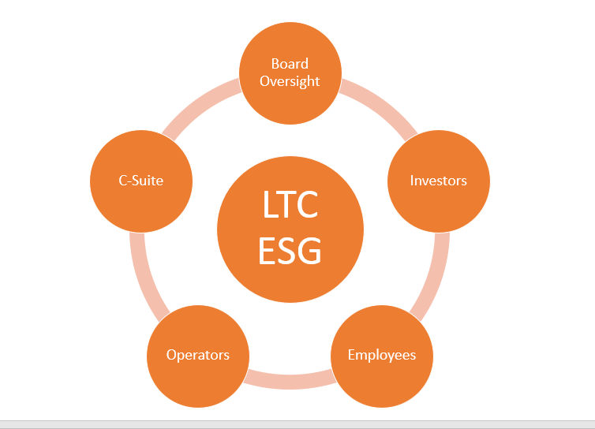

As a capital provider and triple-net lessor, we have a unique view of our opportunities and challenges when it comes to ESG matters. While we do not directly control the operations of the buildings in our portfolio, we do control how we operate our own business and how we engage with and influence our operators. We believe aligning our ESG interests with creative capital solutions and shared success across all stakeholders is a key element of being a good corporate citizen.

In the past year, we have initiated programs to assist our operators in identifying and implementing sustainable business solutions that positively benefit the environment and society as well as their financial sustainability.
LTC also provides free consultation with third parties to help our operators identify and better understand their options for adopting more sustainable practices. We encourage our operators to focus not only on remediation efforts, but also new methods that help ensure best practices. This is further supported by LTC’s ability to provide attractive financing and incentives to support the implementation of more sustainable opportunities.

ESG Accomplishments Through 2022
Environment | - Adopted and published an Environmental Sustainability Policy  - Began “greening” new and amended operator leases and enhanced underwriting criteria to include ESG  - Implemented third party tools for analyzing, tracking, and reporting environmental data  - Purchased carbon offsets for employee travel and corporate headquarters
Social | - Adopted and published a Human and Labor Rights Policy and Human Capital Policy  - Conducted employee engagement surveys  - Adopted select United Nations Sustainable Development Goals
Governance | - Established a Board-level ESG Committee and an internal ESG Steering Committee  - Enhanced our proxy to highlight ESG initiatives  - Adopted and published a Vendor Code of Conduct  - Conducted operator surveys to better understand where they are in their own ESG journeys  - Engaged key external partners, consultant, and vendors to better understand our ESG opportunities and communicate our ESG story  - Enhanced our Cybersecurity policy, disclosure, and training  - Aligned our inaugural Sustainability report with the Sustainability Accounting Standards Board (SASB) reporting framework  - Committed to aligning with the Taskforce on Climate-Related Financial Disclosures framework for future ESG-related

2023 ESG Agenda
Environment | - Measure and report on energy and water usage, and waste management at LTC headquarters and at select operator portfolios  - Continue to build out our use of ClimateCheck®, which provides detailed climate risk data for individual properties and portfolios, assessing exposure to extreme weather events  - Enhance SASB reporting and initiate TCFD reporting  - Collect, analyze, and report environmental data for select properties in our portfolio
Social | - Continue to conduct annual employee survey  - Enhance employee engagement programs
Governance | - Update disclosures annually  - Enhance stakeholder communication via proxy, website, investor presentation

1.0 Environment
We recognize the impact the real estate sector can have on the environment and believe that using resources efficiently and minimizing waste is essential for maintaining clean air, water, and land. We’re committed to implementing environmentally sustainable practices in our own operations, and to encouraging, incentivizing, and assisting our operators in their efforts to address environmental opportunities and challenges. In 2022, we published our Environmental Sustainability Policy, which governs our activities in this regard.

Under the triple-net structure, our operators are responsible for maintaining the properties in our portfolio that they lease. As such, we historically have not collected property data specific to environmental considerations. However, we recognize the importance of having access to this type of data as it may reveal opportunities for action that can inform our operators’ decisions. That’s why we have set a goal to collect, analyze and report energy, water, and waste data for 15% of our portfolio by 2024.

1.1 Managing Climate Risks
Addressing climate-related concerns is important our employees, operators, investors, and the communities in which we have properties. At LTC, we intend to align with the Task Force on Climate-Related Financial Disclosures (TCFD) framework, which will help guide our strategy for identifying, managing, and disclosing climate risks and opportunities.

Most of LTC’s assets are located outside of extreme high-risk areas. As a supplement to our ongoing enterprise risk management program, we utilize ClimateCheck® Enterprise Risk Application to perform both current and longer-term climate change risk analyses, which we share with our operators. Our goal is to help our operators identify how they can prevent and mitigate property damage and loss before extreme weather events occur.

We have integrated this analysis into our underwriting criteria and will continue to perform analyses for new business opportunities and ongoing portfolio management.
LTC ClimateCheck Risk Analysis
Portfolio as of November 2022
 | %
 | Lower | Higher | Extreme
Fire | 73 | 26 | 1
Flood | 57 | 29 | 14
Storm | 12 | 37 | 52
Drought | 58 | 28 | 14
Heat | 13 | 65 | 23

Climate Risk Profile for LTC Headquarters

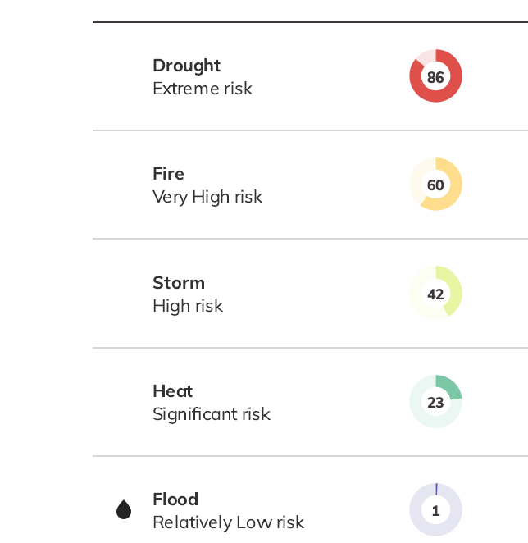

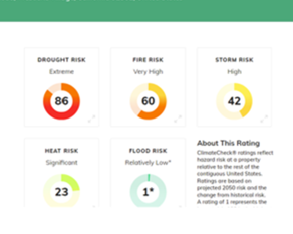

Simply for reference, this is how Sabra does it…..

1.2 Our Environmental Initiatives
Throughout the LTC organization, we are committed to conducting business in an environmentally responsible manner. We actively pursue opportunities to mitigate environmental risks and reduce our environmental impact. Below we highlight a few of the day-to-day activities we engage in to promote environmental stewardship in our corporate offices.

[Connor: Can we turn these into a graphic?

- Increasing Energy Efficiency:
  - automatic lights, internal temperature controls, automatic HVAC controls on evenings and weekends, power saver mode on printer and copy machines, automatic faucets, and toilets.
- Reducing Water Usage:
  - tri-temp water from reverse osmosis water systems to eliminate plastic or glass tank refill bottles
- Hoteling Workspace:
  - Evolving our corporate headquarters to a hoteling workspace environment in which employees will reserve in-office workspace, resulting in reduced energy, waste, and water usage in the office, and from commuting.
- Reduce, Reuse, Recycle
  - Recycling is promoted throughout our offices, including electronic file-sharing, recycled paper for printing, ink cartridge recycling, and digital notepad.
- Green Energy:
  - We participate in the California Clean Power Alliance Program, an opt-in program that acquires and delivers green energy supply (solar, wind, water) sourced locally and regionally.
- Carbon Offsets:
  - Purchased to offset employee travel and office space.

1.3 Supporting Our Operator’s Environmental Efforts
We believe that assessing and improving the environmental footprint of our properties will enhance the value of our portfolio as well as increase efficiencies for our operators, enhancing their own bottom line. We support our operators by promoting sustainable best practices, recommending environmentally friendly products and vendors, and financing environmental initiatives at attractive rates. We are also incorporating ‘green lease’ provisions into new and amended leases.
Callout
Two Ignite KC Buildings
LED lighting throughout, energy efficient windows, and a white TPO roof material to minimize temperature impact and reflect sunlight. Does a woman-owned development company/owner of the seller count too?!?!

In addition, we recently surveyed a subset of our operators to better understand their current ESG practices. We learned that more than 70 percent of survey respondents are currently pursuing energy efficiency practices. The survey also revealed that 80 percent of respondents are engaged in waste management and recycling practices.

Anthem, one of our operators that oversees XXX buildings in our portfolio, is WELL Certified™. The WELL Building Standard is a performance-based system for measuring, certifying, and monitoring features of the built environment that impact human health and well-being, through air, water, nourishment, light, fitness, comfort, and mind. [Something about ALG and Deerwood??]

2.0 Our Social Impact
Being a good corporate citizen starts with our dedicated team. LTC employees drive our continued success through their expertise and passion for the work we do. Our ability to thrive as a capital provider in the seniors housing and care space is fully dependent on their commitment. We, in turn, support them through competitive compensation and leading benefits programs. We also are committed to investing in their futures and helping them develop professionally and personally to build their careers. This approach has enabled us to develop a very loyal employee base with an average tenure across the company of XX years at the company.

2.1 Respecting Our Employees
We foster an environment in which respect, collaboration, dignity, transparency, and integrity are embedded in our daily interactions as well as in how we conduct business with all stakeholders. This has enabled us to attract, develop, and retain high-caliber, talented employees with diverse backgrounds and skills and to create a workplace that allows each employee to contribute to the collective success of our company.
Highlight Box
- 25 Total Employees
- 10 Years Average Employee Tenure

These values are reflected in our Human and Labor Rights Policy, along with our many programs and initiatives developed to promote a positive and fulfilling employment experience.

- LTC does not discriminate based on an individual’s race, gender, age, color, religion, national origin, mental or physical disability, sexual orientation, ancestry, genetic information, military or veteran status, creed, pregnancy, marital status, citizenship, gender identity, gender expression, or any other status protected by applicable law.
- We respect our employees’ legal right to self-organization, to form, join, or assist labor organizations, to bargain collectively through representatives of their own choosing, and to engage in other concerted activities for the purpose of collective bargaining or other mutual aid or protection.
- At LTC, we believe in sharing our success with our employees and we offer fair and competitive compensation at or above reasonable living wage standards. As inflation across the U.S. quickly rose in 2022, we recognized the financial burden this placed on our employees. As a result, we offered all VP and below employees an inflation bonus to alleviate the strain.
- All employees are offered a comprehensive package of benefits as detailed in the table [below or wherever the table is placed]
- We believe everyone has the right to be treated with respect and we do not tolerate harassment and discrimination, child labor, or the use of slavery and other forms of forced or coerced labor or servitude.
- Employee safety and health are key elements of LTC’s working environment, and we are dedicated to maintaining a safe and healthy workplace for our employees.

LTC EMPLOYEE BENEFITS PROGRAM
Medical Plans  Pay 100% of healthcare premiums for employees and all eligible dependents | 401(k) Plan  Offer a 401(k)-retirement plan with an employer contribution matching program | Paid Time Off  Flexible paid time off program for all employees
Dental & Vision Plans  Pay 100% of premiums for employees and all eligible dependents | Discretionary Bonuses  Employees have opportunities to earn discretionary bonuses, restricted stock awards and performance-based unit awards. | Paid Holidays  LTC has 10 paid holidays annually
Life Insurance  Employer-funded life insurance | Profession Development  Internal and external programs to promote professional and personal development | Family/Pregnancy Leave Program  Leave for new parents and leave for pregnancy-related disabilities
Disability Insurance  Employer-funded short and long-term disability insurance | Flexible Work Locations  Work from home options are available in most position | Organ & Bone Marrow Donation Leave
Employee Assistance Program  An external program to support employees’ mental health and well-being | Bereavement Leave  Paid time off to an employee following the death of a family member | Disability and Medical Leave  Leave, if necessary, to accommodate a workplace injury or qualified disabled worker

2.2 Diversity, Equity, and Inclusion
We value the diversity of the unique individuals who comprise our team - from entry level to senior level and to our Board of Directors. Seeking out and embracing individuals who bring diverse thoughts, backgrounds, skill sets, experiences, and talents has been the foundation of LTC’s success for three decades. These unique perspectives have both guided us with their experience and led us to explore new opportunities. Wendy Simpson, LTC’s CEO since 2007 and Chair since 2013, is one of only 10 female chief executives of REITs in the U.S.

Insert graphic from LTC website
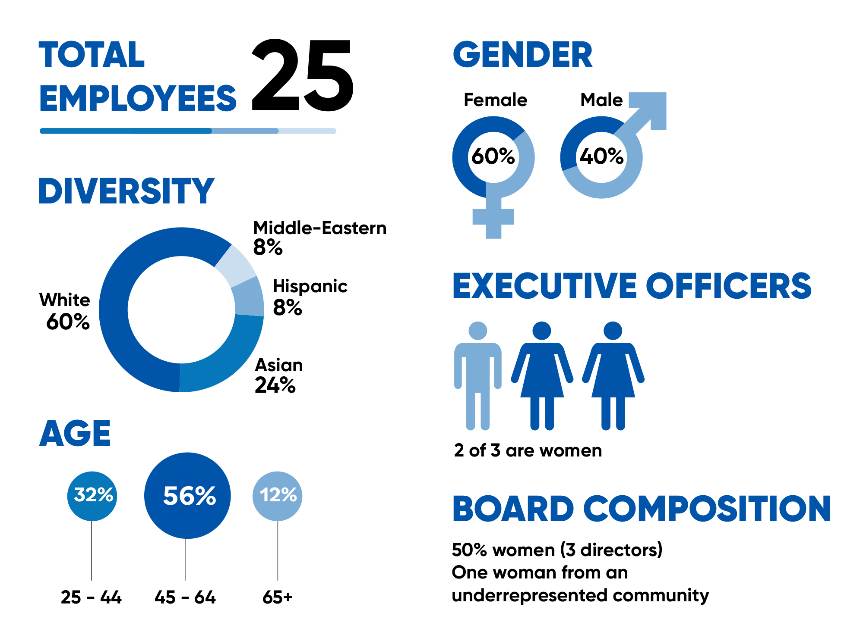

In addition to our own team members and Board of Directors, our operators also have diverse employee teams. [Any stats?] The CEOs of three of our operators are female. [Is there any more detail we could include to give this statement context? E.g., what percentage of operators industry-wide are led by females?)

2.3 Employee Training and Development
In today’s fast-paced environment, maintaining skills and knowledge is no longer enough. We want to ensure our team members have professional development opportunities to build a fulfilling career at LTC. We invest in employee training by providing access to in-class and online learning. We also promote participation in professional seminars and continuing education and pay for attendance at industry conferences.

In addition, for employees with at least one year of service, we grant up to three days leave to take professional licensing examinations. We also pay for the annual renewal fee for a professional license and encourage membership and participation in professional societies.
Collaborative Work Day
Through our employee engagement survey, employees shared that while they appreciated the ability to work remotely, they also missed the ability to collaborate with their colleagues. So, we created the Collaborative Work Day. One day a month, every locally based employee comes to the office to work on collaborative projects. Whether it’s a major initiative or simply catching up with colleagues on routine work, these days in the office enable direct interaction that is strengthening the fabric of LTC’s culture.

2.4 Employee Engagement
Effective employee engagement can increase productivity and tenure, strengthen company culture, and foster healthier, happier professional and personal lives. We conduct employee engagement surveys to ensure we know how our employees are feeling and to solicit their input on a wide range of workplace issues. In our most recent survey, 90 percent of our team members stated they were “Satisfied” or “Very Satisfied” with their employment at LTC.

[Insert stat on employee turnover]

One important learning that surfaced as the post-COVID option to return to the office emerged was our employees’ desire to see one another and work together again in person, even if this was only an occasional event. That was the catalyst for our monthly Collaborative Work Day, which continues to this day.

2.6 Community & Industry Engagement
We strive to make an impact by offering charitable support to our operating partners, their residents and employees, and the seniors housing and care industry. At our corporate headquarters, many of our employees support our local community through voluntary contributions and through our company-wide holiday season initiative of supporting local underprivileged children. We also organize a team of employees along with their families and friends to participate in the annual “Walk to End Alzheimer’s” event. The company matches employee contributions, which in 2021, amounted to more than $10,600 in donations.

In addition, LTC supports a number of industry associations that operate at the national, state, and local levels.

[Graphic illustration to include the following logos:



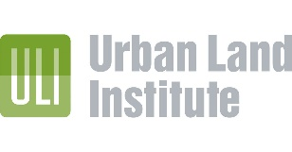

3.0 Governance
Good corporate governance is rooted in ethics, integrity, accountability, and transparency. We’ve built our business on sound governance principles and practices to ensure we are a trusted leader in our sector. These principles and practices are the foundation of sustainable value creation, building stakeholder trust and driving responsible business practices.

3.1 LTC’s Board of Directors
LTC’s Board of Directors consist of six members, five of whom are independent and three are female. Each member of the Board brings a diverse set of backgrounds and leadership skills, including broad experience in leadership, finance, real estate, human capital management, risk oversight, ESG, legal/regulatory, and cybersecurity.

[Sample chart of experience and skill sets for Directors:]

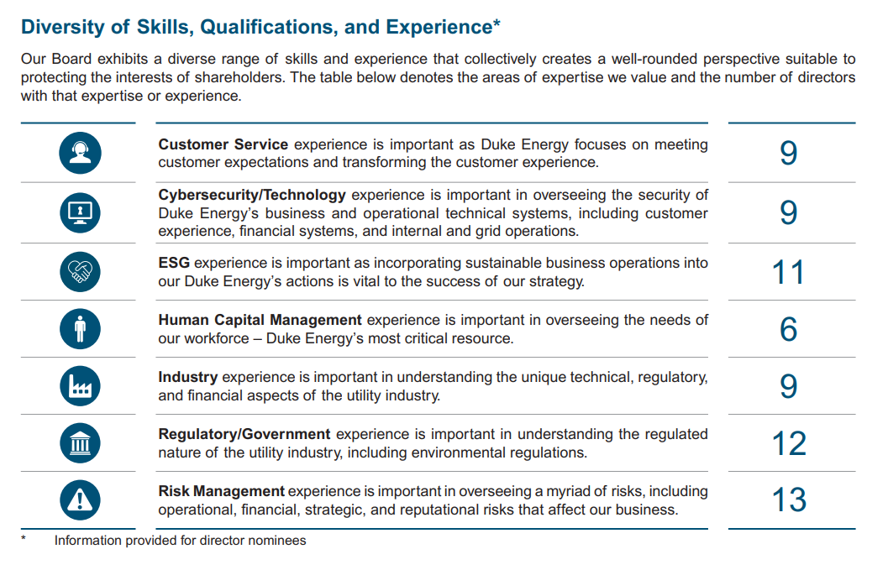

Our Board members sit on various committees, including an ESG Committee that was established in 2021 to oversee LTC’s environmental, social, and governance practices and performance. Our ESG Committee receives quarterly updates from LTC leadership on a wide range of ESG matters. Additional committees include:
- Audit Committee
- Compensation Committee
- Investment Committee
- Nominating and Corporate Governance Committee
For more information about our Board of Directors, committee charters, and corporate governance measures, visit Investor Relations at LTC Properties, Inc. or refer to our 2022 Proxy Statement.

3.2 Stakeholder Engagement
We actively engage with key stakeholders across our business as open dialogue helps us better understand and respond to emerging issues that may impact our business in the short or long-term. Keeping our finger on the pulse of issues and topics that are important to our business strengthens our relationship with stakeholders and contributes to our success. Below is a sampling of how we engage with our stakeholders.

Stakeholder Group | Area of Focus | How We Engage & Respond
Employees | - Satisfaction  Employee satisfaction, engagement, and retention | - Annual employee satisfaction survey  - Pay a fair living wage plus industry-leading health, financial and personal benefits  - Non-discriminatory, safe, and healthy workplace  - Opportunity for continuing education and conference / attendance  - Access to management team on all levels
Operators | - Relationships:  Creating and maintaining relationships with operators existing or new to LTC | - Greening new and amended leases for mutual benefit  - Offer financing for sustainable projects at attractive rates  - Contribute to operators’ charities supporting staff with hardships  - Host collaborative mindshare  - Host educational calls on regulatory topics  Access to decision makers
Investors / Analysts | - Transparency  Open, honest communication | - Public disclosure reports  - Quarterly earnings calls  - Annual shareholder meeting  - Press releases as warranted  - Attend virtual and in-person conferences and road shows  Site visits connecting operators with investors
Industry | Participation | - Support multiple industry associations and organizations  - Sponsor industry conferences  - C-suite participation on panels, webinars, media interviews  Host networking events fostering collaboration

3.3 Code of Business Conduct and Ethics
Ethics, most especially integrity, have always been a significant part of our culture and dictate the way we conduct business. Operating with a strong sense of integrity is critical to maintaining trust and credibility with our lessees, mortgagors, financing sources, employees, and shareholders.

Our Code of Business Conduct and Ethics outlines expected behaviors for all employees and members of the Board of Directors. We expect all employees and Directors to conduct business fairly, ethically, and in compliance with applicable laws and regulations as well as company policies.

3.4 Vendor Code of Conduct
We demonstrate our respect for operators and other stakeholders by always operating ethically and with integrity. Our company standards include ethical business practices and regulatory compliance.

Similarly, our goal is to work with vendors that share our values – vendors who treat people with respect and conduct business in an ethical and honest manner. Our Vendor Code of Conduct shares with vendors our expectations with respect to ethical business practices and the treatment of their employees.

3.5 Political Contributions
LTC is transparent in its sharing of information related to public official engagement and political contributions. Our business is affected by public policy at the local, state, regional, and national levels. Our Code of Business Conduct and Ethics specifically details our expectations of employees when interacting with public officials, political action committees, party, or ballot measures. In 2021, LTC made no political contributions. Certain LTC executives personally contributed a collective $10,000 to the American Seniors Housing Association (ASHA)PAC in 2021. ASHA works to address relevant policies such as long-term care financing and retirement incentives, senior living workforce shortage, and ensuring access to capital to meeting the demand for seniors.

3.6 Whistleblower Protection
Our Human and Labor Rights Policy provides protection for whistleblowers and prohibits retaliation for whistleblower reports made in good faith. We have established a whistleblower dedicated email address. We encourage anyone, including employees, contractors, operators, and vendors, to report any issues or concerns about potential ethical, legal, or regulatory violations, including any issues or concerns regarding our internal controls or our accounting or audit practices.

3.7 Cybersecurity
Cybersecurity is an integral part of risk management at our company. Cybersecurity is overseen by the Board and the Audit Committee, who are assisted by subject matter experts including our information technology director. The Board and the Audit Committee receive reports on cybersecurity from management at least quarterly and more often as needed.

We have a robust employee education program addressing tactics such as phishing campaigns to help mitigate cybersecurity risk. Various authentication technologies and third-party monitoring are also employed to mitigate these risks. We annually test our information security systems through a third-party vendor, and we annually review the information security protocols used by our vendors who have access to our financial data. We are not aware of any material losses to our business or results of operations in at least the past three years due to information technology failures, data breaches, or other cybersecurity attacks.

4.0 Standards and Frameworks

LTC’s Board has committed to alignment / adoption of the following standards and frameworks:

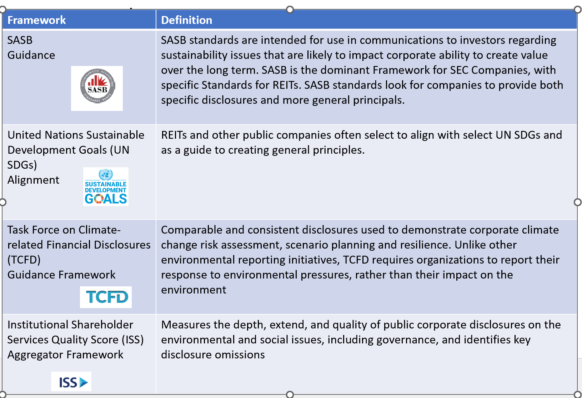

4.1 Sustainability Accounting Standards Board (SASB)
The SASB Standards provide guidance for the disclosure of material sustainability information by companies to their stakeholders. The below table incorporates the SASB Standards related to Real Estate Activities.

Topic | Accounting Metric | Category | SASB Code | Response
Energy Management | Energy consumption data coverage as a percentage of total floor area, by property subsector | Quantitative | IF-RE-130a.1 | We are evaluating opportunities to disclose this data in future reports.
 | (1) Total energy consumed by portfolio area with data coverage, (2) percentage grid electricity, and (3) percentage renewable, by property subsector | Quantitative | IF-RE-130a.2 | We are evaluating opportunities to disclose this data in future reports.
 | Like-for-like percentage change in energy consumption for the portfolio area with data coverage, by property subsector | Quantitative | IF-RE-130a.3 | We are evaluating opportunities to disclose this data in future reports.
 | Percentage of eligible portfolio that (1) has an energy rating and (2) is certified to ENERGY STAR, by property subsector | Quantitative | IF-RE-130a.4 | We are evaluating opportunities to disclose this data in future reports.

 | Description of how building energy management considerations are integrated into property investment analysis and operational strategy | Discussion and analysis | IF-RE-130a.5
Water Management | Water withdrawal data coverage as a percentage of (1) total floor area and (2) floor area in regions with High or Extremely High Baseline Water Stress, by property subsector | Quantitative | IF -RE -140a.1 | We are evaluating opportunities to disclose this data in future reports.
 | (1) Total water withdrawn by portfolio area with data coverage and (2) percentage in regions with High or Extremely High Baseline Water Stress, by property subsector | Quantitative | IF -RE -140a.2 | We are evaluating opportunities to disclose this data in future reports.
 | Like-for-like percentage change in water withdrawn for portfolio area with data coverage, by property subsector | Quantitative | IF -RE -140a.3 | We are evaluating opportunities to disclose this data in future reports.
 | Description of water management risks and discussion of strategies and practices to mitigate those risks | Discussion and analysis | IF -RE -140a.4 | We are evaluating opportunities to disclose this information in future reports.

Management of Tenant Sustainability Impacts | (1) Percentage of new leases that contain a cost recovery clause for resource efficiency-related capital improvements and (2) associated leased floor area, by property subsector | Quantitative | IF-RE-410a.1 | We are evaluating opportunities to disclose this data in future reports.
 | Percentage of tenants that are separately metered or sub-metered for (1) grid electricity consumption and (2) water withdrawals, by property subsector | Quantitative | IF-RE-410a.2 | We are evaluating opportunities to disclose this data in future reports.
 | Discussion of approach to measuring, incentivizing, and improving sustainability impacts of tenants | Discussion and analysis | IF-RE-410a.3
Climate Change Adaption | Area of properties located in 100-year flood zones, by prop | Quantitative | IF-RE-450a.1
 | Description of climate change risk exposure analysis, degree of systematic portfolio exposure, and strategies for mitigating risks | Discussion and analysis | IF-RE-450a.2

Activity Metric | Category | Code | Client Response
Number of assets, by property subsector | Quantitative | IF-RE-000.A | 204 properties in total  - Xx Skilled nursing centers  - Xx Assisted living facilities  - Independent living facilities  - Memory care facilities
Leasable floor space, by property subsector | Quantitative | IF-RE-000.B
Percentage of indirectly managed assets, by property subsector | Quantitative | IF-RE-000.C
Average occupancy rate, by property subsector | Quantitative | IF-RE-000.D

4.2 United Nations Sustainable Development Goals
The U.N. Sustainable Development Goals (SDGs) are a collection of 17 global goals and 169 targets that are part of a collaborative effort to achieve peace, prosperity, and a protected planet. The goals address challenges associated with poverty, inequality, climate change, environmental protection, peace, and justice. The table below describes the goals in which we have the greatest opportunity for action and positive influence.

U.N. Sustainable Development Goals (SDGs) | How LTC Supports the U.N. SDGs
  Good Health and Well-Being  Ensure healthy lives and promote well-being for all at all ages | We pay 100% of the heath care premiums for employees and all eligible dependents. The benefits we offer include medical, dental, and vision coverage, paid time off, paid holidays, bereavement leave, employer-funded life and disability insurance, an employee assistance program, disability and medical leave, family and pregnancy leave, and organ and bone marrow donation leave.  As a REIT that invests primarily in seniors housing and health care properties, the buildings in our portfolio enable our operators to provide safe environments, access to healthcare, good nutrition, socialization, and wellness activities for the residents that call them home.
  Gender Equality  Achieve gender equality and empower all women and girls | We recognize, value, and are grateful for the diversity of the unique individuals who comprise our team. Sixty percent of our employees are white, 24 percent are Asian, eight percent are Hispanic, and eight percent are Middle Eastern. In addition, 60 percent of our workforce are female, and two-thirds of our executive team are women. In addition, 50 percent of our Board members are women.  Recently, our Board of Directors committed to and adopted Board Diversity Guidelines to continue to enhance our outreach to diverse candidates.
  Decent Work and Economic Growth  Promote inclusive and sustainable economic growth, employment, and decent work for all | We provide a living wage for all employees and comply with national wage regulations, such as the minimum wage and overtime payments. We also believe the benefits we offer meet or exceed market standards. For qualified employees, we offer a 401(k)-retirement plan with an employer matching contribution program. We offer an opportunity to earn discretionary bonuses, restricted stock and performance-based unit awards, and flexible working locations for certain job functions.

4.3 Task Force on Climate-Related Financial Disclosures
The Task Force on Climate-Related Financial Disclosures (TCFD) was created by the Financial Stability Board in 2015. Alignment with TCFD’s disclosures recommendations covers four different areas including governance, strategy, risk management, and metrics and targets. Disclosures in alignment with TCFD provides comparable and consistent information that investors, lenders, and other interested stakeholders can reference to better assess the impact and effects an organization has on climate change.

At LTC Properties, Inc., we committed to initiate our alignment with TCFD’s disclosure beginning November 2022. Our first step is disclosing the implementation of ClimateCheck Enterprise Risk Application both at headquarters and across select portfolios, and discussing how climate change could potentially impact properties, operators, residents and shareholders.

As of period end 09/30/2022
A green lease is a standard lease that has “rehabilitated” certain clauses to better align financial incentives and sustainability goals between a landlord and a tenant. It is a modern take on the traditional commercial lease that can prove financially beneficial to both landlord and tenant while also benefiting the environment. Source: Institute for Market Transformation

