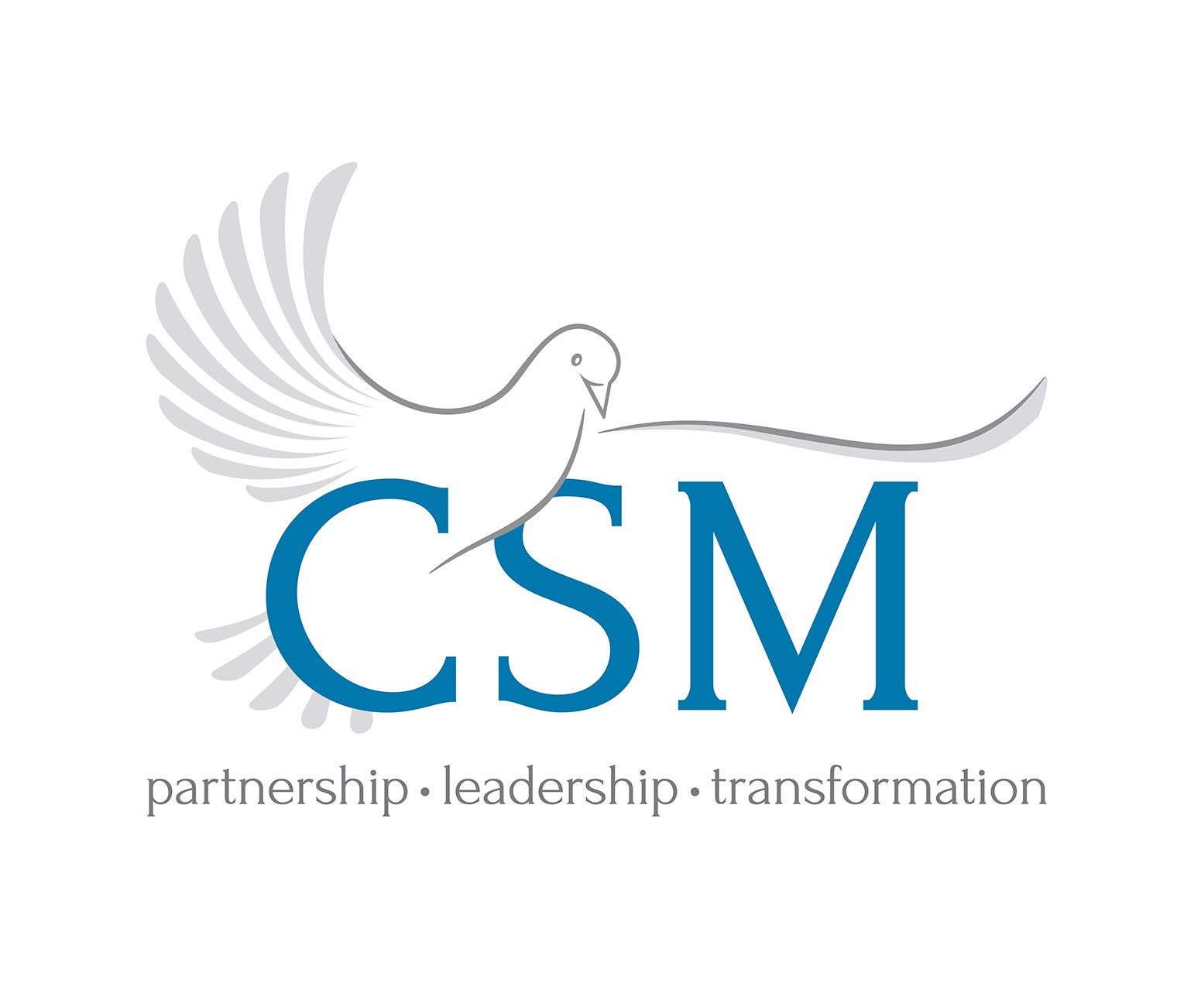

The CSM Philanthropy Code of Ethics
The Association of Fund-raising Professionals begins its webpage about ethics with this statement: “Ethical standards and principles are the foundation for maintaining donor and public trust”. Since its beginnings in 2017, CSM has noticed more and more the essential nature of that statement – our donors in our Christian schools want to know that we have and practice ethical standards with their money. It is surprising that few Christian schools note on their website philanthropy pages their stance on the ethical procedures they follow in cultivating / stewarding and soliciting donors. This is even more surprising given the number of times our schools ask our parents for money. While we have other statements that we ask other people to hold themselves accountable to, we don’t make ourselves accountable to our donors in any way. We invite all Christian schools to change that and provide that accountability.
We wish we could say that Christian schools, because they are Christian, of course follow high ethical standards. However, that would not be true. The following are examples of lapses in ethical standards in our recent memory:
- Using a donor’s money given for one project to support a different one without the donor’s approval
- Failing to receipt a donor’s gift
- Failing to thank a donor for a gift
- Inability to track a donor’s giving history with the school
- Using Foundation principal money to cover a loan
- Exaggerating the amount of money raised to date
and many more.
We therefore call on all Christian schools who raise money (and who doesn’t?) to commit to philanthropic ethical standards, publish them on the school’s website, and state that commitment on all significant communications and solicitations.
We suggest that this be part of Board induction and signed along with the Conflict-of-Interest Policy. Principals and philanthropy professionals should commit to these as part of their contracts with the school.
We recommend two sets of standards: the Donor Bill of Rights from the Association of Fundraising Professionals; the CSM Philanthropy Code of Ethics.
The CSM Philanthropy Code of Ethics was created in 2022 by Christian School Management.

The CSM Philanthropy Code of Ethics
Professionals and volunteers who practice philanthropy in Christian schools make these commitments to their donors:
- We promise to build a relationship with you as Jesus did with his own Philanthropy Committee (Luke 8:3).
- We promise to cover our ‘ask’ with a canopy of prayer.
- We promise that we will use your gift to move the school forward on behalf of the children within the context of a plan showing excellent stewardship and financial sustainability.
- We promise to strategically ensure that philanthropy dollars go to extending the mission in the life of the child and will not be diverted to running the operations budget except to support financial aid.
- We promise not to show partiality to one over another because of the gifts they have or have not made.
- We promise to accept only gifts that are mission-appropriate.
- We promise to involve you, if you wish, as a partner with the school.
- We promise that asking you to invest in God’s work at the school will be accompanied by the School’s accountability and good stewardship in spending your money in the way you intended.
- We promise to be grateful to God and to you for your generosity to the “family of believers” in the school, ask you for gifts that fit your own prosperity, and honor you as a giver.

The Donor Bill of Rights (AFP)
Philanthropy is based on voluntary action for the common good. It is a tradition of giving and sharing that is primary to the quality of life. To assure that philanthropy merits the respect and trust of the general public, and that donors and prospective donors can have full confidence in the not-for-profit organizations and causes they are asked to support, we declare that all donors have these rights:
I. To be informed of the organization's mission, of the way the organization intends to use donated resources, and of its capacity to use donations effectively for their intended purposes.
II. To be informed of the identity of those serving on the organization's governing board, and to expect the board to exercise prudent judgment in its stewardship responsibilities.
III. To have access to the organization's most recent financial statements.
IV. To be assured their gifts will be used for the purposes for which they were given.
V. To receive appropriate acknowledgement and recognition.
VI. To be assured that information about their donation is handled with respect and with confidentiality to the extent provided by law.
VII. To expect that all relationships with individuals representing organizations of interest to the donor will be professional in nature.
VIII. To be informed whether those seeking donations are volunteers, employees of the organization or hired solicitors.
IX. To have the opportunity for their names to be deleted from mailing lists that an organization may intend to share.
X. To feel free to ask questions when making a donation and to receive prompt, truthful and forthright answers.
The Donor Bill of Rights was created by the Association of Fundraising Professionals (AFP), the Association for Healthcare Philanthropy (AHP), the Council for Advancement and Support of Education (CASE), and the Giving Institute: Leading Consultants to Non-Profits. It has been endorsed by numerous organizations.
"Association of Fundraising Professionals (AFP), all rights reserved. Reprinted with permission from the Association of Fundraising Professionals."
Commitment to these two statements provides the school with answers when the donor asks questions about your fund-raising efforts. It also provides some clarity to Christian School Boards who have not been involved in philanthropy at this level before. Your professionals and volunteers will, we believe, be grateful for the direction it provides your philanthropic efforts, and the integrity it demonstrates.
On the CSM website, we have a short commitment form for you to fill in. If you do that, we will provide you with the right to show the CSM Certified Code of Ethics logo on your website.

CSM Mission: For Jesus; Through Mission; With Students
Website: christianschoolmanagement.org
Email: christianschoolmanagement@gmail.com
Membership: $8.37 month; $100.44 annually
CSM is a 501(c)(3) dedicated to healthy, hopeful Christian schools. It works with Christian schools that have an average tuition K-12 under $14,655. 10% of its revenues is tithed into the CSMA Foundation in order to assist Christian leaders and schools with advice/counsel and to fund Christian school research. We charge for consulting based on the tuition level of the individual school to make it affordable for all.
Copyright ©2022 CSM. All rights reserved.

Christian School Management
“For Jesus, through mission, with students”
christianschoolmanagement@gmail.com www.christianschoolmanagement.com 519 401 2351
©2018

2

Christian School Management

