List for new labels

- Prime Rib (6 oz and 12.5 oz)
Contains: Dehydrated garlic, spices including celery, sugar, onion powder, salt, monosodium glutamate dehydrated parsley extracts of turmeric and no more than 2% soy oil to prevent caking.
Prime Rib Seasoning
Calories | 0
Serving Size | 1/4 Tsp 1g
Per Serving | Grams | % Daily Value
Total Fat | 0 | 0.0%
Trans Fat | 0 | 0.0%
Sodium | 190.574 | 7.6%
Tot Carbs | <1g | 0.0%
Protein | 0 | 0.0%
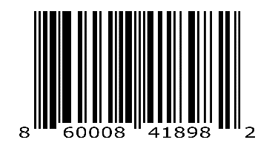

- Whisky Steak (5.5 oz and 11oz)
Contains: Garlic, spices including celery, salt, sugar, artificial bourbon flavor, onion, parsley spice extractives and not more than 2% soy oil and silicon dioxide to prevent caking.
Whiskey Creek Drunken Chicken
Calories | 0
Serving Size | 1/4 Tsp 1g
Per Serving | Grams | % Daily Value
Total Fat | 0 | 0.0%
Trans Fat | 0 | 0.0%
Sodium | 163.2 | 6.5%
Tot Carbs | <1g | 0.0%
Protein | 0 | 0.0%

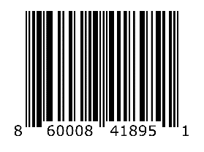

- Garlic Butter (5.5 oz and 11 oz)
Contains: Garlic, sugar, onion, spices, butter flavor, salt, oil of garlic, FD&C yellow #5 and not more than 2% soy oil and silicon dioxide to prevent caking.
Garlic Butter
Calories | 0
Serving Size | 1/4 Tsp 1g
Per Serving | Grams | % Daily Value
Total Fat | 0 | 0.0%
Trans Fat | 0 | 0.0%
Sodium | 136 | 5.4%
Tot Carbs | <1g | 0.0%
Protein | 0 | 0.0%

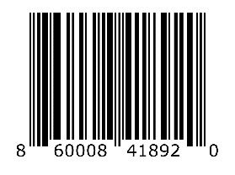

- Heart of Texas Brisket (6 oz and 13 oz)
Contains: Spices including celery, salt, sugar, paprika, onion, modified food starch, garlic, turmeric, cinnamon, spice extractives including paprika, and celery, and not more than 2% silicon dioxide to prevent caking.

Heart Of Texas Brisket Seasoning
Calories | 1
Serving Size | 1/4 Tsp 1g
Per Serving | Grams | % Daily Value
Total Fat | 0 | 0.0%
Trans Fat | 0 | 0.0%
Sodium | 272.68 | 10.9%
Tot Carbs | <1g | 0.0%
Protein | 0 | 0.0%

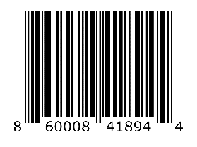

- Drunken Chicken (5.5 oz and 10.5 oz)
Contains: Garlic, sugar, spices including celery, salt, artificial bourbon flavor, onion, paprika, turmeric, and not more than 2% soy oil to prevent caking.
Drunken Chicken
Calories | 0
Serving Size | 1/4 Tsp 1g
Per Serving | Grams | % Daily Value
Total Fat | 0 | 0.0%
Trans Fat | 0 | 0.0%
Sodium | 163.2 | 6.5%
Tot Carbs | <1g | 0.0%
Protein | 0 | 0.0%
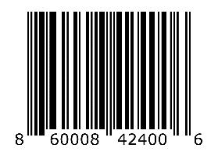

- CAJUN SEASONING (6 oz and 13 oz)
Contains: Spices including paprika and celery, onion and garlic powder, salt, monosodium glutamate, modified food starch, extracts of paprika and not more than 2% silicon dioxide to prevent caking.
Cajun Seasoning
Calories | 0
Serving Size | 1/4 Tsp 1g
Per Serving | Grams | % Daily Value
Total Fat | 0 | 0.0%
Trans Fat | 0 | 0.0%
Sodium | 253.074 | 10.1%
Tot Carbs | <1g | 0.0%
Protein | 0 | 0.0%
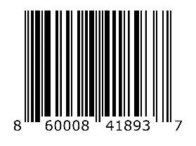

- RANCH (5.5 oz and 11 oz)
Contains: Onion, garlic, spices, dehydrated parsley, monosodium glutamate, salt and not more than 2% silicon dioxide to prevent caking.
Ranch
Calories | 0
Serving Size | 1/4 Tsp 1g
Per Serving | Grams | % Daily Value
Total Fat | 0 | 0.0%
Trans Fat | 0 | 0.0%
Sodium | 132.94 | 5.3%
Tot Carbs | <1g | 0.0%
Protein | 0 | 0.0%
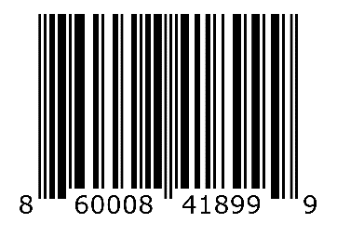

- Hawkeye Seafood Blend (7 oz and 13 oz)
Contains: Spices including celery and sage, garlic, sugar, salt, monosodium glutamate, onion, brown sugar, paprika, mustard, citric acid, parsley flakes, lemon oil, spice extractives including turmeric, FD&C yellow #5 and not more than 2% soy oil and silicon dioxide to prevent caking
Seafood Blend

Calories Per Serving | 0
Serving Size | 1/4 Tsp 1g
Per Serving | Grams | % Daily Value
Total Fat | 0 | 0.0%
Trans Fat | 0 | 0.0%
Sodium | 202 | 8.0%
Tot Carbs | <1g | 0.0%
Protein | 0 | 0.0%
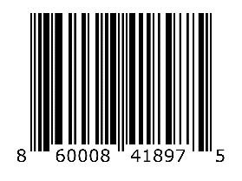

- All-In Seasoning (7 oz and 13 oz)
Contains: Spices including celery, garlic, onion, sugar, brown sugar, paprika, salt, monosodium glutamate, mustard, citric acid, parsley flakes, spice extractives including turmeric, FD&C yellow #5 and not more than 2% soy oil and silicon to prevent caking
Hawkeye All In
Calories Per Serving 0
Serving Size 1/4 Tsp 1g
Per Serving Grams
% Daily
Value
Total Fat 0 0.0%
Trans Fat 0 0.0%
Sodium 198 8.0%
Tot Carbs <1g 0.0%
Protein 0 0.0%
Hawkeye All In
Calories Per Serving 0
Serving Size 1/4 Tsp 1g
Per Serving Grams
% Daily
Value
Total Fat 0 0.0%
Trans Fat 0 0.0%
Sodium 198 8.0%
Tot Carbs <1g 0.0%
Protein 0 0.0%
Hawkeye All In
Calories Per Serving 0
Serving Size 1/4 Tsp 1g
Per Serving Grams
% Daily
Value
Total Fat 0 0.0%
Trans Fat 0 0.0%
Sodium 198 8.0%
Tot Carbs <1g 0.0%
Protein 0 0.0%
All-In

Calories Per Serving | 0
Serving Size | 1/4 Tsp 1g
Per Serving | Grams | % Daily Value
Total Fat | 0 | 0.0%
Trans Fat | 0 | 0.0%
Sodium | 198 | 8.0%
Tot Carbs | <1g | 0.0%
Protein | 0 | 0.0%
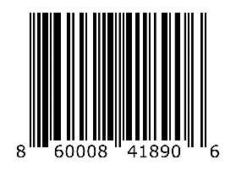

- Lemon Pepper (6.5 oz and 13 oz)
Contains: Spice, citric acid, dehydrated onion and garlic, salt, sugar, celery seed, lemon juice solids. Emon oil, FD and C Yellow #5 Lake, and no more than 2% silicon dioxide to prevent caking.
Lemon Pepper
Calories | 0
Serving Size | 1/4 Tsp 1g
Per Serving | Grams | % Daily Value
Total Fat | 0 | 0.0%
Trans Fat | 0 | 0.0%
Sodium | 267.12 | 10.7%
Tot Carbs | <1g | 0.0%
Protein | 0 | 0.0%
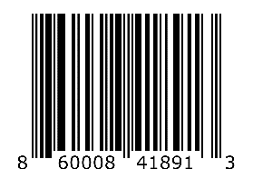

- BBQ (6 oz and 12 oz)
Contains: Spices, sugar, including paprika and turmeric, dextrose, onion powder, salt, monosodium glutamate, garlic power, and no more than 2% silicon dioxide and soybean oil to prevent caking.
BBQ
Calories | 1
Serving Size | 1/4 Tsp 1g
Per Serving | Grams | % Daily Value
Total Fat | 0 | 0.0%
Trans Fat | 0 | 0.0%
Sodium | 124.9 | 5.0%
Tot Carbs | <1g | 0.0%
Protein | 0 | 0.0%
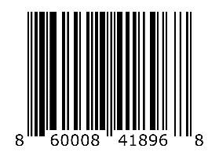
- Caribbean Jerk Seasoning (6.5 oz and 11.5 oz)

Contains: Sugar, spices, onion powder and not more than 2% soy oil to prevent caking

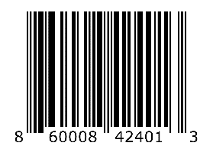

- Margarita Chicken (6.5 oz and 11.5 oz)

Contains: Garlic, citric acid, onion salt, sugar monosodium glutamate, spices including celery, spice extractives including turmeric, grill flavor, lime oil, parsley and not more than 2% soy oil and silicon dioxide to prevent caking

- No Salt Season It (4.5 oz and 12 oz)

Contains: Spices including celery, garlic, onion, modified food starch, sugar and not more than 2% silicon dioxide to prevent caking

- Spicy BBQ (5 oz and 11.5 oz)

Contains: Spices including celery, garlic, spice extracts, salt and not more than 2% soy oil and silicon dioxide to prevent caking

- Sugar & Cinnamon Blend (6 oz and 12.5 oz)

Contains: Sugar, cinnamon, and brown sugar.

- Spicy All-In
All-In Seasoning (7 oz and 13 oz)
Contains: Spices including celery, garlic, onion, sugar, brown sugar, paprika, salt, monosodium glutamate, mustard, citric acid, parsley flakes, spice extractives including turmeric, FD&C yellow #5 and not more than 2% soy oil and silicon to prevent caking
Hawkeye All In
Calories Per Serving 0
Serving Size 1/4 Tsp 1g
Per Serving Grams
% Daily
Value
Total Fat 0 0.0%
Trans Fat 0 0.0%
Sodium 198 8.0%
Tot Carbs <1g 0.0%
Protein 0 0.0%
Hawkeye All In
Calories Per Serving 0
Serving Size 1/4 Tsp 1g
Per Serving Grams
% Daily
Value
Total Fat 0 0.0%
Trans Fat 0 0.0%
Sodium 198 8.0%
Tot Carbs <1g 0.0%
Protein 0 0.0%
Hawkeye All In
Calories Per Serving 0
Serving Size 1/4 Tsp 1g
Per Serving Grams
% Daily
Value
Total Fat 0 0.0%
Trans Fat 0 0.0%
Sodium 198 8.0%
Tot Carbs <1g 0.0%
Protein 0 0.0%

Calories Per Serving | 0
Serving Size | 1/4 Tsp 1g
Per Serving | Grams | % Daily Value
Total Fat | 0 | 0.0%
Trans Fat | 0 | 0.0%
Sodium | 198 | 8.0%
Tot Carbs | <1g | 0.0%
Protein | 0 | 0.0%

- Orange Chicken

Contains: Spices including celery, garlic, sugar, citric acid, orange flavor, salt, monosodium glutamate, onion, chardex flavor, spice extractives including turmeric, FD&C yellow #5 and #6, parsley and not more than 2% soy oil and silicon dioxide to prevent caking

- SPICY CAJUN SEASONING (6 oz and 13 oz)
Contains: Spices including paprika and celery, onion and garlic powder, salt, monosodium glutamate, modified food starch, extracts of paprika and not more than 2% silicon dioxide to prevent caking.
Cajun Seasoning
Calories | 0
Serving Size | 1/4 Tsp 1g
Per Serving | Grams | % Daily Value
Total Fat | 0 | 0.0%
Trans Fat | 0 | 0.0%
Sodium | 253.074 | 10.1%
Tot Carbs | <1g | 0.0%
Protein | 0 | 0.0%

