Deliverables
Fonts in Montserrat (different font weight according to text)
Green/Black and Green/White theme
All pages need to be designed preferably in Figma or Adobe XD.
Be as creative as possible. Tabs do not need to be on the bottom, they can be creative and on top with just text without icons.
You can also go the normal way and do it with tabs on the bottom with icons.
Show the best you can do.
App startup
- Animation of logo
- Slogan typing animation ‘G’day mate.’
- “Terms and Conditions”
- ‘Agree and Continue’
- Background designs, green

Register Page
- Logo on top
- Register using phone number
- Register using Google
- Register using email
- Some designs

Congratulations page, you have been registered.

Upload info/name page
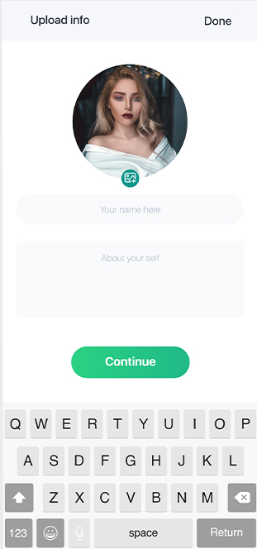

Tabs from left to right –
‘Wallet’ ‘Trade’ ‘CHATS’(middle and main tab) ‘Market’ ‘Settings’

Wallet
- Initial Stage (setup) – REFER TO [1] in attachment WalletApp.jpg
  - Create new wallet
  - Import wallet
- Crypto wallet page
- Show all coins in wallet
- Refer to [2]
- Transactions button (shows all recent transactions)

Trade
- Buy Crypto using Apple Pay or other methods (design all these methods in different pages)
- Swap tokens
- Send > take to send page
  - Send to a MyMate Tag
  - Send to a Phone Contact
  - Send to an ETH Address
- Receive > take to receive page (refer to [3])

CHATS
- All messages appear here (like whatsapp)
- Able to message anyone
- Normal messaging app
- ‘MyMate’ logo icon somewhere in the messaging for someone to send tokens
- Branded similar to apple pay in messages (As below) with amount
- Otherwise normal messaging app (as below)
- NFT Trades
  - Middleman service.
  - User 1 sends NFT
  - User 2 gets notification with NFT preview, can click on it to ensure NFT is legit (etherscan)
  - User 2 confirms legit
  - User 1 receives money
  - User 2 receives NFT.
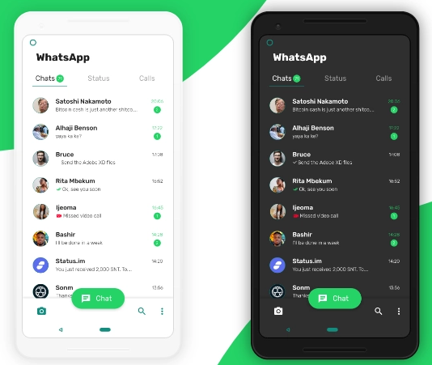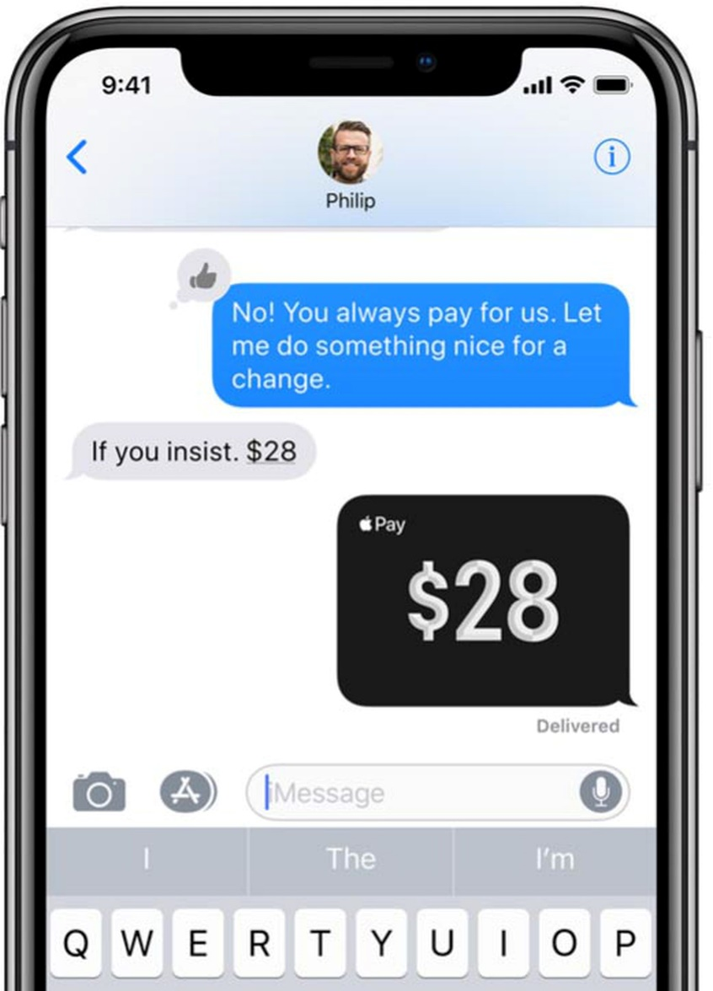

Market
- Refer to [4]
- Can click on each token – refer to under [4]
- Can send/buy from there

MyMate (logo)
- Rewards Page – refer to [5]
- Also Settings page

