Nexxview Website Design
  - RidgeView Project

Change CONTROL
We approve the project as described above, and authorize the team to proceed.
Name | Title | Date
Peter Scantland |  | March 15, 2023

Overview
 | This section should give a basic overview of the project and the organization behind it. An overview could include:  - About the organization  - We are a small development team looking for projects that are close to our hearts and represent locations and services we want available to us. We are experienced project managers and builders who will help our buyers find the right location, right builders and right managers for their property.  - What problem are you trying to solve?  - In recent years, more and more city dwellers have been looking to small towns as an opportunity to relocate or invest in Airbnb properties. With the rise of remote work and the increasing popularity of small-town living, many people are discovering the benefits of a slower-paced lifestyle, lower cost of living, and closer-knit communities. Small towns offer the chance to escape the hustle and bustle of the big city and enjoy a simpler way of life, with access to fresh air, outdoor recreation, and local charm.  - We are this audience and have taken action to help ourselves and others move forward. We have purchased properties in PEI to enhance and sell to those looking for a slice of the country.  - This website needs to briefly describe NexxView Development Partners and it’s development projects.  - High-level project scope  - New one theme site for the company and RidgeView project. Site is ready to add other projects.  - Technical details  - Bluehost hosting  - Wordpress site, Elementor editing  - Target market  - We are targeting upper middle class folks how are looking to invest in a property and possible build a second home or retirement home that can be AirB&B.

Project scope
Expand on the current template

High-level requirements
Describe the high level requirements for the project. For example:

Content Structure
Site map
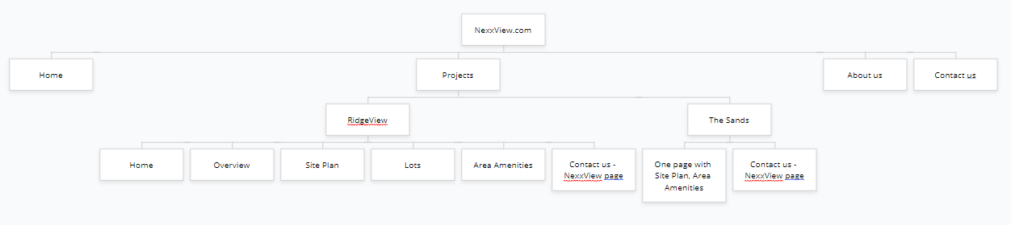

Sample Sites
Same sites

- Kokomo Beach Club

- New Homes in Goderich | The Bluffs at Huron

- Bluffs Bay – Georgian Bay Waterfront Lots

- Pinery Bluffs, Real Estate Lots For Sale in Grand Bend Ontario Area

- Bois Blanc Island Resort (boisblanccanada.com)

- Braestone | Horseshoe Valley's Country Estate Community

- Home - Nature Ridge Homes

Photos
Photos

