
I would like something similar to this design. Replace “The Hacker” with “The Covert Angler” and replace “Sunday Red Golf” with a picture of the purple and black fishing lure below
The Covert
Angler
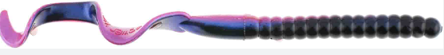

These are just some examples I found that I liked the look of the moon, clouds, and grass.
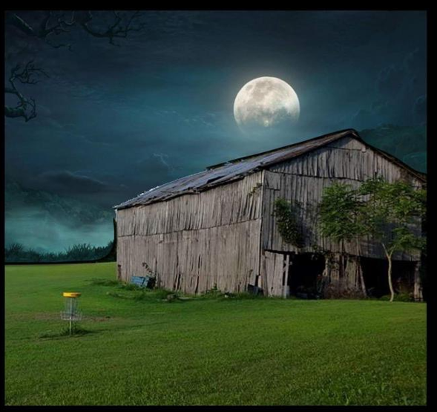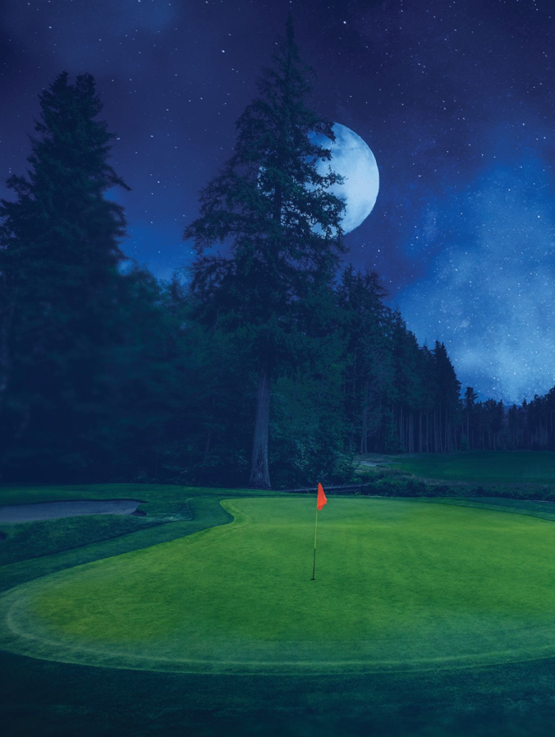

These are some examples of golf course ponds that someone would fish. I would like a scene showing someone fishing at night on a spot similar to these pictures which includes the following:
- Green & flag – usually the flag on the green is red, yellow, white, or blue. Whichever goes best in your color scheme will work
- Sand Bunker
- No Fishing Sign
- Trees in background (no palm trees)
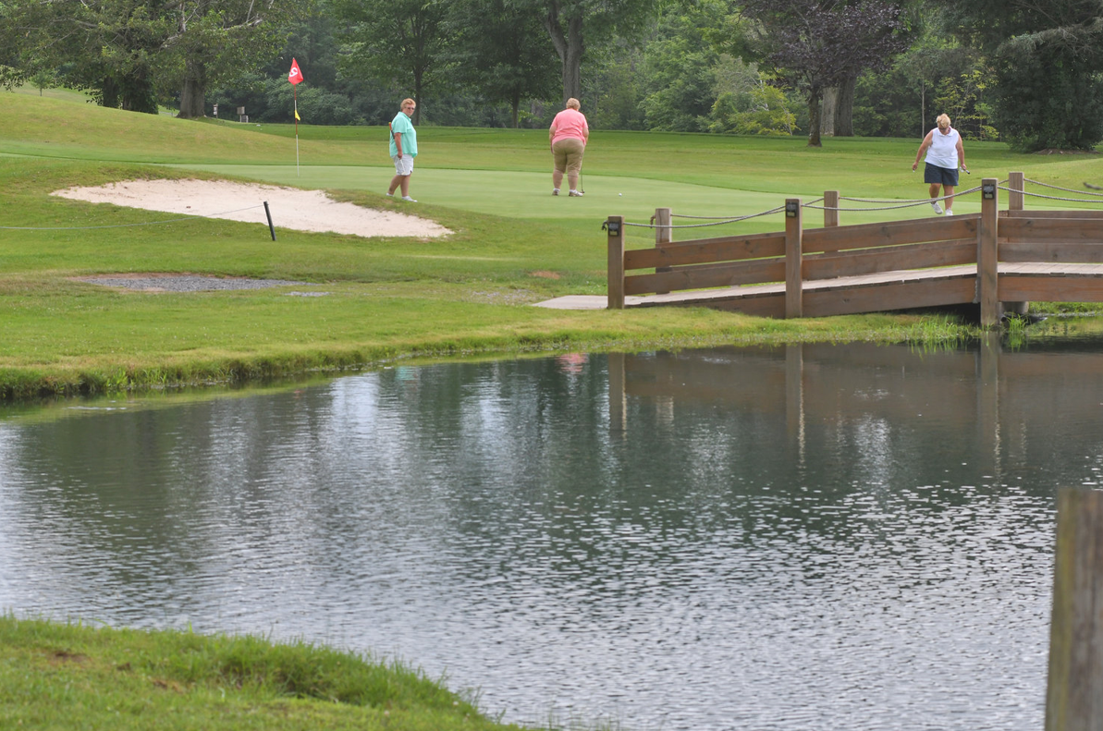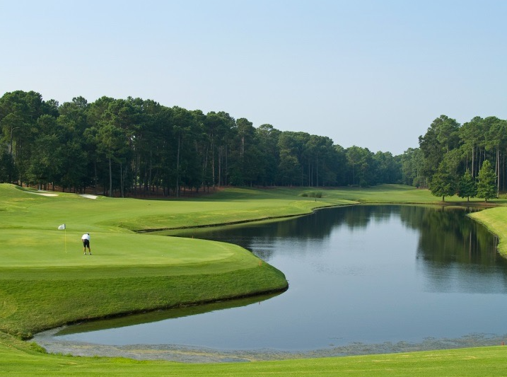
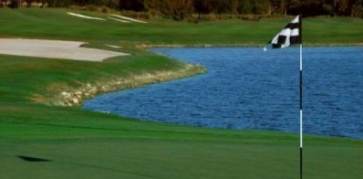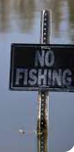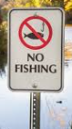
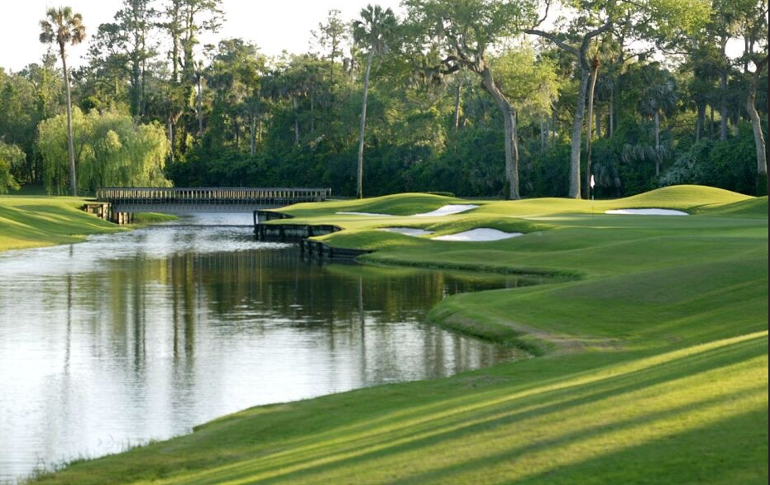
Examples of fisherman fishing or catching a fish. Side view or back view is fine.
