PuttingMaster Logo/Brand Design Overview

Who are we and what do we have?
PuttingMaster® is a trademarked name and brand owned by HE2, LLC. Our first product, a golf putting training aid, is called J316 and has a provisional patent filing submitted with the USPTO in 2018.
It’s a very simple training concept with very dramatic results. The product is based upon the generic sports training principle of “aim small, miss small”, using dramatically smaller balls than regulation golf balls, stroked to an impossibly tiny target. The balls are 60% smaller but with the same weight as a regulation golf ball. And we’ve removed the dimples to make it even more challenging. The target is a 3/16” “marker” (stick) which is inserted into a practice putting green and used as a putting objective from distances of 3, 5, 7, 10 and 15 feet. Users must strike the ball with slightly greater force and precision in order to hit the target. The balls and marker are colored bright red to promote visual contrast.
The results are substantial. Our studies across a wide range of golf handicaps show that with just 3-5 minutes of J316 practice per day, users experienced an average “one-putt” (putts made with a regulation golf ball on the first try) improvement of 41% inside 15 feet, within one week. In the golf world, this is a MASSIVE achievement.
Our founders have had this product on the market for 2+ years, but have not done a lot to promote it, save some minor exposure at PGA merchandising events. We have sold a few hundred units, but have held back production because of the limitations of the inventor’s garage! We’re currently working with a manufacturing firm on new ball construction, a sleek carrying case and some sexy, interesting packaging. Here are images of the case, with the balls…
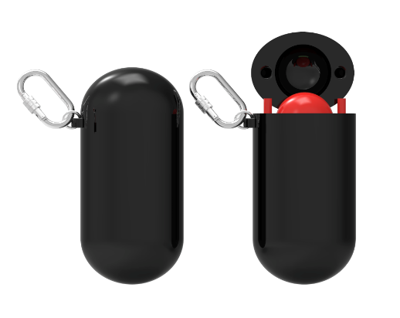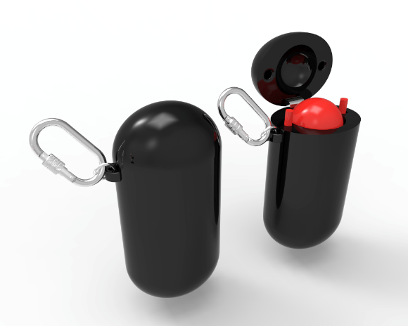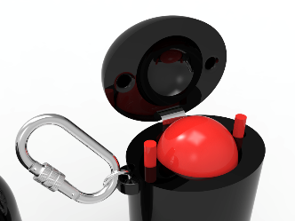

Packaging is not yet finalized, but will likely look like this:
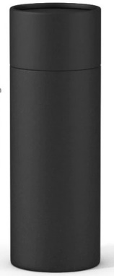
Summary of the product and packaging:
Black satin case, shiny red balls and markers, black matte cylindrical packaging. Clean and simple.
What are we looking for?
This Powerpoint project is initiated as part of a larger initiative to update the current company branding, logo and website in an effort to present clearer, more consistent and visceral messaging to consumers and partners about the value of PuttingMaster®. We will be editing and updating current content on the website in addition to creating new content, however, the core messages around “precision practice” will remain the same.
The .ppt will be used to pitch our solution and business model to several constituencies, including, but not limited to: strategic partners (golf equipment manufacturers and the like), retail and wholesale partners (Golf Galaxy, PGA Tour Superstore, Dicks Sporting Goods, etc.), golf associations (PGA of America, USGA, regional groups and facilities) and to end customers. As such, we’re looking for a format that can be tailored to these different prospects, while maintain a core, compelling value proposition.
It's important to note that we’re at the tail end of a logo design project that will put PuttingMaster at the center of the brand, as opposed to the HE2 logo you’ll see on the website. We should have that logo selected within the next couple days and will update this project accordingly. The winning design will likely come from one of the following:
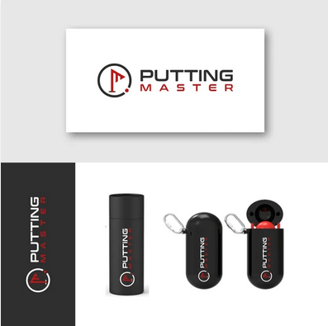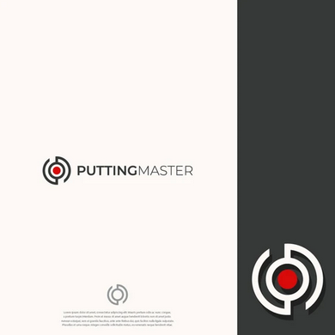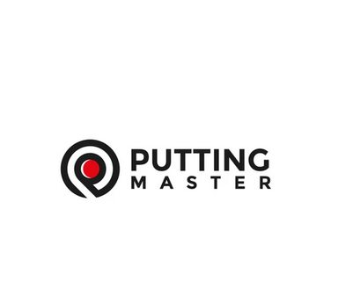
Budget and timeline
Since we are well down the path towards full production of our new product, we want to complete this project ASAP. Ideal timeframe will be to choose a winning design by the first week of December 2022.
We consider this effort a critical part of our marketing strategy, so there is really no defined budget for the entire project. We are a frugal startup, however, and will certainly make decisions with cost in mind.
Company background
More detailed information on the company, our founders and our initial product can be found on http://puttingmaster.com .
Target Market and Competition
Our market is really all golfers worldwide, however, the likely buyer demographics will be a subset of avid male and female golfers ranging in age from 18 to 70+, with medium to high disposable income. Our price point will be low enough for all golfers to afford.
There are hundreds of putting aids on the market. From hockey puck-shaped balls to mirrors, sticks, putting mats and oversized, overweighted balls. There are several categories of these training aids intended to help golfers with their:
- Putting stroke (pace, impact and direction)
- Alignment
- Green reading
Many of the most successful aids are either bulky to use or complex to set up, or both.
However, our biggest competitor by far is that a very large percent of our target market spends little to no time actually practicing their putting. Given that it’s the easiest of all the golf strokes to make, golfers report that putting practice is tedious and boring. This is why our study results are so profound: 3-5 minutes per day, 41% improvement within a week.
Style and Design Preferences
Our mantra is “simple, precision practice”. As such, we would like our brand to invoke that simplicity and precision. Some other terms that encompass how we’d like our brand perceived:

- Exciting
- Quality
- Sleek
- Innovative
- Exposing
- Addictive
- Game Changing
- Paradigm shifting
- Eye opening
- Difficult
- Challenging
- Revealing
- Fun
- Enthusiastic
- Wow factor

Our current black and red colors are important for the product, but do not necessarily need to be central to the logo, presentation and web schemes.

