Based on your recommendation, I have grouped some similar services into categories,
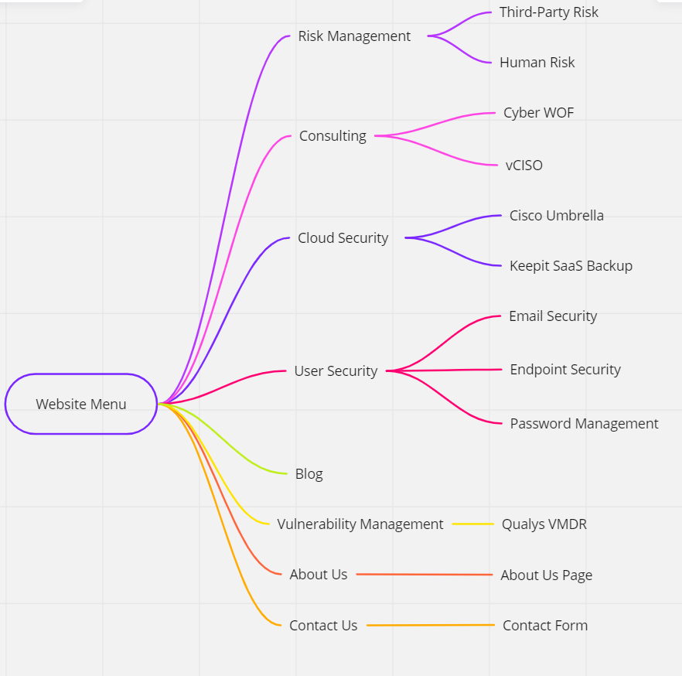

I think for the front page :
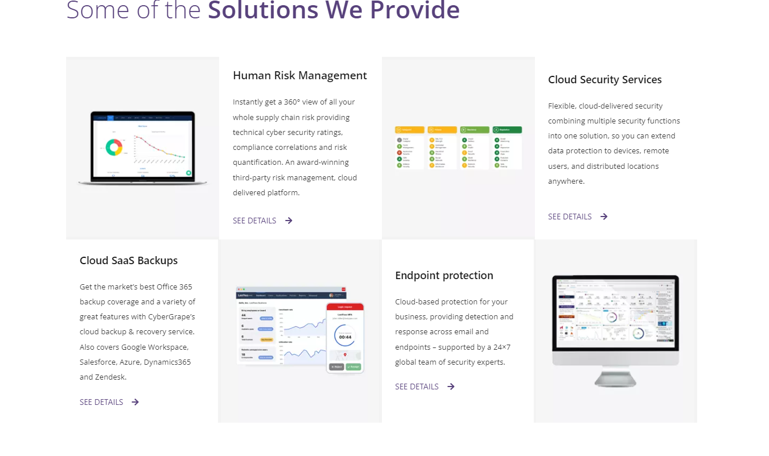

Lets keep the 4 and have:
 | Third-Party Risk Management  Instantly get a 360° view of all your whole supply chain risk providing technical cyber security ratings, compliance correlations and risk quantification. An award-winning third-party risk management, cloud delivered platform. |  | Human Risk Management  Calculate, reduce and monitor human cyber risk with the new-class of user-focused security. Cloud delivered security awareness training, simulated phishing attacks, dark web monitoring and compliance policy management tailored to your business.
vCISO  Description:  If a fulltime CISO is too costly for a small business, a virtual CISO (vCISO) can fulfil the need by working part time to provide that same enterprise-calibre expertise. We can help to craft a security program fit for your business. |  | Cybersecurity warrant of fitness  Like motor vehicles, an organisation's Cyber Security should be checked on a regular basis by a third party to ensure the security controls in place are relevant and capable of keeping their business and staff cyber safe. | See our all our services  Here

